
RAJALAKSHMI INSTITUTE OF TECHNOLOGY
(An Autonomous Institution, Affiliated to Anna University, Chennai)

DEPARTMENT OF CSE (ARTIFICIAL INTELLIGENCE AND MACHINE LEARNING)
ACADEMIC YEAR 2025 - 2026
SEMESTER III
ARTIFICIAL INTELLIGENCE LABORATORY
MINI PROJECT REPORT

REGISTER NUMBER | 2117240030015
NAME | AVANINDH SUGUNAN.A
PROJECT TITLE | Smart Maze Solver
DATE OF SUBMISSION
FACULTY IN-CHARGE | Mrs. M. Divya

Signature of Faculty In-charge

INTRODUCTION
Artificial Intelligence (AI) is the field of computer science focused on creating systems that can simulate human intelligence — including learning, reasoning, and decision-making. AI enables machines to solve problems, adapt to new situations, and interact intelligently with their environment.
This mini project, Maze Solver Game, demonstrates how AI concepts can be applied to navigate complex environments using logical reasoning and algorithmic decision-making. The game involves generating a random maze and allowing a player to solve it manually, with future enhancements enabling AI to solve the maze automatically.Maze solving is a classic problem in AI and robotics, representing real-world challenges like pathfinding, obstacle avoidance, and efficient decision-making. By implementing this project, we explore how search algorithms like recursive backtracking and breadth-first search (BFS) can be used to generate and solve mazes intelligently.
The Project aims to:
- Showcase AI reasoning through maze generation and navigation
- Provide an interactive platform for understanding pathfinding algorithms
- Lay the foundation for future AI enhancements like auto-solving and adaptive learning
- Let me know if you’d like a shorter version for a single bullet slide or a more visual layout with icons and flowcharts!
.
PROBLEM STATEMENT
To design and implement an interactive maze game that allows a user to navigate from a defined start point to an end point within a randomly generated maze. The maze must be solvable in every instance and visually rendered using Python and Pygame.
The project aims to:
- Generate a new, solvable maze each time the game is run
- Enable player-controlled movement through the maze using keyboard input
- Provide visual and audio feedback upon reaching the goal
- Demonstrate core AI concepts such as logical reasoning, pathfinding, and decision-making
This project highlights how artificial intelligence principles can be applied to real-time problem-solving in a game environment.

GOAL
Expected Result:
The Maze Solver Game should generate a random, solvable maze and allow the player to successfully navigate from the start point to the end point using logical movement. Upon reaching the goal, the game should provide visual and audio feedback and offer a restart option.
Possibilities and Outcomes:
- ✅ The player successfully reaches the goal using manual navigation.
- 🔁 The maze changes every session, offering a new challenge each time.
- 🔊 Sound effects and win messages enhance user experience.
- 🧠 The project demonstrates how AI concepts like maze generation and pathfinding can be applied in interactive environments.
- 🚀 Future versions may include AI auto-solving, hint systems, difficulty levels, and performance tracking.
This project showcases how artificial intelligence and algorithmic logic can be used to solve spatial problems in a game-based setting.

THEORETICAL BACKGROUND
Conceptual Foundation
Maze solving is a classic problem in artificial intelligence and robotics, representing real-world challenges like pathfinding, obstacle avoidance, and spatial reasoning. This project applies AI principles to generate and solve mazes using algorithmic logic.
🧠 Algorithm Used
- Recursive Backtracking (Maze Generation):
A depth-first search-based algorithm that carves paths by visiting unvisited cells and backtracking when no options remain. It guarantees a solvable maze and produces visually complex layouts.
- Player-Controlled Navigation:
The user manually navigates the maze using keyboard input. The game logic ensures movement is only allowed through valid paths, reinforcing decision-making and spatial awareness.
📚 Literature Survey
- Recursive Backtracking:
Widely used in maze generation due to its simplicity and guaranteed solvability. Produces mazes with long corridors and few branches.
- Prim’s Algorithm:
Generates mazes with more uniform branching; useful for grid-based environments but more complex to implement.
- Kruskal’s Algorithm:
Treats maze as a graph and builds a minimum spanning tree. Good for randomized layouts but less intuitive for real-time generation.
- A Search (Advanced):*
Combines path cost and heuristic to find optimal paths. Ideal for AI auto-solvers but not used in this version.

ALGORITHM EXPLANATION WITH EXAMPLE
Recursive Backtracking (Maze Generation)
Explanation:
Recursive backtracking is a depth-first search algorithm used to generate mazes by carving paths through a grid. It starts at a cell, marks it as visited, and recursively visits neighboring unvisited cells, backtracking when no options remain.
Steps:
- Start at cell (1,1)
- Randomly choose a direction (up, down, left, right)
- If the next cell is within bounds and unvisited, carve a path and move there
- Repeat until all reachable cells are visited
- Backtrack when stuck
Example:
- Start at (1,1)
- Move right to (1,3), carve path
- Move down to (3,3), carve path
- Continue until maze is complete
- Result: A solvable maze with one cl

IMPLEMENTATION AND CODE
import pygame
import random
import os

# --- Constants ---
WIDTH, HEIGHT = 600, 600
ROWS, COLS = 31, 31 # Must be odd for proper maze carving
CELL_SIZE = WIDTH // COLS

# Colors
WHITE = (255, 255, 255)
BLACK = (30, 30, 30)
GRAY = (180, 180, 180)
BG_COLOR = (240, 240, 255)

# --- Pygame Setup ---
pygame.init()
pygame.font.init()
pygame.mixer.init()

win = pygame.display.set_mode((WIDTH, HEIGHT))
pygame.display.set_caption("🌟 Maze Game - Player Controlled")
font = pygame.font.SysFont('comicsansms', 36, bold=True)

# --- Load Assets ---
def load_sprite(filename):
path = os.path.join(os.getcwd(), filename)
img = pygame.image.load(path)
return pygame.transform.scale(img, (CELL_SIZE, CELL_SIZE))

player_sprite = load_sprite("player.png")
start_img = load_sprite("start.png")
end_img = load_sprite("end.png")
move_sound = pygame.mixer.Sound("move.wav")
win_sound = pygame.mixer.Sound("win.wav")

# --- Maze Generation (Recursive Backtracking) ---
def generate_maze():
maze = [[1 for _ in range(COLS)] for _ in range(ROWS)]

def carve(x, y):
maze[x][y] = 0
directions = [(0,2), (2,0), (0,-2), (-2,0)]
random.shuffle(directions)
for dx, dy in directions:
nx, ny = x + dx, y + dy
if 1 <= nx < ROWS-1 and 1 <= ny < COLS-1 and maze[nx][ny] == 1:
maze[nx][ny] = 0
maze[x + dx//2][y + dy//2] = 0
carve(nx, ny)

carve(1, 1)
maze[1][1] = 0
maze[ROWS-2][COLS-2] = 0
return maze

# --- Drawing ---
def draw_maze(maze, player_pos):
win.fill(BG_COLOR)
for i in range(ROWS):
for j in range(COLS):
rect = pygame.Rect(j*CELL_SIZE, i*CELL_SIZE, CELL_SIZE, CELL_SIZE)
if maze[i][j] == 1:
pygame.draw.rect(win, BLACK, rect)
else:
pygame.draw.rect(win, WHITE, rect)
pygame.draw.rect(win, GRAY, rect, 1)

win.blit(start_img, (CELL_SIZE, CELL_SIZE))
win.blit(end_img, ((COLS-2)*CELL_SIZE, (ROWS-2)*CELL_SIZE))

x, y = player_pos
win.blit(player_sprite, (y*CELL_SIZE, x*CELL_SIZE))
pygame.display.update()

# --- Text Rendering ---
def draw_text(message, color=(255, 215, 0)):
overlay = pygame.Surface((WIDTH, HEIGHT))
overlay.set_alpha(180)
overlay.fill((0, 0, 0))
win.blit(overlay, (0, 0))

text_surface = font.render(message, True, color)
shadow = font.render(message, True, (0, 0, 0))

# Shift text upward for full visibility
text_rect = text_surface.get_rect(center=(WIDTH // 2, HEIGHT // 2 - 40))
shadow_rect = shadow.get_rect(center=(WIDTH // 2 + 2, HEIGHT // 2 - 38))

win.blit(shadow, shadow_rect)
win.blit(text_surface, text_rect)
pygame.display.update()

# --- Wait for Key Press ---
def wait_for_key():
waiting = True
while waiting:
for event in pygame.event.get():
if event.type == pygame.QUIT:
pygame.quit()
exit()
elif event.type == pygame.KEYDOWN or event.type == pygame.MOUSEBUTTONDOWN:
waiting = False
pygame.time.Clock().tick(10)

# --- Main Game Loop ---
def main():
maze = generate_maze()
player_pos = [1, 1]
clock = pygame.time.Clock()
running = True

while running:
clock.tick(60)
draw_maze(maze, player_pos)

for event in pygame.event.get():
if event.type == pygame.QUIT:
running = False

keys = pygame.key.get_pressed()
x, y = player_pos

moved = False
if keys[pygame.K_UP] and x > 0 and maze[x-1][y] == 0:
player_pos[0] -= 1
moved = True
if keys[pygame.K_DOWN] and x < ROWS-1 and maze[x+1][y] == 0:
player_pos[0] += 1
moved = True
if keys[pygame.K_LEFT] and y > 0 and maze[x][y-1] == 0:
player_pos[1] -= 1
moved = True
if keys[pygame.K_RIGHT] and y < COLS-1 and maze[x][y+1] == 0:
player_pos[1] += 1
moved = True

if moved:
move_sound.play()

if player_pos == [ROWS-2, COLS-2]:
draw_maze(maze, player_pos)
win_sound.play()
draw_text("🎉 You Win! Press any key to restart")
while pygame.mixer.get_busy():
pygame.time.Clock().tick(10)
wait_for_key()
main() # Restart the game

main()

OUTPUT
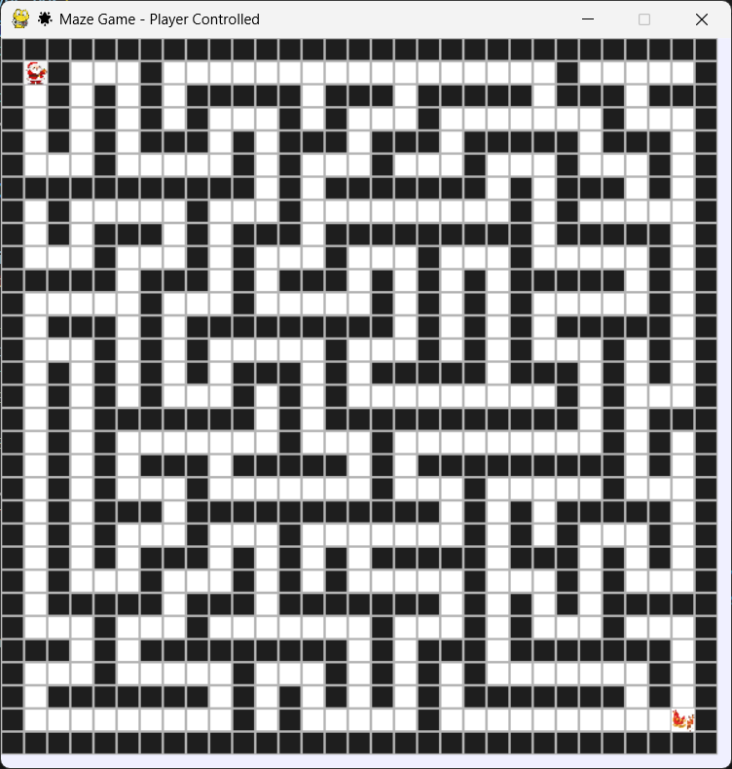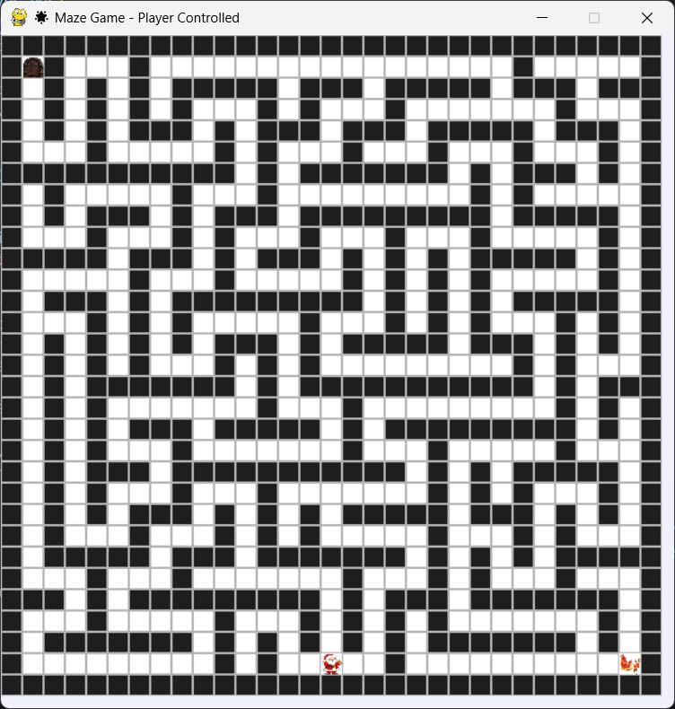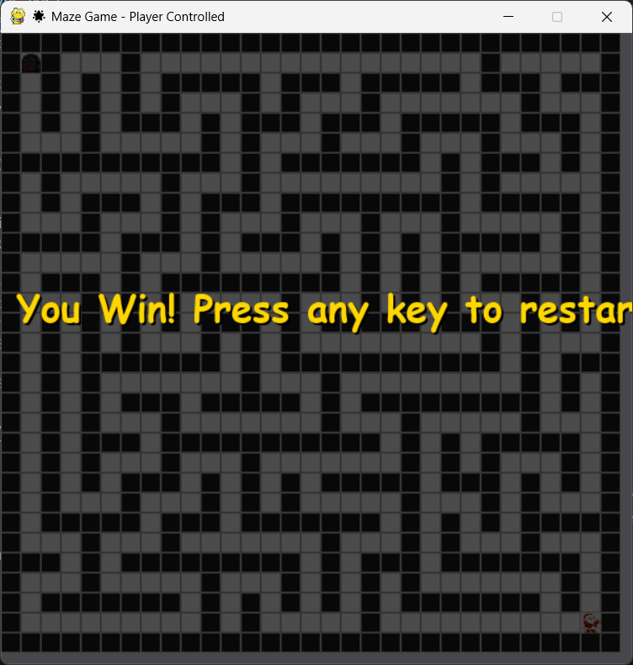
RESULTS AND FUTURE ENHANCEMENT
- Possibility and comparison of your way of solving the problem with others.

Git Hub Link of the project and report | https://github.com/avanindh2-sudo/aiminiproject
REFERENCES
- At least 5 Resources that you referred (May be books/on-line resources (E-Books, standard Videos and blogs Strictly no conversational agents like ChatGPT, Gemini etc.,)

