

**Sadhana Education Society’s**

**L.S.RahejaCollege of Arts and Commerce**

**Juhu Road, Santa Cruz (West),Mumbai**

Title of the project

**SUCCESS TEAM POINT WEBSITE**

Submitted by

**Mr. Nikhil Jaya Puthran**

Seat no:

**Mr. Avanish Subhashchandra Yadav**

Seat no:

2017-2018

Under the Guidance of

Mrs. Nidhi Sawant

Submitted in partial fulfillment of the requirements for qualifying

B.Sc.(I.T.) Semester – VI Examination

UNIVERSITY OF MUMBAI



**Sadhana Education Society’s**

**L.S. Raheja College of Arts and Commerce**

**Juhu Road, Santa Cruz (West),Mumbai**

***CERTIFICATE***

***This*** ***is*** ***to*** ***certify*** ***that*** ***the*** ***project*** ***entitled***

***_____________________________________________________________***

***Undertaken at the ____________________________________________by Mr./Ms._____________________________ Seat no. __________________ in partial fulfillment of B.Sc. IT degree (Semester. VI) Examination had not been submitted for any other examination and does not form part of any other course undergone by the candidate.***

***It is further certified that he/she has completed all required phases of the project.***

**___________________________**

**______________________**

**Signature of Internal Examiner**

**Signature of Coordinator**

**___________________________**

**_________________________**

**Signature of External Examiner**

**Signature of Principal**

**Format c**: Certificate from Guide / Company

**(On Company’s Letterhead)**

**Certificate**

This is to certify that the project entitled _______________________________________

Undertaken at the ___________________________________________________by Mr./Ms._____________________________ Seat no. __________________ in partial fulfilment of B.Sc. IT degree (Semester. VI) Examination has been completed under my supervision.

Signature of External Guide

----------------------------------------------------------------------------------------------------------

**Acknowledgement**

The presentation of this report gives us the feeling of fulfilment. after months of hard work, finally I am very happy to present my final year project ―**SUCCESS TEAM POINT WEBSITE**. But it wouldn’t be right to do so without thanking those who have helped me in converting my thoughts into reality. So I would like to take full advantage of this opportunity to thank each and every person who have helped me throughout the completion of my project.

I am thankful to my college for giving us opportunity to make this project a success. I express my thanks to our principle **Dr.Debajit.N.Sarkar** for giving us the opportunity to carry out this project.

I give my special thanks and gratitude towards **Mrs.Nidhi Sawant** for encouraging me to complete this project, guiding me and helping me throughout the obstacles in the project

Without her assistance, my project would have been impossible. Also, I have present my obligation towards all our past year’s teachers who have best towed deep understanding and knowledge in us. Over the past years, we are obliged to our parents and family members who always supported me and greatly encouraged me in each and every step.

We will be forever indebted to all our friends who really encouraged me and last but not the least the entire B.Sc.(I.T.) staff. Finally, we would like to thank each and every individual who was directly or indirectly involved in the contribution of the project .

By.

Mr. Nikhil Jaya Puthran & Avanish Subhashchandra Yadav

|  |  |
| --- | --- |
| **Sr. No** | **Topics** |
|  | **Synopsis** |
|  | **System Analysis** |
|  | 1. Project Planning and Scheduling |
|  | 1. Gantt chart |
|  | 1. Requirement Gathering |
|  | 1. Objective and Scope of the Website |
|  | 1. Problems with Existing system |
|  | 1. Advantage of Proposed System |
|  | 1. Feasibility Study |
|  | 1. Cost benefit Analysis |
|  | 1. Requirement Specification |
|  | 1. Tools and Technology |
|  | **System Design** |
|  | 1. Event Table |
|  | 1. Entity Relationship Diagram |
|  | 1. Use Case Diagram |
|  | 1. Class Diagram |
|  | 1. Dataflow Diagram |
|  | **Coding Phase** |
|  | 1. Database Design |
|  | 1. Forms & Screen Layouts |
|  | **Testing Phase** |
|  | 1. Module Testing |
|  | 1. Integration testing |
|  | 1. System Testing |
|  | **Maintenance and Evaluation** |
|  | Future Enhancements |
|  | **BIBLIOGRAPHY** |

**TABLE OF CONTENTS**

**Synopsis**

**“SUCCESS TEAM POINT”**

**1.Project Summary**

Title: **Student Management System**

This section introduces Website project for **Student Management System** Class. It will allow class to address students by showcasing their course, facilities and faculty by providing access to the various facilities provided by the class in an easy and interactive manner as well as it will help other people to know more about the class.

**2.Origin Of The Proposal**

Project has no such origin as it comes from an idea where the problem arise as the interaction among the students and the college staff for the information about the facilities, faculties and also the courses and their improvement section .As this website provides information about the student at the tip of the finger just by entering candidate’s no to fetch the information regarding the specific student. Which is lot more easier than the old school counters of college.

**3.Definition of the Problem**

* The basic aim of problem analysis is to obtain clear understanding of the needs of the clients and the users, what exactly is desired from the website, and what the constraints on the solution are. Analysis leads to the actual specification.
* There are three basic approaches to problem analysis
* Informal Approach.
* Conceptual modeling-based Approach
* Prototyping Approach.
* In this project we useInformal Approach to understand the exact requirement of the class where the information about the system was obtained by interaction with the client & end user, Questionnaires & studying the existing documents.

**4.Objective**

4.1 Introduction

This website will have following aims:

* Help students to communicate with the faculties
* Help users to access website and its privileges based on their roles.
* Attract and also inspire even more candidates to apply for the class.

4.2 Scope

Project will have following major modules:

* Home Page

It will be start page for website. It will contain brief overview of the class. They can be redirected to their individual pages if more information is required by user. User can also register for the discussion forum.

* About Us
* History

Will give a brief history about class

* Values

Values on which institution was build and stands for it

* Contact Us

Will give an opportunity to unregistered users for asking queries that will be forwarded to the administrator of the website.

* Additional Modules based on roles:

1. Administrator (Admin):

* 1. Add/edit/delete Accounts
  2. Add/edit/delete Quiz
  3. Add/edit/delete WebPages
  4. Add/edit/delete exam schedule and results
  5. Update Attendance
  6. Administer content from feedback forms

1. Student:
   1. Sign up
   2. Communicate with faculty
   3. Download Documents
   4. View Gallery
   5. Play Quiz
   6. Feedback
2. Faculty:
   1. Sign up
   2. Upload Documents
   3. Communicate with Students

## 4.3 Types of Users

* ***Administrator***

Site administrator has complete control of all the activities of the website. Site admin can view as well as update accounts, gallery, database, etc.

* ***Student***

Student is a part of any of courses in class and is currently student of the class.He/she can provide feedback or communicate with faculty and Download documents.

* **Faculty**

Faculty can teach any subjects in class can upload notes & other documents and communicate with students.

**5.Current Status**

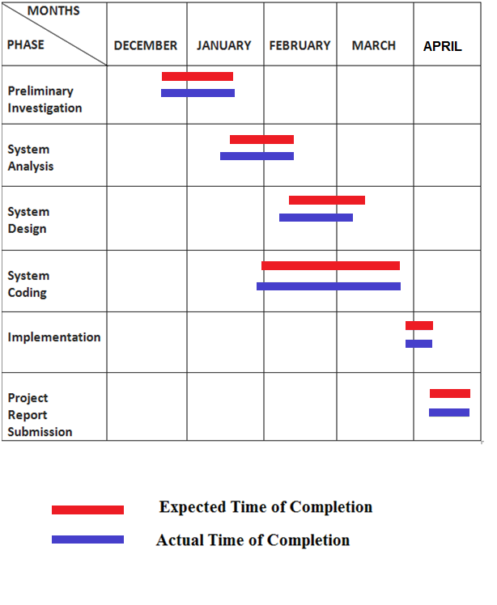

**6.Workplan/Methodology**

To create a website which delivers better return on investment is not just about visual design, and it’s not just about usability or accessibility, or indeed about the website architecture. An effective website requires an in-depth understanding of the competitive marketplace within which it operates. And to understand the marketplace and to tap into it requires a sound internet business and marketing plan.

**7.Time Schedule**

**8.Budget**

**Cost Benefit Analysis** (CBA) is an economic tool to aid social decision-making. CBA is a term that refers both to:

* A formal discipline used to help appraise, or assess, the case for a project or proposal, which itself is process known as project appraisal; and
* An informal approach to making economic decisions of any kind.

Functional Benefits and costs are often expressed in money terms and adjusted for the time value of money, so that all flows of benefit and all flows of project costs over time are expressed on a common basis in terms of their “present value”.

The project cost is less as mentionedabove; even we can sell the project to other organisation which will benefit them with minor changes as per their need.

**Example**

Cost is required for the project is to install the necessary software and hardware requirements.

Software may include installing SQL server on the system. Cost due to the time taken for the completion of the project which can be done on situation based.

**Project Planning & Scheduling**

The Project Plan is one of the most important and useful documents in our toolkit, and should be referred to an updated throughout the project lifecycle. It is a step-by-step approach to creating a simple and effective project plan at the beginning of a project.

**Spteducation.com** is a class management website for **Success Point Team** where the client needs processes to be made online instead of personal visits or manually handled things.

The students & the faculties will make registration through the registration forms available on the website& will get a profile to manage their account. The motto of this website is to make things easier for the students as well as the faculties of the class. It will help the students to get online help for their queries & for the faculties to solve the queries through the website, instead of attending the phone calls.

The website will include various materials such as Video Files, Audio Files, Power Point Presentations, Word documents & E-books which can be downloaded by the students. The Students can also give complaints or suggestions as well as feedbacks.

To design the website various methods will be used such as System analysis, System design, Coding, Testing, Report submission.

The users will need a computer with basic configuration with internet connection to use this website & a Headphone to listen the audio visual lectures.

The project will be evaluated by the client & the project manager to review & approve decision regarding the development.

The project will be completed till May 2015 & will be live for the users as there are many things that are coming up in the development process.

**Gantt chart**



**Requirement Gathering**

***Problem Statement:***

* The basic aim of problem analysis is to obtain clear understanding of the needs of the clients and the users, what exactly is desired from the website, and what the constraints on the solution are. Analysis leads to the actual specification.
* There are three basic approaches to problem analysis
* Informal Approach.
* Conceptual modeling-based Approach
* Prototyping Approach.
* In this project we use Informal Approach to understand the exact requirement of the class where the information about the system was obtained by interaction with the client & end user, Questionnaires & studying the existing documents.

**STAKEHOLDERS:**

**Stakeholder Definition**

Stakeholders are an integral part of a project. They are the end-usersor clients, the people from whom requirements will be drawn, the people who will influence the design and, ultimately, the people who will reap the benefits of the completed project. It is extremely important to involve stakeholders in all phases of a project for two reasons:

**Firstly:** Experience shows that their involvement in the project significantly increases the chances of success by building in a self-correcting feedback loop.

**Secondly**: Involving them in a project builds confidence in the product and will greatly ease its acceptance in the target audience.

There are different types of stakeholders and each type should be handled differently:

1. User:

A person who uses or visits the Website

1. Admin:

A person who make decisions about Handling & Updating the website (in contrast to user); Users are those who have the problem that is being solved by the development of website.

Ex. Owner.

1. [Project Manager](http://www.csi.uottawa.ca:4321/oose/projectmanager.html):

The person responsible for performing project management tasks.

1. Developer:

A person involved in the development of the website.

**Objective & Scope of the Website**

**Objective of the System:**

* The objective of the Website is to provide a system which handles the information of the students visiting the class. It maintains the data of what was the purpose of visit. Data will be stored in the database. It also maintains the student’s attendance & other records.

There is some objective that we kept in mind while designing the website.

* **Practically:** The system is quite stable and can be operated by the people with average intelligence.
* **Efficiency:** We have tried to involve accuracy, timeliness and comprehensiveness of the system output.
* **Cost:** It is desirable to aim for the system with a minimum cost subject to the condition that it must satisfy the entire requirement.
* **Flexibility:** We have tried that the system should be modifiable depending on the changing needs of the user. Such modifications should entail extensive reconstructing or recreation of website. It should be portable to different computer systems.
* **Security:** This is very important aspect which is followed in this designing phase and tried to covers the areas of hardware reliability, fall back procedures, and physical security of data.

In the class there is a standard set of audiovisual equipment and tools available to the faculties. These might include e-books, discussion forum, uploading and downloading data possibly an online chat, and even the online test. The Class website has equivalent equipment and tools in the form of network-based website applications. This equipment and the equivalent website applications in class are as follows:

* Online Discussion Forum
* Online Test
* Available of notes, E-books
* Provision for uploading and downloading data
* Online Chat

The website will consist of a number of inputs and input files including the following:

* Video Files
* Sound Files
* MS PowerPoint Files
* Document Files
* PDF Files

***Scope of the System***

* The scope of this project is to design and develop a system that is necessary for the management of class.
* The system that gives an easy access to the facilities & services for online management. This gives more control over the operations.
* Project scope from user perspective, limits the range of students to only those who have internet connection.
* The aim of this project is to promote an efficient, user-friendly, time-saving safe way for user to get the information online.

This project is helpful in the Automation of student attendance, notes & other facilities in an easy & efficient way.

**Problems with the**

**Existing System**

***Problems:***

* Student’s data was being handled manually.
* For every problem either the student has to contact the faculty or vice-versa over the phone, such as Time table, Test Schedule, etc.
* The students as well as the faculties need to wait until the class are open.
* Students have to personally visit classin advance forenquiries.
* Admission process is Time Consuming.
* There are chances where errors could be caused due to manually handled system
* The records were maintained manually in registers.
* Risk of mismanagement of data.
* Less Security.

**Advantages of**

**Proposed System**

***Advantages:***

* Error in the Information is Reduce due to Process being Online.
* High Accuracy, Data security & Smooth data flow.
* System is more User-friendly & Convenient to Users.
* Students & faculties can view Information Such as Test schedules, Attendance, Marks obtained in test, .This System will include a Web-Site which can accessed by any User from any place or devices having Internet Connection.
* New Students can Register (Sign Up) for the class after taking the admission.
* User friendliness is provided in the website with various controls.
* The system makes the overall project management much easier and flexible.
* There is no risk of data mismanagement at any level while the project development is under process.
* It provides high level of security with different level of authentication
* Users from any part of the world can make use of the system.
* New system will be much better in performance as compared to existing one

**Feasibility Study**

**Project feasibility** study is an activity that verifies whether a project can be started and completed successfully. The objective of feasibility study is to determine whether the development of the Project has a reasonable chance of success.

***Technical Feasibility:***

* This type of feasibility involves the study of various Hardware and Website components Available for use. Any Website project be equally feasible with available Hardware too.
* Should have Pentium IV or higher.
* Minimum 512MB of RAM.
* Minimum 40GB of Disk Space.
* Modem or LAN to get connected to Internet.
* **For Users:**
* Internet Browser
* Internet Connection

***Economic Feasibility:***

The project is economically feasible as the only cost involved is having a computer with the minimum requirements.

For the users to access the website, the only cost involved will be in getting access to the Internet.

This involves the feasibility of the proposed project to generate economic benefits.

***Financial Feasibility:***

Financial feasibility should be distinguished from economic feasibility.

Financial feasibility involves the capability of the Project Organization to raise the appropriate funds need to implement the proposed project.

As there are less stake holders in the project, it is financially flexible and can be used by any other class with a little modification.

**Cost Benefit**

**Analysis**

**Cost Benefit Analysis** (CBA) is an economic tool to aid social decision-making. CBA is a term that refers both to:

* A formal discipline used to help appraise, or assess, the case for a project or proposal, which itself is process known as project appraisal; and
* An informal approach to making economic decisions of any kind.

Functional Benefits and costs are often expressed in money terms and adjusted for the time value of money, so that all flows of benefit and all flows of project costs over time are expressed on a common basis in terms of their “present value”.

The project cost is less as mentionedabove; even we can sell the project to other organisation which will benefit them with minor changes as per their need.

**Requirement Specification**

***Functional Requirements:***

**Functional requirements** are listed in the following sections as use cases for the faculty and students actors separately.

**For Faculties**

* Scheduling Lectures
* Exam or Quiz preparation
* Document Upload/Deletion/Edition
* Solve queries

**For Students**

* Registration -Enrolment
* Document/Lecture download
* Check Attendace
* Check marks
* Ask queries
* Appear for Quiz

***Technical Requirements:***

**Hardware Specification**

Student/User: -

* Should have Pentium IV or higher.
* Minimum 512MB of RAM.
* Minimum 40GB of Disk Space.
* Modem or LAN to get connected to Internet.

**Website Specification**

The following items are required:-

* Operating System- Windows-XP or higher
* .Net Framework 4
* Visual Studio 2010
* Microsoft SQL Server 2008.

***Non-Functional Requirements:***

* It consists of following parameters :-

**Reliability**: The system will consistently perform its intended function.

For e.g.the important information must be validated.

**Efficiency**: Unnecessary data will not be transmitted on the network and database server will be properly connected.

**Reusability**: The system can be reused in any organization or site of the same group, by defining the organization master definition under website license agreement.

**Integrity**: Only System Administrator has rights to access the database, not every user can access all the information. Each user will be having rights to access the modules.

**Tools & Technology**

***SQL SERVER 2008 (Structured Query language):***



**Microsoft SQL Server** is a [relational database management system](https://en.wikipedia.org/wiki/Relational_database_management_system) developed by [Microsoft](https://en.wikipedia.org/wiki/Microsoft). As a [database server](https://en.wikipedia.org/wiki/Database_server), it is a [software product](https://en.wikipedia.org/wiki/Software_product) with the primary function of storing and retrieving data as requested by other [software applications](https://en.wikipedia.org/wiki/Software_application)—which may run either on the same computer or on another computer across a network (including the Internet).

SQL Server 2008 was announced at TechEd 2009, and was [released to manufacturing](http://en.wikipedia.org/wiki/Released_to_manufacturing) on April 21, 2010.SQL Server 2008 R2 adds certain features to SQL Server 2008 including a management system branded as [Master Data Services](http://en.wikipedia.org/wiki/Microsoft_SQL_Server_Master_Data_Services), a central management of master data entities and hierarchies. Also Multi Server Management, a centralized console to manage multiple SQL Server 2008 instances and services including relational databases, Reporting Services, Analysis Services & Integration Services.

SQL Server 2008 R2 includes a number of new services, including [Power Pivot](http://en.wikipedia.org/wiki/PowerPivot) for [Excel](http://en.wikipedia.org/wiki/MS_Excel) and [SharePoint](http://en.wikipedia.org/wiki/SharePoint), [Master Data Services](http://en.wikipedia.org/w/index.php?title=Master_Data_Services&action=edit&redlink=1),[StreamInsight](http://msdn.microsoft.com/en-us/sqlserver/ee476990.aspx), [Report Builder](http://en.wikipedia.org/w/index.php?title=Report_Builder&action=edit&redlink=1) 3.0, [Reporting Services](http://technet.microsoft.com/en-us/sqlserver/ff660783.aspx) Add-in for SharePoint, a Data-tier function in Visual Studio that enables packaging of tiered databases as part of an application, and a SQL Server Utility named UC (Utility Control Point), part of AMSM (Application and Multi-Server Management) that is used to manage multiple SQL Servers.The [Full-text search](http://en.wikipedia.org/wiki/Full_text_search) functionality has been integrated with the database engine. According to a Microsoft technical article, this simplifies management and improves performance.

Spatial data will be stored in two types. A "Flat Earth" (GEOMETRY or planar) data type represents geospatial data which has been projected from its native, spherical, coordinate system into a plane. A "Round Earth" data type (GEOGRAPHY) uses an ellipsoidal model in which the Earth is defined as a single continuous entity which does not suffer from the singularities such as the international dateline, poles, or map projection zone "edges". Approximately 70 methods are available to represent spatial operations for the Open Geospatial Consortium [Simple Features for SQL](http://en.wikipedia.org/wiki/Simple_Features_for_SQL), Version 1.1.

SQL Server includes better compression features, which also helps in improving scalability.It enhanced the indexing algorithms and introduced the notion of filtered indexes. It also includes *Resource Governor* that allows reserving resources for certain users or workflows. It also includes capabilities for [transparent encryption of data](http://en.wikipedia.org/wiki/Transparent_Data_Encryption) (TDE) as well as compression of backups.SQL Server 2008 supports the [ADO.NET Entity Framework](http://en.wikipedia.org/wiki/ADO.NET_Entity_Framework) and the reporting tools, replication, and data definition will be built around the [Entity Data Model](http://en.wikipedia.org/wiki/Entity_Data_Model).[SQL Server Reporting Services](http://en.wikipedia.org/wiki/SQL_Server_Reporting_Services) will gain charting capabilities from the integration of the data visualization products from[Dundas Data Visualization, Inc.](http://en.wikipedia.org/wiki/Dundas_Data_Visualization,_Inc.), which was acquired by Microsoft.On the management side, SQL Server 2008 includes the *Declarative Management Framework* which allows configuring policies and constraints, on the entire database or certain tables, declaratively.The version of [SQL Server Management Studio](http://en.wikipedia.org/wiki/SQL_Server_Management_Studio) included with SQL Server 2008 supports [IntelliSense](http://en.wikipedia.org/wiki/IntelliSense) for SQL queries against a SQL Server 2008 Database Engine.SQL Server 2008 also makes the databases available via PowerShell providers and management functionality available as [Cmdlets](http://en.wikipedia.org/wiki/Cmdlets), so that the server and all the running instances can be managed from Windows.

***VISUAL STUDIO 2010:***

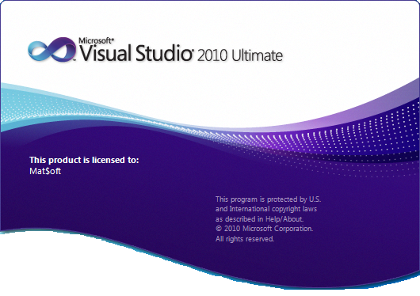

Visual Studio 2010 has the Dev10 code name and was released on April 12, 2010 along with the .NET Framework 4. Visual Studio 2010 has a new editor that uses WPF (Windows Presentation Foundation), sprinkles the Ribbon interface, supports monitors multiple, Windows 7 multi touch, SharePoint functionality, Windows Azure tools and IntelliTrace , a new product that helps eradicate bugs .Will come with Expression Studio, Business & Enterprise Servers and Microsoft Office in both Ultimate and Premium versions.

A major new feature is support for [Win RT](http://en.wikipedia.org/wiki/WinRT) and [C++/CX](http://en.wikipedia.org/wiki/C%2B%2B/CX) (Component Extensions). Support for [C++ AMP](http://en.wikipedia.org/wiki/C%2B%2B_AMP) ([GPGPU](http://en.wikipedia.org/wiki/GPGPU) programming) is also included.

On 16 September 2011, a complete 'Developer Preview' of Visual Studio 11 was published on Microsoft's website. Visual Studio 11 Developer Preview requires Windows 7, Windows Server 2008 R2, Windows 8, or later operating systems.Versions of [Microsoft Foundation Class Library](http://en.wikipedia.org/wiki/Microsoft_Foundation_Class_Library) (MFC) and C runtime (CRT) included with this release cannot produce website that is compatible with Windows XP or Windows Server 2003 except by using native multi-targeting and foregoing the newest libraries, compilers, and headers.However, on 15 June 2012.

On 24 August 2011, a blog post by Sumit Kumar, a Program Manager on the Visual C++ team, listed some of the features of the upcoming version of the Visual Studio C++ IDE:

* **Semantic Colorization**: Improved syntax coloring, various user-defined or default colors for C++ syntax such as macros, enumerations, typenames, functions etc.
* **Reference Highlighting**: Selection of a symbol highlights all of the references to that symbol within scope.
* **New Solution Explorer**: New solution explorer allows for visualization of class and file hierarchies within a solution/project. Searching for calls to functions and uses of class will be supported.
* **Automatic Display of IntelliSense list**: IntelliSense will automatically be displayed whilst typing code, as opposed to previous versions where it had to be explicitly invoked through use of certain operators (i.e. the scope operator (::)) or shortcut keys (*Ctrl-Space*or *Ctrl-J*).
* **Member List Filtering**: IntelliSense uses [fuzzy logic](http://en.wikipedia.org/wiki/Fuzzy_logic) to determine which functions/variables/types to display in the list.
* **Code Snippets**: Code snippets are included in IntelliSense to automatically generate relevant code based on the user's parameters, custom code snippets can be created.

The source code of Visual Studio 2012 consists of approximately 50 million lines of code.

***ASP.NET:***



ASP.NET, the next version of ASP, is a programming framework used to create enterprise-class Web Applications. These applications are accessible on a global basis leading to efficient information management. The advantage ASP.NET offers is more than just the next version of ASP.

ASP.NET is a web application framework developed and marketed by Microsoft to allow programmers to build dynamic web sites, web applications and web services.

ASP.NET is built on the Common Language Runtime (CLR), allowing programmers to write ASP.NET code using any supported .NET language.

* Advantages Using ASP.NET
* ASP.NET drastically reduces the amount of code required to build large applications.
* ASP.NET makes development simpler and easier to maintain with an event-driven, server-side programming model.
* ASP.NET pages are easy to write and maintain because the source code and HTML are together.
* The source code is executed on the server. The pages have lots of power and flexibility by this approach.
* The source code is compiled the first time the page is requested. Execution is fast as the Web Server compiles the page the first time it is requested. The server saves the compiled version of the page for use next time the page is requested.
* The HTML produced by the ASP.NET page is sent back to the browser. The application source code you write is not sent and is not easily stolen.
* ASP.NET makes for easy deployment. There is no need to register components because the configuration information is built-in.
* The Web server continuously monitors the pages, components and applications running on it. If it notices memory leaks, infinite loops, other illegal website or activities, it seamlessly kills those activities and restarts itself.
* ASP.NET validates information (validation controls) entered by the user without writing a single line of code.
* ASP.NET easily works with ADO .NET using data-binding and page formatting features.

**EVENT TABLE**

**Definition of Event:**

An occurrence at a specific time and place, that can be described and is worth remembering. It is used in system analysis and design.

Focusing on events will give you a way to divide the system requirements so you can study separately.

**Need:**

The complex system needs to be broken into manageable units to be understood and decomposing the events based on events.

**Types of Events:**

1. External : Outside System
2. Temporal : Based on System deadlines
3. State: Something inside System triggers processing needs.

**Event table:**

A table that list events in tabular format that is in rows and key pieces of information about each event in columns.

**Designing of event table:**

* While developing the list of events, the analyst should note additional information about each event for later use
* This information is entered in an event table.
* An event table comprises of rows and columns.
* Each row in the event table records information about one event.
* And each column about its key piece of information about that event.

**An Event table should consist of the following attributes:**

* Event
* Trigger
* Source
* Activity
* Response
* Destination

**Event:**

An event is an activity that changes the state of the source.

For e.g. clicking a Button, moving the mouse, etc.

**Trigger:**

An occurrence that tells the system that has occurred, either the arrival of data needing or of a point in time.

**Source:**

An external agent or actor that supplies data to the system.

**Activity:**

|  |  |  |  |  |  |  |
| --- | --- | --- | --- | --- | --- | --- |
| **Sr.**  **No** | **Event** | **Trigger** | **Source** | **Activity** | **Response** | **Destination** |
| **1** | Student Registers | Register Request | Student | Validation of entered details | Registration Notification & Welcome Message | Student |
| **2** | Student Logs In | Login Request | Student | Validate Student’s Username& Password | Username & Password Validation Notification | Student |
| **3** | Student Download  Documents | Request for Download | Student | Check for  Available  Notes | Available  Documents | Student |
| **4** | Student Views  Gallery | Request for Gallery | Student | Check Gallery  Pages | Gallery of  Class | Student |
| **5** | Student  Play  Quiz | Request for Quiz | Student | Check for Quiz  Questions | Quiz | Student |
| **6** | Student  Gives Feedback | Gives Feedback | Student | All required fields filled | Thank You message | Student |
| **7** | Student  Chats | Request for  Chat | Student | Check Online  Users | Chat Box Opens | Student |
| **8** | StudentSigns Out | Logout Request | Student | Using of Sign-out Control | Sign-out Notification | Student |

Behavior that the system performs when an event occurs.

**Response:** An output produced by the system that goes to a destination.

**Destination:**

An external agent or actor that receives data from the system.

**Student Side:**

|  |  |  |  |  |  |  |
| --- | --- | --- | --- | --- | --- | --- |
| **Sr.**  **No** | **Event** | **Trigger** | **Source** | **Activity** | **Response** | **Destination** |
| **1** | Student Registers | Register Request | Student | Validation of entered details | Registration Notification & Welcome Message | Student |
| **2** | Student Logs In | Login Request | Student | Validate Student’s Username& Password | Username & Password Validation Notification | Student |
| **3** | Student Download  Documents | Request for Download | Student | Check for  Available  Notes | Available  Documents | Student |
| **4** | Student Views  Gallery | Request for Gallery | Student | Check Gallery  Pages | Gallery of  Class | Student |
| **5** | Student  Play  Quiz | Request for Quiz | Student | Check for Quiz  Questions | Quiz | Student |
| **6** | Student  Gives Feedback | Gives Feedback | Student | All required fields filled | Thank You message | Student |
| **7** | Student  Chats | Request for  Chat | Student | Check Online  Users | Chat Box Opens | Student |
| **8** | StudentSigns Out | Logout Request | Student | Using of Sign-out Control | Sign-out Notification | Student |

**Faculty Side:**

|  |  |  |  |  |  |  |
| --- | --- | --- | --- | --- | --- | --- |
| **Sr.**  **No** | **Event** | **Trigger** | **Source** | **Activity** | **Response** | **Destination** |
| **1** | Faculty Registers | Register Request | Faculty | Validation of entered details | Registration Notification & Welcome Message | Faculty |
| **2** | Faculty Logs In | Login Request | Faculty | Validate Faculty’s Username & Password | Username & Password Validation Notification | Faculty |
| **3** | FacultyUpload  Documents | Request for Upload | Faculty | Upload  Documents | Upload Success  Message | Faculty |
| **5** | Faculty  Chats | Request for  Chat | Faculty | Check Online  Users | Chat Box Opens | Faculty |
| **6** | Faculty Signs Out | Logout Request | Faculty | Using of Sign-out Control | Sign-out Notification | Faculty |

**Admin Side:**

|  |  |  |  |  |  |  |
| --- | --- | --- | --- | --- | --- | --- |
| **Sr.**  **No** | **Event** | **Trigger** | **Source** | **Activity** | **Response** | **Destination** |
| 1 | Admin  Login | Log-In Request | Admin | Validate Admin ID & Password | Admin ID & Password Validate Notification | Admin |
| 2 | Accept/  Reject  Account | New  Accounts | Admin | Accept/  Reject | Added/  Rejected Notification | Admin |
| 3 | Delete  Account | Accounts  Request | Admin | Account  Deleted | Delete Notification | Admin |
| 4 | Update  WebPages | Update  Request | Admin | Necessary Data Updated | Update  Success Notification | Admin |
| 5 | Update  Attendance | Update  Request | Admin | Attendance Updated | Update  Success Notification | Admin |
| 6 | Upload Quiz | Upload Request | Admin | Upload Quiz | Upload  Success Notification | Admin |
| 7 | View  Received  Feedbacks | Request  For  Feedbacks | Admin | Feedback  Page | Feedback  Page  Opens | Admin |
| 8 | Upload Results | Upload Request | Admin | Upload Results | Upload  Success Notification | Admin |
| 9 | Admin  Sign Out | Sign-out Request | Admin | Using of Sign-out Control | Logout Notification | Admin |

**Entity Relationship Diagram**

The Entity Relationship Diagram is based on perception of a real world that consists of a collection of basic objects called as Entity and relationships among these objects. Entities in database are described as set of attributes.

* A Relationship is an association among several Entities.
* The set of entities of the same type are called as Entity Set.
* The set of Relationships of same type are called as Relationship Set.

**Notations used in E-R diagram:**

It represents Entity Set.

It represents Attributes.

It represents relationship

**E-R Diagram:**

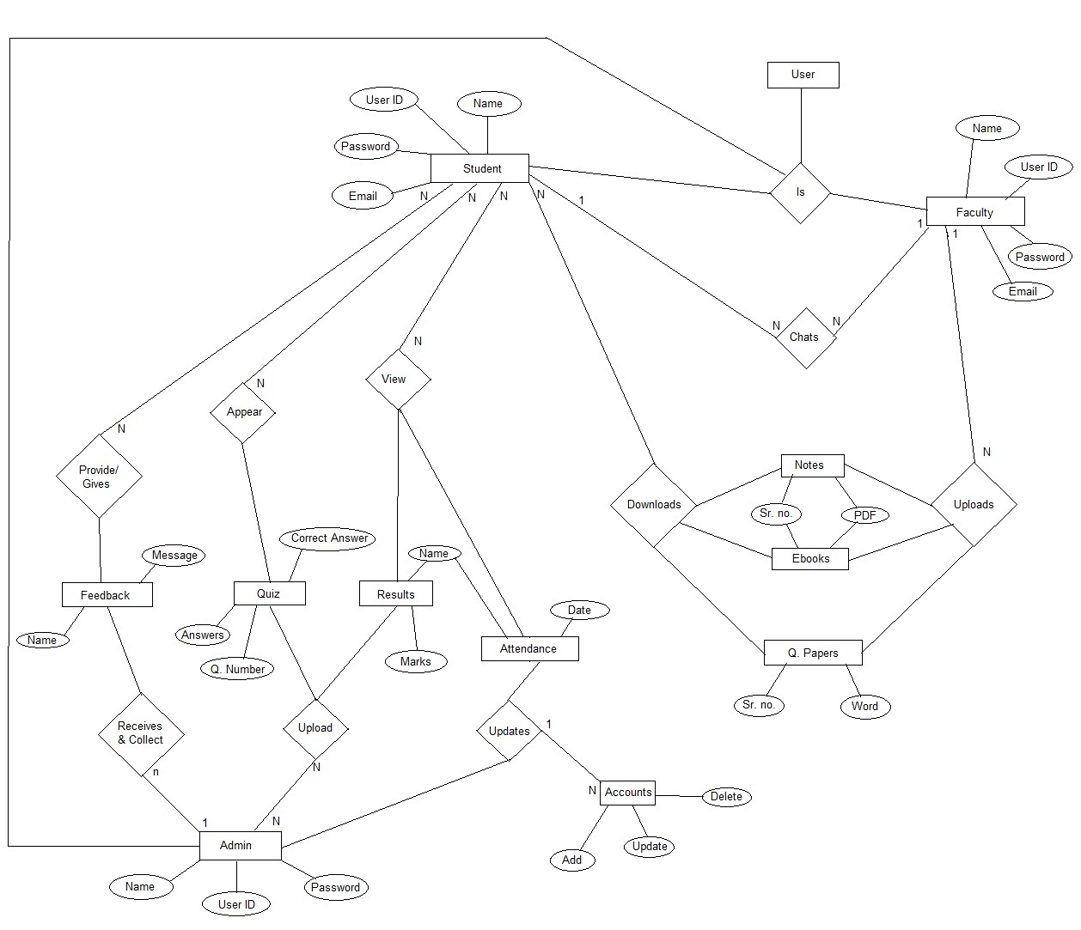

**Use Case Diagram**

## *Definition:*

Use-Case Diagrams model the functionality of a system using actors and use cases. Use cases are services or functions provided by the system to its users.

### Basic Use-Case Diagram Symbols and Notations:

##### System:

Draw your system's boundaries using a rectangle that contains use cases. Place actors outside the system's boundaries.

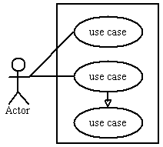

##### Use Case:

Draw use cases using ovals. Label with ovals with verbs that represent the system's functions.

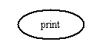

##### Actors:

Actors are the users of a system. When one system is the actor of another system, label the actor system with the actor stereotype.

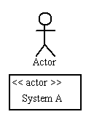

##### Relationships:

Illustrate relationships between an actor and a use case with a simple line. For relationships among use cases, use arrows labeled either "uses" or "extends." A "uses" relationship indicates that one use case is needed by another in order to perform a task. An "extends" relationship indicates alternative options under a certain use case.

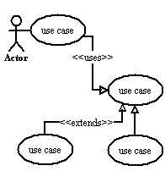

**Admin:**

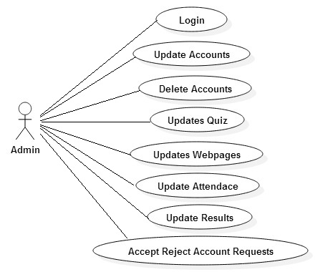

**Faculty:**

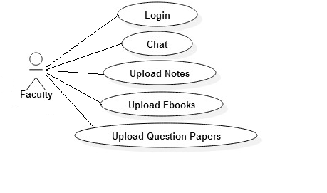

**Student:**

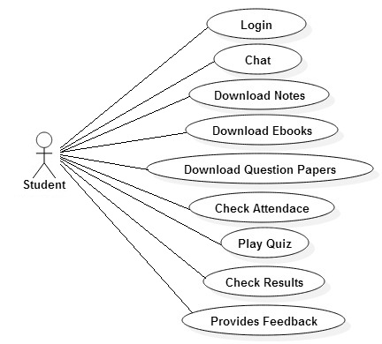

**Class Diagram**

Class Diagrams are the backbone of almost every object-oriented method including UML. They describe the static structure of a system.

### BASIC CLASS DIAGRAM SYMBOLS AND NOTATIONS:

Classes represent an abstraction of entities with common characteristics. Associations represent the relationships between classes.

Illustrate classes with rectangles divided into compartments. Place the name of the class in the first partition (centred, bolded, and capitalized), list the attributes in the second partition, and write operations into the third.  
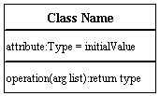

##### ACTIVE CLASS

Active classes initiate and control the flow of activity, while passive classes store data and serve other classes. Illustrate active classes with a thicker border.

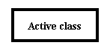

**VISIBLITY:**

Use Visibility marker to signify who can access the information within the class.

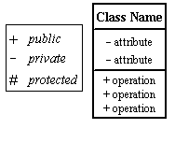

##### MULTIPLICITY (CARDINALITY)

Place multiplicity notations near the ends of an association. These symbols indicate the number of instances of one class linked to one instance of the other class. For example, one company will have one or more employees, but each employee works for one company only.

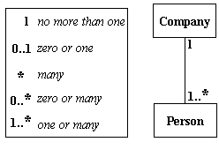

**CONSTRAINT**

Place constraints inside curly braces {}.

http://wc1.smartdraw.com/resources/tutorials/images/uml_constraint.gif  Simple Constraint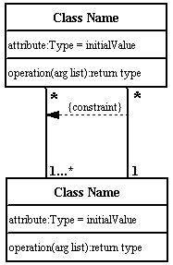

##### COMPOSITION AND AGGREGATION

Composition is a special type of aggregation that denotes a strong ownership between Class A, the whole, and Class B, its part. Illustrate composition with a filled diamond.

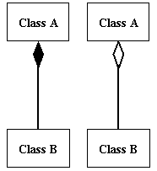

##### GENERALIZATION

Generalization is another name for inheritance or an "is a" relationship. It refers to a relationship between two classes where one class is a specialized version of another. For example, Honda is a type of car. So the class Honda would have a generalization relationship with the class car.

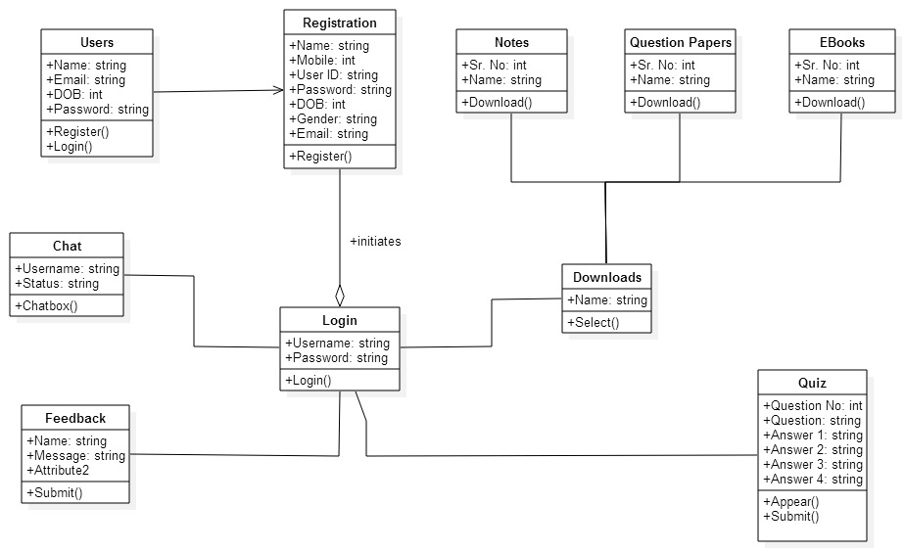

**Dataflow Diagram**

**Introduction:**

* DFD shows functional relationships of the values computed by the system
* It includes input values, output values, internal, data soure.
* DFD shows the flow of data values from their source in objects through process that transform them to their destination in other objects
* A DFD does not show the control information such as time at which the process is executed this information belongs to dynamic model.

**Components of DFD’s:**

**External Entity:**

* Rectangle represents the external entities, which are source of destination of data.
* A Human being is a simple example of External Entity

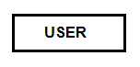

**Process:**

* A process is drawn as ellipse or circle
* It contains a system on which the user is going to perform a task.

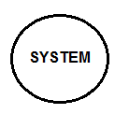

**Data Stores:**

* Data store is a passive object within DFD which stores data for later Process
* One Can say database of the website



**Data Flow:**

* Data flow connects the output of an object or process to input of another object or process
* Double headed arrows can be used to show two ways flows
* Data flow is represented as an arrow between procedure and consumer data

**Reports:**

* Final outcome can be showed with the help of reports
* They are mainly obtained from data stores
* They are represented by square which is sliced from top right corner

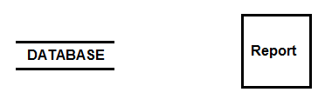

**Quiz:**

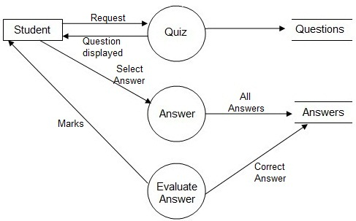

**Upload/ Download:**

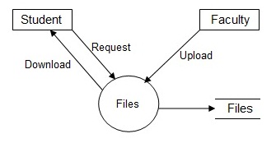

**Chats:**

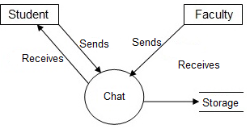

**Database Design**

***Faculty Database:***

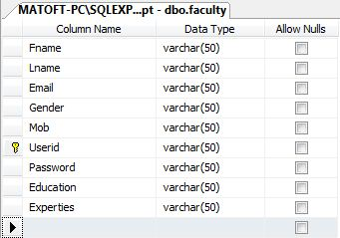

***Enquiry Database:***

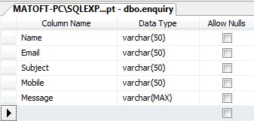

**Student Database:**

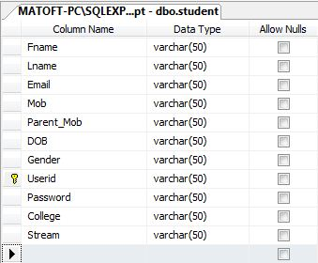

**Feedback Database:**

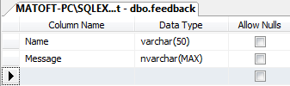

**Testing Phase**

The goal of this document is to develop a test plan for class management. This document defines all the procedures and activities required to prepare for testing of the functionalities of the system which are specified. The objectives of the test plan are to define the activities to perform testing. Website testing is a process of running with intent of finding errors in website. Website testing assures the quality of website and represents final review of other phases of website like specification, design, code generation, etc.

**Testing and its types**

* Testing is a process of examining a product to determine what effects it contains, whether defect is in code or system. Hence we have tested this application by reviewing the construction, the composition by exercising the functions, matching output with assumed output and examining results.
* Since we have tested throughout the development of our website, we need to continue testing after we post our files on the web. We can load our file on to the web server and test them before making your URL available for users to access the website.
* Each phase of our website development has a parallel activity

**Module Testing**

* This is a first step of testing phase, in this phase modules are tested against the specifications mentioned during system design.
* Module testing also deals with the errors which are occurred during coding phase and previous phases. So we can say Unit testing deals with the internal logic of the module.
* In the class Management modules are Login module, Registration module. We have used White-Box Testing, in terms of the code’s inner structure and its control flow. This has also helped us in finding bugs which led to including validations as and when required.

**Integration Testing**

* In Integration testing a system consisting of different module are tested for the problem arising from the component interaction.
* The main goal of this phase is that to check whether the module can be integrated together hence this phase deals with checking whether the user interface is working properly or not.
* We have conducted test for subsystem created by combining three modules which had been mentioned earlier and it resulted in proper functionality as required.

**System Testing**

* System testing verifies the entire application as a whole, after integration of all modules and its validation, according to our original site requirement. Certain Categories of system testing have been included:
* **Compatibility Testing:** We have accessed the performance of our entire application in a particular environment define by its hardware, software, etc.
* **Load Testing:** The response time is quite impressive as it response time does not exceed the average response time of the website.
* **Security Testing:** Only registered users can access & download the content of the website such as notes, documents, etc. Others can only view the Website.
* **Performance Testing:** The Updates made by the admin are very well reflected on the website the very next second.

**Maintenance & Evaulation**

**Site Maintenance:**

* The term support and maintenance describes activates that occur after the system is made operational. Support activates assist users in realizing the full benefit of the system. Maintenance activates ensure that the site functions at peak efficiency and that needed changes are implemented with minimal disruption to the organization.
* Website maintenance is done to accomplish the following objectives:
* Correct faults
* Improved performance of website
* Update the website with the latest Technology
* Plan to add new functionalities
* Inform and feature content continuously
* Website should be alive and fresh
* Place more emphasis on user interface design and functionalities
* Adaptive maintenance modify website to adapt to environment such as change in hardware, platform, database or upgrading to new technology.
* The performance of the website can be measured by two factors:
* **Efficiency:** It indicates the matter in which the inputs are used by the website.

**Effectiveness:** The effectiveness is the measure for deciding the website provides the desired output. When the website is ineffective, it goes out of control and it needs a major correction.

**Future Enhancements**

**Future Enhancements:**

1. Discussion Forum will be implemented

2. Chat Features will be implemented

3. Video Lectures will be implemented

4. Will try cover all university of India.

5. and Many More New Ideas

BIBLIOGRAPHY

Following websites are referred to create this project reports.

**BOOKS**

* **ASP.Net-The Complete Reference by McGraw hill**

**WEBSITE**

* [**www.youtube.com**](http://www.youtube.com)
* [**www.stackoverflow.com**](http://www.stackoverflow.com)
* [**www.developer.android.com**](http://www.developer.android.com)
* [**www.mu.ac.in**](http://www.mu.ac.in)
* [**www.microsoft.com**](http://www.microsoft.com)
* [**www.asp.net**](http://www.asp.net)
* **www.microsoft.com**

**SEARCH ENGINE REFERENCED**

* [**www.google.com**](http://www.google.com)
* [**www.wikipedia.com**](http://www.wikipedia.com)