**Regularization**

Regularization is a concept to implement the trade-off of the bias and variance that helps to reduce the prediction error. Let’s talk about some of the common techniques of regularization.

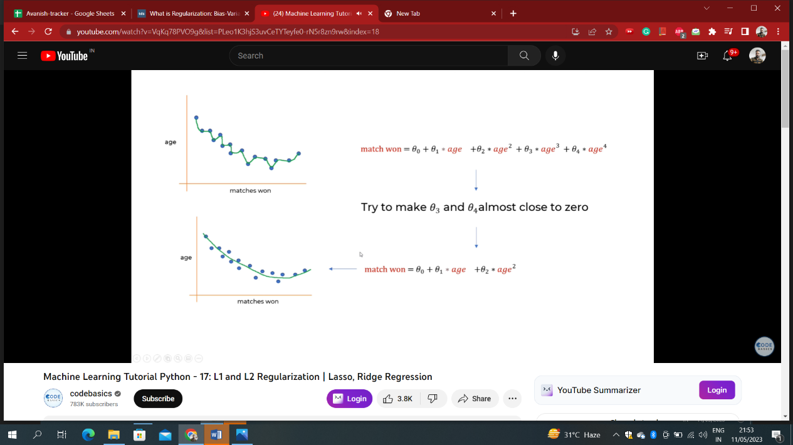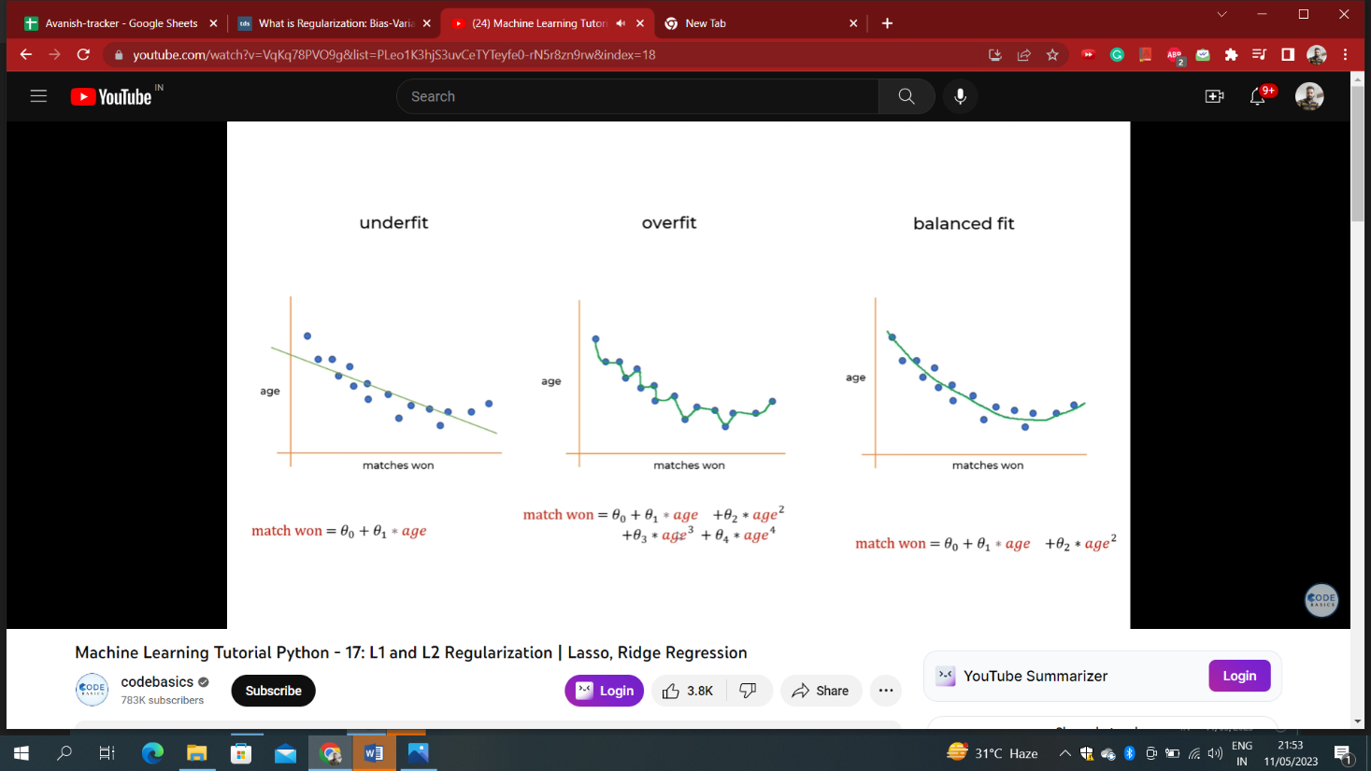

In the above case, we can see that weights like Ɵ3 and Ɵ4 are made almost close to zero to shrink or reduce some of the features which further reduces the complexity of the regression equation and finally there’s reduction in overfitting of the model. For this, mean square error(mse) or cost function(mse or cost function are used interchangably) is minimized by penalising it with regularization terms and thus reduction in mse.

In a linear regression model, we can penalize the cost function to build different models that implement regularization as shown below:

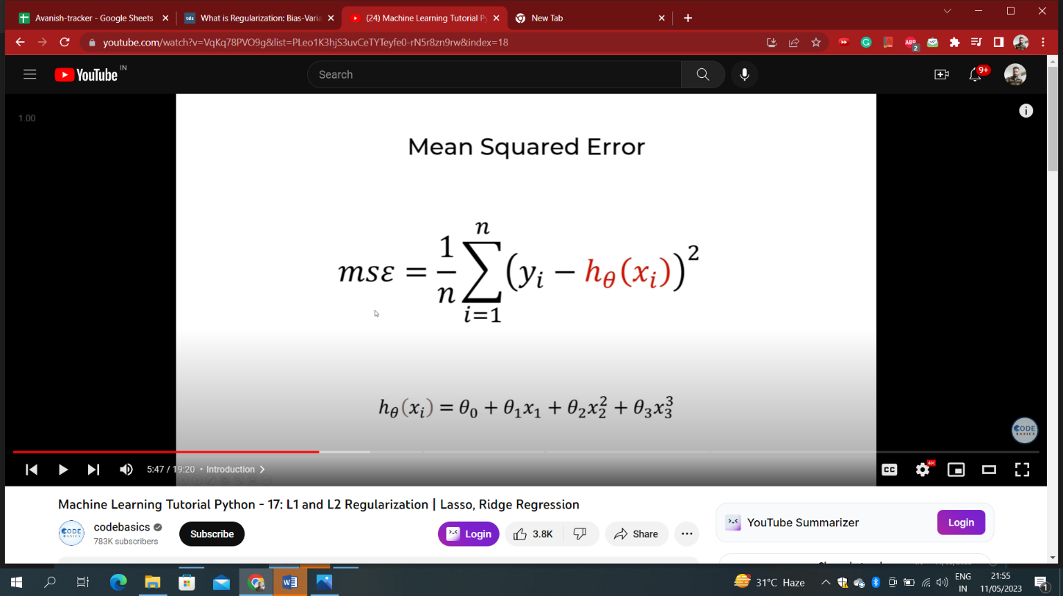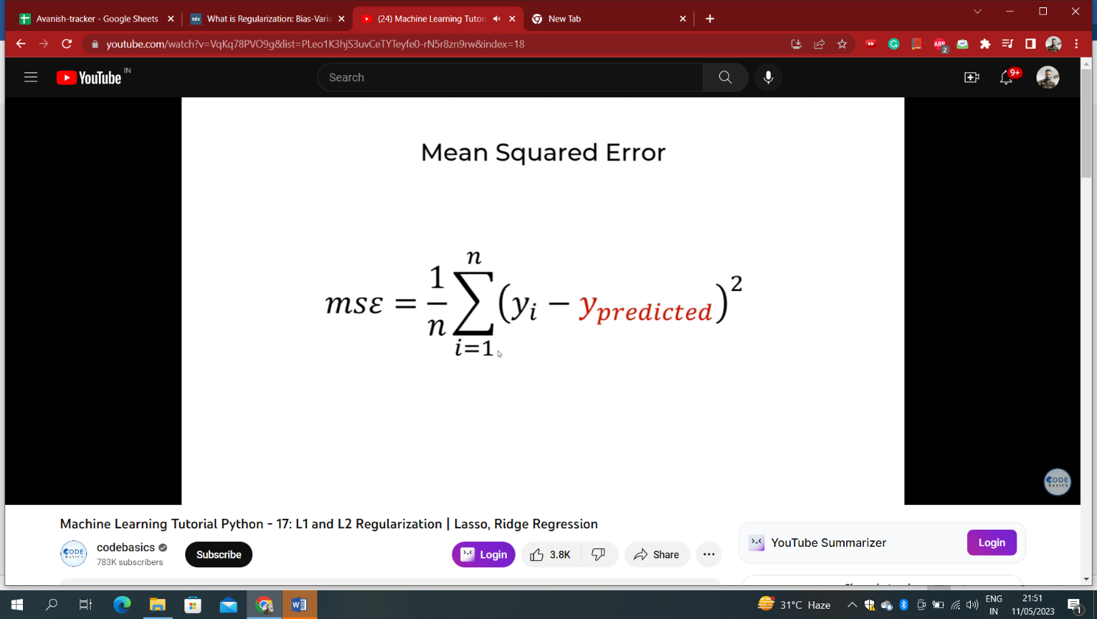

1. In a **Ridge Regression(L2)** model, we modify the cost function to be

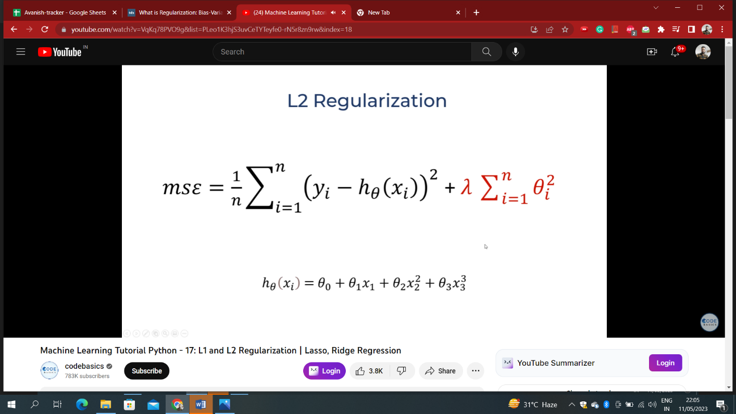 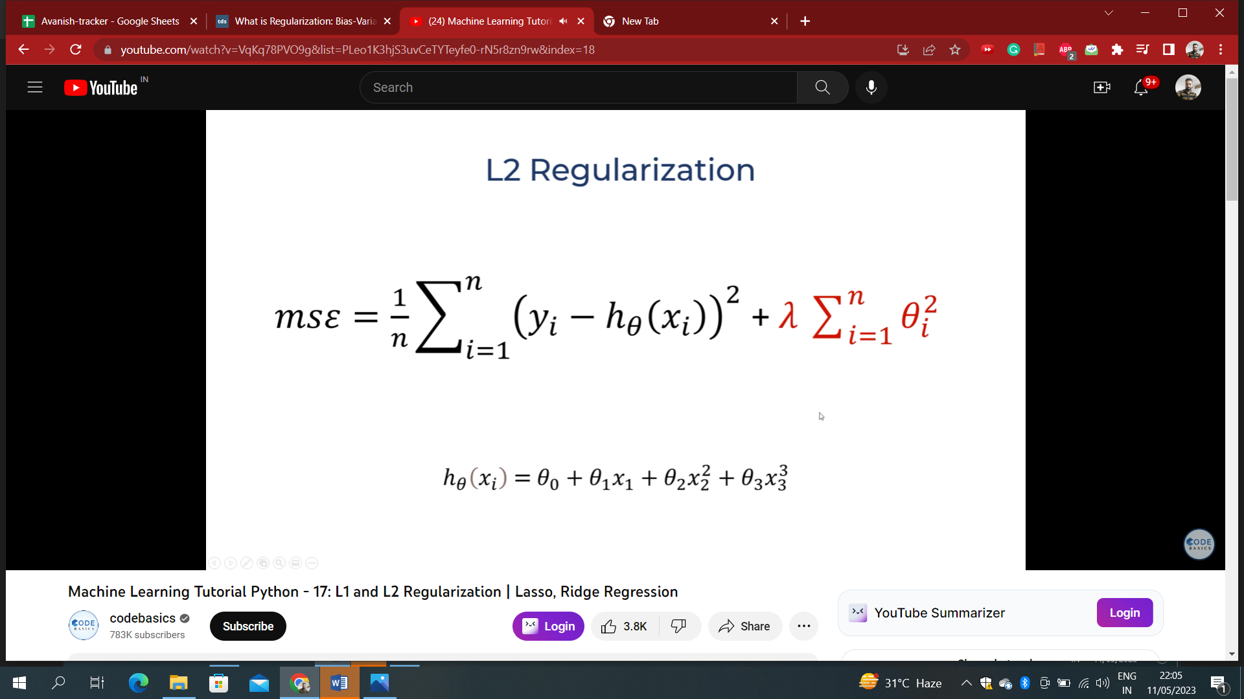

Where i is each iteration and n is the total number of iterations

2. In a **Lasso Regression(L1)** model, we modify the cost function to be

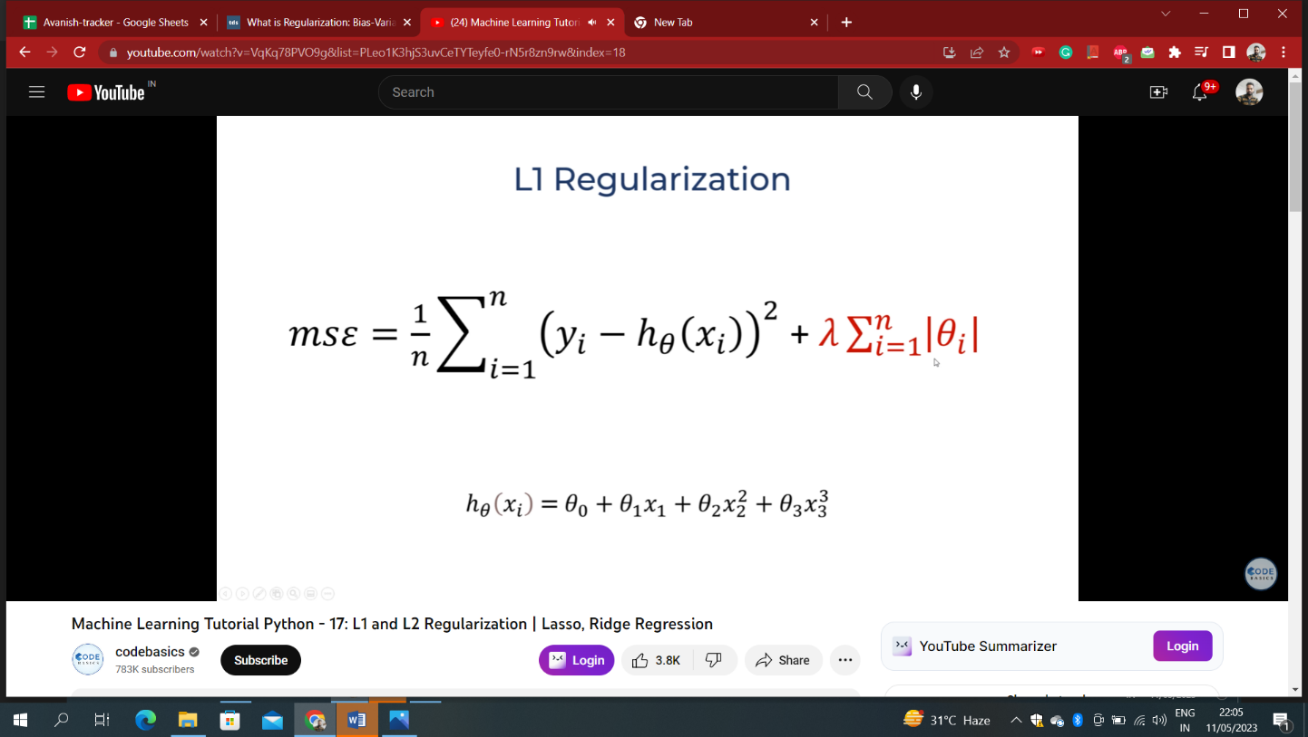 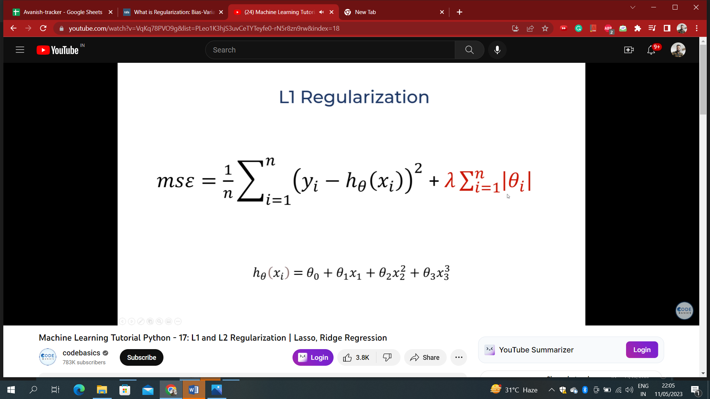

3. In an **Elastic-net Regression** model, we modify the cost function to be

https://miro.medium.com/v2/resize:fit:875/0*ZNnjTcnqdtjgrVUE.png

These three variants of linear regression are associated with Regularization, which penalizes the flexibility and **complexity**of a model to prevent the risk of **overfitting**.

Here λ is a hyper-parameter that determines how much flexibility a model would be penalized. The higher the value of λ, the more constraint is applied to the weight of each feature, as a result, it prevents the weights from getting too big and hence avoids overfitting. However, if the value of λ is too high, it might create the issue of under fitting because the weights of key explanatory variables become too small and it can’t accurately explain the response variable.

Below is the ml code and results showing the benefits of regularization in reduction of the overfitting of a model:

