Game Design Document

Fill up the following document

1. Write the title of your project.

Space Escape

1. What is the goal of the game?

Try score as many points as you can (escape the planet) by avoiding the obstacles

1. Write a brief story of your game.

A pair of astronauts have gone to space but have found themselves in a tricky situation where asteroids and other obstacles are blocking their path. Your goal is to help the astronauts steer their rocket to safety before you lose all your lives.

1. Which are the playing characters of this game?

* Playing characters are the ones who respond to the user based on the input from the user.
* Cars, monkeys, dinos, wizards, etc., are the playing characters in the game.

|  |  |  |
| --- | --- | --- |
| Number | Character Name | What can this character do? |
| 1 | Rocket | Fly using arrow keys |
| 2 |  |  |
| 3 |  |  |
| 4 |  |  |
| 5 |  |  |
| 6 |  |  |
| 7 |  |  |
| 8 |  |  |

1. Which are the Non-Playing Characters of this game?

* Non-Playing characters are the ones that don't have an action or behavior when the user interacts with the game.
* Hurdles, stones, bananas, coins, etc., are non-playing characters in the game.

|  |  |  |
| --- | --- | --- |
| Number | Character Name | What can this character do? |
| 1 | Asteroids | Try make the rocket lose lives |
| 2 | Balls | Try make the rocket lose lives |
| 3 | Score | Count how many times you make it past the asteroids |
| 4 |  |  |
| 5 |  |  |
| 6 |  |  |
| 7 |  |  |
| 8 |  |  |

Draw your imagination of this game. What does this game look like?

* Draw the game either on your computer or on paper.
* Add images of the game scenes to show each of the playing and non-playing characters at least once.

I have already started designing my game and this is what it looks like 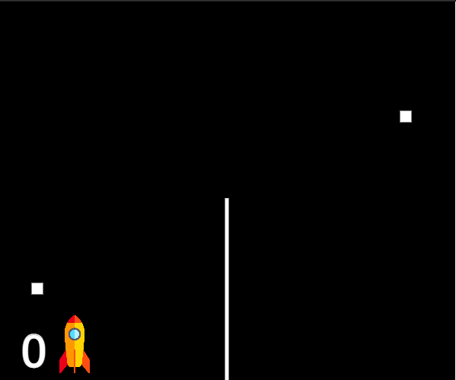

How do you plan to make your game engaging?

I plan to make my game engaging by with most game elements. Such as chance vs skill because to defeat this game you have to be good at avoiding the obstacles. As well as other elements which are storyline, conflict and good aesthetics.