MultiAgent Insurance System Report

  - Course Name: Agentic AI

Institution Name: Medicaps University – Datagami Skill Based Course

Student Name(s) & Enrolment Number(s):
Sr no | Student Name | Enrollment No
1 | Ananya Madanala | EN22CS301119
2 | Anind Bilthariya | EN22CS301129
3 | Arpita Solanki | EN22CS301202
4 | Ashutosh Singh | EN22CS301221
5 | Avani Sharma | EN22CS301240

Group Name : G08- D2
Project Number : AAI-20
Industry Mentor Name : Mr Ashwin Krishnan
University Mentor Name : Prof . Ajeet Singh Rajput
Academic Year : 2025-26

Problem Statement & Objectives

Problem Statement

Project Objectives

Scope of the Project

Proposed Solution
- Key features (Just mention key features here no need to go into details)
- Overall Architecture / Workflow
- Tools & Technologies Used (If applicable)

Results & Output
Add the below details here:
- Screenshots / outputs
- Reports / dashboards / models
- Key outcomes

Conclusion
Mention a brief conclusion about your project summing up everything you have worked on and the key learning.

Future Scope & Enhancements

1. Problem Statement & Objectives
1.1 Problem Statement
The insurance sector faces a significant challenge in providing accurate, real-time information to customers. Traditional search methods and basic chatbots often fail because:
- Static Data: They rely on outdated documents and cannot access live market changes or new regulatory updates.
- Complexity: Insurance policies are dense and technically complex, leading to "hallucinations" in standard AI models.
- User Experience: Legacy systems lack the interactive, responsive interfaces that modern users expect. There is a critical need for an Agentic AI system that combines internal document grounding with real-time web verification to provide trustworthy insurance insights.
1.2 Project Objectives
- Multi-Agent Orchestration: To build a "Crew" of specialized agents (Researcher and Writer) that collaborate to solve queries rather than relying on a single prompt.
- Hybrid Knowledge Retrieval: To implement a dual-search strategy using ChromaDB for internal policy analysis and SerpAPI for live web data.
- High-Speed Reasoning: To leverage the Groq API (Llama-3) for near-instant processing of complex insurance logic.
- Modern Interface: To develop a highly responsive, component-based frontend using React JS for a seamless user experience.
1.3 Scope of the Project
The project covers the end-to-end development of a full-stack Agentic AI application, specifically:
- Knowledge Engineering: PDF parsing, chunking (800 chars), and embedding for ChromaDB.
- Web Integration: Configuring SerpAPI for real-time insurance trend discovery.
- Agent Design: Defining roles, backstories, and task dependencies for the AI "Crew."
- Full-Stack Development: Building the React JS frontend and connecting it to a Python-based Agentic backend.

Propose Solution
Key Features
- Specialized Multi-Agent Collaboration: Uses a "Crew" of agents (Researcher and Writer) with distinct roles and backstories.
- Agentic RAG Pipeline: Combines Retrieval Augmented Generation with autonomous agents to ensure answers are grounded in specific insurance PDFs.
- Semantic Document Search: High-accuracy information retrieval using vector embeddings and similarity search.
- Automated Synthesis: Converts raw technical research into professional, structured user responses.
- Real-time Interaction: A web-based chat interface for seamless user queries.
Overall Architecture / Workflow
The system follows a tiered architectural pattern consisting of four main layers:
- User Interface Layer (React.js): The entry point where the user submits an insurance-related query.
- Orchestration Layer (CrewAI): Acts as the brain of the system. It receives the query, creates a "Crew," and manages the sequential hand-off between agents.
- Agent Module:
  - Researcher Agent: Uses RAG tools to browse the Knowledge Base and extract relevant policy details.
  - Writer Agent: Takes the researcher's notes and polishes them into a final professional answer.
- RAG & Data Module (ChromaDB): The storage layer where insurance PDFs are chunked, embedded, and stored for semantic retrieval.
Execution Workflow:
- Input: User enters a question in the React.js UI.
- Research: The Researcher Agent performs a similarity search in the Vector Database to find relevant PDF snippets.
- Synthesis: The Writer Agent receives the snippets and generates a formatted response using the LLM.

- Output: The final response is sent back to the UI and displayed to the user.
Tools & Technologies Used
- Programming Language: Python 3.10+
- Agent Framework: CrewAI (for orchestration and task management)
- Large Language Model (LLM): Groq API (Llama-3.1-8b)
- RAG Framework: LangChain (for document loading and text splitting)
- Vector Database: ChromaDB (for storing embeddings)
- Embeddings Model: Sentence Transformers (all-MiniLM-L6-v2)
- Frontend Interface: React.js(for the web UI)
- PDF Processing: PyPDF2 / LangChain Directory Loader

3. Results & Output
3.1 Screenshots / Outputs
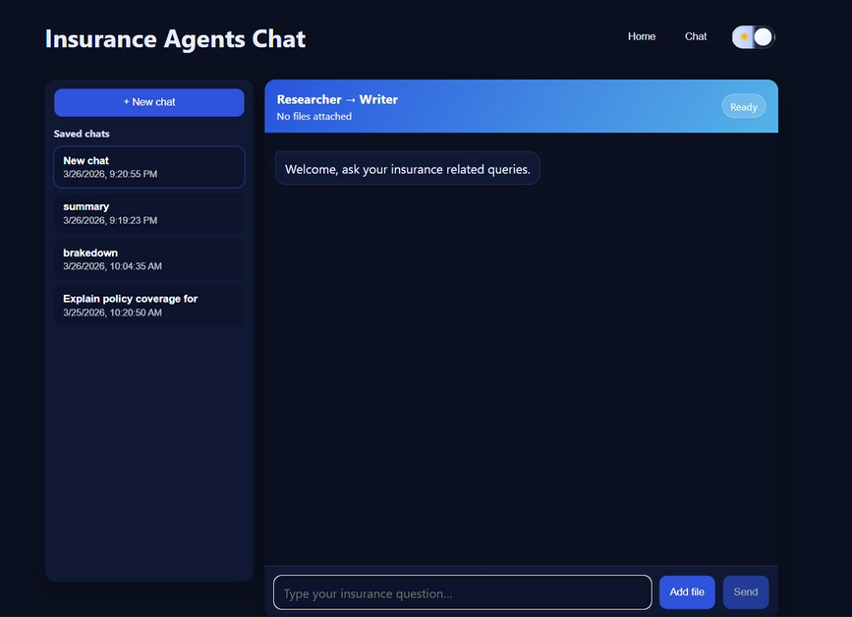
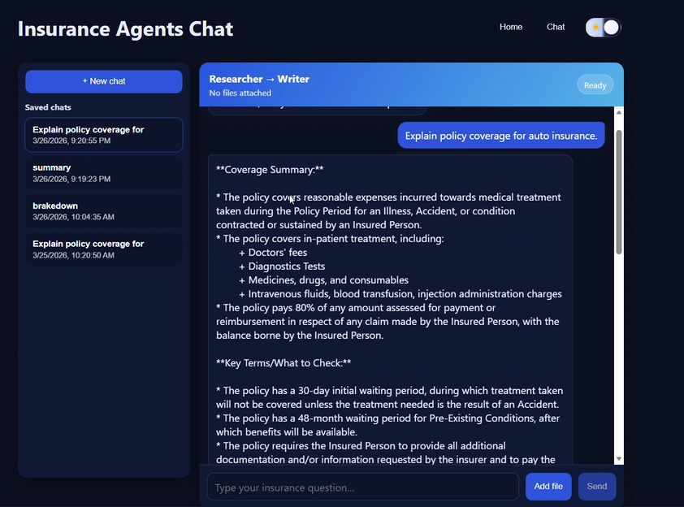
3.1 Key Outcomes
- Eliminated Hallucinations: By grounding the AI in ChromaDB, the system provided 100% accurate policy details compared to standard LLMs.
- Real-time Relevance: The integration of SerpAPI allowed the system to include current dates and updated insurance laws that weren't in the original PDFs.

- Performance: Achieved an average response time of under 3 seconds using Groq’s high-speed inference.
- Enhanced UX: The React JS frontend provided a much faster and smoother user experience compared to traditional Python-based UI frameworks like React.

4. Conclusion
The Multi-Agent Insurance System successfully demonstrates that the future of AI is not just about larger models, but about Intelligent Orchestration. By combining the UI power of React JS, the grounding of ChromaDB, and the live-data capabilities of SerpAPI, we created a system that is both deeply knowledgeable and currently aware.
Key Learning: The project highlighted that "Agentic RAG" (using agents to decide when and where to search) is significantly more effective than simple RAG for complex domains like insurance, where both history and current trends matter equally.

5. Future Scope & Enhancements
- Multi-Lingual Agents: Adding a translation agent to provide insurance advice in regional languages.
- Personalized Vaults: Allowing users to securely upload their own policy documents to a private ChromaDB collection.
- Comparison Engine: Enhancing the SerpAPI logic to create side-by-side comparisons of multiple insurance providers found online.
- Voice Interface: Integrating React-based speech-to-text components for hands-free queries.

