  - Deploy Insurance App to Kubernetes

Report

  - Course Name: DevOps

Institution Name: Medicaps University – Datagami Skill Based Course

Student Name(s) & Enrolment Number(s):
Sr no | Enrollment no | Student Name
1 | EN22CS301119 | Ananya Madanala
2 | EN22CS301129 | Anind Bilthariya
3 | EN22CS301202 | Arpita Solanki
4 | EN22CS301221 | Ashutosh Singh
5 | EN22CS301240 | Avani Sharma

Group Name : 08D2
Project Number : DO-20
Industry Mentor Name: Mr. Vaibhav
University Mentor Name: Prof. Akshay Saxena
Academic Year: 2025-26

Problem Statement & Objectives
1. Problem Statement
In modern applications, deploying and updating software without downtime is a major challenge. Traditional deployment methods often cause service interruption, leading to poor user experience. There is a need for a system that ensures smooth deployment, continuous availability, and easy scalability of applications.
2. Project Objectives
- To deploy an insurance application using Docker and Kubernetes
- To implement containerization for easy application packaging
- To automate the deployment process using CI/CD pipeline
- To ensure high availability and scalability of the application
3. Scope of the Project
This project focuses on the deployment and management of an insurance application using DevOps practices. It includes containerization using Docker, orchestration using Kubernetes, and automation using CI/CD pipelines.
The scope covers:
- Packaging the application into a Docker container
- Deploying the containerized application on Kubernetes
- Managing application lifecycle using Kubernetes

Proposed Solution
1. Key Features
The system provides the following key features:
- Containerization: The application is packaged into Docker containers for portability
- Kubernetes Deployment: The application is deployed and managed using Kubernetes
- Rolling Updates: Enables updating the application without downtime
- High Availability: Multiple pods ensure continuous availability
- Automation: CI/CD pipeline automates build and deployment process
- Scalability: The system can scale up or down based on demand
- Reliability: Kubernetes automatically restarts failed containers
2. Overall Architecture / Workflow
The system follows a structured workflow for deployment and execution:
- The developer writes or updates the application code and pushes it to a GitHub repository.
- The CI/CD pipeline (GitHub Actions) is triggered automatically.
- The pipeline builds a Docker image of the application.
- The Docker image is pushed to Docker Hub (container registry).
- Kubernetes pulls the latest image from Docker Hub.
- The application is deployed in the form of pods inside the Kubernetes cluster.
- A Kubernetes Service exposes the application to users through a browser.
3.Tools & Technologies Used
The project uses the following tools and technologies:
- Programming Language: Python (for application development)
- Frontend: Streamlit (for user interface)
- Containerization Tool: Docker (to package the application)
- Container Registry: Docker Hub (to store images)
- Orchestration Tool: Kubernetes (Minikube) (to manage containers)

- CI/CD Tools: GitHub Actions
- Version Control: Git & GitHub (for code management)

Results & Output

1. Screenshots / Outputs

Deployed Application:
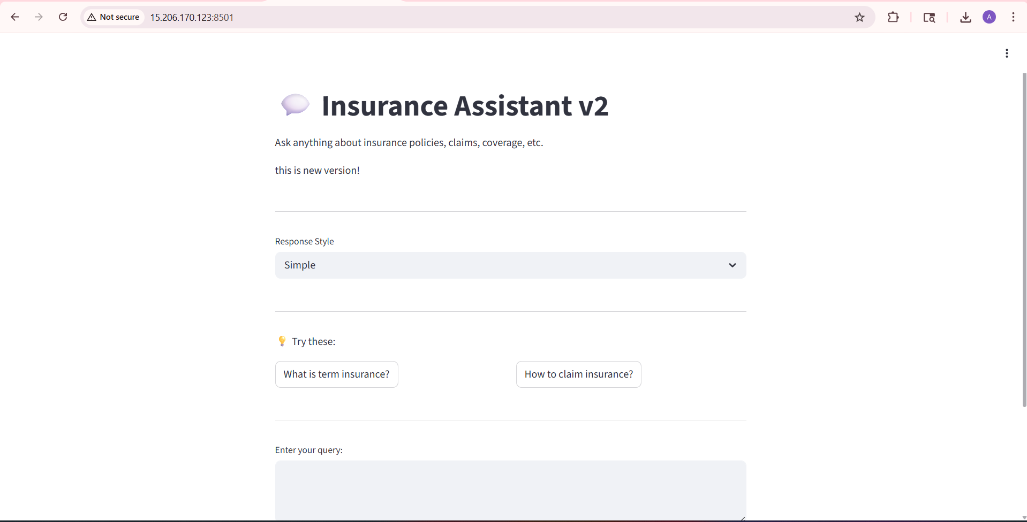

Workflow:
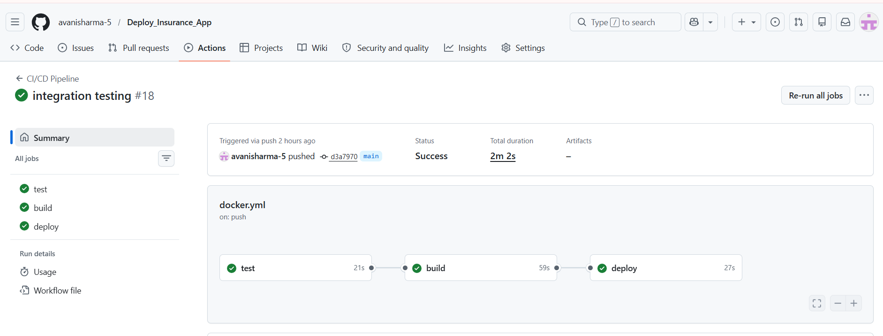

Key Outcomes
- Successful deployment of the insurance application on Kubernetes
- Achieved zero downtime during updates using rolling updates
- Improved application availability and reliability
- Automated deployment reduced manual effort
- Gained practical knowledge of Docker, Kubernetes, and CI/CD

Conclusion
This project demonstrates how modern DevOps tools can be used to deploy and manage applications efficiently. By using Docker, the application is containerized and made portable. Kubernetes ensures that the application runs reliably with high availability and self-healing capabilities. The use of rolling updates allows the application to be updated without any downtime, improving user experience.
Overall, the project provides a strong understanding of real-world deployment practices and highlights the importance of automation, scalability, and reliability in software systems.

Future Scope & Enhancements
The project can be further improved with the following enhancements:
- Deploying the application on cloud platforms like AWS, Azure, or GCP
- Implementing auto-scaling using Horizontal Pod Autoscaler (HPA)
- Integrating monitoring tools like Prometheus and Grafana
- Adding security features like authentication and authorization
- Improving CI/CD pipeline with advanced testing and validation
- Implementing centralized logging and alert systems

