**Android**

Android is an Operating System developed by Google to be used on mobile devices (basically smartphones and tablets). It is built on the open Linux Kernel. It delivers a complete set of software for devices, i.e., an operating system, middleware and key mobile applications. It was built to enable developers to create compelling mobile applications that take full advantage of all a handset has to offer. Since it is open source, therefore, it can be extended to incorporate new technologies as they emerge.

Android's user interface is mainly focused on direct manipulation, using fingers for touch gestures such as swiping, tapping and pinching, to manipulate on-screen objects, along with a virtual keyboard for text input. Further developments along with specialized user interface in the form of Android TV for televisions, Android Auto for cars, and Android Wear for wrist watches have been made.

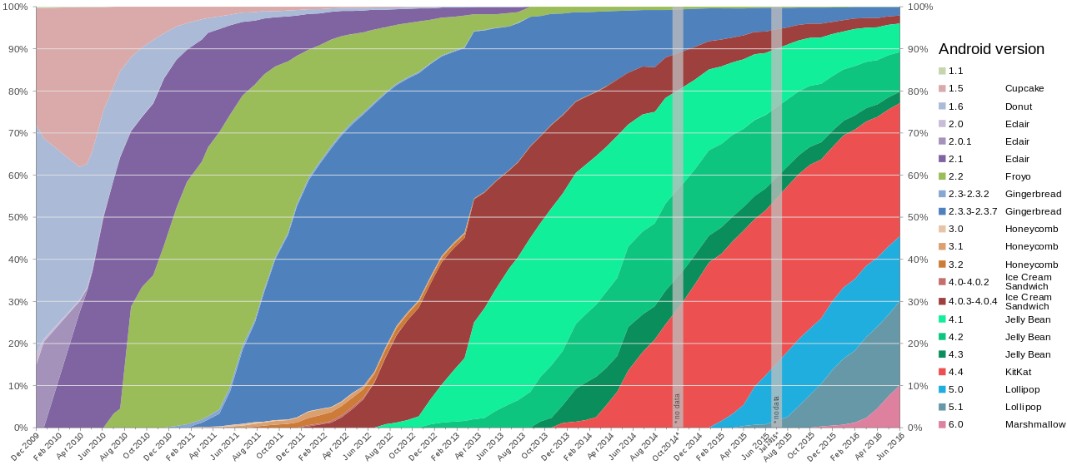

Fig. Global Android version distribution since December 2009

Table : Versions of Android

| **Code name** | **Version number** | **Initial release date** | **API level** |
| --- | --- | --- | --- |
| N/A | 1.0 | 23 September 2008 | 1 |
| 1.1 | 9 February 2009 | 2 |
| [Cupcake](https://en.wikipedia.org/wiki/Android_Cupcake) | 1.5 | 27 April 2009 | 3 |
| [Donut](https://en.wikipedia.org/wiki/Android_Donut) | 1.6 | 15 September 2009 | 4 |
| [Eclair](https://en.wikipedia.org/wiki/Android_Eclair) | 2.0 – 2.1 | 26 October 2009 | 5–7 |
| [Froyo](https://en.wikipedia.org/wiki/Android_Froyo) | 2.2 – 2.2.3 | 20 May 2010 | 8 |
| [Gingerbread](https://en.wikipedia.org/wiki/Android_Gingerbread) | 2.3 – 2.3.7 | 6 December 2010 | 9–10 |
| [Honeycomb](https://en.wikipedia.org/wiki/Android_Honeycomb) | 3.0 – 3.2.6 | 22 February 2011 | 11–13 |
| [Ice Cream Sandwich](https://en.wikipedia.org/wiki/Android_Ice_Cream_Sandwich) | 4.0 – 4.0.4 | 18 October 2011 | 14–15 |
| [Jelly Bean](https://en.wikipedia.org/wiki/Android_Jelly_Bean) | 4.1 – 4.3.1 | 9 July 2012 | 16–18 |
| [KitKat](https://en.wikipedia.org/wiki/Android_KitKat) | 4.4 – 4.4.4 | 31 October 2013 | 19–20 |
| [Lollipop](https://en.wikipedia.org/wiki/Android_Lollipop) | 5.0 – 5.1.1 | 12 November 2014 | 21–22 |
| [Marshmallow](https://en.wikipedia.org/wiki/Android_Marshmallow) | 6.0 – 6.0.1 | 5 October 2015 | 23 |
| [**Nougat**](https://en.wikipedia.org/wiki/Android_Nougat) | **7.0** | **22 August 2016** | **24** |