**SCALA USING CMD**

AVANI SHAJI KRISHNA

22BTRAD007

04.09.23

**VARIABLES AND VALUES:**

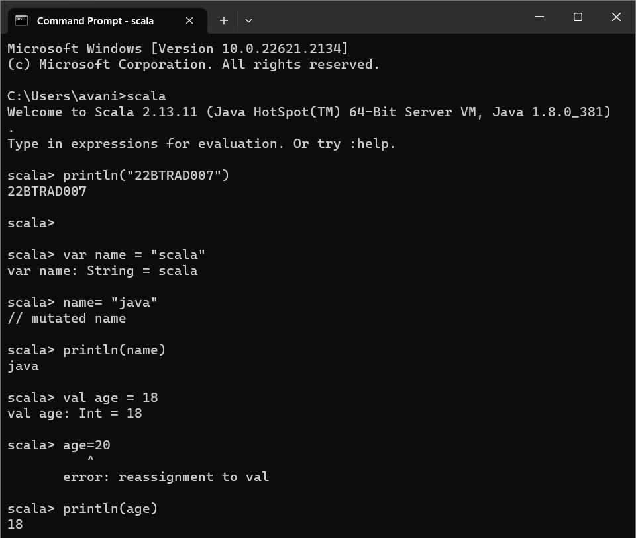

**IF-ELSE:**

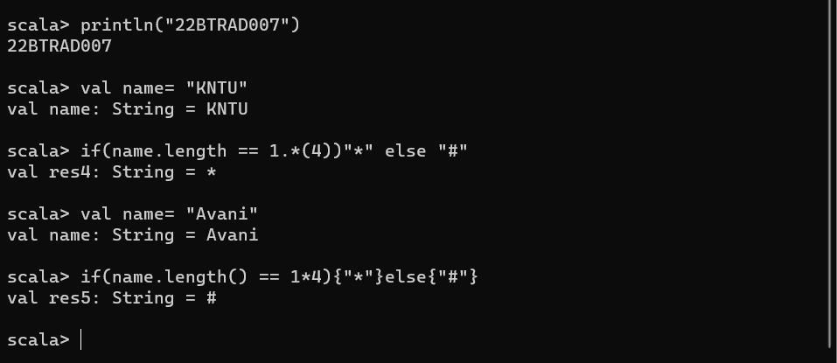

**WHILE AND DO-WHILE:**

