# #Appending two datasets:

frames = [fake_news, true_news]

news_dataset = pd.concat(frames)

news_dataset

O/P:

subject date news output

0 News December 31,

2017

Donald Trump Sends Out Embarrassing

New Year’... fake

1 News December 31,

2017

Drunk Bragging Trump Staffer Started

Russian ... fake

... ... ... ... ...

21415 worldnews August 22,

2017

Vatican upbeat on possibility of Pope

Francis ... true

21416 worldnews August 22,

2017

Indonesia to buy $1.14 billion worth of

Russia... true

44898 rows × 4 columns

#News-Punctuation Cleaning:

O/P:

subject date news output

0 News December 31,

2017

donald trump sends out embarrassing newyear’... fake

1 News December 31,

2017 drunk bragging trump staffer started russian ... fake

2 News December 30,

2017 sheriff david clarke becomes an internet joke... fake

3 News December 29,

2017

trump is so obsessed he even has obama’s

name...

fake

4 News December 25,

2017 pope francis just called out donald trump dur... fake

#News-Stop words:

O/P:

subject date news output

1 News December 31,

2017

drunk bragging trump staffer started russian

c...

fake

2 News December 30,

2017

sheriff david clarke becomes internet joke

thr... fake

3 News December 29,

2017

trump obsessed even obama’s name coded

website... fake

4 News December 25,

2017

pope francis called donald trump christma spe...

Count of fake news and true news:

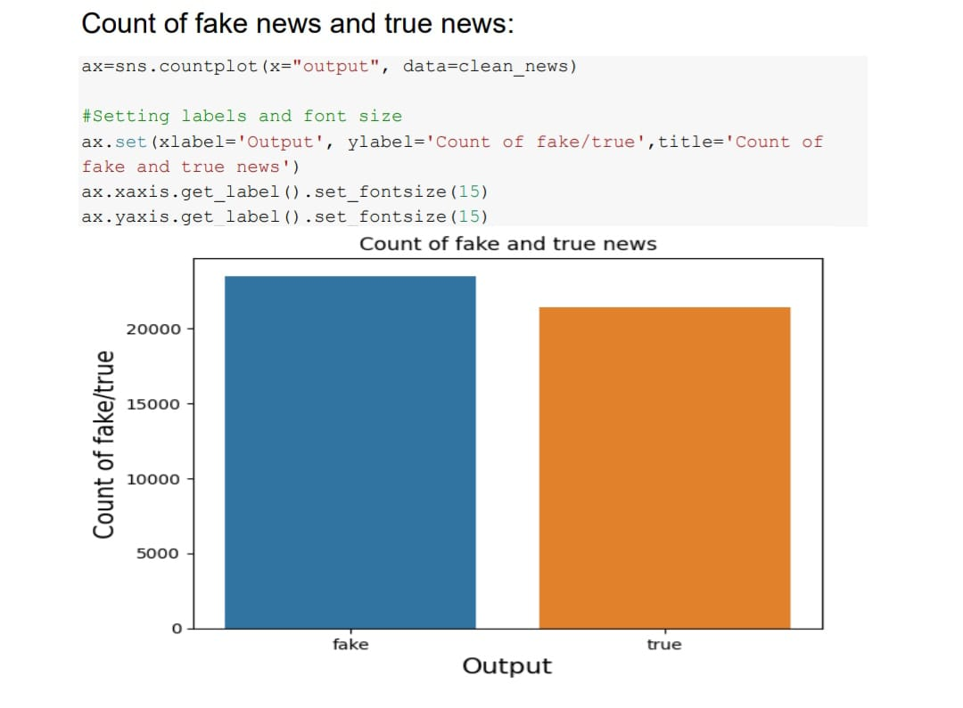

Word Cloud of Fake and True News:

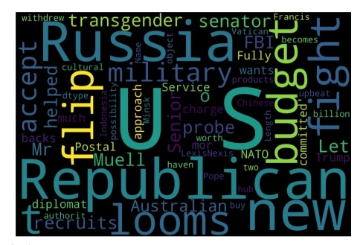

Stemming the reviews:

O/P:

drunk brag trump staffer start russian collus investigationhous

intellig committe chairman devin nune go bad day assumpt like mani us

christoph steeledossi prompt russia investig lash depart justic fbi

order protect trump happen dossier start investig accord document

obtain new york timesform trump campaign advis georg papadopoulo drunk

wine bar reveal knowledg russian opposit research hillari clintonon

top papadopoulo covfef boy trump administr alleg much larger role none

damn drunken fool wine bar coffe boy help arrang new york meet trump

presid abdel fattah elsisi egypt two month elect known former aid set

meet world leader trump team trump ran mere coffe boyin may

papadopoulo reveal australian diplomat alexand downer russian offici

shop around possibl dirt thendemocrat presidenti nomine hillari clinton exactli much mr papadopoulo said night kensington wine room

australian alexand downer unclear report state two month later leak

democrat email began appear onlin australian offici pa