PROJECT NAME: KHANA KHAZANA

NAME: Avantika Srivastava

ROLL.NO:2102901520036

SUBMITTED TO: Mr. Vijay Kumar

TECH – STACK: React.js , Edmam Api

CODE SNIPPETS

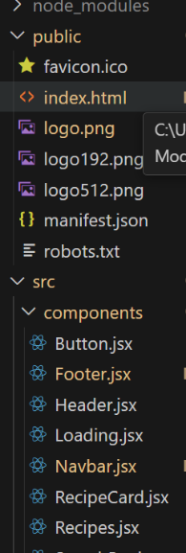

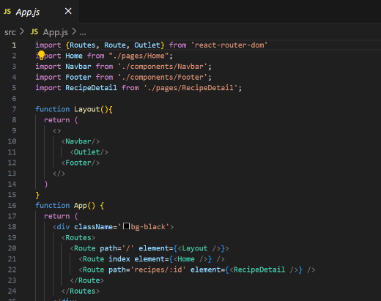

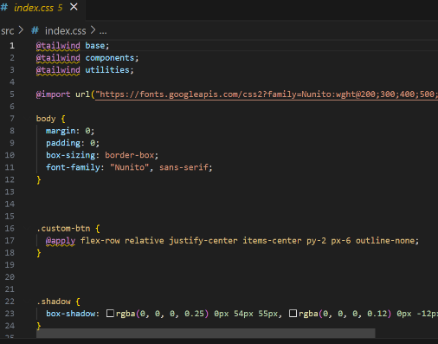

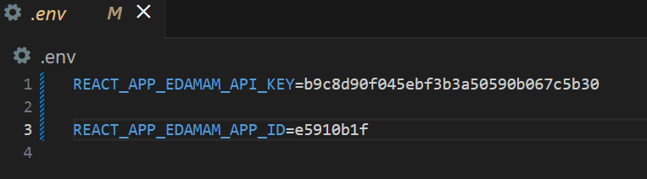

OUTPUT

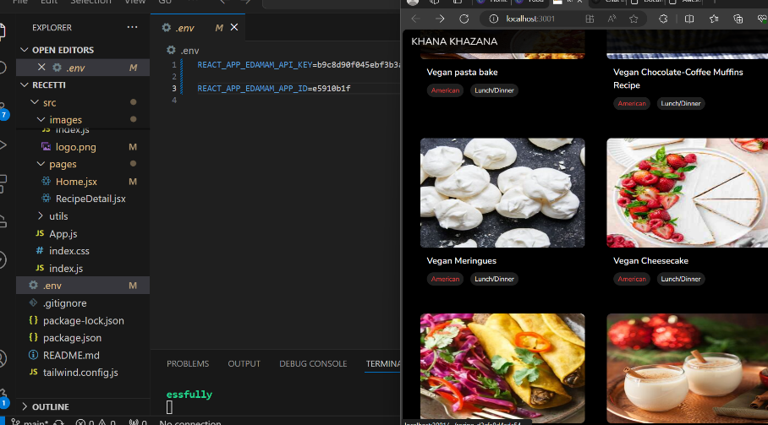

It is a responsive website.

