# Use AI to personalize meal plan / diet plan

JINGYI ZHANG jyz0328@bu.edu

## Abstract

The topic I get interested in is use AI to personalize health. The more detailed direction I want to focus on is to use AI to personalize meal plan/ diet plan. That is to say, I want to use AI to design an app or website which can make personalize meal plan for people. My target is not only make these meal plan healthy and full of nutrition, but also make people able to make these meal planning fit with their schedule/ their physical situation /fit with their taste .

To further this topic, I searched online and get a useful report called **An AI Based Approach for Personalized Nutrition and Food Menu Planning** ([1]).After studying the literature, I want to use the Harris-Benedict formula and the food pyramid to calculate the amount of various nutrients each person needs in a day. The recipe is then personalized according to the user's time and willingness to eat several meals and taste preferences. The above ideas require a lot of data and data analysis, so I may use convolutional neural network (CNN) and recurrent neural network (RNN) to analyze and predict the ideal recipe model. I also use image analysis to analyze the actual nutrient intake of the user during a meal.

I also chat with CHATGPT and get a paper from it. I realize that I also need to collect users’ allergies and daily activity levels to make app more accurate. What’s more, how users manage time is also an important factor.

## Introduction /Reason for choosing this topic

Food and meal are important. Getting enough nutrition are vital for people to keep healthy and get energy for have a good life. However, people may be busy of work and study, and then do not focus on their meal plan and may just eat Mcdonald every day, which cause weight and health problems in the future. However, if I can design an app or website which create personalize meal plan for people , people can get nutritional food conveniently.

## Background / online research

To thoroughly understand the topic, I find a project report called **An AI Based Approach for Personalized Nutrition and Food Menu Planning** ([1]).In this literature, I understand how to judge the standard of food nutrition and know how to quantify the nutrition of food. The so-called nutrients required by the body may be called nutrients. Macronutrients, which include fats, carbohydrates, fiber, protein, and water; Micronutrients are minerals and vitamins. In general, our bodies get energy by metabolizing these nutrients. The energy obtained from food is expressed in calories (C) or joules (J). The study used segmentation techniques and nutritional imaging to assess a person's daily nutrient needs. Optical character recognition (OCR) and face recognition are also methods to get nutrient needs information. In this study, a person's nutritional requirements were calculated from height, weight, age, and physical activity, which were used to calculate the body's metabolic capacity to infer the micronutrients needed in each situation. Not only that, given that what a person actually eats and what is expected is rarely exactly the same, the system must account for the difference in grams at the beginning and end of the plate in order to redistribute the amount of micronutrients missing from the next meal according to the recommended diet.In addition, the study used object recognition images to distinguish various foods and form a systematic data set.In the study , users were advised to take a photo of their food before and after a meal and upload it to the app, so that the app could analyze the difference between the user's actual and expected nutrition.

Except the project mentioned above, I also search online and find some apps and websites which are developed for giving people nutritional plans based on people’s requirement. In these apps, users need to provide their age, sex and other biological information. Then apps will give users suggestions about which nutrition they should take. These apps have some similarity with my topic. But I also hope the app I design can also fit with people’s lifestyle and time schedule, which is a big difference.

## Plan / next step I want to work

Combined with the current background, I want to use AI technology to make an app which can develop personalized meal plan. My target is not only make these meal plan healthy and full of nutrition, but also make people able to make these meal planning fit with their schedule. To do this, I first need to collect data on people's physical skills, such as age, height, weight, and gender, and then use the Harris-Benedict formula to estimate the BMR (Basal Metabolic Rate) to calculate the number of calories a person needs in a day. Then, use the known food pyramid or look up the dietary structure to calculate the amount of protein, carbohydrates, fats, vitamins and minerals the user needs for the day. Then, in theory, my target audience is all people who don't know enough about healthy nutrition and want to make their diet healthy. However, in fact, the people who need to use the app to achieve good health are most likely those who can only use the app I developed (rather than watching videos and reading books) to achieve healthy diet because of their busy work and life. So, I also ask users how much time they can spend eating in a day to determine whether the suggested items are more of a quick meal or something that takes a long time to cook. In addition, I ask users how many times a day they would like to eat (usually 3,4,5 times) to better allocate the amount of food per meal. In addition, considering that what I actually eat may not be the same as what I plan to eat, the app I design may also consider taking pictures before and after meals with image recognition, as in previous studies, so as to calculate nutrition intake. Not only that, I will also design a taste survey questionnaire for users, so that the food can meet their tastes as much as possible. I also consider giving regular questionnaires to users to learn how to improve my app.

There are many new ideas and changes in my thinking that are different from previous studies. First of all, I use the Harris-Benedict formula to calculate the metabolism required by a person, which is not proposed in the previous literature. Secondly, I proposed the concept of distributing nutrient composition by pyramid. Then, I took into account the actual user's life situation and came up with personalized recipes based on the user's time abundance and willingness to eat several meals and taste preferences. As for the image recognition method, it is indeed the previous technology, so I may consider replacing other methods in the future.

In my opinion, people's age, height, weight and gender can be regarded as data to be collected, and the last recipe can be regarded as the final required model. Convolutional neural network (CNN) and recurrent neural network (RNN) are the techniques used in the deep learning model I consider.

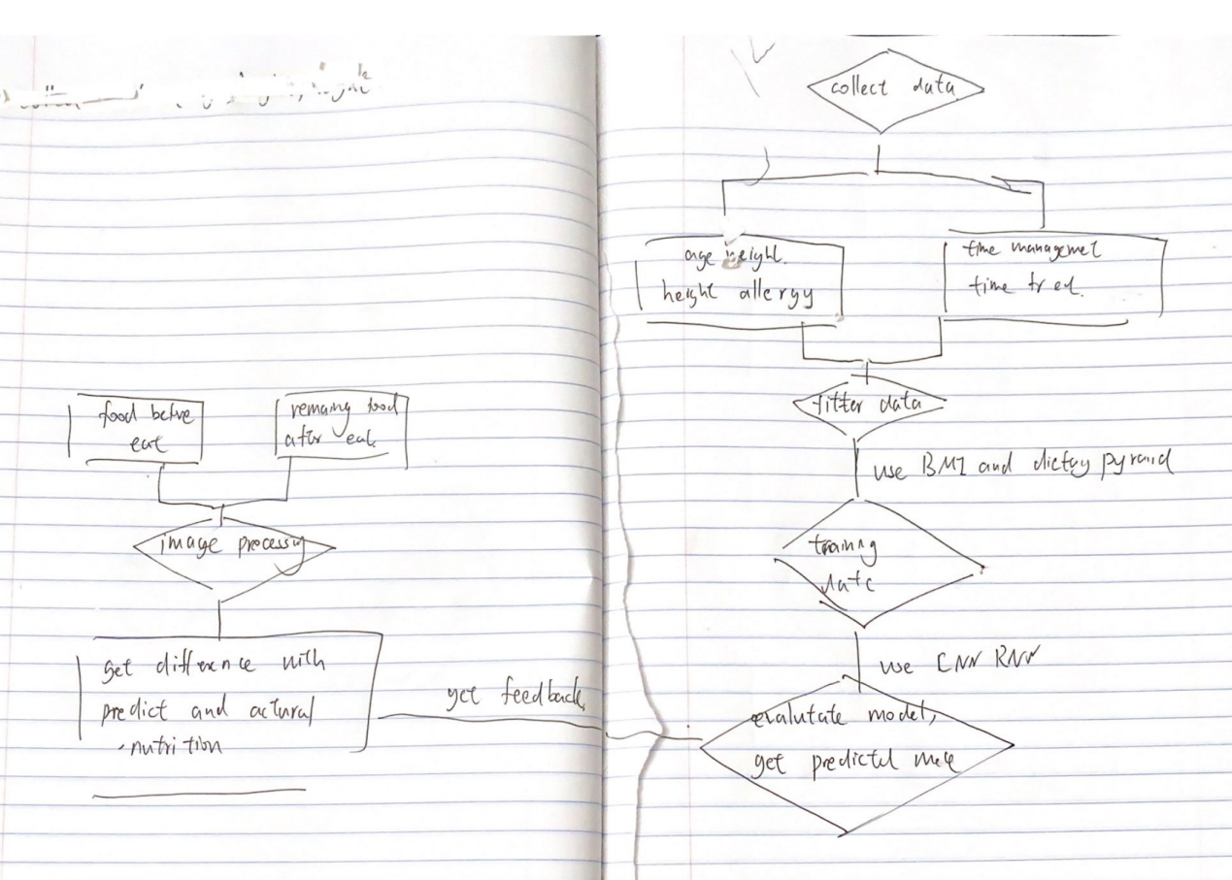

FLOW CHART IN HAND WRITTING VERSION/ drawio version

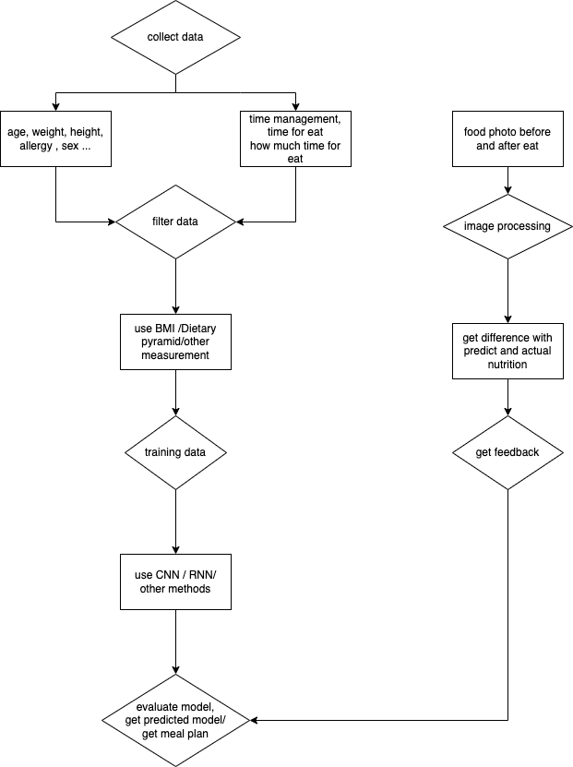

## CHATGPT paper analysis

I also use CHATGPT to write the paper and here is what CHATGPT create.Since it is long I put it in [2] to let you see. I learn from this CAHTGPT paper that we both try to use nutrition knowledge and use physiological information provided by users to personalize meal plan. However, I notice that CHATGPT also consider allergies, and daily activity levels into account, which were the factors I ignored. So I will also consider these two factors into required information from users. On the other hand, CHATGPT introduce a time management system , while I just define how many time do a user eat every day and how many time do they have on preparing food. I think it is not necessary for me to know detail time management, but I should know on what time do users plan to eat and what activity level do users have every day ( for example, knowing on what time do users do exercise ).

## Conclusion

To design an app to personalize meal plan, I need to collect physiological data and time management data , and then use AI and data deep learning training model ( such as Convolutional neural network (CNN) and recurrent neural network (RNN) ) to get ideal meal plan for each person. I hope this app enable people to make these meal plans fit into their schedules and help people stay healthy.

## Reference

1. :https://ieeexplore.ieee.org/document/9983099
2. Chatgpt paper

*Title: Designing an AI-Powered App or Website for Personalized Meal Planning*

*Abstract: This paper aims to explore how artificial intelligence (AI) technology can be utilized to design an application or website that creates personalized meal plans for individual users. These meal plans not only need to be healthy and nutritionally balanced but also adaptable to the user's schedule. By merging AI with the principles of nutrition and user time management, we strive to address the challenges people face in meal planning amidst their fast-paced lives.*

*Background: The fast-paced nature of modern life and hectic work schedules make it challenging for many individuals to maintain healthy eating habits. The varying dietary needs and timetables of individuals complicate the task of creating personalized meal plans for everyone. Traditional meal planning methods often require significant time and expertise, which is impractical for most people. Therefore, leveraging AI technology to solve this problem has become crucial.*

*Method: We plan to develop an application or website that personalizes meal plans based on information provided by users. Users will be asked to provide personal details such as age, gender, body mass index (BMI), dietary preferences, allergies, and daily activity levels. We will then utilize this information and the latest nutritional guidelines to generate a personalized meal plan.*

*To ensure meal plans align with the user's schedule, we will introduce a time management system. Users can specify their available time slots each day, and the meal planning will be done accordingly, ensuring that users can easily adhere to the plan.*

*Outcome: The outcome of this research will be an application or website that can generate personalized meal plans based on individual needs and schedules. This will contribute to improving people's dietary habits, making it easier for them to adopt a healthier lifestyle. Furthermore, this innovation holds the potential to have a positive impact in areas such as health management, weight control, and dietary allergy management.*

*Conclusion: By integrating the principles of artificial intelligence, nutrition, and time management, we can design an application or website aimed at helping people better manage their dietary choices. This will enhance the quality of people's lives, making it easier for them to embrace healthier eating habits.*