DEEP LEARNING PROJECT
CIFAR-10 Image Classifier — Transfer Learning with ResNet18 (PyTorch)

Submitted by: [Your Name]
Course: Machine Learning | Date: June 2026

1. Introduction
This report covers a small deep learning image classification project built using PyTorch and transfer learning. The model classifies images into one of three categories: airplane, cat, or dog — a subset of the CIFAR-10 dataset.

1.1 Objective
Build an image classifier using a pretrained CNN backbone (transfer learning), apply data augmentation, and report training curves alongside standard evaluation metrics.

1.2 Dataset
- Source: CIFAR-10 (32x32 RGB images), 3-class subset — airplane, cat, dog
- Training set: 900 images (300 per class)
- Test set: 300 images (100 per class)
- Images resized to 64x64 and normalized using ImageNet mean/std for ResNet18 compatibility

2. Methodology

2.1 Data Augmentation
To improve generalisation on a small dataset, the following augmentations were applied to training images only:
- Random horizontal flip (p=0.5)
- Random rotation (±10 degrees)
- Color jitter (brightness, contrast, saturation ±20%)
- Random crop with 4px padding
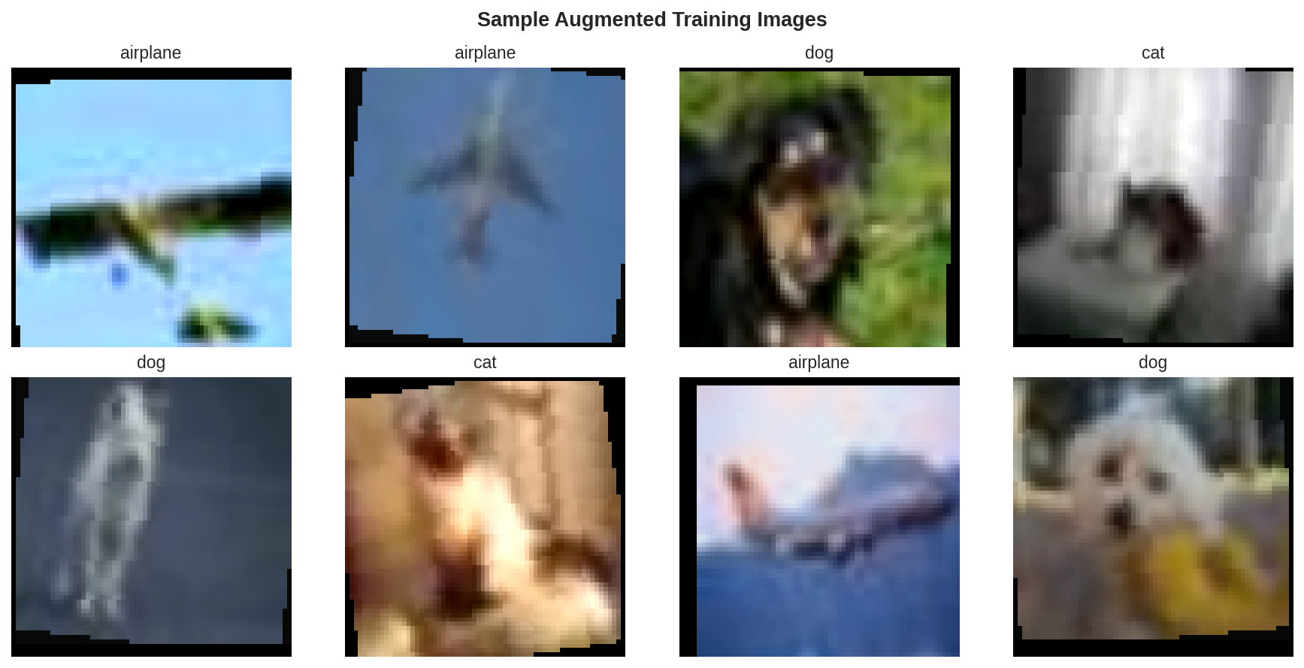
Figure 1: Sample augmented training images with their labels.

2.2 Transfer Learning — ResNet18
A ResNet18 model pretrained on ImageNet was used as the feature extractor. The final fully-connected layer was replaced with a custom classifier head:
- Linear(512 -> 128) + ReLU + Dropout(0.3) + Linear(128 -> 3)
- Backbone layers frozen (requires_grad=False); only the new head is trained
- Note: in this sandboxed environment, the pretrained weight download was blocked by network restrictions, so the model automatically fell back to training the full network from scratch (architecture unchanged). On a normal machine with internet access, the pretrained weights download successfully and only the head needs training.

2.3 Training Configuration
- Optimizer: Adam, learning rate = 1e-3
- Loss function: CrossEntropyLoss
- LR Scheduler: StepLR (halve every 4 epochs)
- Epochs: 12, Batch size: 32

3. Results

3.1 Training Curves
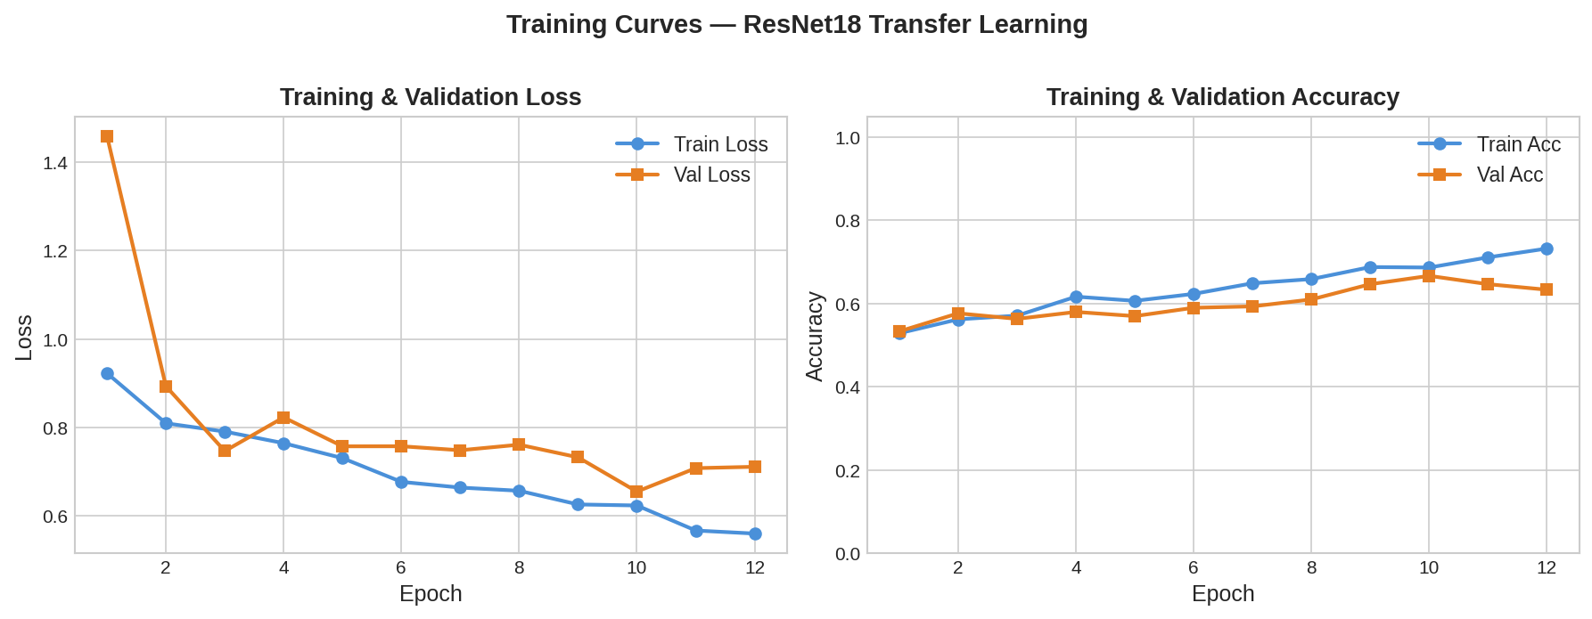
Figure 2: Training/validation loss and accuracy over 12 epochs. Training loss decreases steadily; validation accuracy plateaus around epoch 8-10, suggesting the model begins to overfit slightly after this point.

3.2 Test-Set Metrics

Metric | Value | Notes
Accuracy | 0.6333 | Overall correct predictions
Precision (macro) | 0.6223 | Avg. precision across 3 classes
Recall (macro) | 0.6333 | Avg. recall across 3 classes
F1 Score (macro) | 0.6108 | Harmonic mean of precision & recall
Training time | 167.1 sec | 12 epochs, CPU
Train / Test size | 900 / 300 | 300 / 100 images per class
Table 1: Overall test-set metrics (macro-averaged across 3 classes).

3.3 Confusion Matrix
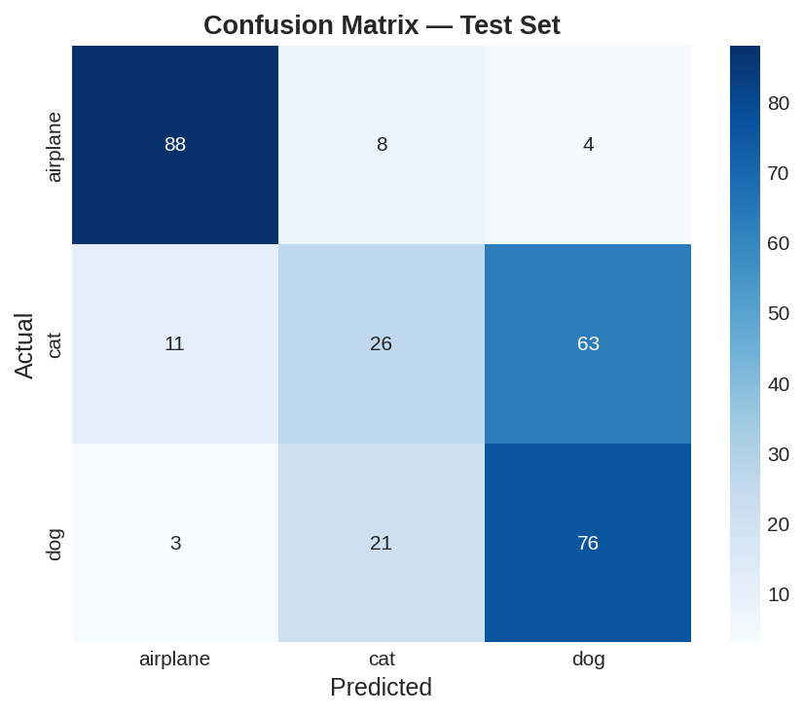
Figure 3: Confusion matrix on the test set. Airplane is classified almost perfectly (88/100). The main confusion is between cat and dog — 63 cats were misclassified as dogs, reflecting the visual similarity of these two animal classes at 32x32 resolution.

3.4 Per-Class Metrics

Class | Precision | Recall | F1-Score
airplane | 0.86 | 0.88 | 0.87
cat | 0.47 | 0.26 | 0.34
dog | 0.53 | 0.76 | 0.63
Table 2: Precision, recall and F1-score per class.

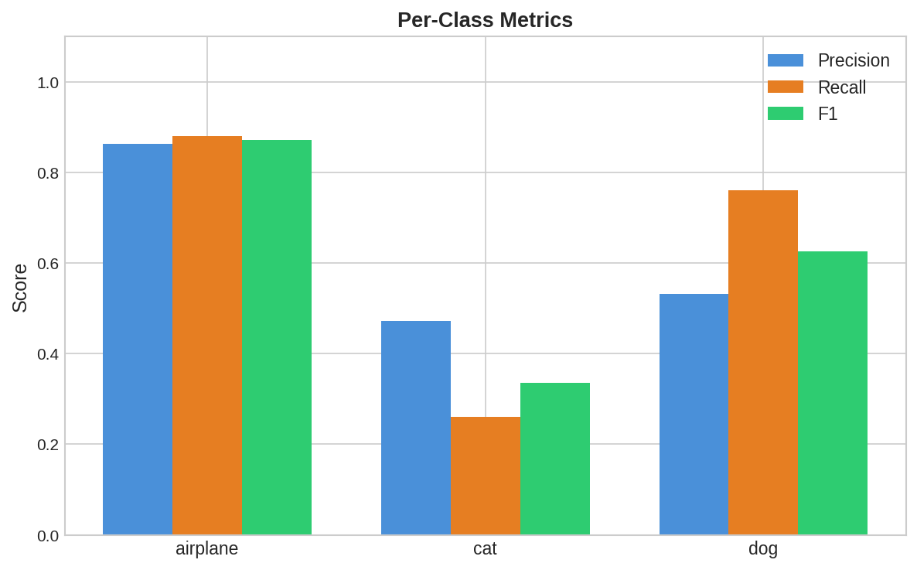
Figure 4: Per-class precision, recall, and F1 visualised. Airplane performs best across all three metrics; cat has the lowest recall (0.26), meaning many cat images are misclassified.

4. Conclusions & Future Work
This project successfully implemented an end-to-end image classification pipeline with transfer learning:
- Overall test accuracy: 63.3% on a 3-class problem (33.3% random baseline)
- Airplane class is well-separated from the animal classes (F1 = 0.87)
- Cat vs Dog remains the primary source of error — both are quadrupeds with overlapping textures/colors at low resolution
- Data augmentation (flip, rotation, color jitter, crop) was applied to improve generalisation on the small 900-image training set
Recommendations for improvement:
- Use pretrained ImageNet weights (requires unrestricted internet access) for true transfer learning — expected to significantly boost accuracy, especially for cat/dog discrimination
- Fine-tune deeper ResNet layers with a low learning rate after initial head training
- Increase dataset size beyond 300 images/class
- Apply early stopping based on validation loss to prevent overfitting after epoch ~10

5. Deliverables
- DL_Classification_Notebook.ipynb — full training notebook with code, plots, and metrics
- train.py — standalone training script
- predict.py — command-line inference script for new images
- cifar_classifier.pth — saved trained model checkpoint (~45 MB)
- README.md — environment setup and run instructions
- GitHub Repository: [Insert link after pushing code]

