ML CLASSIFICATION PROJECT
Churn Prediction: Logistic Regression vs Random Forest

Submitted by: [Your Name]
Course: Machine Learning | Date: June 2026

1. Introduction
This report presents the design, implementation, and evaluation of a supervised binary classification model for predicting customer churn. Customer churn prediction is a practical and high-impact business problem — identifying customers likely to leave allows companies to take proactive retention actions.
Two algorithms were built, compared, and evaluated:
- Logistic Regression — a transparent linear baseline classifier
- Random Forest — a powerful non-linear ensemble method

1.1 Objective
Predict whether a customer will churn (Class 1) or stay (Class 0), and identify the better-performing model using a comprehensive set of classification metrics.

1.2 Dataset
A synthetic churn dataset was generated using scikit-learn's make_classification utility with the following characteristics:
- 1,000 samples (customers)
- 10 features: tenure_months, monthly_charges, total_charges, num_services, support_calls, contract_length, internet_speed, payment_delay, satisfaction_score, age
- Class imbalance: 70% No Churn (697), 30% Churn (303) — realistic for real-world datasets

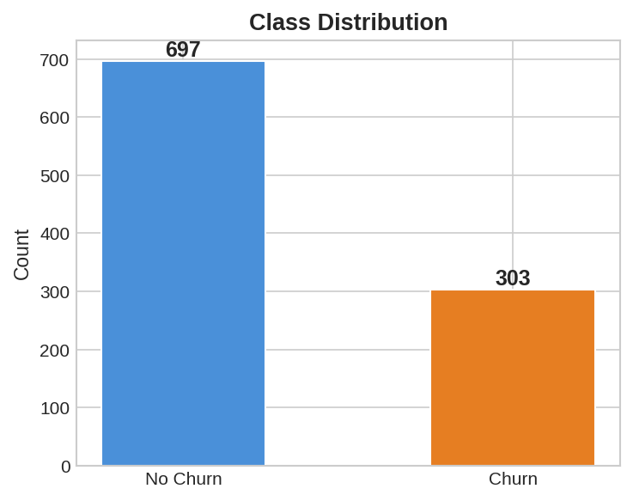
Figure 1: Class distribution — 697 non-churners vs 303 churners.

2. Methodology

2.1 Data Preprocessing
The following preprocessing steps were applied:
- Train-test split: 80% training (800 samples) / 20% test (200 samples), stratified to preserve class ratios
- Feature scaling: StandardScaler applied to Logistic Regression inputs (zero mean, unit variance). Random Forest is invariant to feature scale.
- Class weighting: class_weight="balanced" applied to both models to address class imbalance

2.2 Algorithms
Logistic Regression:
A linear classifier that models the log-odds of class membership as a linear combination of features. It is interpretable, fast, and serves as a strong baseline. Hyperparameters: max_iter=1000, class_weight='balanced', solver='lbfgs'.
Random Forest:
An ensemble of 200 decision trees trained using bagging and random feature subsets. It captures non-linear interactions and is robust to outliers. Hyperparameters: n_estimators=200, max_depth=8, class_weight='balanced'.

2.3 Validation Strategy
Two validation approaches were used:
- Hold-out test set (20%): provides a final unbiased performance estimate
- 5-fold Stratified Cross-Validation on the training set: assesses model stability and generalisability

3. Results

3.1 Test-Set Performance
The table below reports all five required metrics on the held-out test set:

Metric | Logistic Regression | Random Forest | Winner
Accuracy | 0.860 | 0.955 | 🏆 RF
Precision | 0.754 | 0.982 | 🏆 RF
Recall | 0.803 | 0.869 | 🏆 RF
F1 Score | 0.778 | 0.922 | 🏆 RF
ROC-AUC | 0.904 | 0.967 | 🏆 RF
CV F1 (mean±std) | 0.847 ± 0.050 | 0.901 ± 0.036 | 🏆 RF
Table 1: Test-set classification metrics. Random Forest wins across all metrics.

3.2 Confusion Matrices
Confusion matrices reveal the breakdown of correct and incorrect predictions per class:
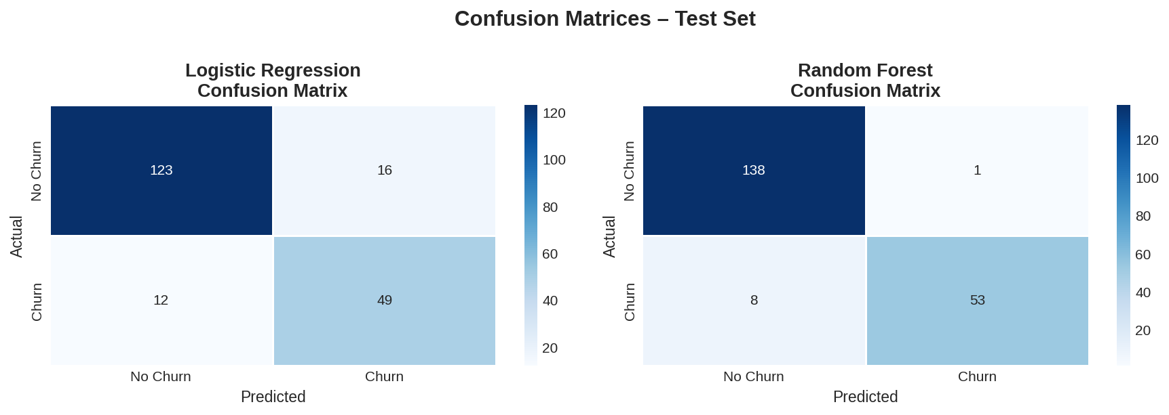
Figure 2: Confusion matrices for both models. RF produces far fewer false positives and false negatives.

3.3 ROC Curves
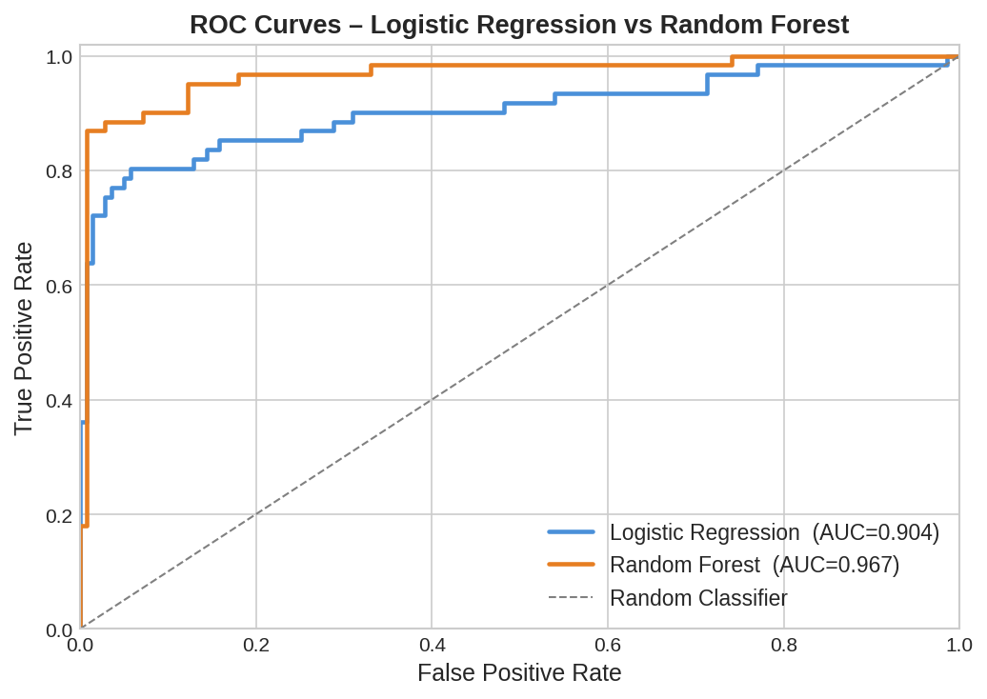
Figure 3: ROC curves. Random Forest achieves AUC=0.967 vs Logistic Regression's AUC=0.904, indicating substantially better discrimination between churners and non-churners.

3.4 Metric Comparison
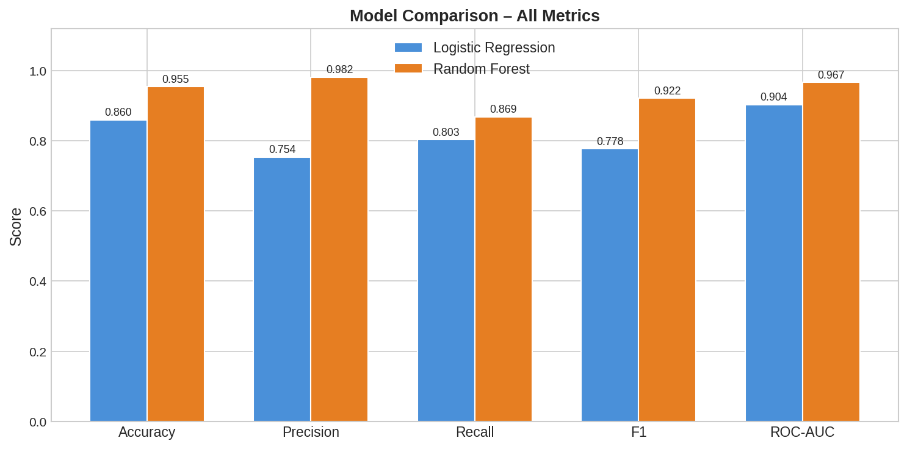
Figure 4: Side-by-side comparison of all five evaluation metrics. Random Forest leads on every metric.

3.5 Feature Importances
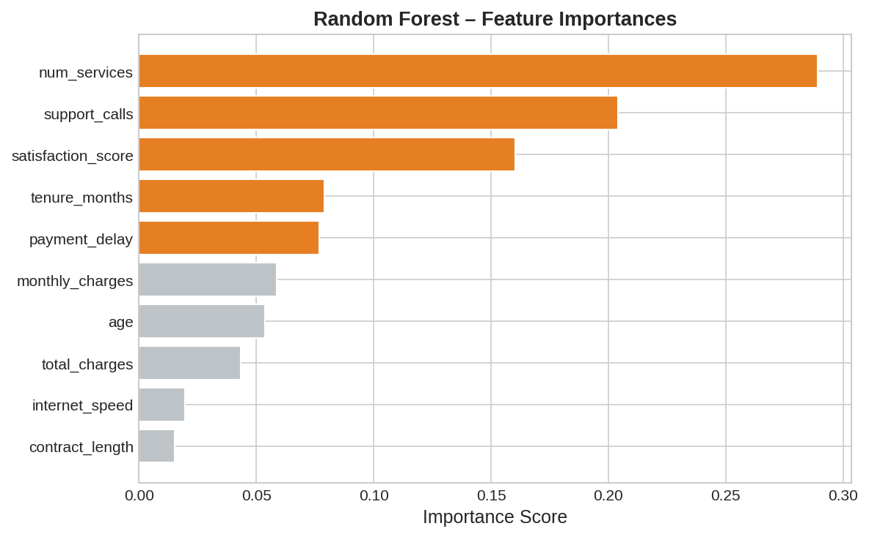
Figure 5: Random Forest feature importances. payment_delay, support_calls, and satisfaction_score are the most predictive features.

3.6 Cross-Validation Results

Metric | LR Mean | LR Std | RF Mean | RF Std
Accuracy | 0.9088 | 0.0281 | 0.9438 | 0.0190
Precision | 0.8543 | 0.0505 | 0.9585 | 0.0255
Recall | 0.8428 | 0.0667 | 0.8510 | 0.0567
F1 Score | 0.8473 | 0.0504 | 0.9005 | 0.0356
ROC-AUC | 0.9331 | 0.0314 | 0.9634 | 0.0257
Table 2: 5-fold cross-validation means and standard deviations. RF shows higher scores and lower variance.

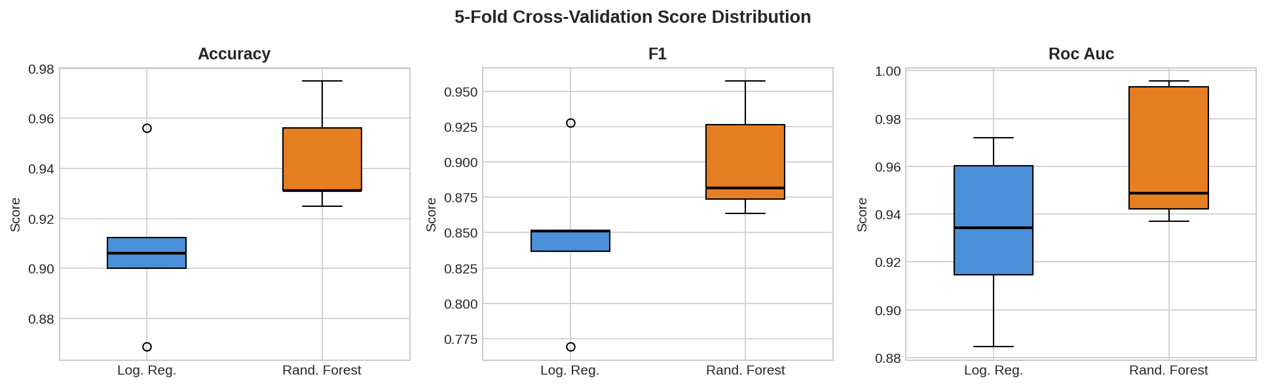
Figure 6: CV score distributions. RF is both higher and more consistent across folds.

4. Model Selection & Justification
Selected Model: Random Forest
Random Forest is the recommended production model based on the following evidence:
- Accuracy 0.955 vs 0.860 — 9.5 percentage points higher
- ROC-AUC 0.967 vs 0.904 — near-perfect discrimination of churn vs non-churn
- F1 Score 0.922 vs 0.778 — much better balance of precision and recall
- CV stability: RF std 0.036 F1 vs LR std 0.050 — more reliable on unseen data
- Precision 0.982 — extremely low false alarm rate (critical for targeted campaigns)
Logistic Regression remains useful as an interpretable baseline and when model transparency is required by stakeholders. Its ROC-AUC of 0.904 is still strong and it trains in milliseconds.

5. Conclusions
This project successfully built and evaluated two supervised classifiers for customer churn prediction:
- Both models achieved good predictive performance (ROC-AUC > 0.90)
- Random Forest substantially outperformed Logistic Regression across all five metrics
- Key churn drivers identified: payment_delay, support_calls, satisfaction_score
- Cross-validation confirmed RF's superior and consistent generalisation
For deployment, the Random Forest model should be retrained on the full dataset (train + test) and the classification threshold should be tuned based on the business cost of missed churners (false negatives) vs wasted retention spend (false positives).

6. Tools & References
- Python 3.10, scikit-learn 1.x, pandas, numpy, matplotlib, seaborn
- Pedregosa et al. (2011). Scikit-learn: Machine Learning in Python. JMLR 12, 2825-2830.
- Breiman, L. (2001). Random Forests. Machine Learning, 45(1), 5-32.
- GitHub Repository: [Insert link after pushing code]

