**HOTEL MANAGEMENT SYSTEM**

### **PREPARED FOR**

JEE Cloud Training Program

Capgemini Technology Services

### **PREPARED BY**

Avantika Singh

Bhrigu Garg

Saurabh Potdar

**Problem Statement:**

To design a hotel management system with various defined roles for the user and admin as well.

Description**:**

This project is aimed at developing Hotel Management System for user. This is a web based application that can be accessed throughout the web. This system can be used to add Hotel, add Room, add City and Customer can book a hotel. This is an integrated system that contains both the user component and the administration component.

Assumptions:

1. One City can have many hotels.
2. One Hotel can have many rooms.
3. One Room can have many bookings.
4. Customer can book one room at a time.

Validations:

1. The adhaar number should be of 12 digits.
2. Username should contain atleast 5 digits.
3. Password must be a strong password.
4. Phone number should be of 10 characters.
5. City name should be unique.

Scope**:**

Using the Hotel Management System, a user can make one booking at a time. The user can select a city and based on that user can select a hotel and the type of room and finally make a booking. The admin can add, update and delete city, hotel and room .

Out of Scope**:**

Customer cannot make more than one booking.

**Class and Methods Description:**

The application will consist of the following classes, the utility of which have been described below:

1. **Customer:** This class stores the details of Customer:

Attributes:

userId: String

userName: String

userEmail: String

userPhone: String

firstName: String

lastName: String

aadharNumber: String

roles: String

active: boolean

Methods: -

*register(): Register a new user*

*Validate if all field are valid and register the user.*

*logIn()*: User will login if credentials are correct.

*logOut()*: Removes all the session related information of a user.

makeBooking(checkInDate, checkOutDate, cityName):Will first show the user a list of available hotels and then the user can select the room.

cancelBooking():

The following methods will only be allowed for user type:

1. **Administrator**. :-

*addCity(City):* Adds a city.

*removeHotel(City):* Removes a City

*addHotel(Hotel):* Adds a hotel.

*removeHotel(Hotel):* Removes a hotel.

*updateHotel(Hotel):* Updates a hotel.

*addRoom(Room):* Adds a Room.

*updateRoom(Room):* Updates room

*deleteRoom(Room):* Deletes room

Sequence Diagram

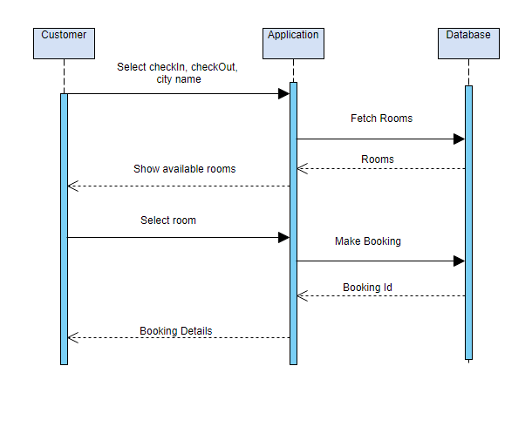

**Class Diagram**

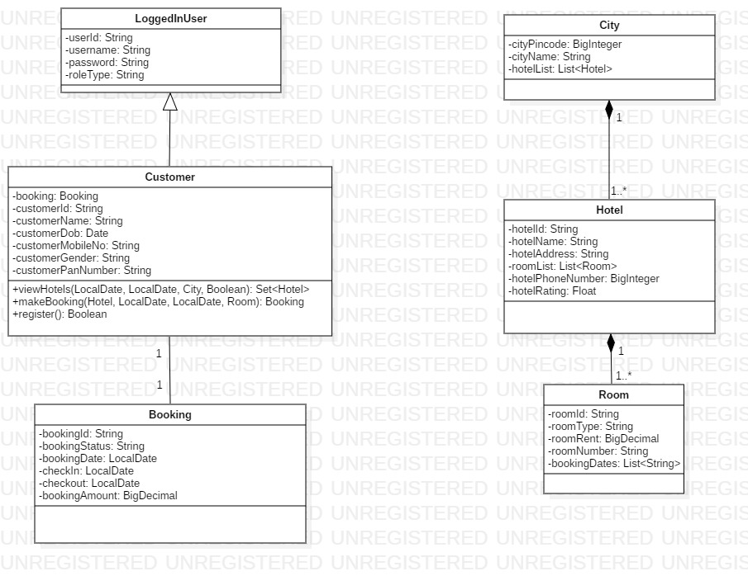

**ER Diagram**

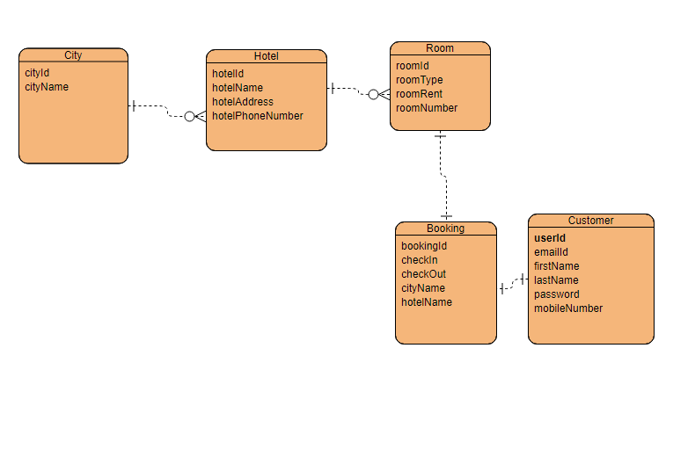

**Activity Diagram**

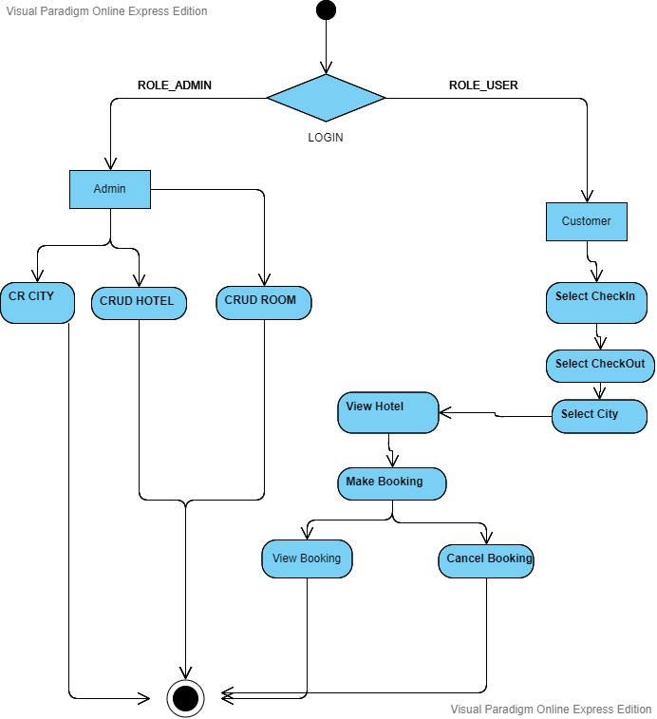

**Use Case**

