SRT411A0

Ivan (Avaplex)

2018-02-15

## GitHub Documents

This is an R Markdown format used for publishing markdown documents to GitHub. The R MarkDown File Generated for Github which include the result automatically is available at same repository “SRT411A0.md” <https://github.com/avaplex/srt411/blob/master/SRT411A0.md>

PDF File and HTML file also Available in this repository to Download

<https://github.com/avaplex/srt411/blob/master/SRT411A0.pdf>

<https://github.com/avaplex/srt411/blob/master/SRT411A0.html>

Note: HTML File should be download and open locally through your browser , you can only view the source inside the GitHub

This is an assignment from SRT411 which is for Introduction to R and Github. This assignment is base on the todo labs from PDF file named A very short introduction to R which can be download from <https://cran.r-project.org/doc/contrib/Torfs+Brauer-Short-R-Intro.pdf>

This info also available in README.md  
To see the resources please see the Resource Section

## R Markdown

This is an R Markdown document. Markdown is a simple formatting syntax for authoring HTML, PDF, and MS Word documents. For more details on using R Markdown see <http://rmarkdown.rstudio.com>.

When you click the **Knit** button a document will be generated that includes both content as well as the output of any embedded R code chunks within the document. You can embed an R code chunk like this:

## For Including Plots

You can also embed plots, without showingcode for example:  
```{r pressure, echo=FALSE}  
plot(pressure)  
```



## Steps for this Assignments: ( this is for windows but can use similar resources for MAC and Linux)

* Install the knitr with R Markdown in RTUDIO  
  install.packages("rmarkdown")
* Install miktex
* Download and Install pandoc
* Download and Install GitHub Git-2.16.1.4-64-bit.exe
* Download and install git through this link  
  <https://git-scm.com/downloads>  
  Git can also be downloaded from:  
  https://github.com/git-for-windows/git/releases/  
  Or any version that is suitable for your platform
* Set up your git email by typing git config --global user.email YOUR_EMAIL. Replace YOUR_EMAIL with an email account.
* Set up your git name by typing git config --global user.name YOUR_NAME. Replace YOUR_NAME with your full name, like John Smith.
* Setup a Github account and a new repository using same Email  
  <https://github.com/join>
* Create an SSH key in GitBash ( on you computer)  
  ssh-keygen -t rsa -b 4096 -C [your_email@example.com](mailto:your_email@example.com)
* Choose a Path and Pass phrase if necessary or just press enter to accept default  
  Ensure the ssh-agent is running: eval $(ssh-agent -s)
* Add SSH Private key to your agent  
  ssh-add ~/.ssh/id_rsa

You can see and read about adding the SSH key to your GitHub account using this link:  
https://help.github.com/articles/generating-a-new-ssh-key-and-adding-it-to-the-ssh-agent/

* Copies the contents of the id_rsa.pub file to your clipboard  
  clip < ~/.ssh/id_rsa.pub  
    
  Follow these steps in your github account  
  In the upper-right corner of any page, click your profile photo, then click Settings.  
  In the user settings sidebar, click SSH and GPG keys  
  Click New SSH key or Add SSH key  
  In the "Title" field, add a descriptive label for the new key. For example, if you're using a personal Mac, you might call this key "Personal MacBook Air".  
  Paste your ssh key  
  Click Add SSH key.   
  If prompted, confirm your GitHub password.  
  Source for this steps:  
  <https://help.github.com/articles/adding-a-new-ssh-key-to-your-github-account/>
* Creating a repository  
  MKDIR <Folder>  
  CD <folder>  
  git init
* To add a readme file for your git: git add README.md  
  check the git status: git status

When you make changes you can commit it using  
git commit -m "Initial version"  
to add all your file to git use: git add .  
to commit a file: git commit -m "Update README.md"  
  
to push a file / files to github

$ git remote add origin  
$ [git@github.com:YOUR_GITHUB_USERNAME/YOUR_GIT_REPO_NAME.git](mailto:git@github.com:YOUR_GITHUB_USERNAME/YOUR_GIT_REPO_NAME.git)  
$ git push -u origin master

* (more info available here ) <https://www.dataquest.io/blog/how-to-share-data-science-portfolio/>
* Now you have everything to do this project
* Create a new .Rmd file in your RStudio and answer the TODO sections in <https://cran.r-project.org/doc/contrib/Torfs+Brauer-Short-R-Intro.pdf>  
  Document , and the generate your RMD, MD, Write your Readme, and Generate your PDF or even World Document (As you see in follow) or HTML from your file

List of resources are available in Resource section

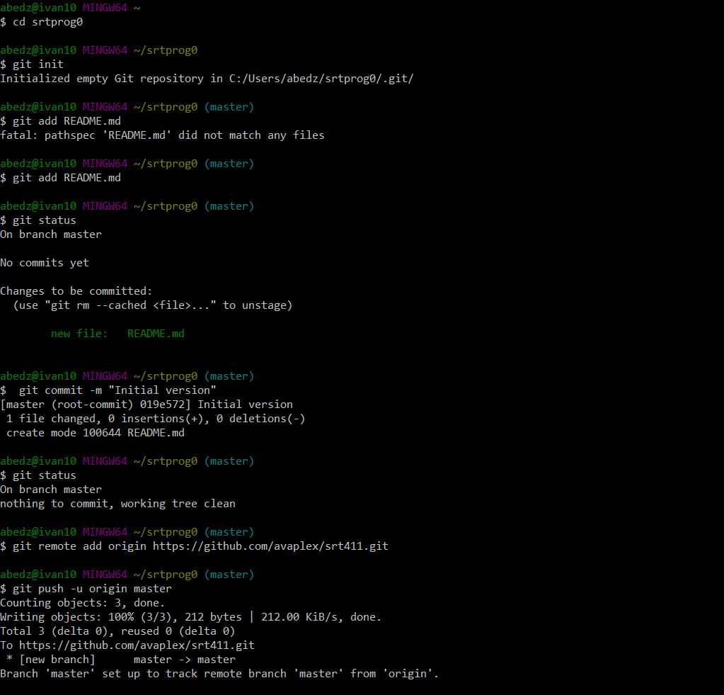

## 3.1 Calculator ToDo

Compute the difference between 2014 and the start year at this university and divide this by the difference between 2014 and the year you were born. Multiply this with 100 to get the percentage of your life you have spent at this university.

(2016-2014)/(2014-1978)*100

## [1] 5.555556

## 3.2 Workspace ToDo

Repeat the previous ToDo, but with several steps in between. You can give the variables any name you want, but the name has to start with a letter

seneca<-2016  
year<-1994  
born <-1978  
multip <-100  
(seneca - year)/(year-born)*multip

## [1] 137.5

## 3.4 Function ToDo

Compute the sum of 4, 5, 8 and 11 by ???rst combining them into a vector and then using the function sum.

td34<-c(4,5,8,11)  
sum(td34)

## [1] 28

## 3.5 Plots ToDo

Plot 100 normal random numbers.

td35<-rnorm(100,0,1)  
plot(td35)

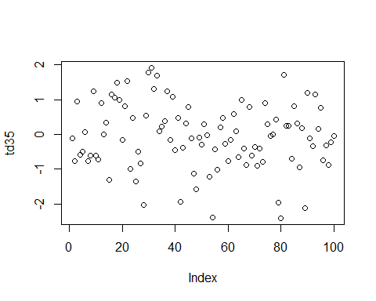

## 4 Help and documentation ToDo

Find help for the sqrt function.

help(sqrt)

## starting httpd help server ... done

## 5 Scripts ToDo

Make a ???le called firstscript.R containing Rcode that generates 100 random numbers and plots them, and run this script several times.

source("firstscript.R")

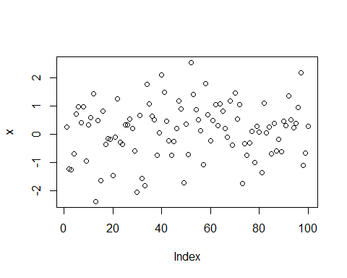

source("firstscript.R")

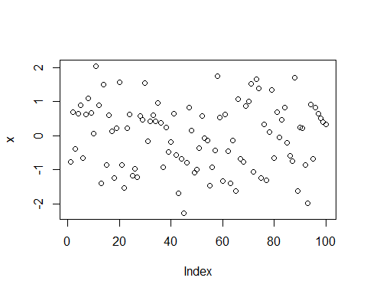

source("firstscript.R")

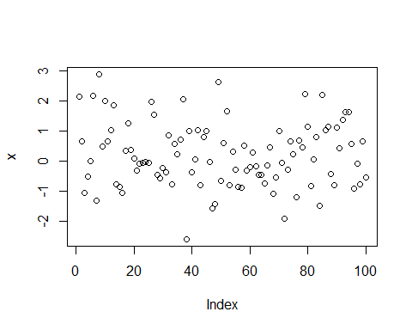

## 6.2 Matrices ToDo

Put the numbers 31 to 60 in a vector named P and in a matrix with 6 rows and 5 columns named Q. Tip: use the function seq. Look at the di???erent ways scalars, vectors and matrices are denoted in the workspace window

P=seq(from=31,to=60,by=1)  
Q=matrix(data=c(31:60),ncol = 5,nrow = 6)  
Q

## [,1] [,2] [,3] [,4] [,5]  
## [1,] 31 37 43 49 55  
## [2,] 32 38 44 50 56  
## [3,] 33 39 45 51 57  
## [4,] 34 40 46 52 58  
## [5,] 35 41 47 53 59  
## [6,] 36 42 48 54 60

## 6.3 Data Frames ToDo

Make a script ???le which constructs three random normal vectors of length 100. Call these vectors x1, x2 and x3. Make a data frame called t with three columns (called a, b and c) containing respectively x1, x1+x2 and x1+x2+x3. Call the following functions for this data frame: plot(t) and sd(t). Can you understand the results? Rerun this script a few times.

x1 = rnorm(100)  
x2 = rnorm(100)  
x3 = rnorm(100)  
t = data.frame(a=x1,b=x1+x2,c=x1+x2+x3)  
plot(t)

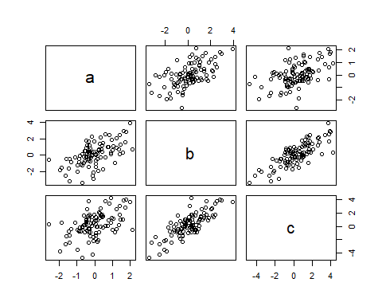

## 7 Graphics ToDo

Add these lines to the script ???le of the previous section. Try to ???nd out, either by experimenting or by using the help, what the meaning is of rgb, the last argument of rgb, lwd, pch, cex.

x1 = rnorm(100)  
x2 = rnorm(100)  
x3 = rnorm(100)  
t = data.frame(a=x1,b=x1+x2,c=x1+x2+x3)  
plot(t$a, type="l", ylim=range(t), lwd=3, col=rgb(1,0,0,0.3))   
lines(t$b, type="s", lwd=2, col=rgb(0.3,0.4,0.3,0.9))  
points(t$c, pch=20, cex=4, col=rgb(0,0,1,0.3))

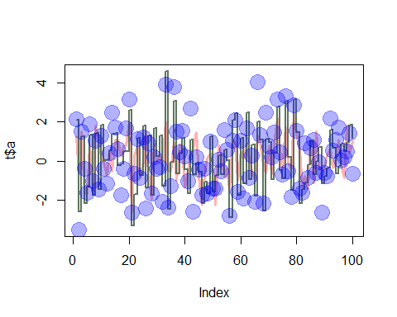

RGB: Red Green Blue value of color ( first 3 column are color intensity , and last is the color alfa work like transparency) Pch: S-compatible vector symbols , asci character, vector symbole, depend on value cex: character (or symbol) expansion: a numerical vector. This works as a multiple of par(“cex”). lwd: line width for drawing symbols see

## 8 Reading and writing data files ToDo

Make a ???le called tst1.txt in Notepad from the example in Figure 4 and store it in your working directory. Write a script to read it, to multiply the column called g by 5 and to store it as tst2.txt

d1<-read.table("tst1.txt",header=TRUE)  
d2<-data.frame(a=c(1,2,4,8,16,32),g=c(2,4,8,16,32,64),x=c(3,6,12,24,48,96))  
(d3<-d1*matrix(c(1,1,1,1,1,1,5,5,5,5,5,5,1,1,1,1,1,1)))

## a g x  
## 1 1 10 3  
## 2 2 20 6  
## 3 4 40 12  
## 4 8 30 24  
## 5 16 160 48  
## 6 32 320 96

write.table(d3,file="tst2.txt",row.names=FALSE)

## 8.1 Reading and writing data files ToDo

only storing the 2nd column in tst3.txt

d = read.table(file = "tst1.txt", header=TRUE)  
d1 = data.frame(a<-c(1,2,4,8,16,32),g<-c(2,4,8,16,32,64),x<-c(3,6,12,24,48,96))  
d2 <-d1$g*5  
write.table(d2, file = "tst3.txt",row.names=FALSE)  
d2

## [1] 10 20 40 80 160 320

## 9 Not Available data ToDo

Compute the mean of the square root of a vector of 100 random numbers. What happens?

td9 <- rnorm(100)  
#or td9<-c(rnorm(100))  
mean(sqrt(td9))

## Warning in sqrt(td9): NaNs produced

## [1] NaN

“NaNs produced”, some negative value is appear when generate 100 random number.To solve the problem, use script

## 10.2 Dates ToDo

Make a graph with on the x-axis: today, Sinterklaas 2014 and your next birthday and on the y-axis the number of presents you expect on each of these days. Tip: make two vectors ???rst

data1<-strptime(c("20180215","20141225","20180321"),format="%Y%m%d")  
data2=c(0,1,3)  
plot(data1,data2,xlab="Date",ylab="Presents",main="Presents I am expecting to receive")

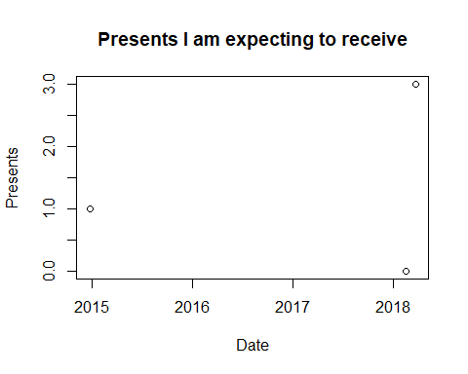

## 11.2 For-loop ToDo

Make a vector from 1 to 100. Make a for-loop which runs through the whole vector. Multiply the elements which are smaller than 5 and larger than 90 with 10 and the other elements with 0.1

h = seq(from=1,to=100)  
s = c()  
for(i in 1:100)  
 {  
 if (i<5 | i >90)  
 {  
 s[i]=h[i] * 10  
 }  
 else{  
 s[i]=h[i]*0.1  
 }  
}  
s

## [1] 10.0 20.0 30.0 40.0 0.5 0.6 0.7 0.8 0.9 1.0  
## [11] 1.1 1.2 1.3 1.4 1.5 1.6 1.7 1.8 1.9 2.0  
## [21] 2.1 2.2 2.3 2.4 2.5 2.6 2.7 2.8 2.9 3.0  
## [31] 3.1 3.2 3.3 3.4 3.5 3.6 3.7 3.8 3.9 4.0  
## [41] 4.1 4.2 4.3 4.4 4.5 4.6 4.7 4.8 4.9 5.0  
## [51] 5.1 5.2 5.3 5.4 5.5 5.6 5.7 5.8 5.9 6.0  
## [61] 6.1 6.2 6.3 6.4 6.5 6.6 6.7 6.8 6.9 7.0  
## [71] 7.1 7.2 7.3 7.4 7.5 7.6 7.7 7.8 7.9 8.0  
## [81] 8.1 8.2 8.3 8.4 8.5 8.6 8.7 8.8 8.9 9.0  
## [91] 910.0 920.0 930.0 940.0 950.0 960.0 970.0 980.0 990.0 1000.0

## 11.3 Writing your own function ToDo

Write a function for the previous ToDo, so that you can feed it any vector you like (as argument). Use a for-loop in the function to do the computation with each element. Use the standard R function length in the speci???cation of the counter. a)

k=1:10  
fun = function(arg1)  
{  
 l = length(arg1)  
 for(i in 1:l)  
 {  
 if (arg1[i] < 5 | arg1[i] > 90)  
 {  
 arg1[i] = arg1[i] * 10  
 } else  
 {  
 arg1[i] = arg1[i] * 0.1  
 }  
 }  
 return (arg1)  
}  
fun(arg1=k)

## [1] 10.0 20.0 30.0 40.0 0.5 0.6 0.7 0.8 0.9 1.0

## Resources:

resources for this poroject:

<https://rmarkdown.rstudio.com/>

<https://git-scm.com/downloads>

<https://nicercode.github.io/guides/reports/>

<http://kbroman.org/knitr_knutshell/pages/markdown.html>

<http://kbroman.org/knitr_knutshell/pages/Rmarkdown.html>

<https://cran.r-project.org/doc/contrib/Torfs+Brauer-Short-R-Intro.pdf>

<https://help.github.com/articles/adding-a-new-ssh-key-to-your-github-account/>

<https://www.dataquest.io/blog/how-to-share-data-science-portfolio/>

<https://www.rstudio.com/wp-content/uploads/2015/02/rmarkdown-cheatsheet.pdf>

<https://cran.r-project.org/doc/contrib/Torfs+Brauer-Short-R-Intro.pdf>