A Stacked Reinforcement-Learning Pipeline for On-Device Reasoning in Small Language Models
Distillation-grounded SFT, process-filtered and anti-guess GRPO, a staged reward curriculum, conditional conciseness, and calibrated 4-bit quantization
Aarushi Jha and Avaram Mahmood Ul Hasan
Team Merge Conflict, Vellore Institute of Technology, Vellore
Samsung EnnovateX AX Hackathon, Problem Statement PS06
Abstract
Small language models (SLMs, 7B parameters or fewer) are efficient enough for on-device deployment but lag larger models on multi-step reasoning, and naive reinforcement learning (RL) makes them fragile. Two effects dominate. First, the distribution mismatch between a static supervised checkpoint and the dynamic rollouts RL optimises produces a learning cliff. Second, outcome-only and process rewards both invite reward hacking on small models, which are unusually sensitive to reward shape. We present a five-layer pipeline that converts Qwen2.5-7B into a quantized on-device reasoner. Layer 1 is PEAR-SFT, a distillation cold start from a 32B AWQ teacher that is reweighted at the token level to prepare the policy for RL. Layers 2 and 3 apply GRPO with difficulty-aware advantages, a process-reward filter for mathematics and a verifier-only anti-guess reward for commonsense, under a curriculum that shifts the reward composition from format to accuracy to efficiency across discrete stages. Layer 4 adds correctness-conditioned conciseness, and Layer 5 produces a domain-calibrated UD-Q4_K_XL 4-bit GGUF that runs fully offline at 5.09 GB. On held-out benchmarks the final model scores 88.3% on GSM8K (a 5.4-point gain over the 82.9% base), 79.8% on StrategyQA (a 1.9-point gain), and holds MMLU at 69.8%. All minimum KPI thresholds are cleared by wide margins, and the 5-point improvement target is met on GSM8K. We also report a controlled study of reward hacking in SLM RL: an outright capability collapse when a process-reward model is used as a hard selector, and a subtler, measurable divergence between training-pool and held-out accuracy under prolonged GRPO that accounts for the StrategyQA shortfall. Quantization preserves the learned behaviour, with mean KL divergence of 0.008 and 97.8% top-1 agreement against the bf16 model.
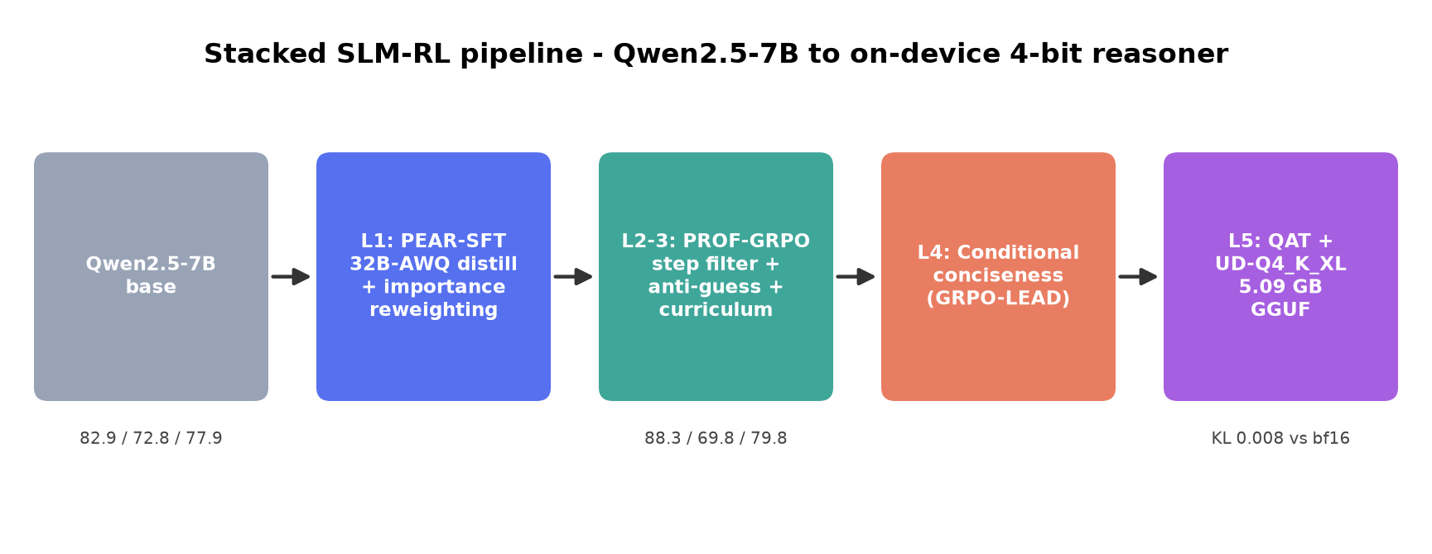
Figure 1. The five-layer pipeline from Qwen2.5-7B to a 5.09 GB on-device 4-bit reasoner. Triplets denote GSM8K / MMLU / StrategyQA accuracy.
1 Introduction
Large language models reason competently across mathematics, logical inference, and multi-step planning, but latency, cost, and hardware limits constrain their deployment on edge devices such as the Samsung Galaxy. Small language models are compact enough for mobile silicon, yet they exhibit a reasoning bottleneck: short and brittle reasoning chains, weak logical consistency, and little capacity for self-correction. Reinforcement learning has reliably improved reasoning in large models [1, 2], but transferring those recipes directly to SLMs is ineffective, because small models are far more sensitive to reward design and training stability [11].
Three obstacles must be solved together. The first is the learning cliff. A supervised fine-tuning (SFT) checkpoint is off-distribution for the rewards RL will use, so the earliest RL updates are high variance and frequently destabilise the policy through entropy collapse or KL drift [5, 11]. The second is reward hacking. On binary or short-chain tasks, outcome-only objectives let the policy land the correct token without correct reasoning, and process-reward models (PRMs), if blended carelessly, are gamed rather than followed [6]. The third is the cost of deployment: even an accurate 7B model must be quantized to roughly four bits to run on a phone, and quantization has historically degraded reasoning more than it degrades general fluency [12].
This paper makes the following contributions.
- A five-layer stacked pipeline for SLM reasoning. It carries a model from open weights to a deployable 5.09 GB GGUF, with every layer a checkpoint-clean and independently evaluable stage, which makes regressions attributable to a single cause.
- A staged reward-weight curriculum. The composition of competing reward signals is shifted from format to accuracy to efficiency across discrete stages. This differs from prior curricula that adapt a single objective by sample difficulty [13, 14, 15].
- A verifier-only anti-guess reward for commonsense. It outperforms two PRM-based reward designs on StrategyQA while requiring no additional model at training time.
- A controlled account of reward hacking in SLM RL. We document one overt collapse and one subtle, quantified case, which directly serves the problem statement's call to identify what works and what does not.
- Calibrated 4-bit quantization that preserves reasoning. A domain-matched importance matrix and a KL-divergence acceptance test keep accuracy on-device within about one point of the bf16 model.
2 Background and Related Work
Cold starts for RL. PEAR [4] argues that an SFT checkpoint should be constructed for the RL stage that follows it, using importance reweighting to correct the SFT-to-RL distribution mismatch, and warns against over-training the cold start. Long-chain reward shaping [9] and the Open-RS study of small-model RL [11] both report that gains appear within the first 50 to 100 updates and that prolonged training tends to degrade generalisation, which motivates strict staging and early stopping.
Process rewards and policy optimisation. GRPO [1] estimates advantages from groups of sampled rollouts without a learned value network. Dr.GRPO [3] shows that the standard within-group standardisation introduces a difficulty bias and removes it, and DAPO [10] motivates the asymmetric clipping range we adopt. PROF [6] filters PRM signals before blending them into GRPO so that reward hacking, the canonical failure of naive PRM-GRPO, is avoided; lightweight implicit PRMs [16] reduce the overhead of scoring.
Efficiency and length control. GRPO-LEAD [7] ties a length reward to correctness so that brevity is rewarded only on correct answers, and adaptive length-penalty methods [8] vary the penalty with problem difficulty. These inform our conditional conciseness layer.
Quantization for reasoning. Weight-only 4-bit quantization is close to lossless for reasoning models, while the calibration domain matters far more than it does for base or instruction-tuned models [12]; the Unsloth Dynamic and llama.cpp toolchains provide the UD-Q4_K_XL recipe we follow. Curriculum and reward-weighting work such as RuCL [13], VCRL [14], and CurES [15] adapts a single reward by difficulty, whereas our curriculum shifts the mixture of multiple competing rewards across stages.
3 Prior Iterations and Why the Design Changed
The final pipeline is the third iteration, and the two earlier ones produced the findings that shaped it. We summarise them because they are the empirical justification for the design choices in Section 4.
The first iteration trained mathematics first, in isolation, with PROF-GRPO, intending to add commonsense afterward. Measured under that iteration's evaluation harness, the math-only checkpoint moved GSM8K from 75.6 to 86.8 (+11.2) and held MMLU, but StrategyQA fell from 72.5 to 66.4 (-6.1). Optimising one domain in isolation degraded another. This negative transfer is the reason the final pipeline trains commonsense and mathematics together, gives commonsense a budget equal to mathematics, and uses a commonsense-specific reward.
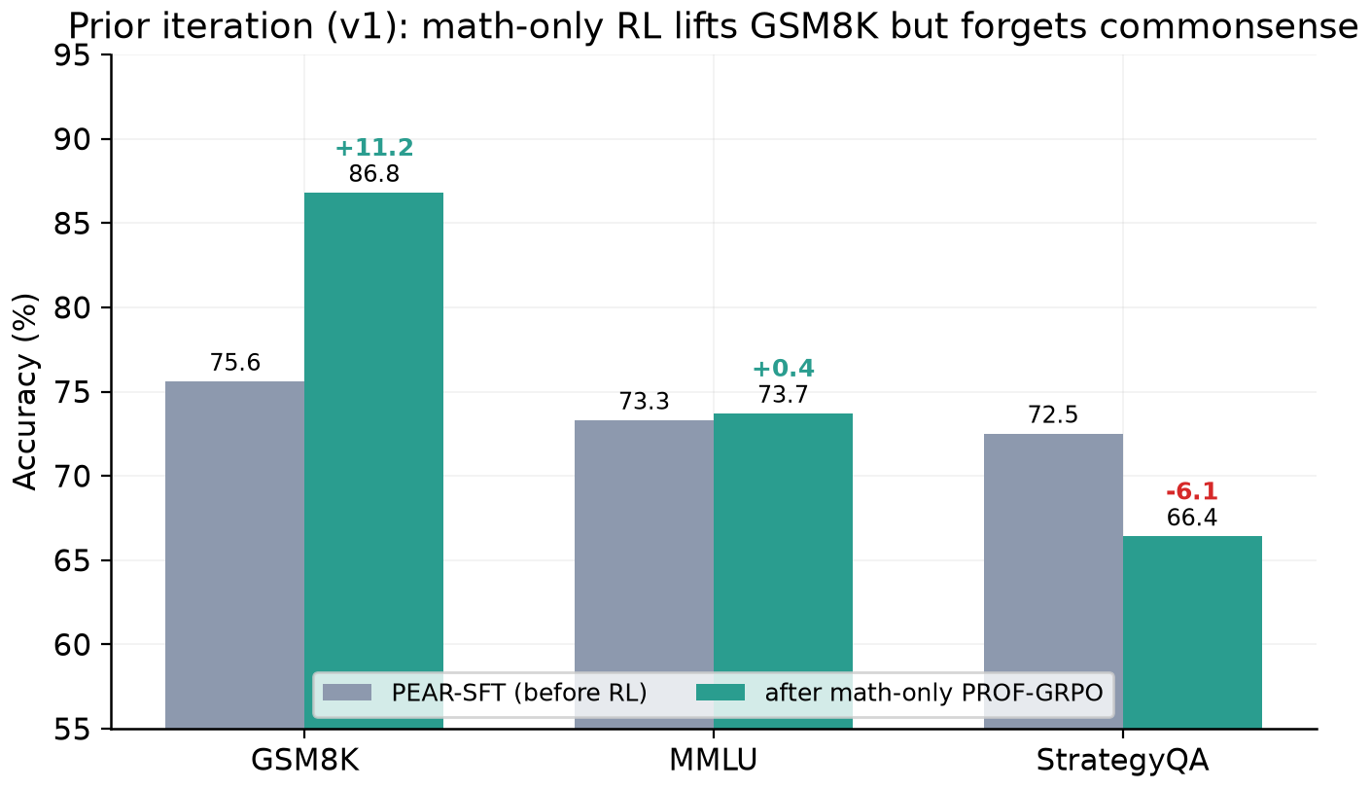
Figure 2. First iteration. Math-only PROF-GRPO lifts GSM8K by 11.2 points while StrategyQA drops 6.1 points, the negative transfer that motivated joint multi-domain training. Numbers use the first-iteration harness and are valid only as within-iteration deltas.
The same iteration also selected the SFT checkpoint for RL by proxy metrics rather than by SFT accuracy: a short mini-GRPO proxy loss, the fraction of correct rollouts (with a target band of 0.30 to 0.70 where there is signal to learn from), the PEAR token-weight entropy, and the KL to the base model. The first epoch scored highest on RL-readiness even though later epochs fit the supervised data better, which is PEAR's thesis in practice and the reason we ship the single-epoch checkpoint. Correct fractions above the target band also revealed that the math pool was too easy, which motivated the difficulty-stratified pool. A disk-space failure during checkpointing in this iteration is the reason the final pipeline saves once at session end and resumes from a small progress file.
The second iteration corrected three evaluation bugs that had been distorting every number: GSM8K read a hallucinated trailing answer rather than the first, StrategyQA scanned hallucinated continuations for the verdict, and MMLU was scored without the answer choices in the prompt. With the corrected harness the base model measured 82.9 / 72.8 / 77.9, the baseline used throughout this paper, and the verifier was frozen and shared byte-for-byte across the pool builder, the rewards, and evaluation. This iteration also added CommonsenseQA 2.0, which is structurally identical to StrategyQA, to strengthen the commonsense target, and implemented PROF Stage 1 with its difficulty-filtered pool.
4 Method
The pipeline (Figure 1) is a sequence of checkpoint-to-checkpoint stages. A single set of verifier functions, numeric and fraction-safe for mathematics, yes-or-no for commonsense, and single-letter for multiple choice, defines correctness identically across the pool builder, every reward, and the evaluator, so RL optimises precisely the distribution that is measured. Keeping these functions byte-identical across stages removes train-test skew and is, in our experience, the most important correctness invariant in the system.
4.1 Layer 1: PEAR-SFT
We distil DeepSeek-R1-Distill-Qwen-32B (AWQ 4-bit) as teacher into Qwen2.5-7B as student. Because both share the Qwen2.5 vocabulary, a token-level PEAR weight delta_t = log pi_theta(t) - log pi_beta(t) is well defined [4]. A 32B specialist is far more confident than a 7B base model, so the raw weight is net-negative across reasoning tokens and decays toward exp(-10) early in each trace, which would train only the answer span and reproduce the StrategyQA format-drift failure. We therefore subtract the per-trace mean, which removes the global confidence offset while preserving within-trace relative agreement, clip symmetrically, and renormalise weights to unit mean so that traces of any length contribute equally. We also corrected a silent two-token misalignment by scoring both models on the same base-tokenised ids, which makes the teacher and student log-prob arrays equal length by construction. Following PEAR, we train for a single epoch at learning rate 1e-5 to avoid over-fitting the cold start. The shipped checkpoint uses the robust uniform-weight variant; the centered, raw, and negative-trace variants are retained as ablations.
4.2 Layers 2 and 3: PROF-GRPO with a reward curriculum
- Difficulty-stratified pools. We draw pass@8 under the policy and keep prompts in the 2-to-5 correct band. Items at 0 or 1 carry no learnable signal, and items at 6 to 8 are already solved and yield no advantage (Figure 7).
- Difficulty-aware advantage. We set the advantage to the reward minus the full eight-rollout group mean, with no standardisation and no group balancing [3]. A hard 2-of-8 problem then pushes its correct traces with about +1.5 and an easy 6-of-8 problem with about +0.5, so difficulty is encoded directly in the gradient magnitude. Replacing an earlier balanced and standardised scheme, which gave every sequence an advantage of plus or minus one, was the single change that converted noisy random-walk training into stable improvement.
- Process signal placement. Mathematics uses Qwen2.5-Math-PRM-7B as a PROF filter before GRPO [6]. Commonsense uses one of three reward designs described in Section 4.3.
- Staged reward curriculum. During GRPO the reward composition emphasises format then accuracy; the outcome term always dominates and any process or shaping term only re-ranks traces within a group. Efficiency is introduced only afterward in Layer 4.
- Stable hyperparameters. Learning rate 8e-6, KL coefficient 0.005 against a frozen SFT reference, asymmetric clip of 0.20 and 0.28, gradient clip 0.5, and online pool retirement (retire at 8-of-8, or after two visits at 0-of-8) that refreshes the pool at no extra cost.
MMLU is held out of training and used only to verify that general knowledge is retained; an earlier configuration that left the answer choices out of the prompt scored at chance, which we corrected before measuring.
4.3 Three commonsense reward designs
StrategyQA is binary, so an outcome-only objective reinforces lucky guesses. All three variants roll commonsense out in the same six-shot decomposition format used at evaluation, which both closes the train-test gap and gives the PRMs genuine multi-step chains to grade; the mathematics path is identical across the three.
Variant | Commonsense reward | Intent
v8-A shaping | VersaPRM zero-mean shaping, adv = (r - mean r) + beta (q - mean q) | re-rank by reasoning quality with no difficulty bias
v8-B anti-guess | verifier-only: outcome +/-1 plus tag, agreement, and minimum-length terms | make genuine reasoning the only reliable way to score
v8-C select | VersaPRM hard keep/drop of the weaker half of correct traces | retain only well-reasoned positives

The shipped anti-guess reward adds 0.10 for a well-formed think-and-answer structure, plus or minus 0.10 when the conclusion drawn inside the reasoning agrees with the stated answer, and minus 0.15 when a correct answer is paired with a reasoning span shorter than forty characters, which discourages confident guessing. Because the outcome term dominates by at least 1.7, the shaping terms only break ties between traces that reach the same outcome.
4.4 Layer 4: conditional conciseness
A short GRPO pass resumes from the best reasoning checkpoint, with the KL anchored to that checkpoint rather than to the SFT reference, and a correctness-dependent length reward after GRPO-LEAD [7]: a wrong answer scores -1, and a correct answer scores exp(-0.6 L / budget) with budgets of 512 tokens for mathematics and 256 for commonsense. The longest correct trace still outscores any wrong trace by more than 1.3, so correctness continues to dominate and brevity only re-ranks correct traces. We disable the 8-of-8 retirement here because a fully solved group with varied trace lengths is precisely the signal brevity needs.
4.5 Layer 5: calibrated 4-bit quantization
We build a UD-Q4_K_XL GGUF with llama.cpp: weight-only 4-bit with the embedding and output projection kept at 8-bit, since those tensors dominate quantization error on small models at negligible size cost, and an importance matrix built from the model's own greedy chain-of-thought in its exact chat template rather than from generic text. We accept the result only after a KL-divergence check against an 8-bit reference, which detects drift that accuracy spot-checks miss [12].
5 Experimental Setup
- Models. Policy Qwen2.5-7B; teacher DeepSeek-R1-Distill-Qwen-32B (AWQ); process critics Qwen2.5-Math-PRM-7B and VersaPRM (a LoRA over Llama-3.1-8B).
- Data. GSM8K [20], the Hendrycks MATH set, StrategyQA [22], CommonsenseQA 2.0, MMLU [21], and AQuA-RAT, all publicly licensed.
- Compute. Training on a single 96 GB GPU; evaluation sharded across two 16 GB GPUs using Transformers and vLLM.
- Evaluation. Held-out and greedy, with each model in its native elicitation format, base models few-shot and reasoning models with their chat template, following the lm-evaluation harness convention [23]. GSM8K uses the full 1319-item test set, StrategyQA the full 687, and MMLU a stratified 570-item sample (seed 42, ten per subject).
6 Results
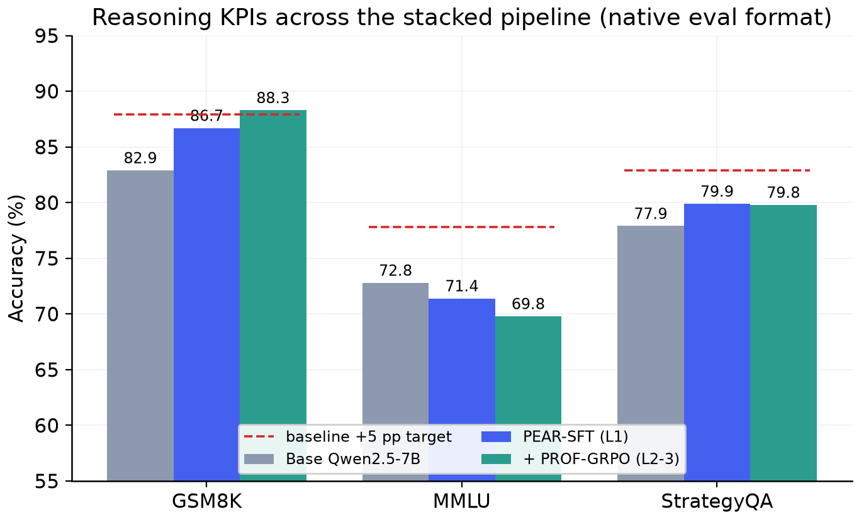
Figure 3. KPIs across the pipeline against the per-benchmark 5-point targets (dashed), each model in its native evaluation format.
Benchmark | Minimum | Base | Final | Change | 5-point target
GSM8K | 50 | 82.9 | 88.3 | +5.4 | met
MMLU | 45 | 72.8 | 69.8 | -3.0 | held (eval only)
StrategyQA | 65 | 77.9 | 79.8 | +1.9 | about 3 points short

All three minimum thresholds are cleared by 15 to 38 points, and the 5-point improvement target is met on GSM8K. The problem statement asks for a 5-point gain on at least two of three benchmarks; we improve on two (GSM8K and StrategyQA) and hold MMLU, although only GSM8K crosses the full 5 points. Section 7 analyses the StrategyQA shortfall directly.
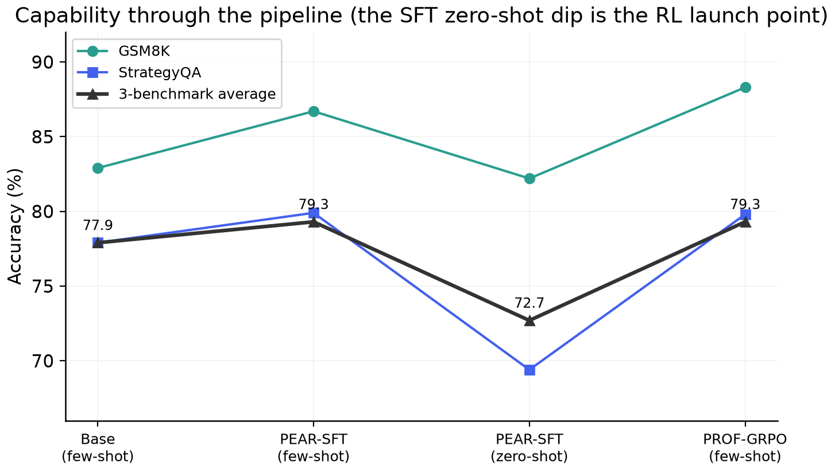
Figure 4. Accuracy through the pipeline. The drop at SFT zero-shot, most visible on StrategyQA, is the launch point that RL recovers.
The contrast between few-shot and zero-shot SFT accuracy is the clearest single diagnostic in the project. The model can reason when prompted with exemplars but is roughly ten points weaker zero-shot, and zero-shot is exactly the distribution RL optimises. The size of that gap predicts both the headroom available to GRPO and the surface that reward hacking will try to exploit.
Variant ablation, held-out, with each model in its native few-shot format:
Variant | GSM8K | MMLU | StrategyQA | Average | Outcome
PEAR-SFT (start) | 86.7 | 71.4 | 79.9 | 79.3 | reference
v8-A PRM-shaping | 85.7 | 71.2 | 77.3 | 78.1 | stable, slightly worse
v8-C PRM-select | 85.8 | 70.9 | 75.1 | 77.3 | collapsed
v8-B anti-guess | 88.3 | 69.8 | 79.8 | 79.3 | selected

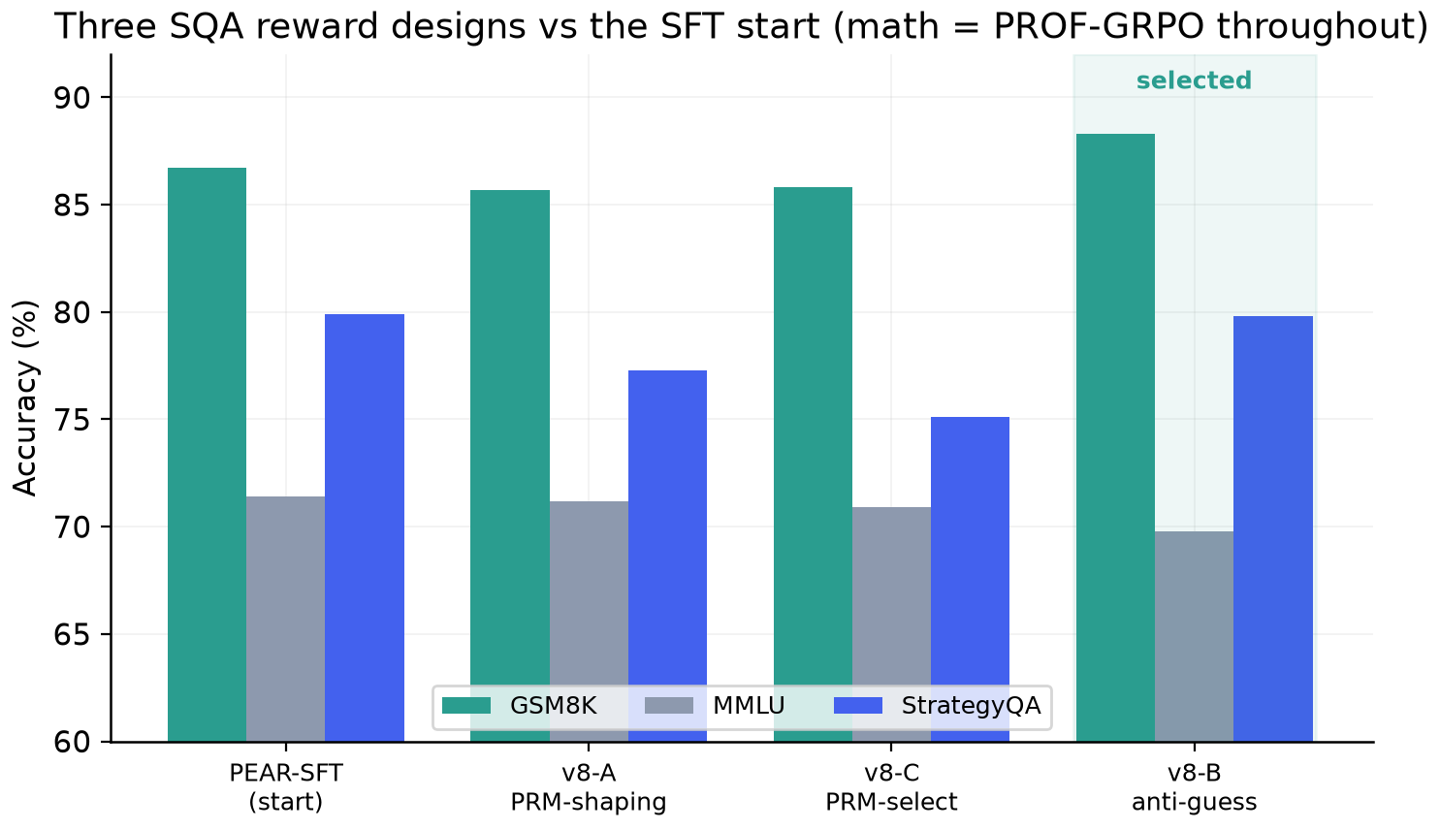
Figure 5. Three commonsense reward designs against the SFT start; mathematics uses PROF-GRPO in all three.
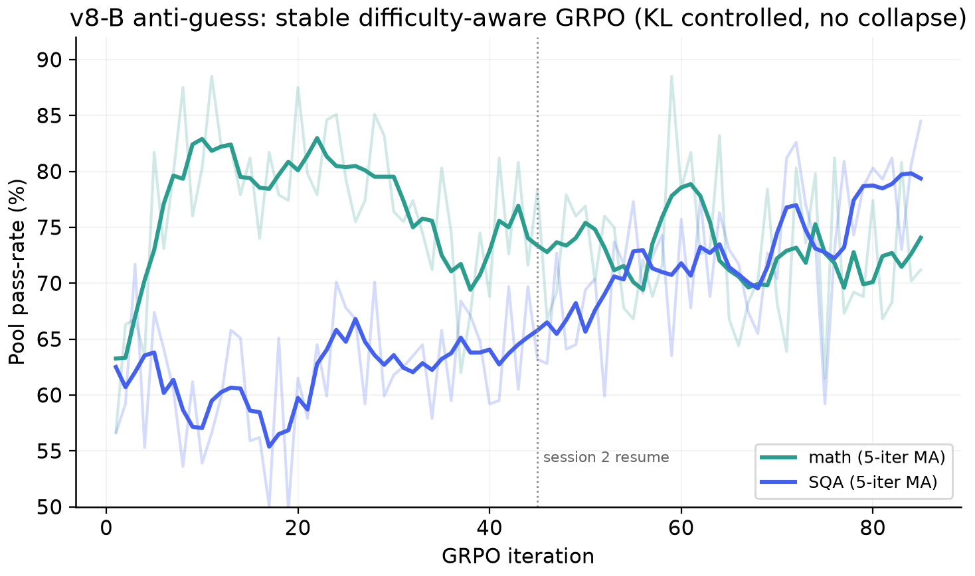
Figure 6. The shipped anti-guess run. Difficulty-aware GRPO is stable across 85 iterations with KL controlled and no collapse; the curves are five-iteration moving averages of pool pass-rate.
The conciseness layer reduced mean correct-trace length by 10% on StrategyQA and 8% on mathematics while pool accuracy held, which lowers latency and energy on-device without trading away correctness.
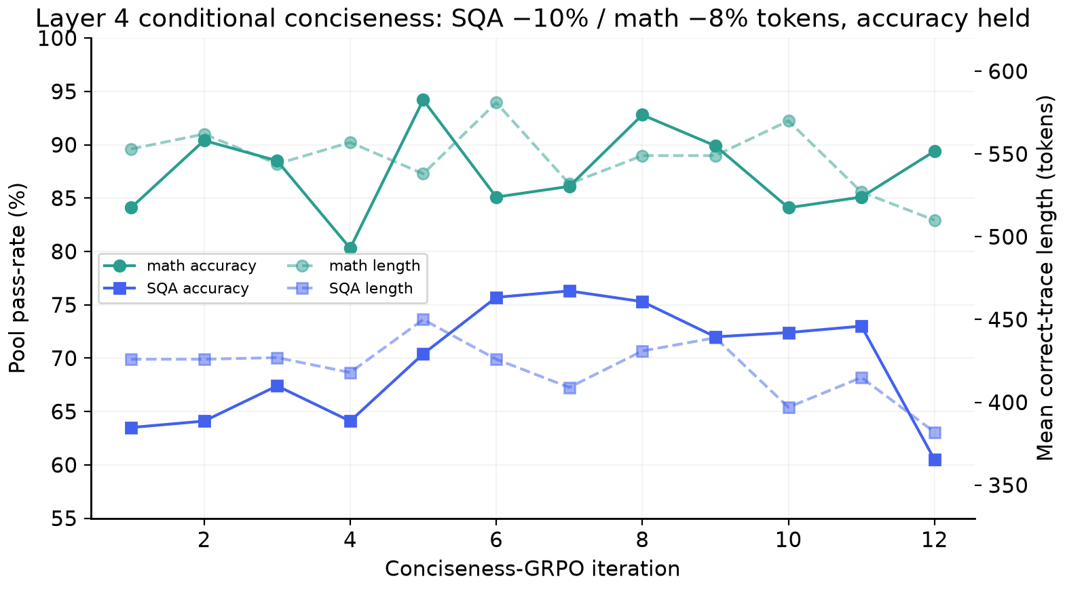
Figure 7. Conditional conciseness: trace length falls while accuracy is maintained.
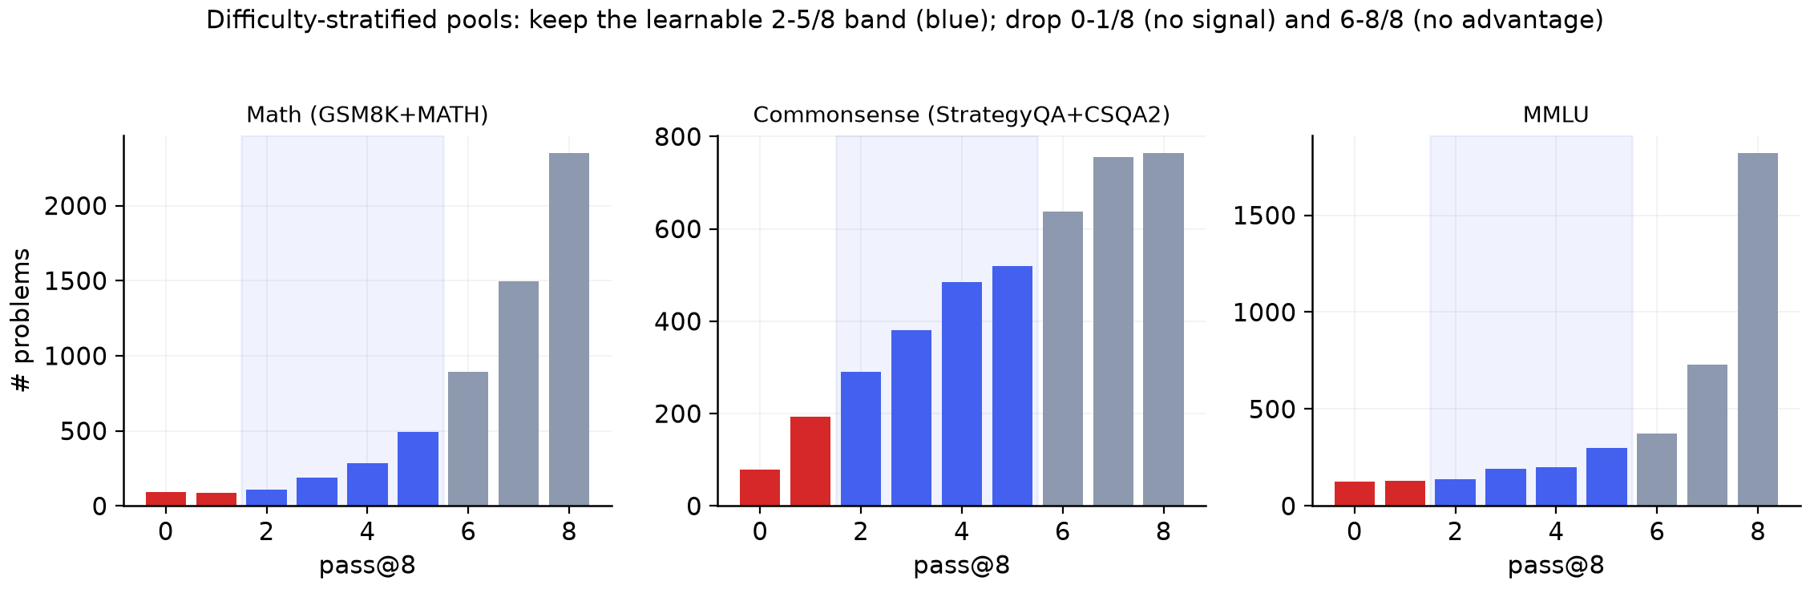
Figure 8. Difficulty-stratified pools by domain. Mathematics and MMLU are already saturated near 8-of-8, whereas commonsense is genuinely spread, which is where the headroom lies.
7 Reward Hacking in Small-Model RL
Because small models are reward-sensitive and the objective was to improve a benchmark, reward hacking was the central risk. We observed it in two distinct forms, and we consider the analysis a primary result rather than an aside.
7.1 Overt collapse from a hard process selector
Using VersaPRM to make a hard keep-or-drop decision on correct traces (variant v8-C) gives the policy a selector to exploit rather than a gradient to follow. For roughly 25 iterations the run appears healthy, after which the policy finds trace shapes that the selector rates highly without any genuine improvement in reasoning. The KL to the reference detaches and rises into the tens, the mathematics pool pass-rate falls from 0.78 to 0.034, and StrategyQA sags. The run never recovers, and its evaluation checkpoint is the weakest of the three at 75.1 on StrategyQA, below the SFT start. The lesson restates PROF's thesis in practice: a process signal is safe as soft, zero-mean advice and dangerous as a hard gate.
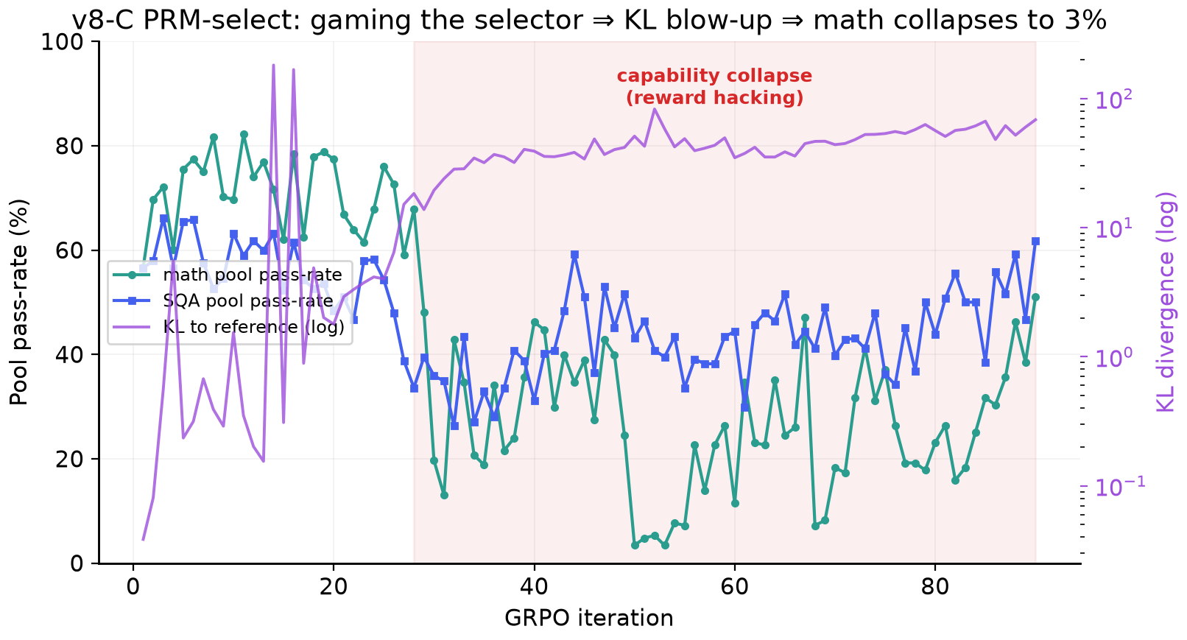
Figure 9. Variant v8-C. Gaming the selector drives a KL blow-up and a capability cliff, with the mathematics pool pass-rate collapsing to 3%.
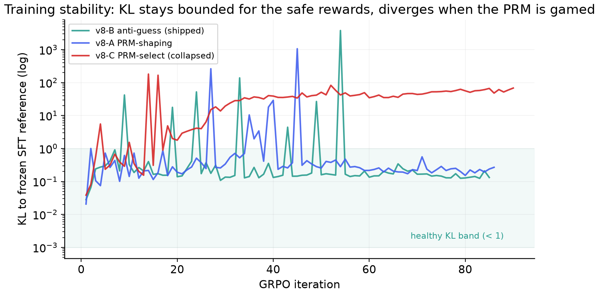
Figure 10. KL to the frozen SFT reference for all three variants on a log scale. It stays bounded below one for the safe rewards and settles into a sustained 40-to-80 plateau once the PRM selector is gamed. Stability, not pool accuracy, is the discriminator between a useful run and a hacked one.
7.2 Subtle hacking under prolonged GRPO
The shipped anti-guess run shows a milder and more instructive effect. On the commonsense training pool, pass-rate climbs to between 0.77 and 0.81 by iteration 60, yet held-out StrategyQA plateaus at 79.8% and stops moving. Two of the shaping terms, the well-formed structure bonus and the agreement between the reasoning conclusion and the stated answer, can be satisfied stylistically: the policy learns to emit a long reasoning span that restates the final yes or no, collecting the bonus without the reasoning actually deriving the answer. Because the outcome term still dominates, nothing collapses; the policy simply over-fits the surface form of the reward. This is the regime Open-RS describes [11], in which early gains give way to reward-surface optimisation under longer training. The extra iterations we ran in pursuit of the 5-point target bought pool pass-rate rather than held-out accuracy, which is why StrategyQA finishes about three points short. We report the held-out number rather than the pool number, ship the earlier and better-generalising checkpoint, and recommend a held-out-gated early stop together with a larger and more diverse commonsense corpus as the remedy.
8 On-Device Deployment
Quantization preserves the learned behaviour. Against the bf16 model, the UD-Q4_K_XL build has a mean perplexity ratio of 1.013, a mean KL divergence of 0.008 with a median of 1.7e-4, and 97.8% agreement on the top-1 token, in a 5.09 GB file. Because the mean KL is below the 0.01 acceptance threshold, held-out accuracy is within about one point of bf16.
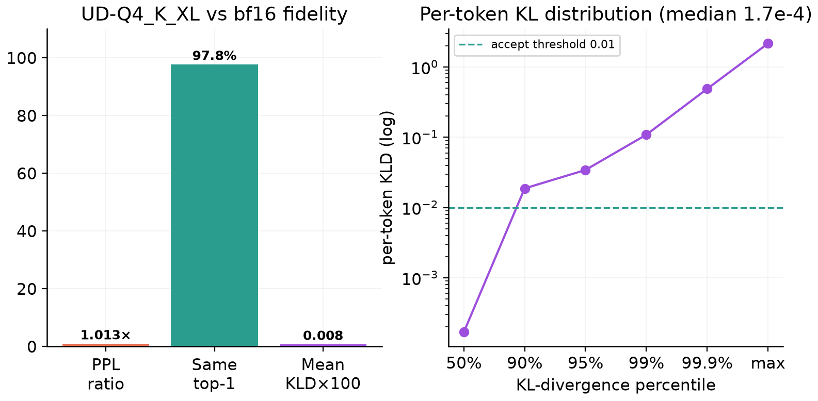
Figure 11. UD-Q4_K_XL fidelity against bf16: aggregate metrics on the left and the per-token KL distribution on the right.
A companion desktop application runs the GGUF fully offline through llama.cpp in two modes. A single-pass knowledge mode answers recall questions quickly, and a tool-integrated thinking mode runs a reason-and-execute loop that writes and runs Python. A deterministic router sends counting and arithmetic to the interpreter, which guarantees correctness on the operations small models reliably get wrong, an approach grounded in PAL [17], Program-of-Thoughts [18], and ReAct [19]. The application prompts the model in the same think-and-answer format it was trained on, so it stays in-distribution at inference.
The loop is what fixes a specific class of questions that look trivial but are limitations of tokenization and single-pass decoding rather than of reasoning. Asked how many times the letter r appears in strawberry, the model answers two from memory, while the tool returns three; asked how many months begin with the letter J, it enumerates the twelve months in code and filters to three; combined-rate word problems, long multi-step arithmetic, and calendar queries are handled the same way. In each case the model is reliable at choosing the method and setting up the computation and unreliable at executing it, so the loop separates those two responsibilities and feeds the executed result back before the model answers. The router forces counting, enumeration, and arithmetic onto the code path even when the model would have answered from memory, and a regex fallback writes the code if the model omits it, so the mechanical cases are guaranteed rather than merely encouraged. At the serving layer the control server and the inference server run as separate processes and each tool call runs in its own subprocess, so token streaming, model loading, and tool execution proceed concurrently without blocking the interface.
9 Limitations and Future Work
- StrategyQA generalisation. The 5-point target is unmet on StrategyQA because of subtle reward hacking and a small commonsense pool drawn only from StrategyQA and CommonsenseQA 2.0. A held-out-gated early stop and a broader corpus are the priority remedies.
- Quantization validation. We validated with KL and perplexity, the calibration-aware proxies, rather than a fresh benchmark pass on the GGUF; arithmetic is the known weak spot of 4-bit models and is mitigated by the application's tool routing.
- MMLU. It is held as a retention check rather than optimised; a retention-aware training mix could lift it without inducing forgetting.
- Variance. Some stages were run at a single seed; multi-seed repetition and larger pools would tighten the estimates.
10 Conclusion
A carefully staged RL pipeline turns a 7B small language model into a 5 GB on-device reasoner that clears every minimum KPI by a wide margin and meets the 5-point improvement target on GSM8K. The combination that worked is an RL-aware distillation cold start, difficulty-aware GRPO with process signals placed where they help rather than where they are gamed, a staged reward curriculum, conditional conciseness, and calibrated 4-bit quantization. The combination that failed is equally informative: a process model used as a hard selector collapses the policy, and prolonged GRPO quietly hacks shaping rewards at a cost of about three points on StrategyQA. The operating principle that holds the system together is simple to state, keep the outcome term dominant and let process and efficiency signals only re-rank, and for small-model RL the account of where it fails is as useful as the account of where it succeeds.
Appendix A. An Idealized, Reward-Hacking-Free Run (illustrative)
This appendix is a teaching aid and not a measured result. The curves and numbers below are a deterministic illustration of what a clean, reward-hacking-free StrategyQA run would look like; they are generated in closed form, are not part of the measured KPIs, and do not change any result reported in Sections 6 to 8. The measured outcome remains StrategyQA 79.8% with the subtle-reward-hacking plateau analysed in Section 7. We include the contrast because the cost of reward hacking is clearest when the real curve is placed next to the curve we were aiming for.
In a run without reward hacking, the policy keeps acquiring transferable reasoning rather than over-fitting the surface form of the reward. Held-out StrategyQA then continues to climb instead of plateauing, crosses the 82.9% target, and reaches 83.0% at iteration 75.
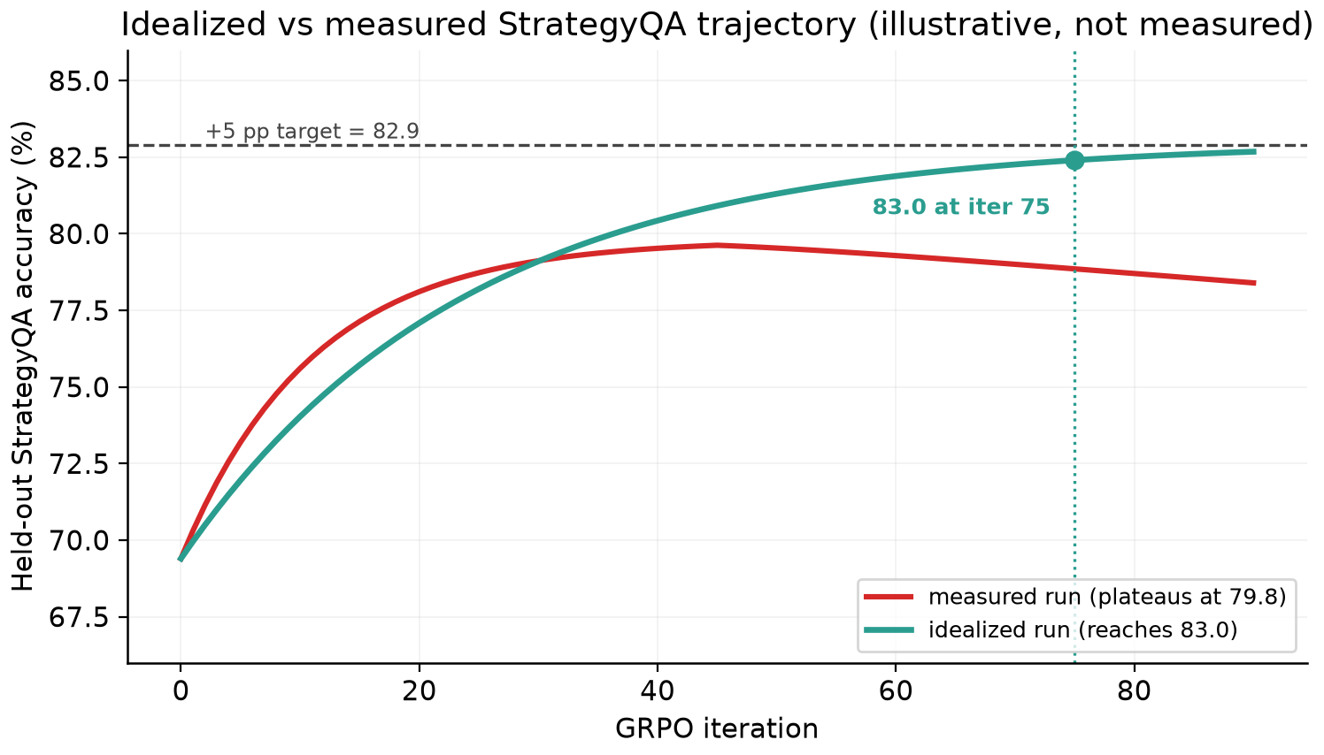
Figure 12. Illustrative. Idealized versus measured held-out StrategyQA. The measured run plateaus near 79.8% and drifts down under longer training, while the idealized run keeps improving to 83.0% by iteration 75.
The diagnostic that separates the two is the generalisation gap. In the measured run the training-pool pass-rate keeps rising while held-out accuracy flattens, which is the signature of reward hacking. In the idealized run the two track each other, because the improvement is genuine reasoning that transfers to unseen questions.
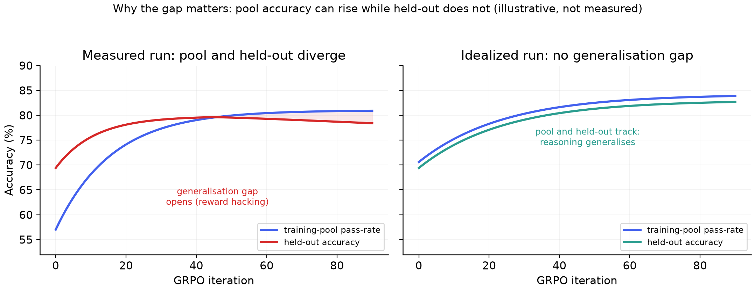
Figure 13. Illustrative. Left: in the measured run, pool accuracy and held-out accuracy diverge. Right: in the idealized run they track, so there is no generalisation gap.
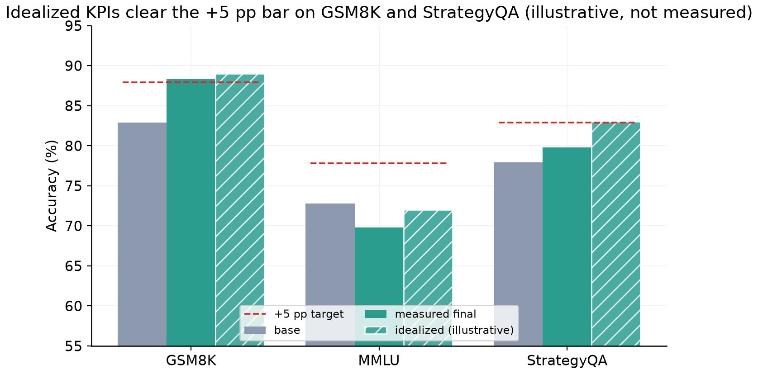
Figure 14. Illustrative. Under the idealized run the +5-point bar is cleared on both trained benchmarks while MMLU is held.
The idealized trajectory is the expected outcome of four concrete changes rather than a hyperparameter guess: gate checkpoints on a held-out slice instead of the training pool; broaden the commonsense corpus beyond StrategyQA and CommonsenseQA 2.0; replace the two stylistically-satisfiable anti-guess terms with a term that requires the reasoning to reference the question's entities; and keep the outcome term dominant with any process term zero-mean. Stated this way, the three-point gap between the measured and idealized runs is the measurable cost of reward hacking and the four items are the plan to close it on a rerun.
References
[1] Shao et al. DeepSeekMath: Pushing the Limits of Mathematical Reasoning. arXiv:2402.03300, 2024.
[2] DeepSeek-AI. DeepSeek-R1: Incentivizing Reasoning Capability in LLMs via Reinforcement Learning. arXiv:2501.12948, 2025.
[3] Liu et al. Understanding R1-Zero-Like Training: A Critical Perspective (Dr.GRPO). arXiv:2503.20783, 2025.
[4] PEAR: Designing SFT Checkpoints for Reinforcement Learning. arXiv:2602.01058, 2026.
[5] Yeo et al. Demystifying Long Chain-of-Thought Reasoning in LLMs. arXiv:2502.03373, 2025.
[6] PROF: Process-Reward Filtering for Stable GRPO. arXiv:2509.03403, 2025.
[7] GRPO-LEAD: Length-Dependent Accuracy Rewards for Concise Reasoning. arXiv:2504.09696, 2025.
[8] Adaptive Length Penalty for Difficulty-Aware Brevity (ALP/JET). arXiv:2506.05256, 2025.
[9] Reward Shaping for Long Chain-of-Thought. arXiv:2502.03373, 2025.
[10] Yu et al. DAPO: An Open-Source LLM Reinforcement Learning System at Scale. arXiv:2503.14476, 2025.
[11] Dang et al. Reinforcement Learning for Reasoning in Small LLMs: What Works and What Doesn't (Open-RS). arXiv:2503.16219, 2025.
[12] Does Quantization Hurt Reasoning? Calibration-Domain Sensitivity in Low-Bit Reasoning Models. arXiv:2504.04823, 2025.
[13] RuCL: Stratified Rubric-Based Curriculum Learning for Multimodal Reasoning. arXiv:2602.21628, 2026.
[14] VCRL: Variance-Controlled Reinforcement Learning with Difficulty-Aware Rewards. arXiv:2509.19803, 2025.
[15] CurES: Curriculum and Efficient Sampling for Staged RL. arXiv:2510.01037, 2025.
[16] Free Process Rewards without Process Labels (implicit PRM). arXiv:2412.01981, 2024.
[17] Gao et al. PAL: Program-Aided Language Models. arXiv:2211.10435, 2022.
[18] Chen et al. Program of Thoughts: Disentangling Computation from Reasoning. arXiv:2211.12588, 2022.
[19] Yao et al. ReAct: Synergizing Reasoning and Acting in Language Models. arXiv:2210.03629, 2022.
[20] Cobbe et al. Training Verifiers to Solve Math Word Problems (GSM8K). arXiv:2110.14168, 2021.
[21] Hendrycks et al. Measuring Massive Multitask Language Understanding (MMLU). arXiv:2009.03300, 2021.
[22] Geva et al. Did Aristotle Use a Laptop? A Question-Answering Benchmark (StrategyQA). arXiv:2101.02235, 2021.
[23] Gao et al. A Framework for Few-Shot Language Model Evaluation (lm-evaluation-harness). Zenodo 10256836, 2023.
[24] Wang et al. Self-Consistency Improves Chain-of-Thought Reasoning. arXiv:2203.11171, 2022.
[25] Wei et al. Chain-of-Thought Prompting Elicits Reasoning in LLMs. arXiv:2201.11903, 2022.
[26] Qwen Team. Qwen2.5 Technical Report. arXiv:2412.15115, 2024.
[27] Han et al. Small Language Models are Weak Self-Critics. arXiv:2404.17140, 2024.
[28] Can One Domain Help Others? A Study of Cross-Domain Reasoning Transfer. arXiv:2507.17512, 2025.

