/*-----------A Banner moving Applet--------*/

import java.awt.*;
import java.applet.*;

/*
<applet code="Banner" width=200 height=200>
<param name="Message" value="Java Banner Example.">
</applet>
*/

public class Banner extends Applet implements Runnable
{
String Msg;
Thread Td=null;
int State;
boolean Stop;

public void init()
{
this.setForeground(Color.red);
this.setFont(new Font("Courier",Font.BOLD,50));

}

public void start()
{
Msg=getParameter("Message");
if(Msg==null) Msg="Default Message";
Msg=" "+Msg;
Td=new Thread(this);
Stop=false;
Td.start();
}

public void run()
{
char Ch;
while(true)
{
try{
repaint();
Thread.sleep(325);
Ch=Msg.charAt(0);
Msg=Msg.substring(1,Msg.length())+Ch;
if(Stop) break;
}
catch(InterruptedException e){}
}
}

public void stop()
{
Stop=true;
Td=null;
}

public void paint(Graphics g)
{
g.drawString(Msg,45 ,(30+475)/2);
}
}

Output

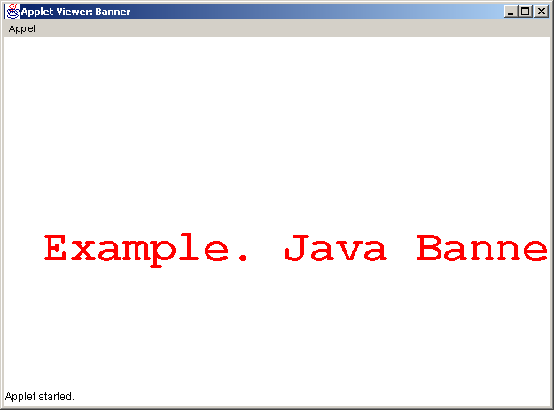

/*-----------An Applet for drawing BAR GRAPH----------*/

import java.awt.*;
import java.applet.*;

/*
<applet code="Bar" width=200 height=200>
<param name="count" value=7>

<param name="label1" value=1990>
<param name="label2" value=1991>
<param name="label3" value=1992>
<param name="label4" value=1993>
<param name="label5" value=1994>
<param name="label6" value=1995>
<param name="label7" value=1996>

<param name="value1" value=20>
<param name="value2" value=30>
<param name="value3" value=10>
<param name="value4" value=5>
<param name="value5" value=20>
<param name="value6" value=15>
<param name="value7" value=50>
</applet>
*/

public class Bar extends Applet
{
int num=0;
String label[];
int values[];

public void init()
{
try{
num=Integer.parseInt(getParameter("count"));
int i;
label=new String[num];
values=new int[num];
for(i=0;i<num;i++)
{ label[i]=getParameter("label"+(i+1));
values[i]=Integer.parseInt
(getParameter("value"+(i+1)));
}
}
catch(NumberFormatException e)
{ System.out.println
("Cannot Parse Integer\n"+e.getMessage());
}
}

public void paint(Graphics g)
{
int MinX=20,MaxX=825,MinY=30,MaxY=475;
int Xlen=MaxX-MinX,Ylen=MaxY-MinY;
float tmp,avg=FindAverage(values,num);
int MaxVal=FindMaxMin(values,num,true);
int MinVal=FindMaxMin(values,num,false);
int Xinc=((int)((float)Xlen/(float)num)),X,Y,i;

X=MinX;i=0;
while(i<num)
{ g.setColor(new Color(0,0,200));
tmp=(((float)values[i])/((float)MaxVal))*
((float)Ylen);

g.fillRect(X,MaxY-(int)tmp,(int)
(Xinc-(float)Xinc*0.5),(int)tmp);

g.setColor(new Color(200,0,0));
g.drawString(label[i],X+3,MaxY+15);
g.setColor(new Color(0,0,0));
g.drawString(values[i]
+"<"+(((float)values[i])/((float)MaxVal)*
(float)100)+"%>",X,MaxY-(int)tmp-5);

X+=Xinc;i++;
}
g.setColor(new Color(0,0,0));
g.drawString("Maximum:"+MaxVal+" Minimum:"
+MinVal+" Average:"+avg,MinX+1,MaxY+30);

return;
}

private int FindMaxMin(int val[],int cnt,boolean Max)
{
int i,maxmin;
maxmin=val[0];
for(i=1;i<cnt;i++)
maxmin=(Max&&val[i]>maxmin)||
(!Max&&val[i]<maxmin)?val[i]:maxmin;

return maxmin;
}

private float FindAverage(int val[],int cnt)
{
int i;
float avg=0;
for(i=0;i<cnt;i++) avg+=val[i];
return avg/((float)(cnt==0?1:cnt));
}
}

Output

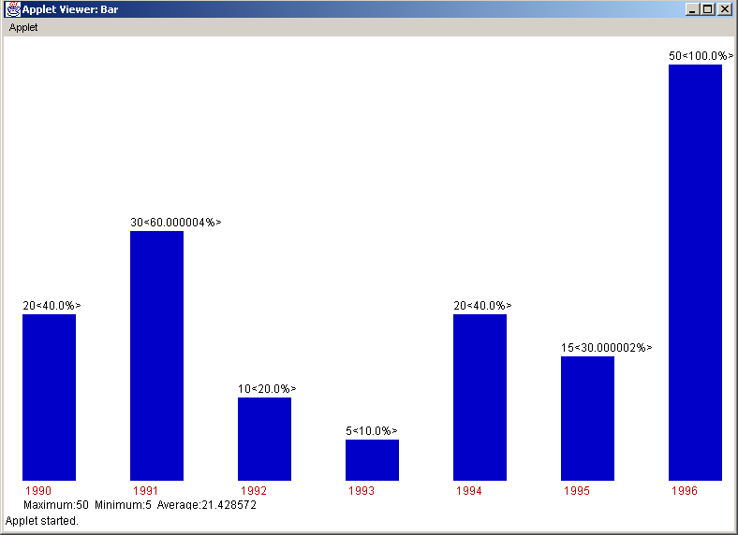

/*-----------Client/Server, an example---------*/

import java.net.*;

public class ClientServer
{
public static int SPort=998;
public static InetAddress CIp;
public static int CPort=999;
public static int BSize=1024;
public static byte Buff[]=new byte[BSize];
public static DatagramSocket DSocket;

public static void RunServer() throws Exception
{
int i=0,RChar=0;
while(RChar!=-1)
{
RChar=System.in.read();
switch(RChar)
{
case -1:System.out.println
("\n\nAborting Server!!!\n\n"+
"You will loose any unsend line!\n");
i=0;

case '\n':DSocket.send(new DatagramPacket
(Buff,i,CIp,CPort));
if(i==0)
{ System.out.println("\n\nServer”+
“ Quits!!!\n\n");
RChar=-1;
}
i=0;break;
case '\r':break;

default:Buff[i++]=(byte)RChar;
}
}
return;
}

public static void RunClient() throws Exception
{ String s="INITSERVER";
while(!s.equals(""))
{
DatagramPacket Pkt=new DatagramPacket(Buff,BSize);
DSocket.receive(Pkt);
s=new String(Pkt.getData(),0,Pkt.getLength());
System.out.println(s.equals("")?
"\n\nQuitting CLIENT!!!":s);
}
return;
}

private static void Usage(String tmp)
{
System.out.println(tmp+"\n\nUsage\n\nFor Server:"+
" java ClientServer <-s> <serverport(def:998)> "+
"<clientport(def:999)>\n\n "+
" <ClientHostName(def:This Machine)>”
+”\n\n"+"For Client: java ClientServer <-c>”+
“ <clientport(def:999)>\n\n");

return;
}

public static void main(String Arg[])
{
int Flg,tmp;
if(Arg.length==4)
{
if(Arg[0].trim().equals("-s")||
Arg[0].trim().equals("-S"))
{
try
{ tmp=Integer.parseInt(Arg[1]);
SPort=tmp;
}
catch(NumberFormatException e) {}
try
{ tmp=Integer.parseInt(Arg[2]);
CPort=tmp;
}
catch(NumberFormatException e) {}
try
{
InetAddress t=InetAddress.getByName(Arg[3]);
CIp=t;
}
catch(UnknownHostException e)
{
System.out.println("\n\nCannot Locate "+Arg[3]+
", Now using default CLIENT(this machine)\n\n");
try{ CIp=InetAddress.getLocalHost(); }
catch(UnknownHostException e1)
{
Usage("\n\nAdd this Machine to Network”+
” to get an IP");
return;
}
}
try
{
DSocket=new DatagramSocket(SPort);
System.out.println("\n\nCTRL+BREAK or “
+”a BLANK-LINE to terminate SERVER."+
"\n\n(This will terminate CLIENT also)"+
"\n\nEnter your Message.\n\n");
RunServer();
}
catch(Exception e)
{
System.out.println("\n\n(Server):”+
”Cannot Connect to the network!!!\n\n");
return;
}
}
else
{
Usage("\n\nUse '-s' or '-S'");
return;
}
}
else if(Arg.length==2)
{
if(Arg[0].trim().equals("-c")||
Arg[0].trim().equals("-C"))
{
try
{ tmp=Integer.parseInt(Arg[1]);
CPort=tmp;
}
catch(NumberFormatException e) {}
try
{
DSocket=new DatagramSocket(CPort);
System.out.println("\n\nWait for “+
”Server to respond!!!\n\nCTRL+C to “+
”terminate CLIENT in any way\n\n");
RunClient();
}
catch(Exception e)
{
System.out.println("\n\n(Client):”+
”Cannot Connect to the network!!!\n\n");
return;
}
}
else
{
Usage("\n\nUse '-c' or '-C'");
return;
}
}
else
{
Usage("");
return;
}

return;
}
}

Output

Running SERVER program:

E:\Java\Programs>java ClientServer -s 1000 1001 x

Cannot Locate x, Now using default CLIENT(this machine)

CTRL+BREAK or a BLANK-LINE to terminate SERVER.
(This will terminate CLIENT also)

Enter your Message.

This is a ClientServer test.
The lines typed will be displayed,
on the ClientWindow.
BlankLine will terminate both.
Ending this session.'

Server Quits!!!

Running CLIENT program:

E:\Java\Programs>java ClientServer -c 1001

Wait for Server to respond!!!

CTRL+C to terminate CLIENT in any way

This is a ClientServer test.
The lines typed will be displayed,
on the ClientWindow.
BlankLine will terminate both.
Ending this session.'

Quitting CLIENT!!!

Usage Syntax:

For Server:
java ClientServer <-s>
<serverport(def:998)> <clientport(def:999)>
<ClientHostName(def:This Machine)>

For Client:
java ClientServer <-c> <clientport(def:999)>

/*--------Simulating an Human Face--------*/

import javax.swing.*;
import java.applet.*;
import java.awt.*;
import java.awt.event.*;

/*
<applet code="Face" width=200 height=200>
</applet>
*/

public class Face extends Applet implements ActionListener
{
int cnt=2;
String s[]={"cry!","smile!"};
String cur;

public void HandleButtonsClick
(int cnt,String s[],ActionEvent e)
{
String c=e.getActionCommand();
if(c.equals(s[0]))
{ cur=s[0]; }
else if(c.equals(s[1]))
{ cur=s[1]; }

return;
}

public void paint(Graphics g)
{
int x=800/2,y=550/2;
g.setColor(new Color(0,0,0));
g.drawLine(x,y-100,x-50,y-150);
g.drawLine(x,y-100,x+50,y-150);
g.setColor(new Color(0,0,200));
g.fillOval(x-45,y-45,15,15); g.fillOval(x+35,y-45,15,15);
g.setColor(new Color(200,0,0));
g.drawOval(x-100,y-100,200,200);
g.drawOval(x-50,y-50,25,25);
g.drawOval(x+30,y-50,25,25);
g.drawOval(x+100,y-50,30,60);
g.drawOval(x-100-30,y-50,30,60);
g.drawLine(x,y-30,x,y+25);
int x1=x-50,y1=y-50;
g.drawArc(x1,y1-15,25,35,0,180);
x1=x+30;
g.drawArc(x1,y1-15,25,35,0,180);
x1=x-25;
y1=y+30;

if (!(cur.equals("")))
{
if(cur.equals(s[0]))
{ g.drawString("Don't Hurt Me!!!",50,50);
g.drawArc(x1,y1,50,50,0,180);}
else if(cur.equals(s[1]))
{ g.drawString("You Are My Friend!!!",50,50);
g.drawArc(x1,y1-30,50,50,180,180); }
}
else
{
g.drawString("Why Don't You Do “+
“Something?",50,50);
g.drawLine(x1,y1+10,x1+50,y1+10); }
}

public void actionPerformed(ActionEvent e)
{
HandleButtonsClick(cnt,s,e);
repaint();
}

public void CreateButtonsAndLayout()
{
this.setLayout(new BorderLayout());
this.setBackground(new Color(250,250,250));
this.setForeground(new Color(0,0,250));
this.setFont(new Font("courier",Font.BOLD,15));
int i;
Button j;
JPanel bbox=new JPanel();
bbox.setLayout(new
FlowLayout(FlowLayout.LEFT,100,10));
bbox.setBackground(new Color(250,250,250));
cur="";
for(i=1;i<=cnt;i++)
{
j=new Button(s[i-1]);
j.setFont(new
Font("courier",Font.BOLD,12));
j.addActionListener(this);
bbox.add(j);
}

this.add(bbox,BorderLayout.SOUTH);
return;
}

public void init()
{
CreateButtonsAndLayout();
return;
}
}

Output

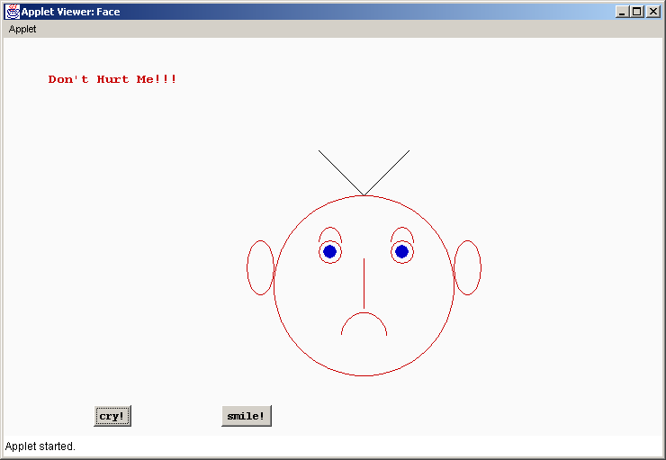

/*-------------An Hybrid Inheritance example----------*/

class Student
{
int rlno;
Student(int rlno)
{
this.rlno=rlno;
}
void PutStudent()
{
System.out.println("\n\n\nRoll Number of “+
”the Student:"+rlno);
return;
}
}

class Test extends Student
{
float Part1,Part2;
Test(int rlno,float Part1,float Part2)
{
super(rlno);
this.Part1=Part1;
this.Part2=Part2;
}
void PutTest()
{
System.out.println("\nMark for Part1:"+Part1);
System.out.println("\nMark for Part2:"+Part2);
}
}

interface Sport
{
final float Spwt=6.0F;
abstract void PutSport();
}

class Result extends Test implements Sport
{
float Total;
Result(int rlno,float Part1,float Part2)
{ super(rlno,Part1,Part2); }
public void PutSport()
{
System.out.println("\nSport Weight:"+Spwt);
}
void PutResult()
{
Total=Part1+Part2+Spwt;
PutStudent();
PutTest();
PutSport();
System.out.println("\nTotal Score:"+Total+"\n\n");
return;
}
}

public class Hybrid
{
public static void main(String s[])
{
Result Res=new Result(1024,27.8F,36.6F);
Res.PutResult();
return;
}
}

Output

E:\Java\Programs>java Hybrid

Roll Number of the Student:1024

Mark for Part1:27.8

Mark for Part2:36.6

Sport Weight:6.0

Total Score:70.399994
/*-------Loading an Image--------*/

import java.applet.*;
import java.net.*;
import java.awt.*;

/*
<applet code="ImageLoad" width=248 height=150>
<param name="img" value="fig.jpg">
</applet>
*/

public class ImageLoad extends Applet
{
Image img;

public void init()
{
img=getImage(getDocumentBase(),getParameter("img"));
}

public void paint(Graphics g)
{ g.drawImage(img,0,0,this); }
}

Output

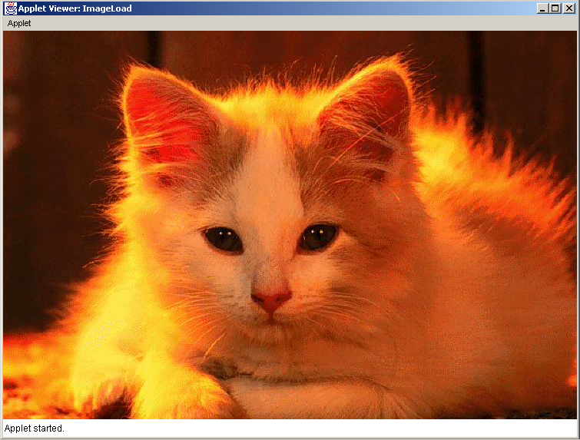

/*-----------Using an Interface-----------*/

interface Area
{
public final static double HALF=.5;
public abstract double ComputeArea(float x,float y);
}

class Rectangle implements Area
{
public double ComputeArea(float x,float y)
{
return x*y;
}
}

class Triangle implements Area
{
public double ComputeArea(float x,float y)
{
return HALF*x*y;
}
}

class InterfaceTest
{
public static void main(String arg[])
{
Area a;
Rectangle r=new Rectangle();
Triangle t=new Triangle();

a=r;
System.out.println("\n\n\nArea Of Rectangle “+
”with Length=4,Height=3 is "+a.ComputeArea(4,3));

a=t;
System.out.println("\n\nArea Of Triangle with “+
“Base=4,Height=3 is "+a.ComputeArea(4,3)+"\n\n");

return;
}
}

Output

E:\Java\Programs>java InterfaceTest

Area Of Rectangle with Length=4,Height=3 is 12.0

Area Of Triangle with Base=4,Height=3 is 6.0
/*--------MultiThreading, an example--------*/

class PrintLine
{
public synchronized void Print(int Num1,int Num2,int Tabs)
{ int i;
System.out.print("\n\n");
for(i=1;i<=Tabs;i++) System.out.print("\t");
System.out.print(Num1+"x"+Num2+"="+(Num1*Num2));
return;
}
}

class Table implements Runnable
{
int Tabs;
int Num;
int Cols;
PrintLine PL;
Thread Td;
Table(int Num,int Cols,int Tabs,PrintLine PL)
{
this.Tabs=Tabs;
this.Num=Num;
this.Cols=Cols;
this.PL=PL;
Td=new Thread(this,"MultiTable"+Num);
Td.start();
}
public void run()
{
int i;
for(i=1;i<=Cols;i++)
synchronized(PL){ PL.Print(Num,i,Tabs); }
return;
}
}

public class MultiTable
{
public static void main(String args[])
{
PrintLine Pl=new PrintLine();
int Cnt=3,Cols=5;
int num[]={3,5,11};
Table Te[]=new Table[Cnt];
int i;
System.out.print("\n\n***Multiplication Tables For”+
“ 3,5,11***\n");
for(i=0;i<Cnt;i++)
Te[i]=new Table(num[i],Cols,i*2,Pl);
for(i=0;i<Cnt;i++)
{ try
{ Te[i].Td.join();}
catch(InterruptedException e)
{ System.out.println("\n"+i+
" th Thread Interrupted\n");}
}
System.out.println("\n\n\nEnding...\n");
return;
}
}

Output

E:\Java\Programs>java MultiTable

***Multiplication Tables For 3,5,11***

3x1=3

11x1=11

5x1=5

3x2=6

3x3=9

3x4=12

3x5=15

5x2=10

11x2=22

11x3=33

5x3=15

5x4=20

5x5=25

11x4=44

11x5=55

Ending...
/*--------Creating a simple GUI using applet-------*/

import java.applet.*;
import java.awt.*;
import java.awt.event.*;

/*
<applet code="Person" width=200 height=200>
</applet>
*/

public class Person extends Applet implements ActionListener
{
int cnt=1;
String s[]={"Accept"};
String cur;

public void HandleButtonsClick
(int cnt,String s[],ActionEvent e)
{
String c=e.getActionCommand();
if(c.equals(s[0]))
{ cur=s[0]; }
return;
}

Label l[]=new Label[7];
TextField t[]=new TextField[5];
CheckboxGroup cgp=new CheckboxGroup();
CheckboxGroup cgp1=new CheckboxGroup();
Checkbox cb[]=new Checkbox[2];
Checkbox cb1[]=new Checkbox[2];

private String GiveProperText(String s)
{
String S1=new String(s.trim());
if(S1.equals("")) return "[unknown]"; else
return S1;
}

public void paint(Graphics g)
{
String prnt;
this.setForeground(new Color(0,0,0));
if(!cur.equals("")){
g.drawString("***REPORT***",50,420);
if((cgp.getSelectedCheckbox()
.getLabel()).equals("Male"))
prnt="Mr." +GiveProperText(t[0].getText())+
" son of,";
else
prnt=((cgp1.getSelectedCheckbox().getLabel())
.equals("Married")?
"Mrs.":"Ms.")+GiveProperText(t[0].getText())+
" daughter of,";

g.drawString(prnt,50,435);
prnt="Mr."+GiveProperText(t[2].getText())+
" and Mrs."
+GiveProperText(t[3].getText())+",";
g.drawString(prnt,50,450);
prnt="Having " +GiveProperText(t[1].getText())+
" years old,";
g.drawString(prnt,50,465);
prnt="Is from "+GiveProperText(t[4].getText())+".";
g.drawString(prnt,50,480);
}
return;
}

public void actionPerformed(ActionEvent e)
{
HandleButtonsClick(cnt,s,e);
repaint();
}

public void CreateControlsAndLayout()
{

this.setBackground(new Color(250,250,250));
this.setForeground(new Color(0,0,250));
this.setFont(new Font("courier",Font.BOLD,15));
Button b;

b=new Button(s[0]);
b.setFont(new Font("courier",Font.BOLD,12));
b.addActionListener(this);

int i,j;
for(i=0;i<7;i++) l[i]=new Label("",Label.RIGHT);
l[0].setText("Name:");
l[1].setText("Age:");
l[2].setText("Sex:");
l[3].setText("Marital Status:");
l[4].setText("Father's Name:");
l[5].setText("Mother's Name:");
l[6].setText("Place:");
for(i=0;i<5;i++)
{ t[i]=new TextField(10);
t[i].setForeground(new Color(0,0,0));
}
cb[0]=new Checkbox("Male",cgp,true);
cb[1]=new Checkbox("Female",cgp,false);
cb1[0]=new Checkbox("Married",cgp1,true);
cb1[1]=new Checkbox("Unmarried",cgp1,false);
this.setLayout(new GridLayout(12,3,1,1));

for(i=0;i<3;i++)
this.add(new Label(i==1?
"-----Fill The Details-----":""));
for(i=0;i<7;i++)
{
this.add(l[i]);
if(i<=1) this.add(t[i]); else
if(i==2)
{ this.add(cb[0]);
this.add(cb[1]);
continue;
}else
if(i==3)
{ this.add(cb1[0]);
this.add(cb1[1]);
continue;
}else this.add(t[i-2]);
this.add(new Label());
}
this.add(new Label());
this.add(b);
return;

}

public void init()
{
CreateControlsAndLayout();
return;
}
}

Output

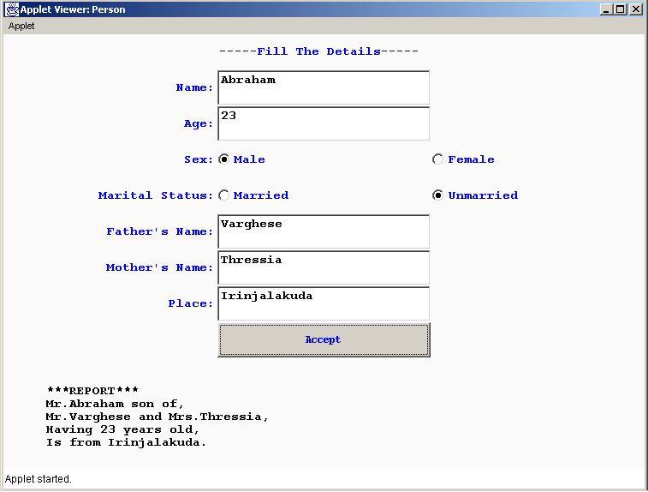

/*-------------Package: an example--------*/

package Pack;

import java.io.*;

public class Pack
{
public static double ReadDouble() throws IOException
{
BufferedReader br=new BufferedReader(
new InputStreamReader(System.in));

Double num=new Double(br.readLine());

return num.doubleValue();
}

public static void main(String arg[])
{
double n1,n2;

try
{
System.out.println("\n\nEnter First Number\n");
n1=ReadDouble();
System.out.println("\n\nEnter Second Number\n");
n2=ReadDouble();
if(n1==n2)
System.out.println("\n\n"+n1+
" equal to "+n2+"\n\n");
else if(n1>n2)
System.out.println("\n\n"+n1+
" is greater than "+n2+"\n\n");
else
System.out.println("\n\n"+n2+
" is greater than "+n1+"\n\n");

return;
}

catch(Exception e)
{
System.out.println("\n\nIllegal Input “+
“Format\n\nError:"+e.getMessage());
return;
}
}
}

Output

E:\Java\Programs>java Pack.Pack

Enter First Number

123

Enter Second Number

123.2

123.2 is greater than 123.0

