public void stop()
{
Stop=true;
Td=null;
}

public void paint(Graphics g)
{
g.drawString(Msg,45 ,(30+475)/2);
}
}

Output

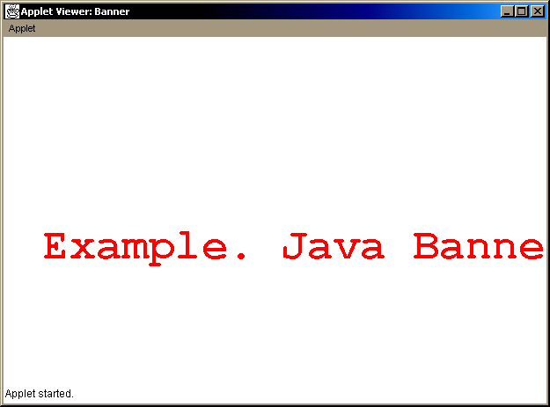

Output

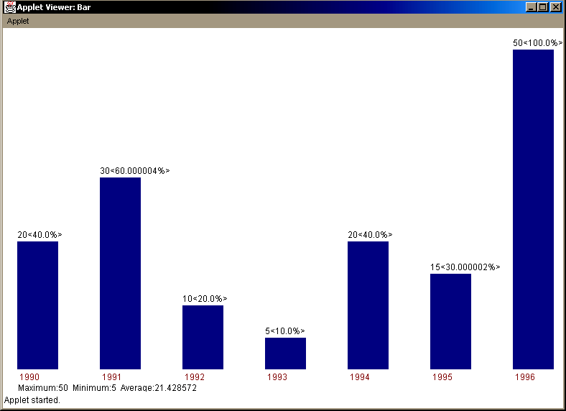

Output

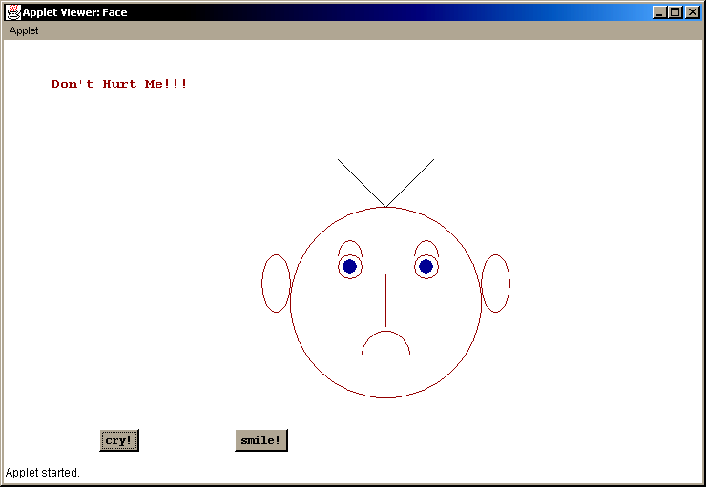

/*-------Loading an Image--------*/

import java.applet.*;
import java.net.*;
import java.awt.*;

/*
<applet code="ImageLoad" width=248 height=150>
<param name="img" value="fig.jpg">
</applet>
*/

public class ImageLoad extends Applet
{
Image img;

public void init()
{
img=getImage(getDocumentBase(),getParameter("img"));
}

public void paint(Graphics g)
{ g.drawImage(img,0,0,this); }
}

Output

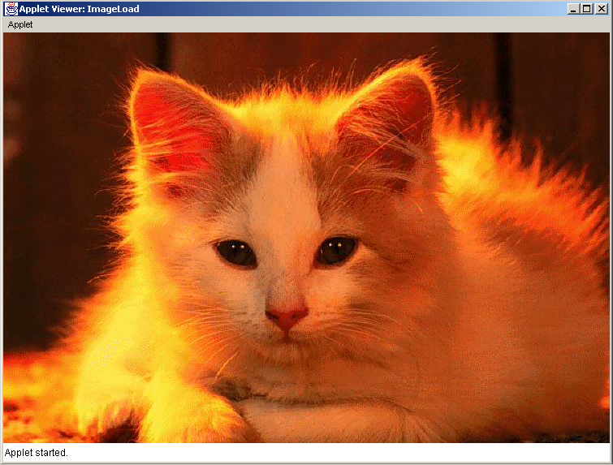

Output

