**4.0 Software Development Plan –––––––––**

## Outline of Software Development Plan

* 1. Plan Introduction
     1. Plan Deliverables
  2. Project Resources
     1. Hardware Resources
     2. Software Resources
  3. Project Organization
  4. Project Schedule
     1. GANTT Chart
     2. Task / Resource Table

**4.1 Plan Introduction**

This Software Development Plan provides the details of the projected development for CaseX, an interactive web application and scalable database solution optimized for the management of physical case data.

The Los Angeles Police Department Homicide Library Unit seeks a database solution for the management of case records dating back to 1960. Case records are currently stored in physical binders. Detectives need a more efficient system to store metadata about the case records, query data, and generate reports. Through CaseX's three main functions: Upload Data, Explore Data, and Generate Reports, users are enabled to effectively manage and understand case data.

## 4.1 Project Deliverables

### Alpha Beta Week 14

Per course requirements, the CaseX Alpha Beta release will occur on Week 14.

### 1.0 Week 16

CaseX v 1.0 will be demoed to the LAPD Homicide Department detectives as a solution for their data management problem.

Resources involved in project development are organized into hardware and software resources. Within those categories, involvement in the development process and/or application execution is indicated.

## Hardware Resources

### Resource Development Execution

|  |  |  |
| --- | --- | --- |
| Macbook Computer (2008 or newer) | ✓ |  |
| 2GB RAM | ✓ | ✓ |
| 16 GB Storage | ✓ | ✓ |
| Wifi Connection | ✓ | ✓ |
| Ethernet Connection | ✓ | ✓ |
| Windows Computer |  | ✓ |

* + 1. **Software Resources**

**Resource Application Development Execution**

|  |  |  |  |
| --- | --- | --- | --- |
| Atom | Text editor | ✓ |  |
| MongoDB | Database | ✓ | ✓ |
| Node.js | Programming language | ✓ | ✓ |
| GitHub | Version control | ✓ |  |
| Postman | HTTP request testing | ✓ |  |
| Google Chrome | End user web browser | ✓ | ✓ |
| Internet Explorer | End user web browser | ✓ | ✓ |
| macOS | Development operating system | ✓ | ✓ |
| Windows OS | End user operating system | ✓ | ✓ |

This section will outline the CaseX project organization, including team member roles, team responsibilities, and coordination between teams.

### Organization Structure

We have organized our project members into three teams: front-end, back-end, and database.

### Name Team Role

|  |  |  |
| --- | --- | --- |
| Andrea Carver | Front-End | Front-End Designer |
| Carleen Petrosian | Front-End | Front-End Designer |
| Eileen Choe | Back-End | Database Development, Back-End Development |
| Allen Vartanian | Back-End | Back-End Development |

* + 1. **Front-End Team**

The Front-End team is responsible for developing the interfaces between end users and the CaseX back-end. They will design interface mockups, design web pages, interact with the back-end, and test across several platforms. Refer to 5.3.1 for detailed functional requirements for the front-end.

### Back-End Team

The Back-End team is responsible for designing, developing, and testing software components on the server-side. Refer to 5.3.2 for detailed functional requirements for the back-end.

### Database Team

The Database team is responsible for designing and implementing the MongoDB database. Refer to 5.3.3 for detailed functional requirements for the database.

### Roles and Responsibilities

Weekly development meetings are held on Fridays from 11:00 AM - 3:00 PM, and Scrum meetings are held Tuesday mornings from 10:00 AM - 11:00 AM. Meetings with the LAPD Homicide detectives are held every 2-3 weeks on Tuesday mornings, during the scrum meeting block.

Weekly tasks for both development teams will be documented, tracked, and updated via the Github Issues system. This allows for all team members to be informed about the project progress, and encourage collaborative development.

# Project Schedule

This section will detail the CaseX project schedule, including the people and resources necessary for each step.

## GANTT Chart

The following GANTT Chart visualizes the duration of the subtasks for CaseX in relationship with each other.

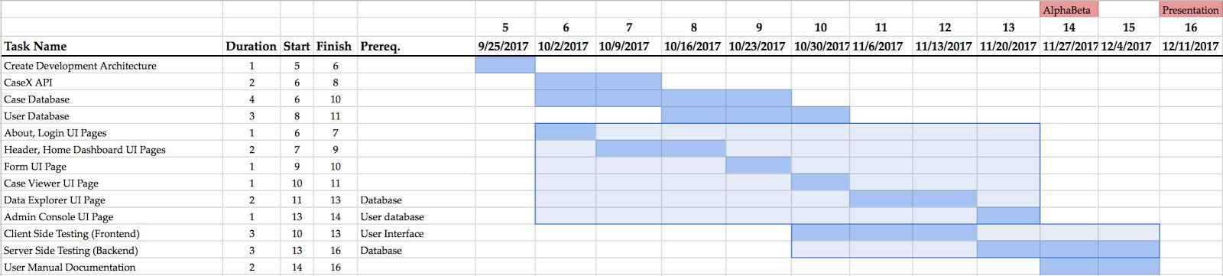

## Task / Resources

### Task People Hardware Software

|  |  |  |  |
| --- | --- | --- | --- |
| Create Development Architecture | Eileen Choe | Macbook | Node.js, MongoDB, Github, macOS, Web Browser |
| CaseX API | Eileen Choe | Macbook | Node.js, Postman, MongoDB |
| Case Database | Eileen Choe, Allen Vartanian | Macbook | Node.js, Postman, MongoDB, macOS |
| User Database | Andrea Carver, Carleen Petrosian | Macbook | Node.js, Postman, MongoDB, macOS |

|  |  |  |  |
| --- | --- | --- | --- |
| Login Authentication | Allen Vartanian | Macbook | Node.js, Postman, MongoDB, macOS |
| About, Login UI Pages | Andrea Carver, Carleen Petrosian | Macbook, Windows Computer | Node.js, Github, Web Browser, Bootstrap |
| Header, Home Dashboard UI Pages | Andrea Carver, Carleen Petrosian | Macbook, Windows Computer | Node.js, Github, Web Browser, Bootstrap |
| Form UI Page | Andrea Carver | Macbook, Windows Computer | Node.js, Github, Web Browser, Postman, Bootstrap |
| Case Viewer UI Page | Andrea Carver, Carleen Petrosian | Macbook, Windows Computer | Node.js, Github, Web Browser, Postman, Bootstrap |
| Data Explorer UI Page | Andrea Carver, Carleen Petrosian | Macbook, Windows Computer | Node.js, Github, Web Browser, Postman, Bootstrap |
| Admin Console UI Page | Andrea Carver, Carleen Petrosian | Macbook, Windows Computer | Node.js, Github, Web Browser, Postman, Bootstrap |
| Client Side Testing (Front-end) | Andrea Carver, Carleen Petrosian | Windows Computer | Mocha, Node.js, Web Browser |
| Server Side Testing (Back-end) | Eileen Choe, Allen Vartanian | Macbook | Node.js Assertion Module |
| User Manual Documentation | Andrea Carver, Carleen Petrosian, Eileen Choe,  Allen Vartanian | Macbook | LaTeX |

Very nice work on this!

5 out of 5% = A-plus

Nothing else needed for this.