Game Design Document

Fill up the following document

1. Write the title of your project.

The one and only coin hitter game

1. What is the goal of the game?

Hit as many coins as you can with the slingshot

1. Write a brief story of your game.

You are on a moving platform and you find a slingshot. The only way to escape and leave the platform is by collecting a total number of 20 coins, How ever you do not want to hit the birds while trying to hit the coins as it will deduct one point per bird hit.

1. Which are the playing characters of this game?

* Playing characters are the ones who respond to the user based on the input from the user.
* Cars, monkeys, dinos, wizards, etc., are the playing characters in the game.

|  |  |  |
| --- | --- | --- |
| Number | Character Name | What can this character do? |
| 1 | The player | Throws rocks with a slingshot to coins and tries to get a total of 20 coins without hitting the birds |
| 3 |  |  |
| 4 |  |  |
| 5 |  |  |
| 6 |  |  |
| 7 |  |  |
| 8 |  |  |

1. Which are the Non-Playing Characters of this game?

* Non-Playing characters are the ones that don't have an action or behavior when the user interacts with the game.
* Hurdles, stones, bananas, coins, etc., are non-playing characters in the game.

|  |  |  |
| --- | --- | --- |
| Number | Character Name | What can this character do? |
| 1 | birds | Birds are just flying around but if they get hit they will steal one of your coins |
| 2 | coins | They need to be collected |
| 3 |  |  |
| 4 |  |  |
| 5 |  |  |
| 6 |  |  |
| 7 |  |  |
| 8 |  |  |

Draw your imagination of this game. What does this game look like?

* Draw the game either on your computer or on paper.
* Add images of the game scenes to show each of the playing and non-playing characters at least once.

Just like the angry bird game there will be a platform, but the platform will be moving. The birds will be vultures as they will steal your coins if you make them angry.

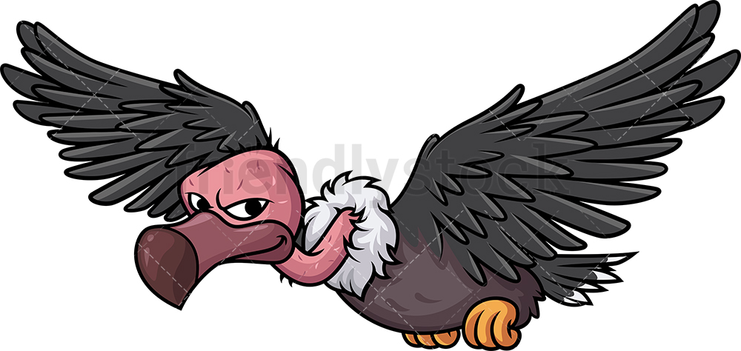

How do you plan to make your game engaging?

As the number of coins the playher gets goes up, the platform’s speed will increase and their will be more vultures, making it harder for the player to get coins.