**Deep Learning**

**Framework**

**Hardware**

For the computation, a personal laptop has been used. It has an Intel i7 CPU with 6 cores and 16GB RAM and an NVIDIA RTX 2070 Max-Q GPU with 8GB of VRAM.

**Software**

The framework in which this part of the project was developed was TensorFlow GPU. This library takes advantage of the CUDA framework for NVIDIA GPUs. Getting CUDA to work was a challenge but the computational advantage far outweighed the effort.

**Segmentation**

**U-Net**

For the segmentation task, a U-Net-like architecture has been used. The architecture was developed by our team, not imported. It consists of a contractive part (using *Max Pooling*) and an expansive path (using *Transpose Convolution*). The intuition behind this architecture is that the model can learn how to generate segmentations of the iris based on the information that has been synthetized in the contractive part and guided by the targets being presented at the end of the expansive path. U-Net is also a great architecture for this task because it manages to stay true to the geometry of the object-to-be-segmented by introducing information about it at each reconstruction stage.

The model has been trained for 200 epochs with an early stopping callback. The optimization algorithm was Adam and the loss function used is Binary Crossentropy.

The F1 score achieved by the model was: 96.76%.

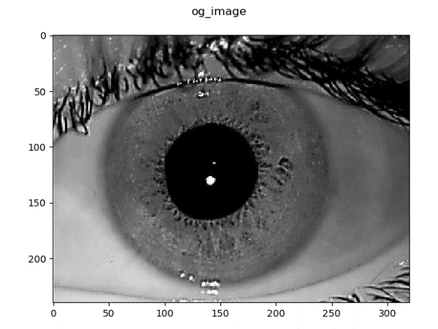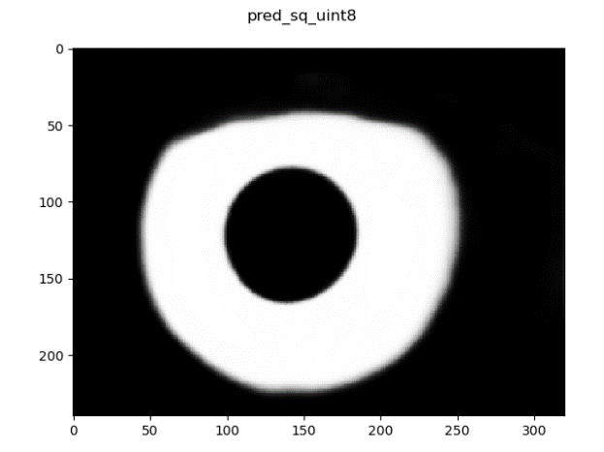

Figure 1. (left) Original Eye Image; (right) Segmentation

**Deep Feature Extraction**

In order to perform the classification necessary for the recognition task, it was necessary to find a representation for the information present in the iris.

**Polar Transformation**

A first stage was to obtain a rectified version of the iris. To do so, the original image was multiplied with the segmentation mask to cut everything but the iris from the image, then a polar transform was applied to the iris image so that the image lost its circular structure. The intuition behind the latter step was that inference power can be wasted by the classification network learning that the iris is round, the aim is to concentrate the analytical power of the network on the features that differentiate between different patient’s irises.

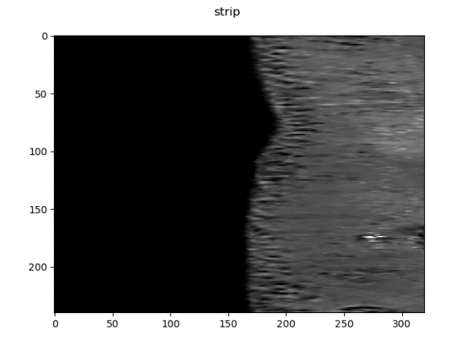

Figure 2. Rectified image of the segmented iris

**Autoencoder**

For the main feature extraction step, an autoencoder network was used. The intuition behind this choice is that the encoder part of the network can be used to extract the essential aspects of the rectified iris image in the shape of a vector that can later be used as a feature vector for the classification algorithms.

**Classification**

For the classification task, two scenarios were considered. In the first one, deep features have been used, those are the output of the encoder when rectified iris images were inputted. This represents the standard way to do recognition. However, it has also been of interest how would classification work directly on the rectified iris images. In this section, both cases will be presented.

**Using Deep Features**

asd

**Using rectified images only**

asd