eCar-Kiosk

Design Specification Document

Akhter Al Amin

Date: Oct-08-2020

Table of Content
Detailed Architecture of eCar-Kiosk 3
1.1 Class Diagram 3
1.2 Dynamic Behaviour (Sequence Diagram) 3
1.3 StateChart Diagram 3

Detailed Architecture of eCar-Kiosk
A detailed description of the system’s architecture and Behaviour is presented.

User Stories
- Epic: User
- As a registered customer, I want to login to the system so that I can rent a car for a certain period of time.
- As a registered manager, I want to login to the system so that I can download monthly or yearly sales reports.
- Epic: Car
- As a manager, I want to see all the car's information that is available in my region so that I can determine whether any car needs servicing or regular maintenance.
- As a customer, I want to be able to see available models and sizes of car so that I can select one according to my preference.
- As a clerk, I want to be able to see the availability of the car so that I can provide customers alternatives if the car they wanted was not available.
- Epic: Rent Car
- As a customer, I want to be able to reserve a car for a certain time length.
- As a manager, I want to be able to see the cancellation request details so that I can decide whether a late cancellation fee should be waived or not.

Class Diagram
A detailed structure of the overall static view of eCar-Kiosk.

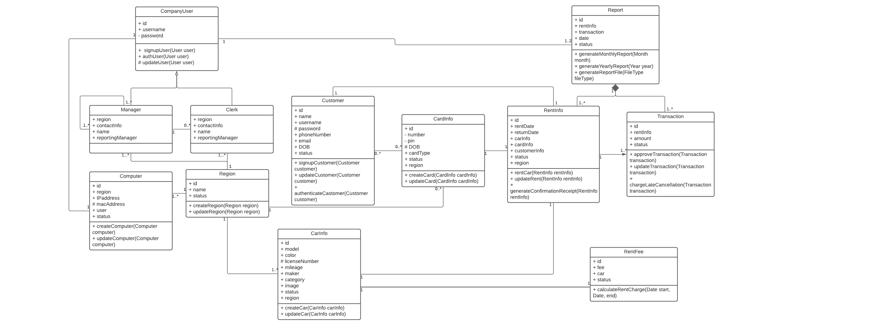

Dynamic Behaviour (Sequence Diagram)
A detailed sequence of the events for the following services:
  - A user to print a rental agreement.
  - A manger to generate a monthly and Annually report.
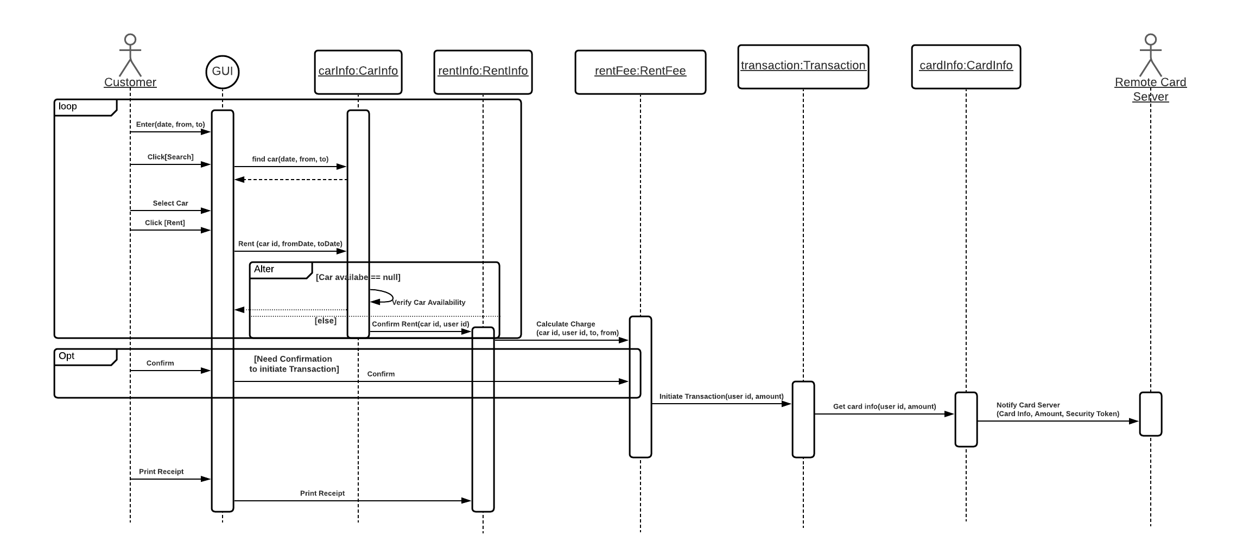
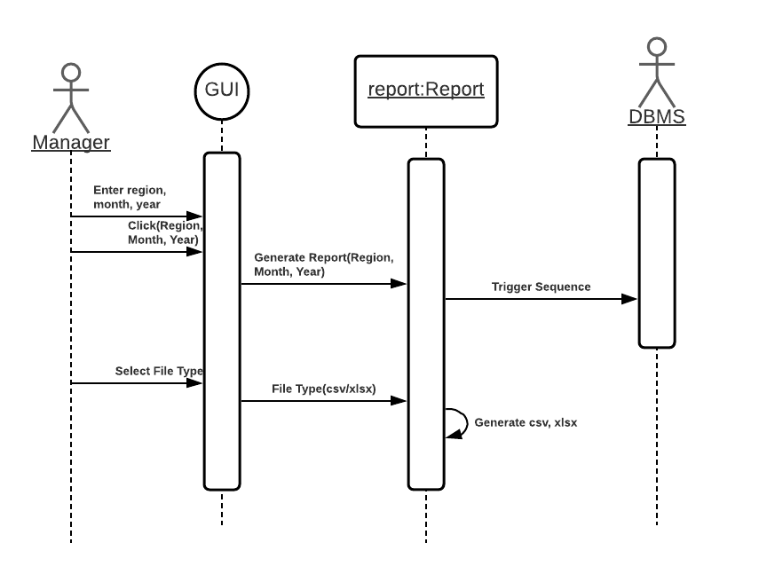

StateChart Diagram
