**MEANGEN DESCRIPTION**

MEANGEN is a mean-line turbomachinery design program which produces a data set for use with STAGEN and MULTALL. It works with compressors and turbines and for axial or radial flow machines. Given the basic design parameters such as mass flow rate, rotational speed, mean radius, etc, it evaluates the flow angles and blade heights and makes an initial guess of blade shapes. It is designed to work with the minimum of user input and so many of the parameters needed are set by default. The use of the defaults is described by comments in the code, they can be changed by editing and recompiling the program.

An update for MEANGEN 17.4 is included at the end of this document.

MEANGEN will produce a basic initial design with no allowance for more complex features such as tip leakages, cooling flows, bleed flows, etc. These features must be added later by editing the output file “**stagen.dat**” , or in some cases by editing the input file to MULTALL.

The program is written in standard FORTRAN77 and should run on any machine with a FORTRAN compiler. It was developed using the LINUX “**gfortran**” compiler.

To run the program, first compile it , then type the name chosen for the executable code , e.g. **meangen.x**, and then answer the questions that appear on the screen. If you choose to input the data from a file it must be named “**meangen.in”** .

The data input to the program can be produced either by answering questions on the screen or from a file named “**meangen.in**”. When first run on a new design the input will usually be from the screen, but the program writes an output file called “**meangen.out**” which mirrors the screen input and on future runs, with only small changes to the same basic design, the input is most easily changed by copying this file to “**meangen.in**” and then editing “**meangen.in**” . An example of “**meangen.in**” is shown at the end of this note. The detailed data input requirements are described by comments in the FORTRAN, which can be seen by studying the code, or by the annotated output file “**meangen .out”**.

MEANGEN writes an output file called “**stagen.dat**” which will immediately run on the 3D geometry generating program STAGEN, which in turn writes an input file for the 3D solver MULTALL. Using the combination a 3D solution can usually be started in minutes and a 3D solution obtained in of order ½ hour.

Meangen basically designs complete stages or multiple stages rather than single blade rows although the latter can be generated, as described later. One of the first questions asked on the screen is whether the machine is a turbine or a compressor. **For a turbine the first blade row must be the stator and for a compressor the first row must be the rotor.** **The direction of rotation is always in the positive circumferential (theta) direction.**

The angle convention is illustrated below. All angles are positive if the associated velocity vector has a positive component in the direction of rotation. Hence compressor rotor inlet angles and turbine rotor exit angles will always be negative and compressor stator inlet angles and turbine stator exit angles will always be positive.

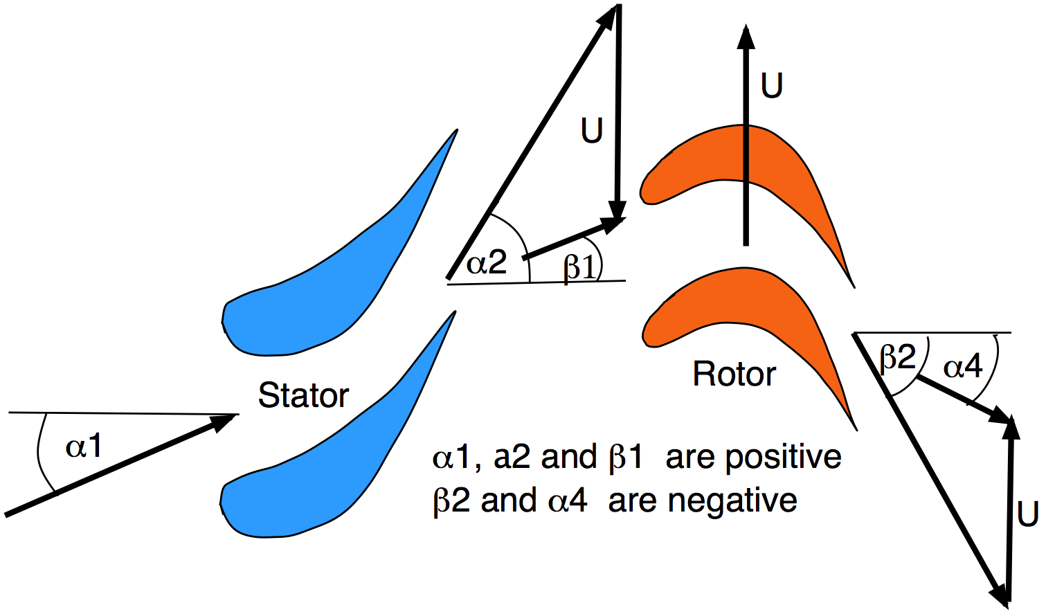

There are a variety of options for specifying the stage geometry.

The simplest option is if it is chosen to design an axial flow machine with repeating stages. This means that each stage has a fixed mean radius and constant axial velocity and with the velocity magnitude and direction being the same at stage inlet and exit. This option is chosen by setting FLO_TYP = “AXI” when requested on the screen. The velocity triangle is then the same at stage inlet and outlet and it is only necessary to specify 3 geometrical or flow parameters to fix the velocity triangles. These can be any 3 chosen from:

Stator inlet flow angle, a1

Stator exit flow angle, a2

Rotor relative inlet flow angle, b1

Rotor relative exit flow angle, b2

Stage reaction, l

Stage flow coefficient, f = Vx/U

Stage loading coefficient , y = DH/U**2

Allowing all combinations of these would give too many options, so the combinations which can be used for input with FLO_TYP = “AXI” are:

f, a2, b2 ) , ( f, b1, b2) , ( l, a1, a2) and (f, y, l) .

The last combination is probably the most convenient as it allows the basic dimensionless groups which determine stage performance to be fixed, it is used with the equation



to obtain ao, the absolute flow angle at stage inlet and exit, then standard velocity triangle relationships are used to obtain the rest of the flow angles.

Using FLO_TYP= “AXI” it is possible to design multistage machines with repeating stages very quickly by simply answering “Y” when asked if the velocity triangles and design radius are the same as for the last stage. The velocity triangles and design radius will then remain the same but the blade height will change. If the design radius is changed between two stages using FLO_TYP = “AXI” then either the change in radius must be small of the gap between stages must be large, otherwise the hub and casing stream surfaces are likely to become highly curved. If the radius change is not small then FLO_TYP = “MIX” should be used.

The alternative, more flexible, choice for specifying the stage geometry is to input the coordinates of the design stream surface, which can include radius changes and can even be fully radial. The variation of meridional velocity ratio along this stream surface must also be specified. The meridional velocity ratio is the ratio of the local meridional velocity to that at the rotor leading edge. This option is selected by choosing FLO_TYP = “MIX” when requested on the screen. There is no assumption of a repeating stage and so 4 pieces of data are needed to specify the velocity triangles. These can be specified either by inputting all 4 blade angles, a1, a2, b1 and b2 or by specifying the absolute flow angles, ao, a4 , at stage inlet and outlet, together with the stage loading coefficient and flow coefficient, both defined at the rotor leading edge. The first option is chosen by setting MIXTYP = “A” , the second by MIXTYP = “B”. When MIXTYP = “A” is used the flow coefficient is obtained from the difference between the first blade exit angle and the second blade inlet angle, hence there is no direct control over the flow coefficient. e.g. for a turbine



For FLO_TYP = “MIX” the stream surface axial and radial coordinates are input separately for each stage and must extend from upstream of the stage to downstream of it. Typically 6 points would be sufficient to define the stream surface through a single stage. **There must be points on the stream surface at the leading and trailing edges of each blade row** and these points are numbered to define the blade positions. The stream surfaces used for input on different stages must form a **continuous smooth surface** but the input points for different stages can overlap if convenient, they are then sorted into a continuous surface by the program.

The blade profiles are first generated on a plane x-y surface and are then transformed onto the input stream surface using



where q is the circumferential angle and r the local radius. This ensures that the angle between a local line at constant circumferential angle and the local flow direction remains unchanged and a flat plate transforms into a log spiral curve. This should ensure that the blade loading remains similar to that of a 2D blade with the same angles and same meridional velocity ratio.

Given the inlet conditions, rotational speed, design radius, velocity triangles and a guessed efficiency the program calculates the density at each station through the machine and from that and the mass flow obtains the annulus area. The stream surface used for design can be chosen to be either the hub, casing or mid-span surface. Given the radius on the mean stream surface and the annulus area, the hub and casing radii are easily obtained. Note that if the change if annulus area across a blade row is large, then hub or casing stream surfaces, which are not the specified design surface, may become unrealistically highly curved. This is especially likely with high pressure ratio turbine stages when the hub steam surface is specified, the casing may then become unrealistic and the “stagen.dat” file should be edited to correct this.

The velocity triangles are specified at the design radius and their variation along the span is obtained by assuming a free vortex design so that r Vq = constant along the span. This should produce a flow with fairly uniform meridional velocities. If the velocity triangles for a stage are the same as for the previous stage, that stage can be generated by simply typing ”Y” when asked if the flow angles are the same.

For FLO_TYP = “AXI” the blade axial chords are input as data and the inter-stage and inter-row spacings are specified as fractions of the axial chord. For FLO_TYP= ‘MIX” the leading and trailing edges, and hence the blade meridional chords and blade row spacings, are specified by the numbered input points on the stream surface. The quasi-orthogonal lines at leading and trailing edges are assumed to be straight and any taper of the axial chord is allowed for by inputting the angle between the QO lines and the axial direction, this angle will be close to 90o for an axial machine and close to 180o for a radial flow machine.

The number of blade sections output to STAGEN is specified by default and typically 3 to 5 sections should be sufficient unless the blade is very highly twisted. The blade geometry on each of these sections is specified by the inlet and exit angles, which are available from the velocity triangles, the maximum thickness to chord ratio and the fraction of axial chord where maximum thickness occurs, which are input as data. The blade angles are set by assuming that the tangent of the relative flow angle varies linearly with a transformed axial chord according to



where E is an exponent which is set in the defaults and Cx is the axial chord. E = 1 gives a linear variation in tan(a) and increasing E moves the point of maximum camber, and hence the blade loading, forwards. Typical values of E would be 1.0 for turbines and 1.5 for compressors. The leading and trailing edge thicknesses are set as fractions of the axial chord by default values.

The angles obtained from the velocity triangles are the flow angles and to allow for differences between the metal angles and the flow angles, the angle of incidence and of deviation can be specified for each blade row. The deviation angles are always positive, but the incidence angles may be either positive or negative as defined in the conventional way.

This procedure allows reasonable blade shapes to be generated but the detailed shape will usually need to be refined within STAGEN in the light of the 3D solution. The number of blades is estimated from a specified default value of a modified Zweifel coefficient. This is modified to allow for changes in radius and in meridional velocity. Different default values are used for turbines and compressors, these can be changed if required, increase the Zweifel coefficient to increase the blade loading and reduce the number of blades. **The estimates of blade numbers are not reliable for radial flow machines** and the blade numbers for these should be estimated independently and the values in the “**stagen.dat**” data set changed if necessary.

MEANGEN will always design complete stages but not all blade rows need be output to the file “**stagen.dat**”, the choice of which blade rows to output is determined by the values of IFOUT, which are requested at the end of the input data. This allows single blade rows to be generated. The easiest way to generate a single blade row is to use FLO_TYP = “MIX”, MIXTYP = “A” to generate a single stage with one of its blade rows having the required angles. The row may be either a stator or rotor. Then set IFOUT = “Y” for that blade row but IFOUT = “N” for the other row. The exit pressure is determined by the stage design, including the deleted blade row, and so its value may need to be changed by editing the file “stagen.dat” .

To generate an IGV in front of a compressor stage, first generate an extra dummy stage in front of the main stages. Use FLO_TYP = “MIX”, MIXTYP = “B” for this stage and set the absolute inlet and outlet angles for the stage to be the inlet and exit absolute flow angles required from the IGV. Set the flow coefficient of the dummy stage to that required for the whole machine and set the loading coefficient to zero. The latter ensures that the rotor of the dummy stage has no turning and does no work and so does not change the inlet stagnation temperature or flow angle. The stream surface through the dummy stage must match that for the other stages and the first stator leading and trailing edge positions on the stream surface should be those required for the IGV. Then set IFOUT = “N” for the rotor of the dummy stage and IFOUT = “Y” for the stator so that only the stator details are output. The other stages of the machine can be designed as usual.

To generate an OGV for a turbine or compressor then add an extra dummy stage after the main stages. Use FLO_TYP = “MIX”, MIXTYP = “B” for this stage with its inlet and outlet absolute flow angles being those required from the OGV. Set the loading coefficient of the dummy stage to zero so that its rotor does not change the outlet pressure or flow angle. The stream surface for the dummy stage must be continuous from that of the main stages.

If the machine is a compressor set the dummy rotor leading and trailing edge points on the stream surface to be **just downstream** of the trailing edge point of the previous stage **and in front of the leading edge point required for the OGV**. The dummy rotor may be given a very small chord if necessary to satisfy this. Set the stator leading and trailing points on the stream surface to be those required for the OGV. Then set IFOUT = “Y” for the stator (i.e. the second blade row) and IFOUT = “N” for the rotor (the first blade row) of the dummy stage.

If the machine is a turbine set the stator (first blade row) leading and trailing edge points of the dummy stage to be those required for the OGV and set the dummy rotor (second blade row) leading and trailing edge points any convenient distance downstream of these. Then set IFOUT = “Y” for the first blade row and IFOUT = “N” for the second blade row of the dummy stage.

**INPUT AND OUTPUT FILES**

When MEANGEN is started it asks whether you want to take input from the screen or from a file. If you choose the screen then all the input is generated by typing in answers to questions on the screen. If you choose input from a file, then the file must be named “**meangen.in**” .

On completion MEANGEN writes a file “**stagen.dat**” , which is an input file for the blade geometry program STAGEN. STAGEN will run using “**stagen.dat**” without any changes to the file and will produce an input file, “**stage_new.dat**”, for the 3D solver MULTALL. However, in most cases it will be necessary to edit “**stagen.dat**” to make changes to the blade geometry. STAGEN also writes a file called **stage_old.dat** which is the data input to MULTALL if using the old style formatted input.

MEANGEN also writes a file called “**meangen.out**” , which is a copy of the input data. To make changes to the input data, edit this file and then copy it to “**meangen.in**”. Then run MEANGEN with the input option chosen as a file. This is usually the easiest way to make changes to a design after the first screen input.

Sample Data set

The data below shows a “**meangen.in**” data set for a single stage centrifugal compressor with axial inlet and radial outlet flow. The text on the right hand side is only used to describe the data, only the numbers and first few characters on a line are actually used to generate the data.

John Denton. February 2017.

**UPDATE 3/10/2017**

A new version MEANGEN-17.4 has been added. This has additions to include a blockage factor, which is sometimes used in compressors to allow for the blockage due to the growth of the annulus boundary layers. It also allows the amount of blade twist to be scaled from the free vortex value so that untwisted or over-twisted blades can be generated. In addition the blade sections can be individually rotated by an amount specified in the input data, the actual rotation is performed in STAGEN.

Because of these additions previous MEANGEN.IN data sets are not quite compatible with version 14.4 although they can easily be updated. Three new data sets for the new version have been added to the sample data sets provided.

C TURBO_TYP,"C" FOR A COMPRESSOR,"T" FOR A TURBINE

MIX FLO_TYP FOR AXIAL OR MIXED FLOW MACHINE

287.150 1.400 GAS PROPERTOES, RGAS, GAMMA

1.000 300.000 POIN, TOIN

1 NUMBER OF STAGES IN THE MACHINE

M CHOICE OF DESIGN POINT RADIUS, HUB, MID or TIP

7000.000 ROTATION SPEED, RPM

20.000 MASS FLOW RATE, FLOWIN.

B MIXTYP = INPUT TYPE FOR FLO_TYP = "MIX" .

1.0000 FLOW COEFFICIENT AT THE FIRST ROTOR LEADING EDGE.

0.000 20.000 STAGE INLET AND OUTLET ABSOLUTE FLOW ANGLES.

5.0000 STAGE LOADING COEFFICIENT AT THE ROTOR LEADING EDGE.

11 NUMBER OF POINTS ON THE STREAM SURFACE.

THE FOLLOWING LINE OF DATA CONTAINS THE STREAM SURFACE AXIAL COORDINATES.

-0.2000 -0.1000 0.0000 0.1000 0.1700 0.1900 0.1950 0.2000

0.2000 0.2000 0.2000

THE FOLLOWING LINE OF DATA CONTAINS THE STREAM SURFACE RADIAL COORDINATES.

0.2000 0.2000 0.2000 0.2200 0.3000 0.4000 0.5000 0.5500

0.7000 0.7500 0.8500

THE FOLLOWING LINE OF DATA CONTAINS THE MERIDIONAL VELOCITY RATIOS.

1.0000 1.0000 1.0000 1.0000 1.0000 0.9000 0.8000 0.7500

0.7000 0.7000 0.6500

3 7 8 9 LEADING AND TRAILING EDGE POINTS ON THE MEAN STREAM SURFACE.

N DO YOU WANT TO CHANGE THE STREAM SURFACE COORDINATES ?

0.800 GUESS OF THE STAGE ISENTROPIC EFFICIENCY

5.000 5.000 ESTIMATE OF THE FIRST AND SECOND ROW DEVIATION ANGLES

0.000 0.000 FIRST AND SECOND ROW INCIDENCE ANGLES

90.000 180.000 QO ANGLES AT LE AND TE OF ROW 1

180.000 180.000 QO ANGLES AT LE AND TE OF ROW 2

N DO YOU WANT TO CHANGE THE ANGLES FOR THIS STAGE ? "Y" or "N"

Y IS OUTPUT REQUESTED FOR ALL BLADE ROWS ?

N ROTOR No. 1 SET ANSTK = "Y" TO USE THE SAME BLADE SECTIONS AS THE LAST STAGE

0.0500 0.3000 MAX THICKNESS AND ITS LOCATION FOR ROTOR 1 SECTION No. 1

0.0500 0.3000 MAX THICKNESS AND ITS LOCATION FOR ROTOR 1 SECTION No. 2

0.0500 0.3000 MAX THICKNESS AND ITS LOCATION FOR ROTOR 1 SECTION No. 3

N STATOR No. 1 SET ANSTK = "Y" TO USE THE SAME BLADE SECTIONS AS THE LAST STAGE

0.0500 0.5000 MAX THICKNESS AND ITS LOCATION FOR STATOR 1 SECTION No. 1

0.0500 0.5000 MAX THICKNESS AND ITS LOCATION FOR STATOR 1 SECTION No. 2

0.0500 0.5000 MAX THICKNESS AND ITS LOCATION FOR STATOR 1 SECTION No. 3