C950 WGUPS Algorithm Overview

Paul Overfelt III
ID #009278142
WGU Email: poverfe@wgu.edu
Date 8/19/2022

C950 Data Structures and Algorithms II

A. Algorithm Identification
The algorithm used within the project is a Greedy Algorithm, which just looks at all the packages left on a truck and delivers the next closest one. This is done in 2 stages. The packages are loaded on the truck manually, then we loop through the tucks package list to find the next closest delivery. After every delivery a running distance total for the truck is calculated and the time is tracked for when each package is delivered.

B1. Logic Comments
Create Empty HashMap
Read Package Data objects into HashMap
Read Distance table
Read Address List
Create a Address List Dictionary( Address:Address ID)
Create truck objects
Load Truck 1
While packages are still on truck deliver package method
if the truck is empty return to hub method and set truck 3 departing time to the same as truck 1 arival time
Load Truck 2
While packages are still on truck deliver package method
if truck is empty return to hub method
Load Truck 3
While packages are still on truck deliver packages
if truck is empty return to hub method
Print Delivery Times and Distances
Main Menu to search for package
1 Look up single package, ask for time and package id
2 Show all packages, ask for time
3 Exit

Deliver_package(truck)
Call find next shortest delivery to find next package to deliver
Updates locations of truck, distance driven, time of package delivery

find_next_shortest_delivery(truck)
Loops through package list to find the shortest distance in the packages list on the passed in truck object and returns the package object

B2. Development Environment
This program was built on Pop_OS! 22.04 in Pycharm 2022.2.1 on python 3.9. Computer is a Dell XPS 15 7590 i7-9750H and 32GB of ram

B3. Space-Time and Big-O
The total Time complexity of the program is O(n^2)
Name | Time-Complexity
Main.py | O(n^2)
read_package_data | O(n)
read_distance_data | O(1)
read_address_data | O(1)
distance_between | O(1)
find_next_shortest_delivery | O(log n)
create_address_dic | O(n)
load_truck | O(n)
deliver_package | O(n)
return_to_hub | O(1)
Package.py | O(1)
package_delivery_status_at_time | O(n)
Truck.py | O(1)
load_package | O(1)
package_delivered | O(1)
hash_table.py | O(n^2)
_get_hash | O(n)
Add | O(n)
Get | O(n)
Delete | O(n)
Keys | O(n)
return_all_iems | O(n^2)

The program space complexity will only expand with more packages and more addresses to deliver to mostly in hash_table.py object. I calculate the Space complexity to be O(n^2)

B4. Scalability and Adaptability
This application underlying data structure is very scalable, as the hash map will adapt its size to fit as many packages as passed into it. The algorithm will scale but not very well, since it is O (n^2) as the amount of packages increases the longer it takes to find the next package to be delivered.

B5. Software Efficiency and Maintainability
For this task the software is very efficient. It may be O(n^2) complex but with only 40 packages to deliver it well fits within the requirements of the project.
It is also maintainable as an object oriented structure was used, and the code is well commented so that a new developer could be brought up to speed quickly.

B6. Self-Adjusting Data Structures
A Hash Table was used as the self adjusting data structure
Strengths | Weaknesses
Speed in which to access items | Does not allow null or empty values
Insertion time complexity = O(1) on new keys | Linearly slower as the load factor increases
Can grow as large as memory space allows

D. Data Structure
I used a linked list hash table with a default set of 32 buckets for lists. It retrieves items by looping linearly though the list if more than one item is in the bucket.

D1. Explanation of Data Structure
The hash table is made up of lists of lists. When objects are inserted into the table with a key value. The key is then hashed by the _get_hash method. This method takes the key and turns it into a hash value by adding up the characters in the key’s Unicode value. So a key value of 11 will be 49 + 49 = key value of 98.
The list hash table can perform insertion and deletion. The insertion function also performs the update action if provided with the same object. The chaining hash table does perform slower then a standard hashing but avoids the issue of hash collisions. The find_next_shortest_delivery uses the unique package ID value of the package to retrieve objects from the hash table.
The table has 3 basic functions. Add, get, delete. Add adds or updates a item in the table. Get returns and item based on the key provided, and delete deletes a item based on the key provided.

G1. First Status Check
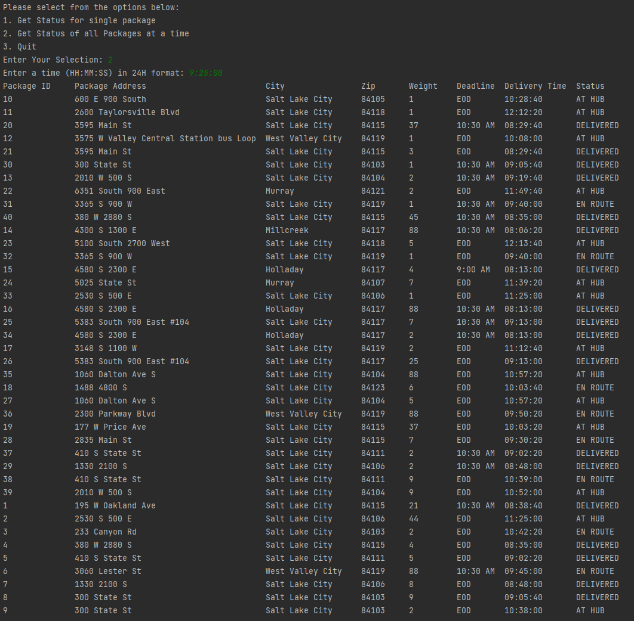

G2. Second Status Check
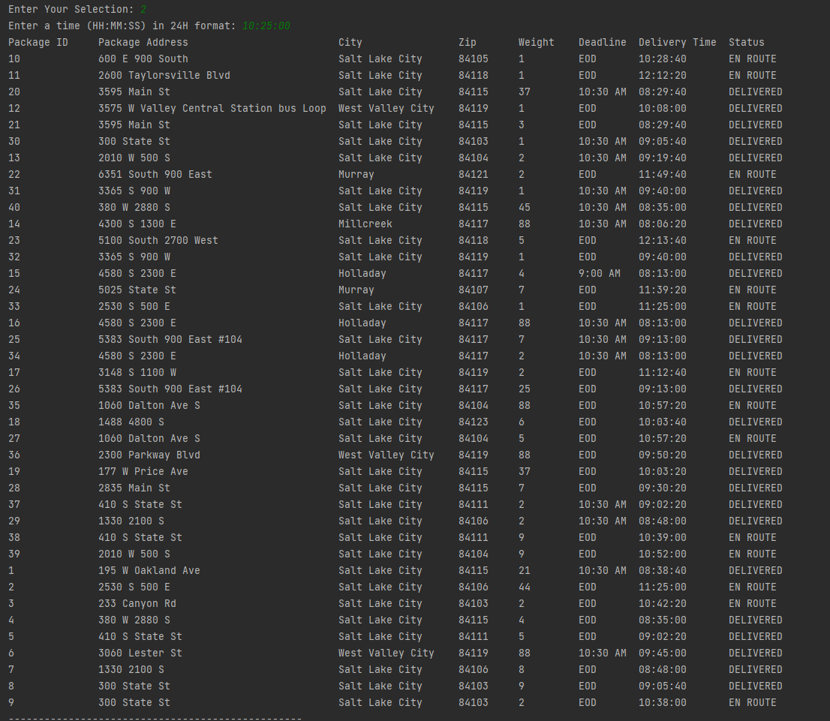

G3. Third Status Check
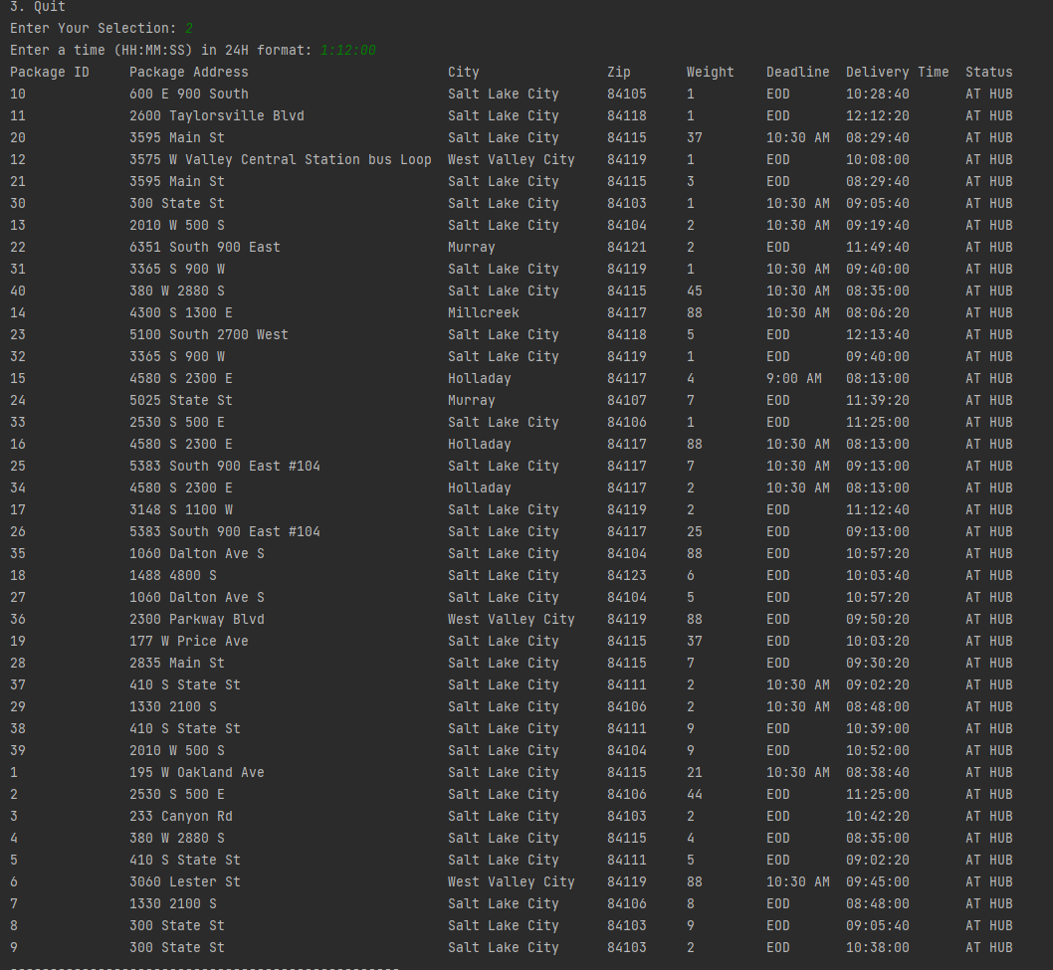

H. Screenshots of Code Execution
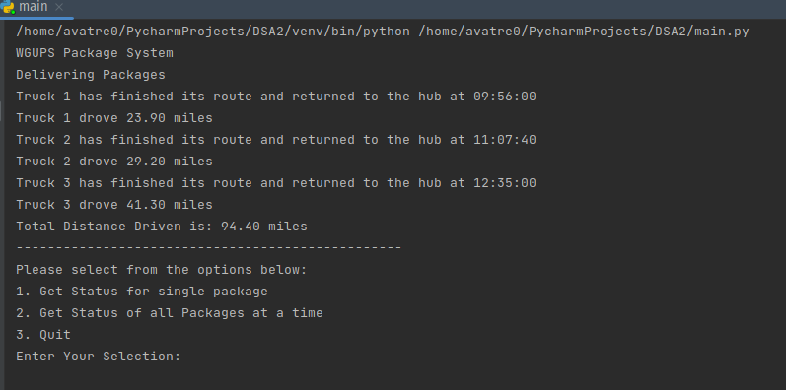

I1. Strengths of Chosen Algorithm
Accuracy: This algorithm delivers the packages on time and under millage. Delivering the packages in 94.40 miles.
Efficiency: The greedy algorithm is O(n) and thus is very efficient, and easy to implement

I3. Other possible Algorithms
Other possible approaches include:
Brute force algorithm.
Dijkstra's algorithm

I3A. Algorithm Differences
 | Brute Force | Dijkstra | Greedy
Time Complexity | O(n*m) | O(n^2) | O(n^2)
Advantages | Finds all routes | Low relative complexity | Easy to implement and low complexity

J. Different Approach
If I were to do this project again I would change the following,
Package assignment. As it is now, in order for the packages to be delivers on time and with the special requirements (only arriving at 9:05, only on truck 2, being delivered with other packages etc), requires the packages to be pre-sorted by hand onto the tucks. I would like to develop some auto sorting algo possibly based on zip code. Also this would require the package objects to have flags for the special requirements.

K1. Verification of Data Structure
The chaining hash table, meets all requirements. It delivered the packages in a total of 94.40 miles. All packages were delivered before deadlines. The table was also able to quickly lookup data inside it.

K1A. Efficiency
The worst case for lookup on the hash table is O(n). This table uses linear probing to find the packages. As packages are added the time to perform the lookup will increase.

K1B. Overhead
As packages are added to the hash table, the likelihood of hash collisions increases, increasing the size of the table. This also affects lookup time as the table will not only need to find the key in the hash, but then find the object in the linked list at the key. To combat this we can increase the size of the table at creation.

K1C. Implications
Changing the number of trucks will not increase the lookup time or space requirement of the hash table. The table does not store data based on trucks. Like wise changing he number of cities shouldn’t make any difference in the lookup process or time-space complexities.
The map only contains package object data, unless we add more packages there should be no changes to the lookup time or time-space complexities.

K2. Other Data Structures
Two other data structures that could be used are
1) Weighted Graph
2) Stack

K2a. Data Structure Differences
Stack: A stack could be created with the order in which packages are to be delivered. You push the item on the stack then pop them off to get the next package to be delivered. This would be more space efficient, but would require pre-loading of the trucks and finding the best path between them before pushing them onto the stack
Weighted Graph: Nodes would represent package delivery addresses. This would eliminate the need to find the next efficient route as it is built into the traversal. The graph would likely be more space-time efficient.

