Ansible Tower on the AWS Cloud

Quick Start Reference Deployment

Tony Vattathil

April 2016

This guide is also available in HTML format at http://aws.amazon.com/quickstart/



Contents

Overview 3

<software> on AWS 3

Quick Links 3

Cost and Licenses 4

Architecture 5

AWS Services 5

Best Practices 6

Design Considerations / Planning / Deployment Scenarios 7

Automated Deployment 8

Prerequisites 8

What We’ll Cover 8

Step 1. Prepare an AWS Account 9

Step 2. <Pre-Launch Tasks> 11

Step 3. Launch the <software> Stack 11

Step 4. <Post-Configuration Tasks> 13

Security 14

Any Other Sections, As Necessary 15

Additional Resources 16

Appendix: Title 19

Send Us Feedback 20

Document Revisions 20

About This Guide

This Quick Start reference deployment guide discusses the steps for deploying and testing a Ansible Tower. It also provides links for viewing and launching [AWS CloudFormation](http://aws.amazon.com/cloudformation/) templates that automate the deployment, and a walkthrough on how you can configure Amazon Elastic Compute Cloud (Amazon EC2) instances that act as Ansible Clients.

The guide is for IT infrastructure architects, administrators, and DevOps professionals who are planning to implement or extend their <software> workloads on the AWS cloud.

[Quick Starts](http://aws.amazon.com/quickstart/) are automated reference deployments for key workloads on the AWS cloud. Each Quick Start launches, configures, and runs the AWS compute, network, storage, and other services required to deploy a specific workload on AWS, using AWS best practices for and security.

# Overview

## Ansible Tower on AWS

## Ansible is designed to a simple IT automation engine that automates cloud provisioning, configuration management, application deployment, intra-service orchestration, and many other IT needs.

## Ansible is designed for multi-tier deployments form its inception, Ansible models your IT infrastructure by describing how all of your systems inter-relate, rather than just managing one system at a time.

## A key advantage to Ansible over other automation engines is that it uses no agents and no additional custom security infrastructure, so it's easy to deploy - and most importantly, it uses a very simple language (YAML, in the form of Ansible Playbooks) that allow you to describe your automation jobs in a way that approaches plain English. Ansible works by connecting to your nodes and pushing out small programs, called "Ansible Modules" to them. These programs are written to be resource models of the desired state of the system. Ansible then executes these modules (over SSH by default), and removes them when finished.

## Quick Links

**Launch   
Quick Start**

If you have an AWS account and you’re already familiar with AWS and Ansible, you can use the **Launch Quick Start** button to build the architecture shown in Figure 1. The deployment takes approximately 20 minutes. If you’re new to AWS or Puppet, please review the implementation details and   
follow the step-by-step instructions provided later in this guide   
to launch the Quick Start.

**View template**

If you want to take a look under the covers, you can choose   
**View template** to see the AWS CloudFormation template that automates this deployment. The default configuration deploys three servers that use the t2.medium instance type by default,   
but you can customize the template if you’d like.

## Cost and Licenses

You are responsible for the cost of the AWS services used while running this Quick Start reference deployment. There is no additional cost for using the Quick Start. As of the date of publication, the cost for using the Quick Start with default settings is approximately $0.18 an hour. Prices are subject to change. See the pricing pages for each AWS service you will be using or the [AWS Simple Monthly Calculator](http://calculator.s3.amazonaws.com/index.html) for full details.

This QuickStart deploy Ansible Tower on AWS cloud and along with Ansible Linux Ansible Client. Ansible and Ansible Tower have separate licensing models.

Ansible Tower Licenses

Ansible Tower is subject to the Ansible Software Subscription and Services Agreement located at http://www.ansible.com/subscription-agreement. Ansible Tower is a proprietary product offered by Ansible, Inc. and its use is not intended to prohibit the rights under any open source license.

While a license is required for Tower to run, there is no fee for managing up to 10 hosts This document provides a walk though of how to acquire a 10 host license

Ansible Licenses

Ansible is licensed under the [GNU General Public License](https://en.wikipedia.org/wiki/GNU_General_Public_License)

# Architecture

Deploying this Quick Start with the **default parameters** builds the following environment in the AWS cloud.

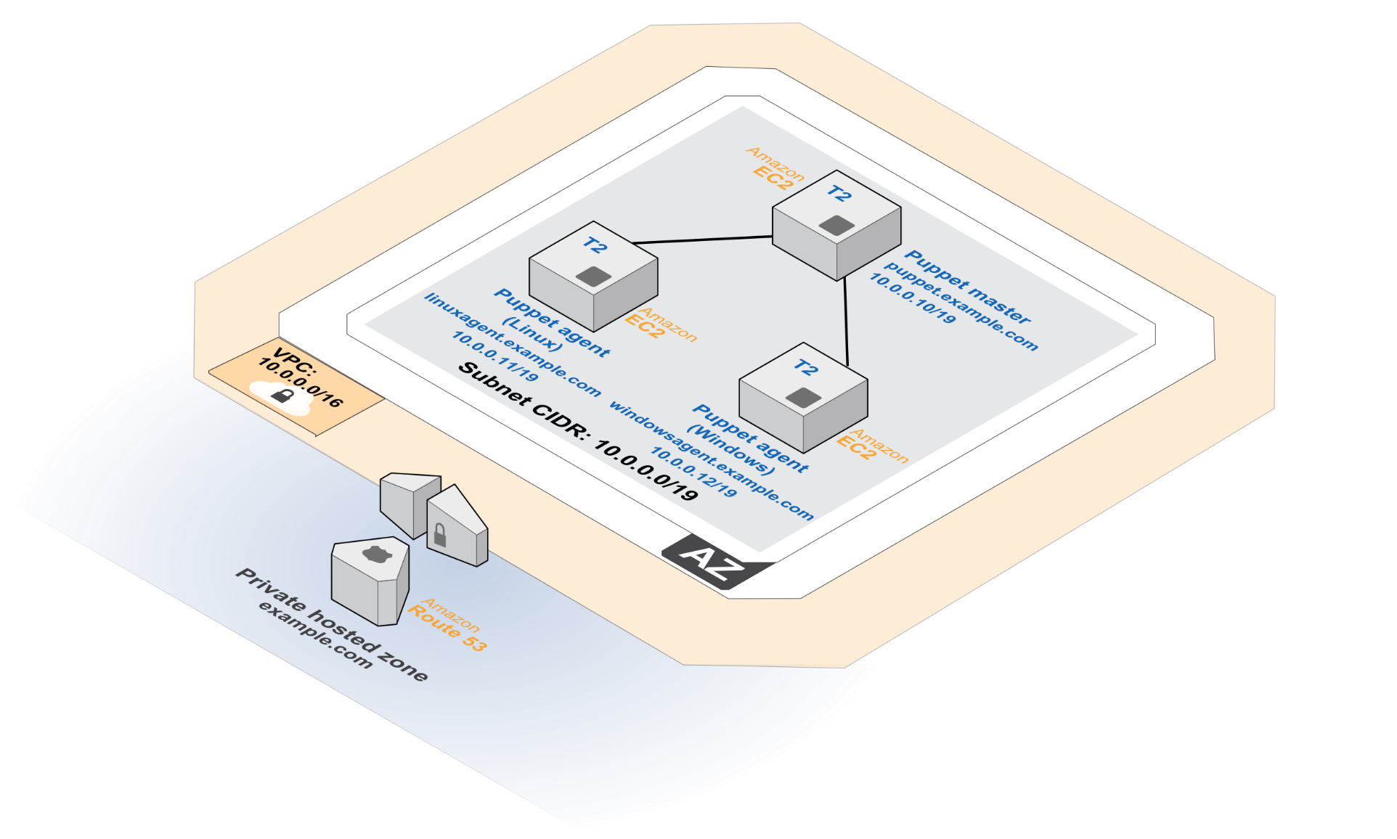Figure 1: Quick Start Ansible Tower on AWS

This Quick Start deploys the resources shown in Figure 1 and uses them as follows:

* An Amazon VPC is created in the region you choose when you launch the stack. A single, public VPC subnet is created in a random Availability Zone.
* One Centos client is deployed as a client into the VPC subnet. RHEL Clients can also be attached using the same procedure detailed in this document.

# Implementation Details

This section discusses the implementation of this Quick Start and explains the considerations for installing and configuring Puppet on AWS. Note that some steps are manual and others are automated for you by this Quick Start.

## AWS Services

The core AWS components used by this Quick Start include the following AWS services. (If you are new to AWS, see the [Getting Started section](http://docs.aws.amazon.com/gettingstarted/latest/awsgsg-intro/intro.html) of the AWS documentation.)

* [Amazon VPC](http://aws.amazon.com/documentation/vpc/) – The Amazon Virtual Private Cloud (Amazon VPC) service lets you provision a private, isolated section of the AWS cloud where you can launch AWS services and other resources in a virtual network that you define. You have complete control over your virtual networking environment, including selection of your own IP address range, creation of subnets, and configuration of route tables and network gateways.
* [Amazon EC2](http://aws.amazon.com/documentation/ec2/) – The Amazon Elastic Compute Cloud (Amazon EC2) service enables you to launch virtual machine instances with a variety of operating systems. You can choose from existing Amazon Machine Images (AMIs) or import your own virtual machine images.
* [Amazon Route 53](https://aws.amazon.com/route53/) – Amazon Route 53 is a highly available and scalable cloud Domain Name System (DNS) web service. It is designed to give developers and businesses an extremely reliable and cost-effective way to route end users to Internet or internal applications by translating host names to IP addresses.

## Ansible Tower Installation

This Quick Start deploys the Puppet master on an EC2 instance that is running Centos7. The installation is automated with a user data script that executes when the instance is launched via AWS CloudFormation. Ansible tower installation files are installed directly from Ansible’s release server

In addition to installing the Ansible Tower a Client is also deployed into the VPC. Please the the section on **Connecting Clients to Ansible** to see how you can attach instances to tower

# Automated Deployment

The AWS CloudFormation template provided with this Quick Start bootstraps the AWS infrastructure and automates the deployment of Ansible Tower on the AWS cloud from scratch. Follow the step-by-step instructions in this section to set up your AWS account, customize the template, and deploy the software into your account.

## What We’ll Cover

The procedure for deploying Ansible Tower on AWS consists of the following steps. For detailed instructions, follow the links for each step.

Prerequisites

* Set up and enable name resolution via DNS.
* Make sure you can use Secure Shell (SSH) for remote connections.

Step 1. Prepare an AWS account

* Sign up for an AWS account, if you don’t already have one.
* Choose the region where you want to deploy the stack on AWS.
* Create a key pair in the region.
* Review account limits for Amazon EC2 instances, and request a limit increase, if needed.

Step 3. Launch the stack

* Launch the AWS CloudFormation template into your AWS account.
* Enter a value for **All parameters** the require input
* Review the other template parameters, and customize their values if necessary.

Step 3 Get Ansible Tower License

* Connect to your Ansible Clients via web browser and follow the steps to license Ansible Tower

## Step 1. Prepare an AWS Account

1. If you don’t already have an AWS account, create one at <http://aws.amazon.com> by following the on-screen instructions. Part of the sign-up process involves receiving a phone call and entering a PIN using the phone keypad.
2. Use the region selector in the navigation bar to choose the Amazon EC2 region where you want to deploy Puppet on AWS.

Amazon EC2 locations are composed of [*Regions* and *Availability Zones*](http://docs.aws.amazon.com/AWSEC2/latest/UserGuide/using-regions-availability-zones.html). Regions are dispersed and located in separate geographic areas.

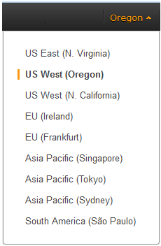

Figure 2: Choosing an Amazon EC2 Region

**Tip** Consider choosing a region closest to your data center or corporate network to reduce network latency between systems running on AWS and the systems and users on your corporate network.

1. Create a [key pair](http://docs.aws.amazon.com/AWSEC2/latest/UserGuide/ec2-key-pairs.html) in your preferred region. To do this, in the navigation pane of the Amazon EC2 console, choose **Key Pairs**, **Create Key Pair**, type a name, and then choose **Create**.

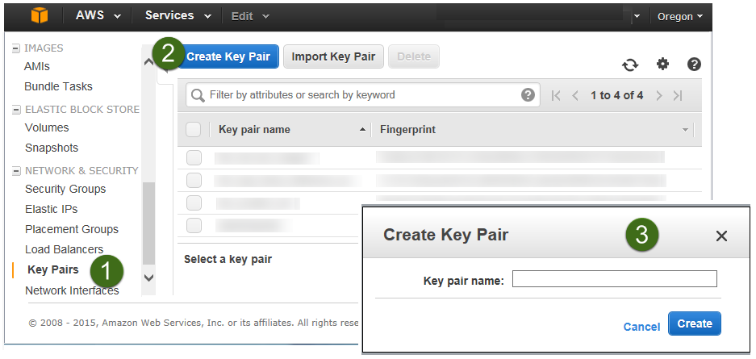

Figure 3: Creating a Key Pair

Amazon EC2 uses public-key cryptography to encrypt and decrypt login information. To be able to log in to your instances, you must create a key pair. With Windows instances, we use the key pair to obtain the administrator password via the Amazon EC2 console and then log in using Remote Desktop Protocol (RDP) as explained in the [step-by-step instructions](http://docs.aws.amazon.com/AWSEC2/latest/UserGuide/ec2-key-pairs.html#having-ec2-create-your-key-pair) in the *Amazon Elastic Compute Cloud User Guide*. On Linux, we use the key pair to authenticate SSH login.

1. If you would like to use a different instance type, [request a service limit increase](https://console.aws.amazon.com/support/home#/case/create?issueType=service-limit-increase&limitType=service-code-) for the Amazon EC2 **t2.medium** instance type. To do this, in the AWS Support Center, choose **Create Case**, **Service Limit Increase**, **EC2 instances**, and then complete the fields in the limit increase form. The current default limit for this instance type is 20 instances.

You might need to request an increase if you already have an existing deployment that uses this instance type, and you think you might exceed the default limit with this reference deployment. It might take a few days for the new service limit to become effective. To learn more, see [Amazon EC2 Service Limits](http://docs.aws.amazon.com/AWSEC2/latest/UserGuide/ec2-resource-limits.html) in the AWS documentation.

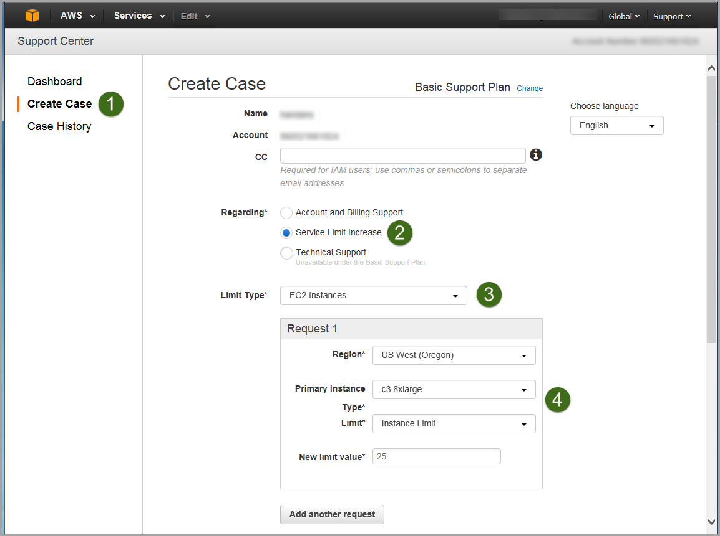

Figure 4: Requesting a Service Limit Increase

## Step 2. Launch the Ansible Tower Stack

The automated AWS CloudFormation template provided with this Quick Start deploys Ansible Tower into an Amazon VPC. Please make sure that you’ve completed the previous steps before launching the stack.

**Launch   
Quick Start**

1. Launch the AWS CloudFormation template into your AWS account.

The template is launched in the US West (Oregon) Region by default. You can change the region by using the region selector in the navigation bar.

This stack takes approximately 20 minutes to create.

**Note** You are responsible for the cost of the AWS services used while running this Quick Start reference deployment. There is no **additional cost** for using this Quick Start.

You can also [download the template](https://s3.amazonaws.com/quickstart-reference/puppet/latest/templates/Puppet-QuickStart.template) to use it as a starting point for your own implementation.

1. On the **Select Template** page, keep the default URL for the AWS CloudFormation template, and then choose **Next**.
2. On the **Specify Details** page, review the parameters for the template. These are described in the following table.

Provide a value for the **KeyPairName** parameter. This parameter require your input. For all other parameters, the template provides default settings that you can customize.

|  |  |  |  |
| --- | --- | --- | --- |
| Parameter label | Parameter name | Default | Description |
| Select a key pair | **KeyPairName** | *Requires input* | Public/private key pair, which enables you to connect securely to your instance after it launches. When you created an AWS account, this is the key pair you created in your preferred region. |
| Set you Tower Admin Password | **AnsibleAdminPassword** | *Requires input* | Must be at least 8 characters containing letters and (minimum 1 capital letter)  (e.g., An$ibl3ChgMe). |
| Source IP for remote access | **RemoteAdminCIDR** | 0.0.0.0/0 | CIDR block or IP address for SSH (e.g., 1.1.1.1/32). |
| CIDR range for your VPC | **VPCCIDR** | 10.0.0.0/16 | CIDR block for the VPC. |
| CIDR range for the subnet in your VPC | **SubnetCIDR** | 10.0.0.0/19 | CIDR block for the subnet. |
| IP address for the Puppet master | **AnsibleTowerIP** | 10.0.0.10 | This is the private IP of your Ansible tower |
| IP address for the Linux Puppet agent | **AnsibleClientLinuxIP** | 10.0.0.11 | IP address of a Linux Instance that can be managed by Ansible |

**Note** You can also [download the template](https://s3.amazonaws.com/quickstart-reference/ansible/latest/templates/Ansible-Tower-QuickStart.template) and edit it to create your own parameters based on your specific deployment scenario.

1. On the **Options** page, you can [specify tags](https://docs.aws.amazon.com/AWSCloudFormation/latest/UserGuide/aws-properties-resource-tags.html) (key-value pairs) for resources in your stack and [set additional options](https://docs.aws.amazon.com/AWSCloudFormation/latest/UserGuide/cfn-console-add-tags.html). When you’re done, choose **Next**.
2. On the **Review** page, review and confirm the settings.
3. Choose **Create** to deploy the stack.
4. Monitor the status of the stack. When the status is **CREATE_COMPLETE**, the Puppet cluster is ready.

## Step 3. Licensing Ansible Tower

1. Navigate to the IP or hostname of your Ansible tower. The ip address can be found in the output section of the Ec2Stack. 
2. You will need to trust the self signed cert. (We recommend that you add your cert to Ansible Tower for higher security) 
3. Click on Advanced to and click proceed to reach the Ansible Web UI 
4. Provide the credential to you noted when you launched this quickstart access Ansible Tower

The default **username** is: **admin**

The **password** is :<the password you set during launch>



(if you forgot your password it will be in the tower_setup_conf.yml which can be found here in your root home dir

The following command will display the admin password

**[centos@ip-10-0-0-10 ~]$ sudo grep admin_password /root/ansible-tower-setup-bundle-2.4.4-1.el7/tower_setup_conf.yml**

**WARNING: This file contains admin user credential we recommend that you delete this folder after you retrieve your credentials**

If you need instructions on ssh to you ec2-instance, **please see the section on accessing ec2 instances**

Note: On CentOS the username to connect is centos not ec2-user

1. Upon successful login you will reach the screen show below. Click the red box to Get a Free Tower Trial License. This action will open a new window navigate to the open window and select **10-NODE BASIC TOWER - FREE TRIAL.** Enter the information requested

Click on the checkbox on the bottom of the screen if you agree with the End User License Agreement. Then

# Troubleshooting

If you encounter a CREATE_FAILED error, we recommend that you relaunch the template with **Rollback on failure** set to **No**. (This setting is under **Advanced** in the AWS CloudFormation console, **Options** page.) With this setting, the stack’s state will be retained and the instance will be left running, so you can troubleshoot the issue.

**Important** When you set **Rollback on failure** to **No**, you’ll continue to incur AWS charges for this stack. Please make sure to delete the stack when you’ve finished troubleshooting.

For additional information, see [Troubleshooting AWS CloudFormation](http://docs.aws.amazon.com/AWSCloudFormation/latest/UserGuide/troubleshooting.html) on the AWS website. If the problem you encounter isn’t covered on that page above, please visit the [AWS Support Center](https://console.aws.amazon.com/support/)

# Security

A security group acts as a firewall that controls the traffic for one or more instances. When you launch an instance, you associate one or more security groups with the instance. You add rules to each security group that allow traffic to or from its associated instances. You can modify the rules for a security group at any time. The new rules are automatically applied to all instances that are associated with the security group.

The security groups created and assigned to the individual instances as part of this solution are restricted as much as possible while allowing access to the various functions needed by Puppet. We recommend that you review security groups and further restrict access as needed once Puppet is up and running.

# Additional Resources

**AWS services**

* Amazon EC2  
  <http://aws.amazon.com/documentation/ec2/>
* AWS CloudFormation  
  <http://aws.amazon.com/documentation/cloudformation/>
* Amazon VPC  
  <http://aws.amazon.com/documentation/vpc/>
* Amazon Route 53  
  <https://aws.amazon.com/documentation/route53/>

**Puppet resources**

* Puppet documentation  
  <https://docs.puppetlabs.com>
* Puppet Labs Training  
  <https://learn.puppetlabs.com>
* Puppet on AWS  
  <https://puppetlabs.com/solutions/aws>
* Provision AWS Infrastructure Using Puppet (blog post)  
  <https://puppetlabs.com/blog/provision-aws-infrastructure-using-puppet>
* Automating AWS with Puppet (video)  
  <https://youtu.be/eyR0LVjxJAs>
* Puppet and AWS: Getting the Best of Both Worlds (video)  
  <https://puppetlabs.com/presentations/puppet-and-aws-getting-best-both-worlds>
* Puppet Forge  
  <https://forge.puppetlabs.com/>
* Puppet Community  
  <https://puppetlabs.com/community/overview>

**Quick Start reference deployments**

* AWS Quick Start home page  
  <https://aws.amazon.com/quickstart/>
* Quick Start deployment guides  
  <https://aws.amazon.com/documentation/quickstart/>

# Send Us Feedback

We welcome your questions and comments. Please post your feedback on the [AWS Quick Start Discussion Forum](https://forums.aws.amazon.com/forum.jspa?forumID=178).

# Additional Resources

**AWS services**

* AWS CloudFormation  
  <http://aws.amazon.com/documentation/cloudformation/>
* Amazon EC2
* User guide for Microsoft Windows: <http://docs.aws.amazon.com/AWSEC2/latest/WindowsGuide/>
* AWS request to remove email sending limitations: <https://portal.aws.amazon.com/gp/aws/html-forms-controller/contactus/ec2-email-limit-rdns-request>
* Amazon Route 53  
  <http://aws.amazon.com/documentation/route53/>
* Amazon VPC  
  <http://aws.amazon.com/documentation/vpc/>

**Quick Start Reference Deployments**

* AWS Quick Start home page  
  <https://aws.amazon.com/quickstart/>
* Quick Start deployment guides  
  <https://aws.amazon.com/documentation/quickstart/>

# Document Revisions

|  |  |  |
| --- | --- | --- |
| Date | Change | In sections |
| April 2016 | Initial publication | - |