

Avazu Tracking SDK Setup

This guide is a document to describe the integration of Avazu Tracking’s iOS and Android SDKs to enable a conversion tracking for Avazu’s mobile app advertisers.

1.Android SDK Tracking 1
Mandatory Permissions 2
Include AvazuTracking Libraries 2
Source Code Changes 2
2. IOS SDK Tracking 2
Import SDK into your Project 3
Integrating tracking SDK 5
FAQ: 6

1.Android SDK Tracking

Mandatory Permissions
Add the INTERNET and ACCESS_NETWORK_STATE permissions to your AndroidManifest.xml file just before the closing </manifest> tag:
<uses-permission android:name="android.permission.INTERNET" />
<uses-permission android:name="android.permission.ACCESS_NETWORK_STATE" />

Include AvazuTracking Libraries
Add the avazutracking-android-sdk.jar to the Libs folder in your project.
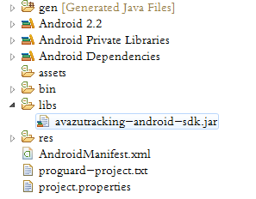

Source Code Changes
Invoke the method within the onCreate of your first activity:

+ (void)reportAppDownloadGoalWithSales:(NSString *)sales;

Parameter | Required | Description | Example
NSString *sales | Yes | Custom User Id | Your sales, if not it fill @"0.00"

- IOS SDK Tracking

Avazu Tracking iOS SDK Requirements:
The Avazu Tracking SDK for iOS contains the code necessary to integrate Avazu’s in-app conversion tracking into your applications. This SDK is designed to work across all iOS platforms, with a minimum OS version of 5.0.
To integrate, perform the below steps:

Import SDK into your Project
Copy the SDK directory into your project directory at first, then open up the popup menu and click into your project within Xcode, and select “Add File to “Your project name”” to import our SDK.
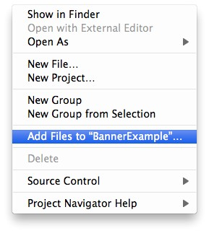

Adding Frameworks
You will need to add some optional/mandatory frameworks into your Xcode project for the SDK . The frameworks required to compile the Avazu Tracking SDK library are given below:
- AVFoundation.framework
- AdSupport.framework
- libz.1.2.5.dylib
- MapKit.framework
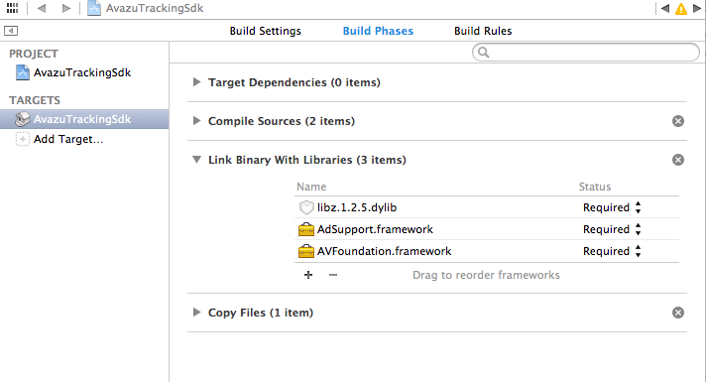
Note: You should mark all framework as optional if your code compiles below iOS version 6.0.

Integrating tracking SDK
It is mandatory to run the SDK Tracking before app launch.
Import the header files of SDK files in the application delegate file as shown below:
#import "AvazuTracking.h"
Perform the Avazu Tracking SDK to send a signal to our tracking server during the first launch of your app within the application delegate file as shown below:
Note: Once your app is installed and launched, our server is getting called and an install is tracked.
- (BOOL)application:(UIApplication *)application didFinishLaunchingWithOptions:(NSDictionary *)launchOptions
{
self.window = [[UIWindow alloc] initWithFrame:[[UIScreen mainScreen] bounds]];
// Override point for customization after application launch.
self.window.backgroundColor = [UIColor whiteColor];
[self.window makeKeyAndVisible];

// Avazu Tracking Sdk
[AvazuTracking reportAppDownloadGoalWithSales:nil];
}

FAQ:
OK, we’ve imported the Avazu Tracking SDK. What to do to get you track conversions?
Read the doc above and use the SDK method + (void)reportAppDownloadGoalWithSales:(NSString *)sales to enable us track your conversion data.
Where can I get more information for the SDK integration?
Please contact your respective Avazu contact to help you for the integration.

Where do it downloadd?
Please entry your terminal, than input the command “git clone https://github.com/avazu/AvazuTrackingSdk.git” to download it.

