Team D – Phoenix - Slack/Hipchat collaboration tool

**Client**: Dr. Michael Oudshoorn

**Team Members’ Roles**

|  |  |
| --- | --- |
| Project Name: | Slack/Hipchat collaboration tool |
| Team Name: | Phoenix |
| Team Members: | 7 |

|  |  |  |  |  |
| --- | --- | --- | --- | --- |
| Team Member | Role | Email | Contact No. | Responsibilities |
| Sanjay Bedudoori | Primary Contact | [S528106@nwmissouri.edu](mailto:S528106@nwmissouri.edu) | +1 660-528-0163 | Represents the entire team and primary contact to the client. Communicates project progress, issues and changes with the client. |
| Venkata Bhardwaj Avasarala | Client Management | [S528103@nwmissouri.edu](mailto:S528103@nwmissouri.edu) | +1 660-528-0954 | Responsible for meeting with a client, give updates to the client and get requirements from client. |
| Sudharshan Reddy Kankara | Requirements management | [S528138@nwmissouri.edu](mailto:S528138@nwmissouri.edu) | +1 660-528-0849 | Responsible for requirements gathering, maintaining and updating them as per client. Also, makes sure that these requirements are met. |
| Shravani Alampalli | Issues management | [S528100@nwmissouri.edu](mailto:S528100@nwmissouri.edu) | +1 484-644-8469 | Responsible for tracking all the issues and ensures that they are resolved on time. |
| Hemanth Sai Kishore Nersu | Data Management | [S528158@nwmissouri.edu](mailto:S528158@nwmissouri.edu) | +1 660-528-0191 | Responsible for collecting, storing, managing the data in the database and connect data with the system. Manages all the data of the project including the database. |
| Anudeep Reddy Mallidi | Quality and testing management | [S528146@nwmissouri.edu](mailto:S528146@nwmissouri.edu) | +1 660-541-3937 | Responsible for handling quality and testing throughout the SDLC process. Manages test cases and provides appropriate deliverables for the test modules. |
| Vineeth Gajula | Communications and documentation management | [S528124@nwmissouri.edu](mailto:S528124@nwmissouri.edu) | +1 660-528-0509 | Manages all the documentation and communication for the project. Tracks all the changes and maintain them. |

**What we have accomplished this week:**

After two client meetings in this week, we have decided our domain as "Project Management Collaboration tool". We have done our research on chatting applications, shared calendar, integration of google drive in this collaboration tool using Google Drive's API , different encryption techniques on plain text which can be used for encrypting messages, Screen sharing application, and different types of databases. We have finalized on some requirements and assigned different team members who will be working on those requirements.

**Requirements Gathered:**

Application will have user login and create account screens.

Application allows user to create team or join team.

Once team is formed, teams can edit documents using shared docs.

Application provides messaging, where teams can chat among themselves.

Application provide teams to store documents and project related files in google docs.

Different roles with in the team can be assigned and permissions can be given.

Application help team members to create tasks and assign tasks to members automatically or manually.

Application provides shared calendar where teams can schedule meetings.

**Findings:**

The google drive integration is available for various platforms and is flexible for the

collaboration tool.

<https://developers.google.com/drive/v3/web/about-sdk>

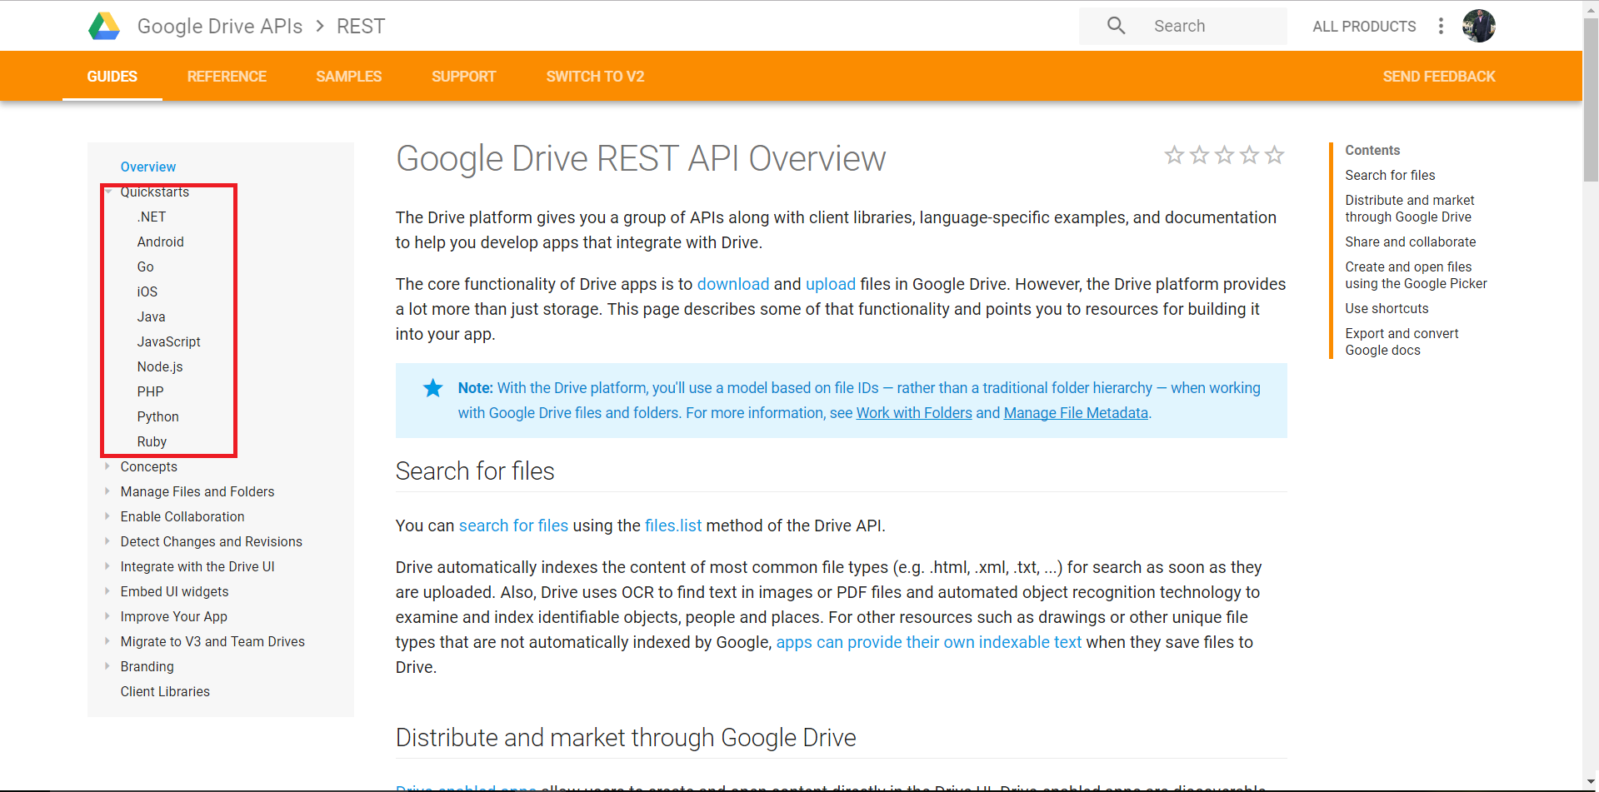

**Client notes:**

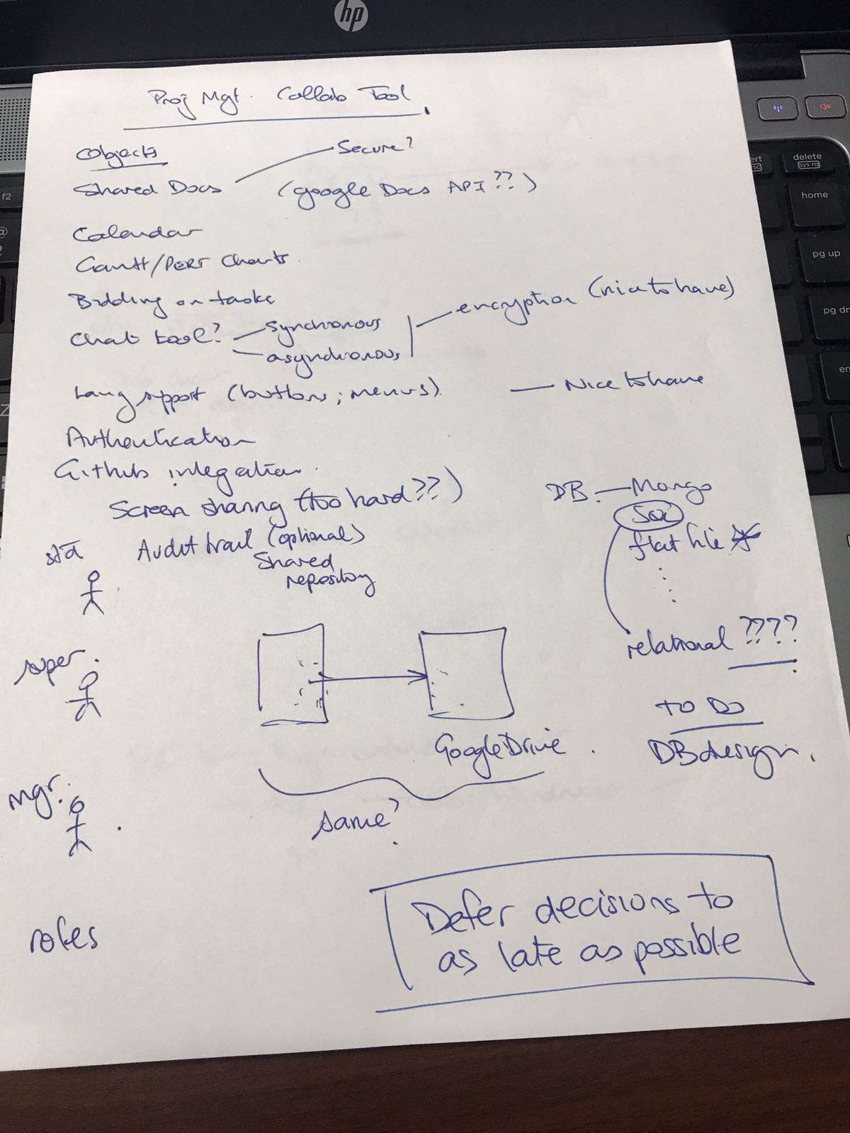

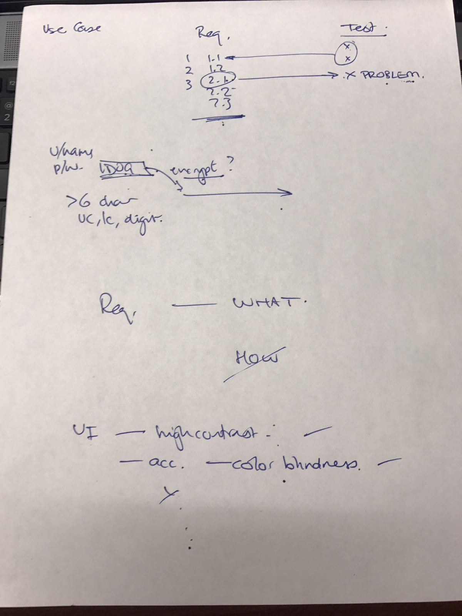

**What we are planning to accomplish next week:**

Next week we will start requirement document. Each team member will be responsible for documenting requirements in requirement document along with use cases and test cases for each requirement.

|  |  |
| --- | --- |
| List of proposed requirements | Assigned to |
| Shared document | ore Hemath Sai Kishore Nersu |
| Shared Calendar | Vineeth Gajula |
| Chat tool | Sudharshan Reddy Kankara |
| Task creation | Sanjay Bedudoori |
| Task Assigning | Sravani Alampalli |
| Roles to team members | Anudeep Reddy Mallidi |
| Google drive integration | Venkata Bhardwaj Avasarala |
| System overview | Sanjay Bedudoori |

GitHub Repository Link:

<https://github.com/vineethgajula1/GDP-Project>