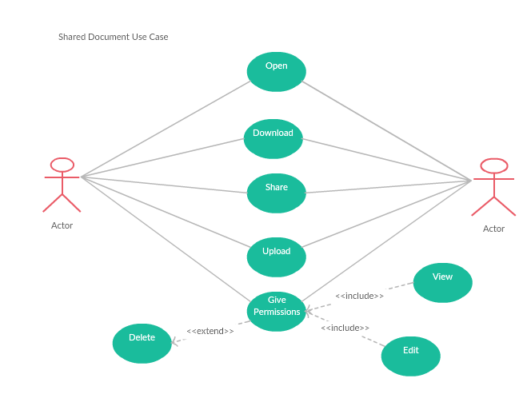

1. User can share documents to other user, this documents may include PDF, docx, ppt etc.
2. User can open, download, share, and upload the documents and give permissions to another user.
3. If the receiver wants to edit the document it will be redirected to google docs where he /she can edit the documents.
4. Sender should give permissions like view, edit, delete and giving permissions like view and edit is mandatory but giving delete is an optional one.