**R5.Chat Tool:**

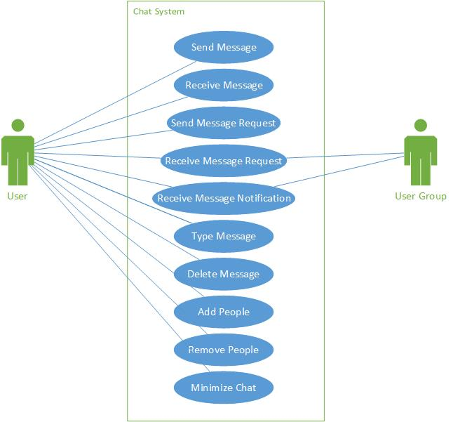

R5.1 User should be able to send and receive messages

R5.2 User should be able to create a group

R5.3 User should be able to add and remove users

R5.4 User should be able to send and receive join requests for joining a conversation or a group

R5.5 User should be able to type and delete a message

R5.6 User should be able to minimize the chat