Software Requirements Specification

Version 1.0

June 26, 2017

Project Management Collaboration Tool

Sanjay Bedudoori

Venkata Bhardwaj Avasarala

Sudharshan Reddy Kankara

Shravani Alampalli

Hemanth Sai Kishore Nersu

Anudeep Reddy Mallidi

Vineeth Gajula

Submitted in partial fulfillment

Of the requirements of

CSIS44-691 Graduate Directed Project 1

Contents

1.0. Introduction 2

1.1. Purpose 2

1.2. Scope of Project 3

2. Requirements 3

R1. Application Signup/Login and Home page 3

R2. Shared Calendar 4

R3. Task Management 5

R4. Shared Document 7

R5. Messaging 7

R6. Google Drive Integration ………………………………………………………..8

3. System Features

3.1. Core Features…………………………………………………………………...9

3.2. Additional Features……………………………………………………………..

# Introduction

## 1.1. Purpose

The purpose of this Software Requirement Specification document is to provide a detailed description of Project Management collaboration tool. It will explain the purpose and features of the system, what the system will do, as well as propose a initial glimpse of the software application’s User Interface. The document will also cover hardware, software and various other technical dependencies.

## 1.2. Scope of Project

The collaboration tool is a project management tool used by teams to work on together, it supports messaging, where messages are sent directly to a person or to a group of people. All files, images, PDF's, documents and spreadsheets can be shared with everyone. Group meetings can be scheduled in shared calendars. Sending notifications and reminders to team members about task deadlines and task progress.

Posting deadlines for the tasks so that an individual can track his/her performance and push notifications about the status of the task. The permissions will be assigned to different users based on their role in the organization which can be managed by the Administrator.

## 1.3. Glossary

|  |  |
| --- | --- |
| **Term** | **Definition** |
| Collaboration tool | Application that helps people to collaborate. The purpose is to support a group of people to achieve a common goal. |
| Calendar | A system for organizing days. A list of planned events can be set. |
| Task Management | Application which allow group of people to work on tasks and manage tasks. |
| Integration | Using Application programming interface of a system in other application and making combined use of both applications. |
| Google Drive | A File storage and organization service. Allows user to share and store their files in cloud. |
| Dashboard | User’s board where user can use the application and customize settings |
| Software Requirements Specification | A document that describes a software system to be developed. It includes functional and non-functional specifications of the software system. |

PRODUCT FEATURES

The following list proposes an outline of key features and functionalities of the Project Management Collaboration tool. Features are divided into two main categories: core features and additional features. Core features are crucial to the application’s operation and will be implemented. Additional features are optional and will be implemented only if time permits.

CORE FEATURES

1. User Sign up & Login

* Allows user to create account with the Project management collaboration tool.
* Enables the user to login into application.
* If the user is not validated, an error message is shown.

1. Group Creation & joining a group

* Allows the user to create and organize groups.
* Allows the user to invite group members by sending invitation to their email accounts.
* Enables user to join the group through the invitation link in their email account.

1. Shared Calendar

* Allows the user to create events by filling start time, end time and description of event.
* Allows the user to send invitations to other users.
* Allows the user to respond to event with accept or decline.

1. Messaging
   * Allows the user to send text messages to a group.
   * Allows the user to send text message to a specific user.
2. Task Management
   * Allows the user to create task with description and deadline.
   * Allows the user to view the status of all tasks.
   * Allows the user to work on task and add notes to task.
3. Google Drive Integration
   * Allow users to invite others to view, download and collaborate on all the files.

ADDITIONAL FEATURES

1. Language Support
   * Allows the user to select language at first time the application runs.
2. Video calling
   * Allows the user to video chat with others.

# 2.0 Functional Requirements

# R1. Application start page

**R1.1** If user opens the application, home page should be displayed. Home page will contain application’s introduction.

**R1.2** Else, Error: Unable to open application, reinstall or refresh the application.

R2. Home page

**R2.1** User should be able view login button and sign up on the top right corner of the page.

**R2.2** Login page is displayed when user clicks on login button.

**R2.3** Else, Error: Unable to open login page, refresh the application.

R3. Login page

**R3.1** Login page will contain text field for email address.

**R3.2** Login page will contain text field for password and password will be hidden when entered.

**R3.3** Login page will contain login button.

**R3.4** Login page will contain “Not an existing user, create a new account” link.

**R3.5** If link is clicked, User shall be redirected to sign up page.

**R3.6** Both the fields, email and password must be marked with * indicating them as mandatory fields.

**R3.7** If the user enters incorrect email with the correct password, “Please enter valid email address” should be displayed.

**R3.8** If the user enters incorrect password with the correct email address, “please enter valid password” should be displayed.

**R3.9** If the user leaves the email field blank, “Username is a mandatory field. Please enter a valid

user name to log in” message should be displayed.

**R3.10** If the user leaves the password field blank, “Password is a mandatory field. Please enter a valid password to log in” message should be displayed.

**R3.11** If the user leaves both the fields that is the email and password as blank the message “Cannot login with mandatory fields left blank” must be displayed.

**R3.12** If the user enters correct credentials he should be able to view the dashboard of his/her account.

R4. Sign Up page

**R4.1** If theuser clicks on sign up button on home page or “Not an existing user, create a new account” link on sign in page. Page is redirected to sign up page.

**R4.2** The sign-up page should consist of fields asking the user to input email, password and confirm password.

**R4.3** The fields email, password, confirm password should be mandatory.

**R4.4** If the user left out any of the mandatory field as blank the message “Mandatory fields should not be left blank” should be displayed.

**R4.5** Validate if the fields password and confirm password are the same.

**R4.6** If the fields password and confirm password are not same display “please make sure the input you enter in both the fields is same” should be displayed.

**R4.7** Once the user enters all the details he should be able to view the create button on the bottom of the sign-up page.

**R4.8** If the user enters all the details as per the requirements on clicking on the create button, the message “successfully created your account” should be displayed.

**R4.9** Once the user creates account he should be able to login to the application by providing his/her credentials in the login page.

R5. Group Creation

**R5.1** If the user logs in for the first time, page shall contain “Create New group” or “Join existing group” text fields.

**R5.2** Else user shall be able to view team’s dashboard.

**R5.3** If user enters a unique group name and clicks on “Create New group” button, a new group is created and page is redirected to “invites” page.

**R5.4** Invites page will contain text field and “send invitations” button.

**R5.5** In text field, user must enter email address of group members separated by comma (,).

**R5.6** Invitations will be sent to the respective email address on click of submit button.

**R5.7** User shall be able to input unique group ID in “Join existing group” and click submit.

**R5.8** A join request will be send to team members email and any one of team member can accept it.

R6. User Dashboard

**R6.1** User dashboard contains tabs on left-hand side of the screen.

**R6.2** Tabs conatin calendar, chat, docs, task management, go to google drive options.

**R6.3** User dashboard contains user’s information on right-hand side of the screen which includes username, team members names and general settings tab.

**R6.4** Whenever user clicks on tabs on left-hand side of the screen, correspoding functionalities will be viewed in the middle of the screen.

R7. Shared Calendar

**R7.1** Calendar is displayed in the middle section of the screen, when user clicks on calendar tab on left hand side of the screen.

**R7.2** A popupis displayed when user click on a day in calendar.

**R7.3** User shall be able to create an event, edit the event details like: event name, event location, date, time or delete event in the popup window.

**R7.4** User shall be able to send invitations to another single user or a group of users.

**R7.5** User shall be able to view the event and respond to the event by accepting or declining the invitation in the popup window, when an event is clicked.

**R7.6** A user who accepts the invitation will be able to see the shared calendar and view all the events he/she will attend.

R8. Task Management

**R8.1** All tasks and a “Create Task” button is displayed in the middle section of the screen, when user clicks on task management tab on left hand side of the screen.

**R8.2** User shall be able to view “create task” page by clicking on “Create Task” button.

**R8.3** “Create task” page will conatin task description, assigned to, task deadline field and save button.

**R8.4** User shall be able to fill all the fields and click on save button. Page will be redirected to “tasks” page and new task will be appended to the previous tasks at the bootom.

**R8.5** User shall be able to view all the tasks that includes task description, whom the task is assigned to, task deadline and status in “tasks” page.

**R8.6** User shall be able to double click any task and view task details in “task detail” page.

**R8.7** User shall be able to set task start and end date and click on save button to save the changes.

**R8.8** User shall be able to change status of task to assigned, in progress and completed.

**R8.9** User shall be able to reassign task to other team members.

**R8.10** User shall be able to add notes to the task and added notes appears in the work detail.

R9. Messaging

**R9.1** User shall be able to open the chat application by clicking on messaging tab on left hand side of the screen.

**R9.2** User shall be able to look at all his contacts in the chat application

**R9.3** User shall be able to click on a particular user and see all his previous chats/start a new chat

**R9.4** User shall be able to click on the add button and send request to new users for chatting with him

**R9.5** User shall be able to send messages.

**R9.6** User shall be able to receive messages.

**R9.7** User shall be able to create a group.

**R9.8** User shall be able to change the settings of a group by clicking on group description inside a group.

**R9.9** User shall be able to add users by clicking on add button inside the settings of a group.

**R9.10** User shall be able to remove a user by clicking on delete a user in the right corner of a user name displayed inside the list of users.

**R9.11** User shall be able to send join requests for joining a conversation or a group.

**R9.12** User shall be able to receive join requests for joining a conversation or a group.

**R9.13** User shall be able to type a message.

**R9.14** User shall be able to send a typed message by clicking on send button.

**R9.15** User shall be able to delete a received or sent message by long pressing the message and then clicking on delete message displayed in a small window near the long-pressed message.

**R9.16** User shall be able to minimize the chat by clicking on minimize button at the top right corner of the screen.

R10. Google Drive Integration

**R10.1** User1 needs to login to Phoenix Collaboration Tool get connected to the google services.

**R10.2** After Logging in user will have feature to get connected to Google Drive services using Google OAuth Application.

**R10.3** The Google OAuth authentication is done using a client secret generated while creating a google Oauth application in Google Drive API Module.

**R10.4** Once the authentication token is received the Google Drive filesystem will be displayed and the User1 will have the ability to view, add, delete and edit files in his/her drive.

**R10.5** Once the user1 grants the permissions for user2 or any other user to view or edit they will be allowed to view or edit the documents using the permissions granted to them.

# 3. System Features

# 3.1. Core Features

**User SignUp & Login**

Once the user opens the application, application home page is displayed with tool introduction, login and sign up buttons. User shall be able to click on login button and page will be redirected to sign in page. Sign in page shall contain email and password fields to authenticate the user. User shall be able to click on sign up and create account.

**Stimulus/Response Sequences**

**Step1:** User opensthe application and view application’s home page.

**Step2:** Application home page contains product information with application’s title.

**Step3:** First time user shall be able to click on signup button and create an account.

**Step4:** User has to provide email address, password and confirm password to create an account.

**Step5:** After creating account, system redirects user to group creation page.

**Step6:** User shall be able to click on login button and enter email and password to login to the application.

**Step7:** System shall evaluate user credentials and redirects the page to user dashboard.

**Step8:** If user credentials are incorrect, sysem shows an error message.

**Group Creation and joining a group**

Once user sign up with the application, user shall be able to view group creation page where user should enter unique group name to create a group. Group will be created and user can send inviations to the team by entering email addresses. Invitations will be sent to group members email. User shall be able to click on the link in email and join the group. Else, user shall be able to enter unique group ID and click on join existing group. An email will be sent to the team members to accept the request. If team accept the request, user shall be able to join the group.

**Stimulus/Response Sequences**

**Step 1:** User enters a group name and clicks on create group.

**Step2:** System verifies whether the group name is unique. If the group name is unique, new group is created.

**Step3:** Else, System will prompt the user to create a unique group name.

**Step4:** After creating group, system will redirect the page to send invitations page.

**Step5:** User shall be able to enter email address of team members and click on send invitations button

**Step6:** System will send invitation emails to team member.

**Step7:** Team member shall click on invitation link and join the team.

**Step8:** User shall be able to enter group ID and click on join existing group button.

**Step9:** System will send join request email to team members already present in the group.

**Step10:** User who is part of the team shall be able to accept the request.

**Shared Calendar**

Once after logging successfully into the application a home screen page for the user is displayed. There are tabs listed on the menu present on the left-hand side of the screen. When user selects shared calendar tab, the user is presented with this screen. User will be able to view all the events added to his/her shared calendar in this screen. User can add events by simply selecting a date in the calendar. Add people to the events and make changes to the events if needed and so on.

**Stimulus/Response Sequences**

**Step 1:** The user selects “Shared calendar” from the menu screen once after successful login to the application

**Step 2:** The userchooses a date from the visible calendar on the screen. The user can create event for the date chosen.

**Step 3:** The user can give the event name, event location, event time details for the selected date.

**Step 4:** The user now can send invitation based on two options.

* Send invitations for a group of members belonging to a team by entering the team name. (or)
* Send invitation to an individual member.

**Step 5:** The user can now select either “save” or “delete” for the event.

**Step 6:** The user is now prompted with “Event successfully added” if user selects “save” (or) prompts to confirm whether the event needs to be deleted if the user selects “delete”.

**Messaging**

Once after logging successfully into the application a home screen page for the user is displayed. There are tabs listed on the menu present on the left-hand side of the screen. When user selects Chat tab, the user is presented with this screen. User shall be able to chat with the whole team or double click on a username and chat individually.

**Stimulus/Response Sequences**

**Step1:** The user selects “chat” from the menu screen once after successful login to the application.

S**tep2:** System opens the group chat window where user shall be able to send messages to the whole group.

**Step3:** User shall be able to double click on a user name on right hand side of the screen.

**Step4:** System opens an individual chat window where user shall be able to send messages to another user.

**Step5:** User shall be able to create chat groups by click on “+” symbol on top of chat window and add members to chat.

**Step6:** System shall create group and add members to the chat window.

**Task Management**

Once after logging successfully into the application a home screen page for the user is displayed. There are tabs listed on the menu present on the left-hand side of the screen. When user selects Task Management tab, the user is presented with this screen. User shall be able to view all tasks which includes task description, assigned to, deadline and status. User shall be able to create new task by entering task description, task deadline and assigned to fields. User shall be able to double click any task and can add notes to task, change task status and reassign task to other team member.

**Stimulus/Response Sequences**

**Step1:** The user selects “task management” from the menu screen once after successful login to the application.

**Step2:** System will display all the tasks to the user that includes task name, deadline and assigned to.

**Step3:** User shall be able to click on create new task button and system will redirect page to create task page.

**Step 4:** User shall be able to enter task description, set task deadline and assign task to team member and click on save button.

**Step 5:** System will redirect page to tasks page where newly created task will be added to the bottom of the task page.

**Step 6:** User shall be able to double click on any task and system will redirect page to task detail page.

**Step 7:** User shall be able to add notes about the task progress and added notes will be appended to work detail.

**Google Drive Integration**

Once after logging successfully into the application a home screen page for the user is displayed. There are tabs listed on the menu present on the left-hand side of the screen. When user selects google suite, the user is presented with this screen. User shall be able to connect to google drive, shall be able to save all type of files and can edit documents online.

**Stimulus/Response Sequences**

**Step1:** The user selects “Google suite” from the menu screen once after successful login to the application.

**Step2:** User shall be able to connect to Google Drive services using Google OAuth application.

**Step3:** System will connect to google drive and user shall be able to access files, edit files and store files in google drive.

4. External Interface Requirements

4.1.1 Welcome screen

**A screenshot of a cell phone

Description generated with very high confidence**

* Welcome screen will contain application introduction and sign in and sign up button.
* Sign in page is displayed, if sign in button is clicked.
* Sign up page is displayed, if sign up button is clicked.

4.1.2 Sign Up Screen

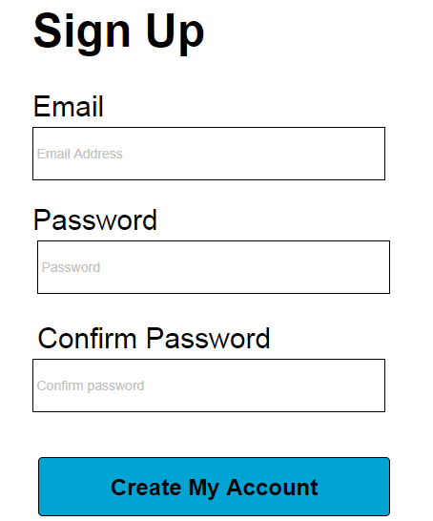

* For first time users only.
* Sign up screen will contain email, password, confirm password and create my account button.
* Notifies the user if password and confirm password are different.
* Notifies the user if account already exists.

4.1.2 Login Screen

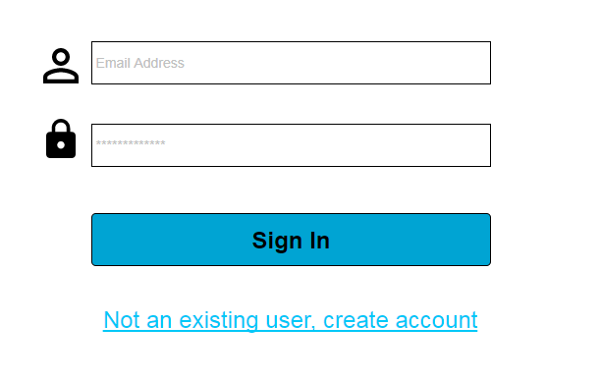

* Sign in page will contain email address, password and sign in button.
* User enters email address and password to sign in and credentials will be validated by system.
* New User can create an account, by clicking on “Not an existing user, create account” link.

4.1.3 Group Creation

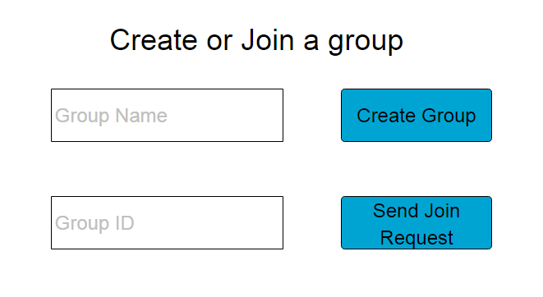

* User shall enter unique group name and click on create group, a new group is created.
* Notifies the user if group name is already in use.
* User shall enter group ID and click on “send join request” button.
* Email will be sent to team member to accept the request.

4.1.4 Send invitations

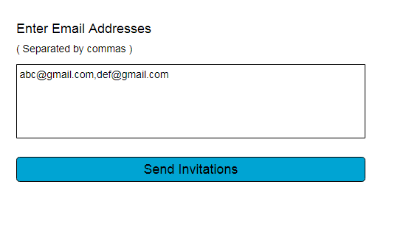

* User should enter email addresses separated by commas in text area and click on send invitations button.
* System will send invitation to email address.

4.1.5 User Dashboard & Messaging

A screenshot of a cell phone

Description generated with very high confidence

* User dashboard will contain chat, calendar, google suite and task management tabs on left hand side of the screen.
* User dashboard will contain user name and all the team member names on right hand side of the screen.
* Whenever user clicks on a tab on left hand side, functionality will be implemented in the middle section.
* User shall be able to click on chat tab and a group chat is opened in the middle screen.
* User can double click on group member names and individual chat window is opened.

4.1.6 Calendar

A screenshot of a computer

Description generated with very high confidence

* User shall be able to click on calendar tab and calendar is opened in the middle section.
* User shall be able to click on any date and create event by entering event name, event location, event time.
* User shall be able to share the calendar to other team members.

4.1.7 Task Management

A screenshot of a cell phone

Description generated with very high confidence

* User shall be able to click on task management tab and all tasks are displayed in the middle section.
* User shall be able to view all tasks that includes task name, whom task is assigned to, task deadline and status of task.
* User shall be able to create new task by clicking on create new task button.

A screenshot of a cell phone

Description generated with very high confidence

* User shall be able to enter task description, set task deadline and assign task to team member and click on save button to create task.

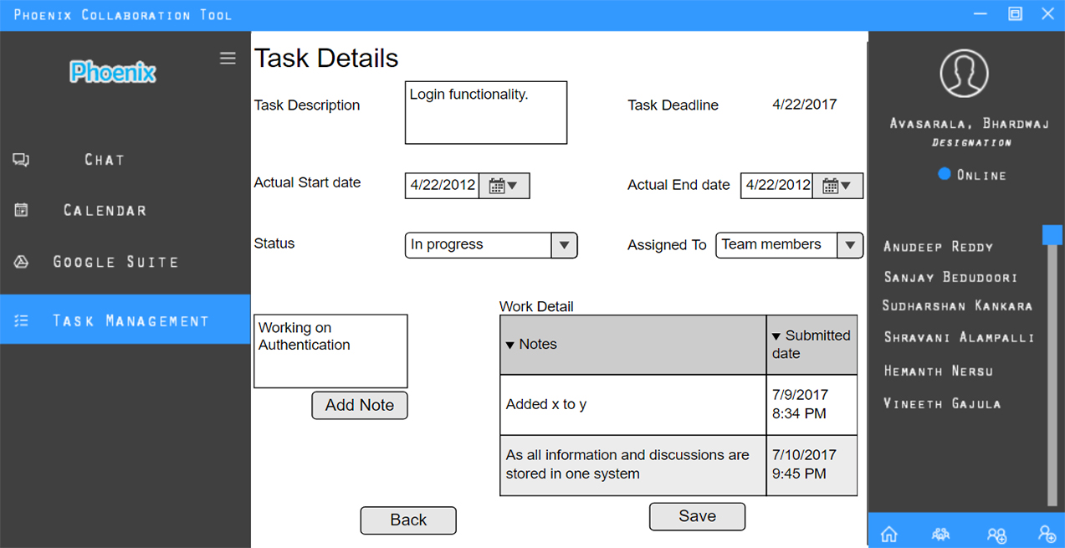

* User shall be able to set task actual start date.
* User shall be able to change task status to pending, assigned, completed and closed.
* User shall be able to add notes and notes will be reflected in the work detail.

4.1.8 Google Suite

A screenshot of a cell phone

Description generated with very high confidence

* User shall be able to click on google suite tab on left hand side of the screen and is prompted to enter google credentials.

A screenshot of a cell phone

Description generated with very high confidence

* Once google authenticates the user, it prompts the user to allow or cancel the access to account.
* Once user clicks on allow, then user can access all the files, edit the files, share the files and store the files.

# 5. Other Nonfunctional Requirements

# 4.1. Performance

Performance Issues might not be of a problem as the features involved in this application are feasible enough to run efficiently with minimum overhead on the server. Navigations and transitions from one screen to another is handled with less computational power. Messaging within a group of users could be synchronous and should not take more time. Pushing notifications about deadlines and tasks scheduling could be made faster by utilizing optimal algorithms which could improve the performance.

# 4.2. Security

The Application has User login which will be authenticated so that only users who register to Phoenix could enter the application. It also offers google login for the users who want to use their google account as a login to access the application. With Google’s OAuth 2.0 authentication protocol, it provides security to the system as unauthorized users couldn’t bypass the login screen.

# 4.3. Reliability

Reliability plays a major role here and it has the highest priority over other non-functional requirements. Once after login, the user shall find accuracy in the systems performance and throughput of the several features it offers in the dashboard like task management, shared calendar, messaging etc. With the google Drive API’s the data is reliable and stored securely in the users google drive account.

# 4.4. Usability

The application is very usable to novice as well as expert users. It has simple sign up screens so novice users can easily register and get access to the application. The dashboard is simpler to use and for the expert users it offers all the features in the side menus and have modern flat icons. On right hand side of the dashboard, application shall have the information about the user’s status, total number of users present in a team and several useful shortcuts to add members to a team etc.

# 4.5. Maintainability

The application shall be recovered from faulty components by regular checkups and analyzing the system performance by overloading the server. Cross checking with the test suite and going through all the test cases and scenarios for each and every requirement under low and high computational stress could tell the system performance. By considering all these and coding accordingly with high performance data structures and giving more time for testing, debugging and recovery could help maintain the code and the system’s performance.