Project Hawaii Android SDK  
Programming Guide

Version 2.1 – October 5, 2012

Abstract

The Hawaii Android Software Development Kit (SDK) is intended to help Android developers use Hawaii services easily and quickly. This document describes how to install and use the Hawaii Android SDK.

Contents

Introduction 2

Prerequisites 2

Installing the Hawaii Android SDK 2

Using the Hawaii Android SDK in an Application 3

Step One: Import Required Client Library Projects and the Jackson Library 3

Step Two: Set Up Your Android Application Project 4

Step Three: Obtain Project Hawaii Authentication Credentials 4

Step Four: Configure Your Hawaii Authentication Credentials 6

Resources 7

**Disclaimer:** This document is provided “as-is”. Information and views expressed in this document, including URL and other Internet Web site references, may change without notice. You bear the risk of using it.

This document does not provide you with any legal rights to any intellectual property in any Microsoft product. You may copy and use this document for your internal, reference purposes.

© 2012 Microsoft Corporation. All rights reserved.

DirectX, Microsoft, Visual Studio, Silverlight, Windows Azure, and Windows are trademarks of the Microsoft group of companies. All other trademarks are property of their respective owners.

# Introduction

The Hawaii Android Software Development Kit (SDK) is intended to help Android developers use Hawaii services easily and quickly. The SDK includes client libraries and sample Android applications for the KeyValue, Optical Character Recognition (OCR), Relay, Rendevezvous, SpeechToText (STT), TextToSpeech (TTS), Translator, and Path Prediction services. Android applications use these client libraries to interact with Hawaii services. To ease development, the SDK provides the complete source code and associated Eclipse project files.

# Prerequisites

Before you can use the Hawaii Android SDK:

* Set up the Android development environment.
* Download the Jackson library.
* Obtain authentication credentials.

To set up the Android development environment

Download the Android development environment, which is available on the following website:

<http://developer.android.com/sdk/installing/index.html>

Ensure that you have the latest versions of the following components:

* [Java Development Kit (JDK)](http://www.oracle.com/technetwork/java/javase/downloads/index.html)
* [Android SDK](http://developer.android.com/sdk/index.html)
* [Eclipse Classic integrated development environment (IDE)](http://www.eclipse.org/downloads/packages/eclipse-classic-42/junor)
* [Eclipse ADT plug-in for Android development](http://developer.android.com/sdk/installing/installing-adt.html)

To download the Jackson library

The SDK uses the Jackson library for JavaScript object notation (JSON) serialization and deserialization. Download the Jackson library from the following website:

<http://wiki.fasterxml.com/JacksonDownload>

Ensure that you download the stable 2.x version, which includes the following three files:

* Jackson-core-2.x.jar
* Jackson-annotations-2.x.jar
* Jackson-databind-2.x.jar

To obtain authentication credentials

For information about Hawaii authentication credentials, see the “Obtain Project Hawaii Authentication Credentials,” section later in the document.

# Installing the Hawaii Android SDK

The SDK is provided in a zip file named **HawaiiAndroidSDK.zip**, which contains the following folders:

|  |  |
| --- | --- |
| Folder | Contents |
| bin | Binary JAR file for client libraries. |
| src | Source code for client libraries, functional test projects, and sample applications. |
| docs | Java documentation generated from code comments. |

To install the Hawaii Android SDK

* Extract the contents of the HawaiiAndroidSDK.zip file to a folder on your local disk.

After you install the SDK, you can develop Hawaii Android SDK applications by using the Eclipse IDE.

# Using the Hawaii Android SDK in an Application

To use the Hawaii Android SDK in your application, follow these steps:

1. Import required client library projects and the Jackson library.

2. Set up your Android application project.

3. Obtain Hawaii authentication credentials.

4. Configure Hawaii authentication credentials in your code.

## Step One: Import Required Client Library Projects and the Jackson Library

The first step in using the Hawaii Android SDK is to import the Hawaii client library projects and the Jackson library into your project.

To import the projects and libraries

1. In the Eclipse IDE, click **File** and then **import…**

2. In the **Import** dialog, expand the **General** folder and then click **Existing projects into workspace**.

3. Copy the name of the source code folder to the **Select root directory** text box. For example:

C:\HawaiiAndroidSDK\src.

4. Press the Tab key to see a list of projects.

5. Select the **HawaiiClientLibraryBase** and **HawaiiSampleAppBase** projects, which every Hawaii Android application requires.

6. Select the client library projects that your application requires. For example, to use the KeyValue service, select the **KeyValueServiceClient** project. The following table lists all the client library projects:

|  |  |
| --- | --- |
| Client Library Project Name | Targeted Service |
| KeyValueServiceClient | KeyValue service |
| OCRServiceClient | OCR service |
| PathPredictionServiceClient | Path prediction service |
| RelayServiceClient | Relay service |
| RendezvousServiceClient | Rendezvous service |
| SpeechToTextServiceClient | Speech-to-text service |
| TranslatorServiceClient | Translator service |

7. Add the Jackson library to each of the imported Hawaii **client library** projects:

* Right click the project name and click **Properties**.
* In the left, click **Java Build Path**.
* Switch to the **Libraries** tab page and **Remove** existing Jackson Jar references if necessary
* Cick **Add External JARs…** button to add the downloaded Jackson library JAR files.

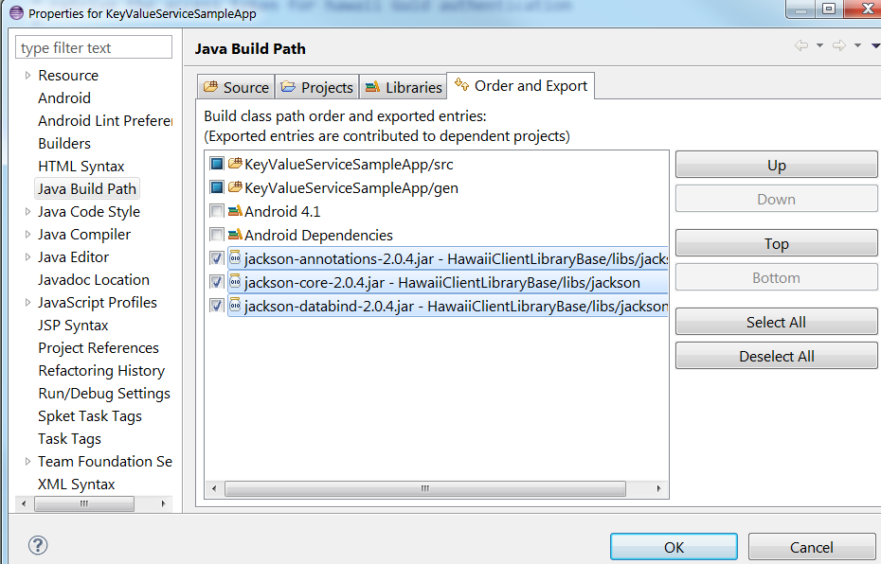Switch to the **Order and Export** tab page and make sure that Jackson Jar references are checked. Please see the below screenshot from the KeyValue service sample app project.

## Step Two: Set Up Your Android Application Project

The following procedure shows you how to set up a project named MyKeyValueServiceApp. See the sample application projects that are provided with the SDK for additional examples

To set up an Android application project

Add the Jackson library to the application. Follow same steps as for client libraries

To set up Translator, Text to Speech and Speech to Text Sample application

The Translator, Text to Speech and Speech to Text sample application requires SD card support.

Follow the below steps to run this sample app in Android emulator:

1. When create Android emulator image, specify the size of SD card

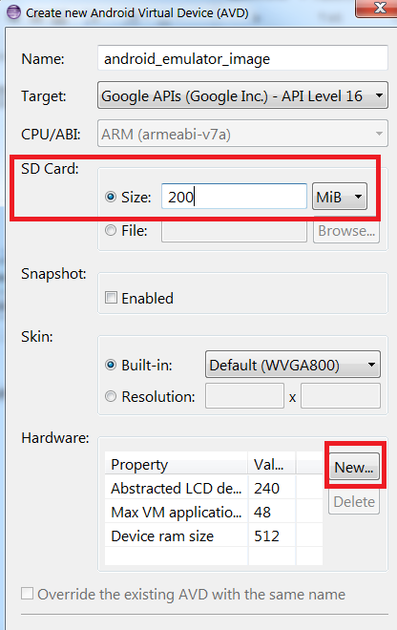

1. Click “**New**” button in the Hardware area and add SD card hardware support as the below screenshot

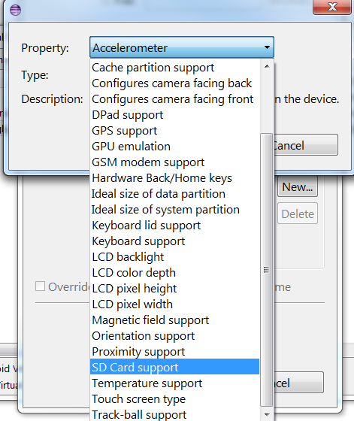

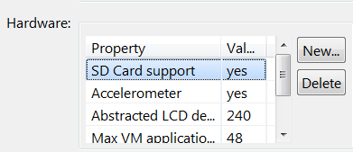

To set up Path Prediction Sample application

The Path Prediction application requires the Google Maps software development kit (SDK).

To enable the sample to render maps, follow these steps:

1. Install the Google API Add-on for the emulator or device.

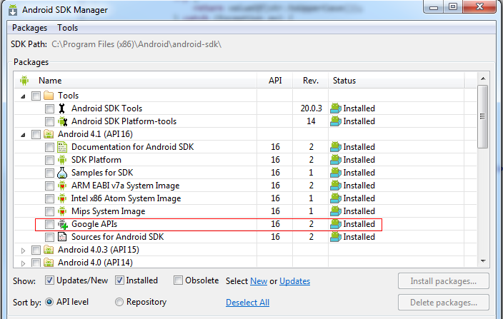

1. Create the “Google APIs (Google Inc)”. image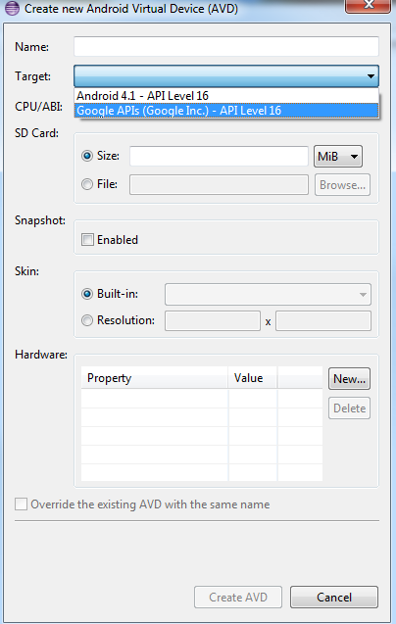
2. Obtain a Google Maps API Key. This API key is bound to a certificate that is used to sign your sample application. For details about how to register with the Google Maps service and obtain an API key [here](https://developers.google.com/maps/documentation/android/mapkey?hl=en-419). Use the -v argument to force md5 fingerprint generation.

Sample command:

keytool -list -alias androiddebugkey -keystore <path_to_debug_keystore>.keystore -storepass android -keypass android –v

1. Open res\values\strings.xml in the sample application and find the "googleMapKey" string element. Replace the default value with your API Key.
2. Run the sample application in the emulator using the image above
3. Since Android emulator can only get GPS location from external input, please open DDMS perspective in eclipse IDE. See the below screenshot.

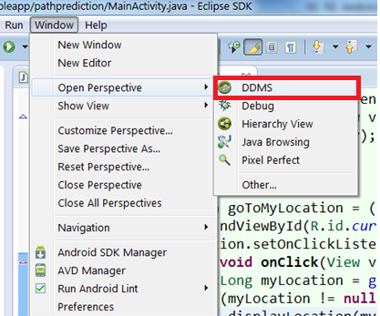

1. In the DDMS perspective, switch to the “**Emulator Control**” tab page in the right area. You can see the “**Location Controls**” area in this tab page and here input the longitude and latitude as the current GPS location. Click “**Send**” button and this GPS data will be sent to the emulator as its current GPS location. Please see the below screenshot.

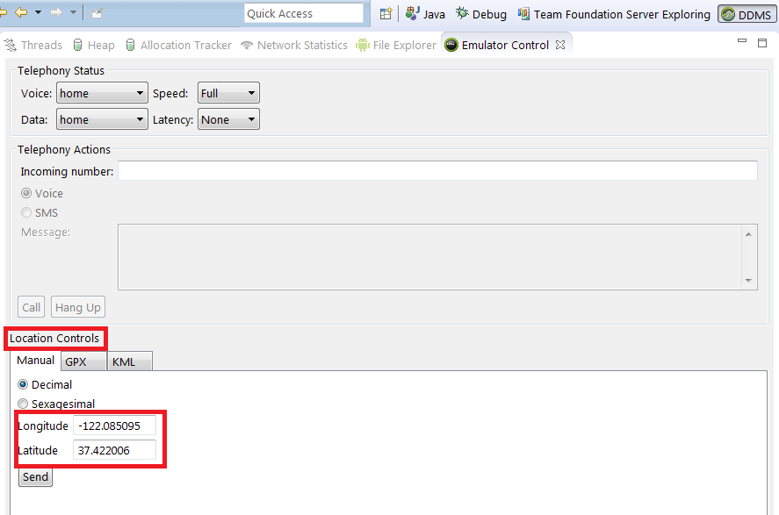

## Step Three: Obtain Project Hawaii Authentication Credentials

Each application that uses a Project Hawaii service must authenticate itself with the service by using either an Azure Data Market (ADM) client ID and secret or a Project Hawaii ID. The STT and OCR services currently use the Project Hawaii ID; all other services use ADM credentials.

You must have a Windows Live ID to obtain either a Project Hawaii ID or ADM credentials. If you do not have a Windows Live ID, see “How do I sign up for Windows Live” at <http://windows.microsoft.com/en-US/windows-live/sign-up-create-account-how>.

To obtain an ADM client ID and secret

1. Go to the Windows Azure Marketplace web page at [https://datamarket.azure.com](https://datamarket.azure.com/).

2. Use your Windows Live ID to sign in and register for ADM.

3. Click the **Developers** link at the bottom of the page to navigate to https://datamarket.azure.com/developer/applications.

4. Click **Register** to create an application that accesses the Project Hawaii Service.

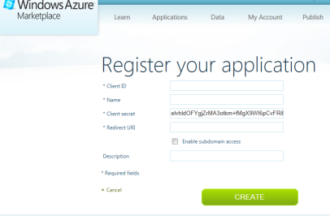

5. On the **Register your application** page, enter the required information:

* The Client ID. This can be any string you choose, but it must be unique and it cannot be changed later. For example, Contoso.MyAppV1.0.
* The name of your application.
* The post-consent redirect URI.
* A description for your application.

**Important** Make a note of the ClientID and Client secret so that you can copy and paste them into your code.

6. Navigate to the following web page and subscribe to the offer:  
<https://datamarket.azure.com/dataset/486345cb-b88f-4e4e-b8c7-5b5cf75cb830>

To obtain a Hawaii Application ID

1. Go to the **Project Hawaii Signup** web page at <http://hawaiiguidgen.cloudapp.net/default.aspx>.

2 Sign in with your Windows Live ID.

3. If you have not yet registered your Live ID, the Project Hawaii Signup page displays a dialog box like the following. Click **Register this Live ID with Hawaii** to register your ID.

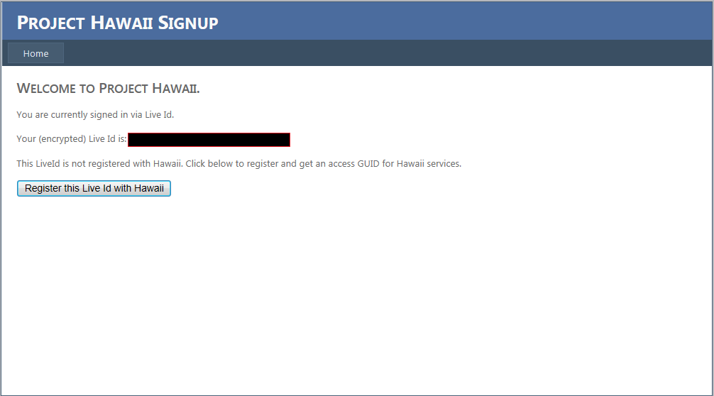

4. When you register your Live ID, Project Hawaii generates a GUID that your application can use to authenticate with the Project Hawaii cloud services.

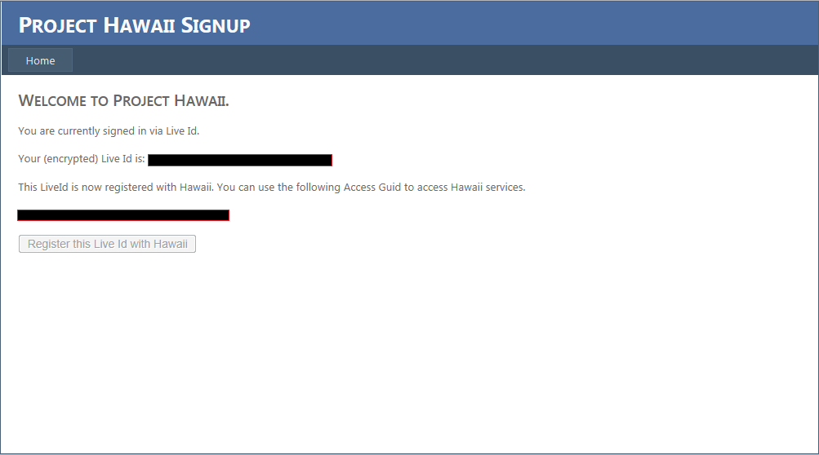

**Important** Make a note of the Access GUID so that you can copy and paste it into your code.

The sample applications that are installed with the Project Hawaii SDK show how to use the Hawaii Application ID for authentication.

## Step Four: Configure Your Hawaii Authentication Credentials

After you have a credential, you must configure your projects to use it.

To configure your credentials

1. Navigate to the **HawaiiSampleAppBase** project.

2. Open the Res\Values\Strings.xml file.

3. Replace the value of each of the following strings with the value from your credentials.

|  |  |
| --- | --- |
| String Name | Value |
| hawaii_ADM_client_ID | Client ID for ADM authentication. |
| hawaii_ADM_client_secret | Client secret for ADM authentication. |
| hawaii_ADM_service_scope | Service scope URL for ADM authentication. |
| hawaii_GUID_app_ID | Hawaii application ID. |

# Resources

This section provides links to additional information about the Hawaii Android SDK and related topics.

Microsoft Research Project Hawaii

<http://research.microsoft.com/en-us/projects/hawaii/default.aspx>