Automating the update of a dynamic blocks “Property table” of the block in an existing drawing is not possible from LISP. As dxf groups 1010 and 1071 can’t be saved.

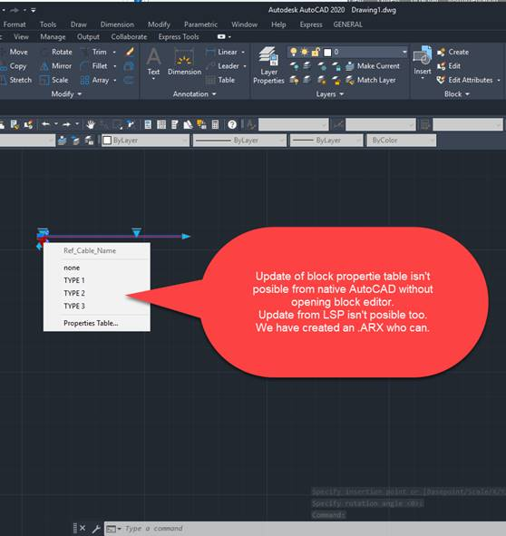

To overcome this flaw, i did create an ARX that can be loaded in AutoCAD that expose an interface (UpdateBlockPropertyTable <block name> <list with table values>) for lisp.

I build a utility which works in ac2017, ac2020, ac2022.

cid:image002.png@01D5E5BF.58700BF0

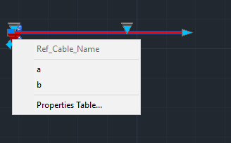

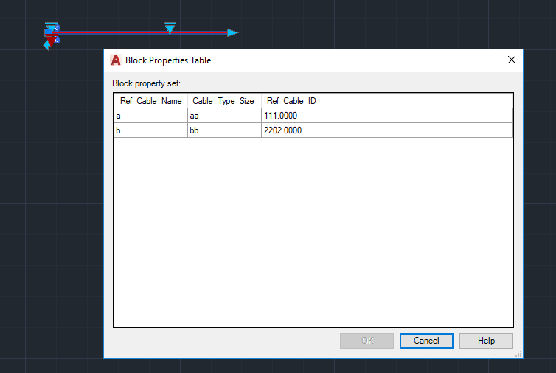

**Arie van Brakel**