RE: Assignment 3 (I did it again for my own practice by better understanding the concepts + using a gradient background, feel free to ignore) J061, Avantika

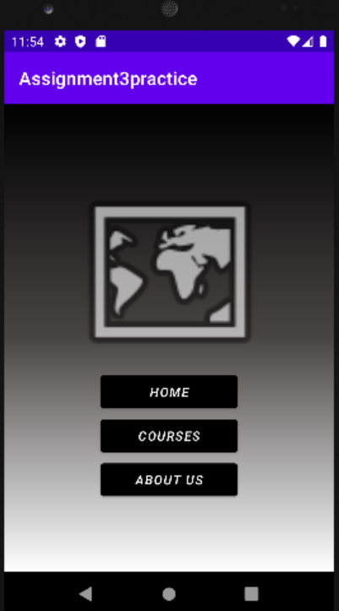

Home:

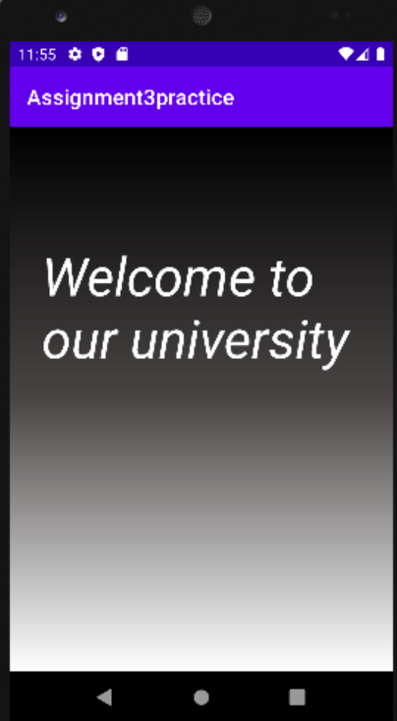

Courses:

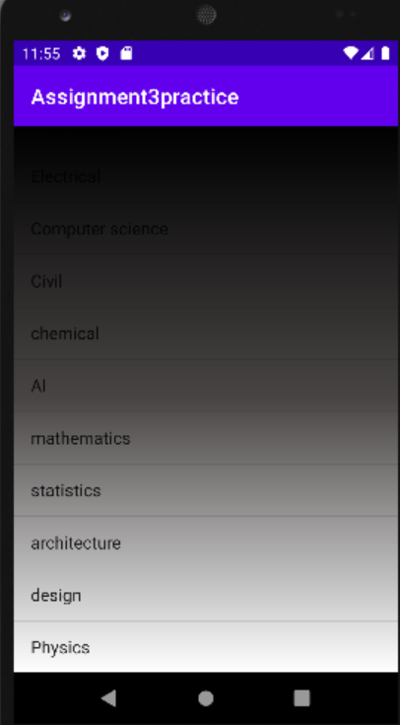

About Us:

