**21MDS16**

**COMPUTING LAB 1**

**OBSERVATION**

**BY**

**ARAVIND.M.S**

**71762132007**

**MSc DATASCIENCE (1ST YEAR)**

**EXCEL**

**DOCUMENTATION**

**DATE: 01.11.2021**

***1.To develop a student’s mark sheet using the column headings: Reg no, name, subjects, average,  
rank, result, total, grade.***

**AIM:**

To develop a student’s mark sheet using the column headings: Reg no, name, subjects, average, rank, result, total, grade.

**TABLE:**

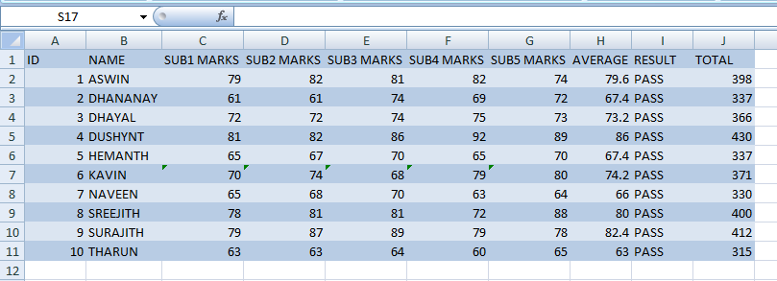

**GRAPH:**

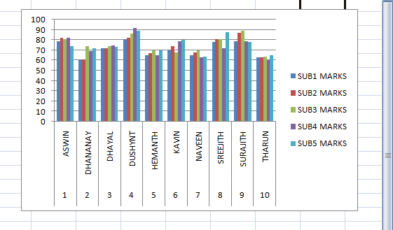

**FORMULAS:**

1.Calculate the total using formula =Sum (rows)

2.Calculate the average using the formula =Average (sub1: sub6)

3.Calculate the rank using formula =if (Result=” pass”, RANK (I2, I2:I6),”NO rank”)

4.Calculate the result using formula =IF (count if (sub1: sub6,”>=40”) =6” pass”,” fail”

5.Calculate the grade using formula =IF (K2="pass”, IF(J2>=90,"O”, IF(J2>=80,"A+”, IF(J2>=70,"A”, IF(J2>=60,"B+”, IF(J2>=50,"B”, IF(J2>=40,"c+”, IF (J2<40,"no grade"))))))),"no grade").

**RESULT:**

Hence we have created Student’s mark list using excel.

**DATE: 08.11.2021**

***2.To calculate the income tax of employees and to create an employment pay slip  
using the column headings:  Emp no, name,  
designation, BP, DA, MA, HRA, GP, PF, NET PAY, Tax Percentages:***

**AIM:**

To calculate the income tax of employees and to create an employment pay slip  
using the column headings:  Emp no, name,  
designation, BP, DA, MA, HRA, GP, PF, NET PAY, Tax Percentages:

**TABLE:**

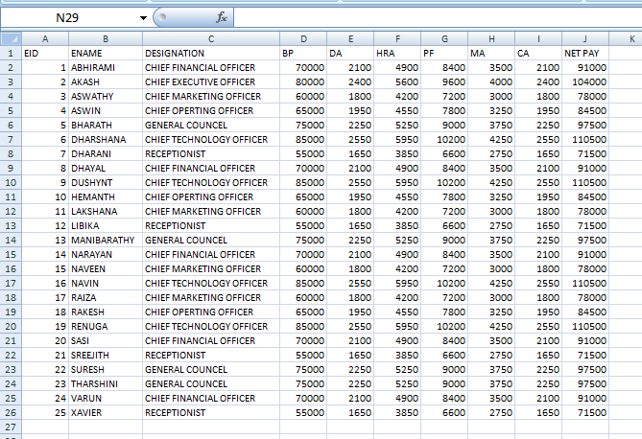

**GRAPH:**

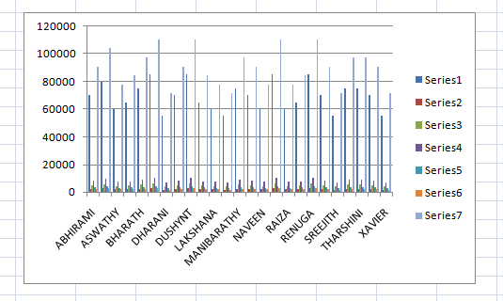

**FORMULAS:**

1.Calculate DA Using the formula = [basic pay*35/100]

2.Calculate HRA Using the formula = [basic pay*8/100]

3.Calculate MA Using the formula = [basic pay*5/100]

4.Calculate CA Using the formula = [basic pay*4/100]

5.Calculate GP Using the formula = BP + DA + HRA + MA + CA

6.Calculate PF Using the formula = [basic pay*12/100]

7.Calculate TAX Using the formula = [basic pay*5/100]

8.Calculate NET PAY Using the formula = [basic pay*35/100]

9.

• DA - Dearness Allowance

• HRA - House Rent Allowance

• MA - Miscellaneous Allowance

• CA - City Allowance

• GP - Gross Pay

• PF - Provident Fund

**RESULT:**Hence we have created employee pay slip using excel.

**DATE: 08.11.2021**

***3. To develop electricity bill calculator using the column headings:  SR NO, NAME, PREVIOUS READING, CURRENT  
READING, UNIT CONSUMED, ELECTRICITY CHARGE, SUR CHARGES, BILL PAYABLE.***

**AIM:**

To develop electricity bill calculator using the column headings:  SR NO, NAME, PREVIOUS READING, CURRENT READING, UNIT CONSUMED, ELECTRICITY CHARGE, SUR CHARGES, BILL PAYABLE.

**TABLE:**

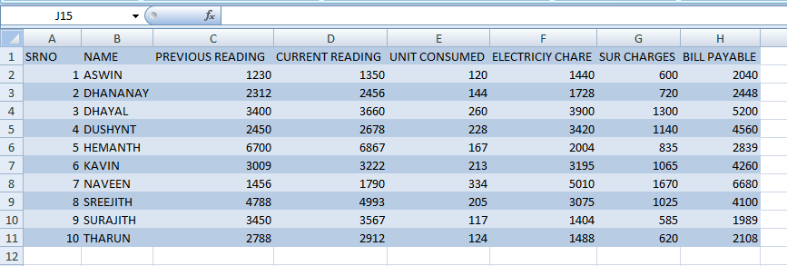

**GRAPH:**

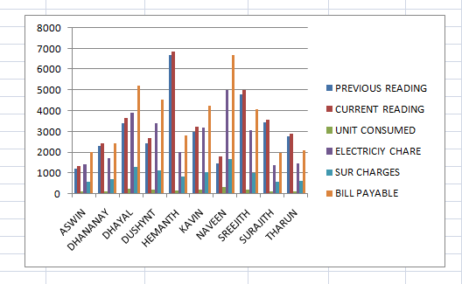

**FORMULAS:**

1.Calculate the unit consumed by formula = (current reading – previous reading.

2.Calculate the electricity charge by formula =IF (unit consumed<=200, unit consumed*12, IF (unit consumed.200, unit consumed*15)))

3.Calculate the payable bill by formulas = Electricity charge + sure charge

**RESULT:**

Hence we have created electricity bill using excel.

**DATE: 15.11.2021**

***4.Consider the problem of preparing a stationary order for the month of March. The item description, quantity and cost per items are available. The total cost per item is to be calculated and the final cost per item involves a sales tax of 2% over the total cost. The gross total and the net total is to be displayed.***

**AIM:**

To develop a table for stationary order for the month of march with the given details.

**TABLE:**

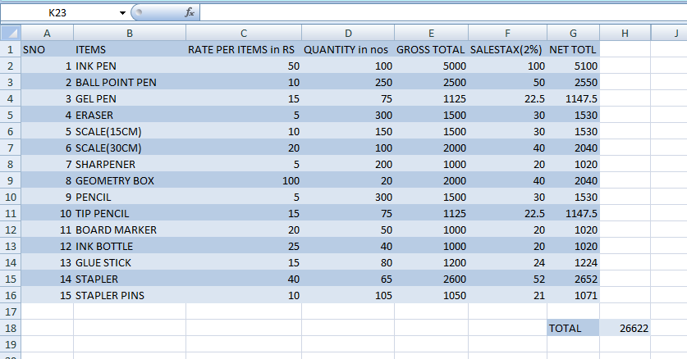

**GRAPH:**

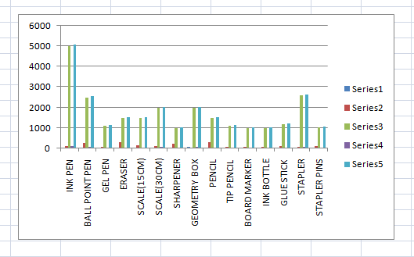

**FORMULAS:**

1.Calculate the formula Gross Total per items =Rate per item*Quantity

2.Calculate the formula sale tax 2% = Gross Total per items*2/100

3.Calculate the formula Net Total per items 2% = Gross Total per items + sale tax 2%

**RESULT:**

Hence we have created stationery order using excel.

**DATE: 15.11.2021**

***5.Create a chart to compare the favorite films data for 15-25year old only (be careful not to include any unnecessary blanks rows or columns in your selected data).Format this chart so that it is a pie chart, with the Barbarella slice “exploded" and each segment labelled:***

**AIM:**

To develop a chart to compare the favorite films data for 15-25year old and format it into a pie chart

**TABLE:**

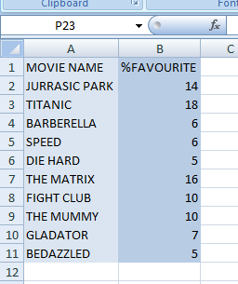

**GRAPH:**

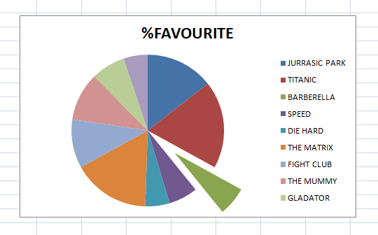

**FORMULAS:**

1.Open a New Worksheet.

2.Enter the given data in the columns

3.Select the table and create a pie chart by following steps, first click insert, pie chart and choose the required layout

**RESULT:**

Hence we have created a pie chart on films enjoyed by 15 – 25 age group using excel.

**DATE: 19.11.2021**

***6. Create a spreadsheet to predict total labour costs for a shop per day, given the following information: There will be 3 grades of staff – managers, counter staff and cleaning staff.***

***There will be 2 shifts – day and night***

***Hourly pay rates per grade per shift will be as follows:***

**AIM:**

To develop a spreadsheet to predict total labour costs for a shop per day, given the following information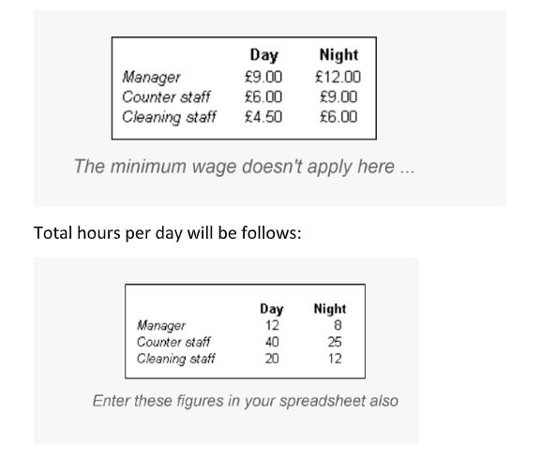.

**TABLE:**

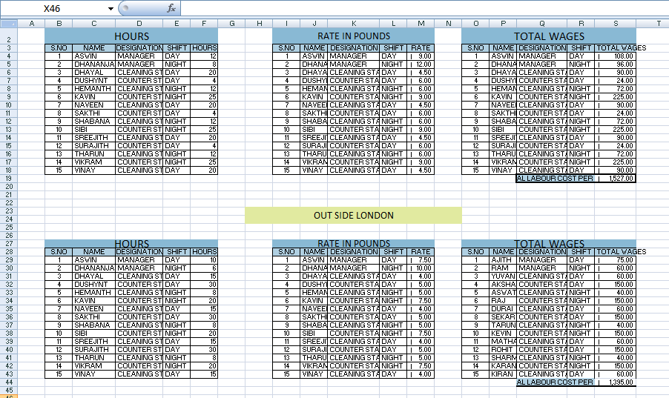

**FORMULAS:**

1.Daily wage of the employees: { =E3:E17*F3:F17}

2.Total daily wage : { =SUM(E3:E17*F3:F17)}

3.Total number of a specified employee, eg: MANAGER =COUNTIF(C3:C17,"MANAGER")+COUNTIF(K3:K17,"MANAGER")

**RESULT:**

Hence we have found the daily wages of the employees, total daily wage of each shop and total number of a specified employee type using array formulae in excel.

**DATE: 19.11.2021**

***7.Create a set of sample values, consider it as matrix. If any of cells are blank then it should be taken as error. You have to create an array formula to count the number of errors by using if and iserror syntax.***

**AIM:**

To develop Create a set of sample values, consider it as matrix. If any of cells are blank then it should be taken as error. You have create an array formula to count the number of errors by using if and is error syntax.

**TABLE:**

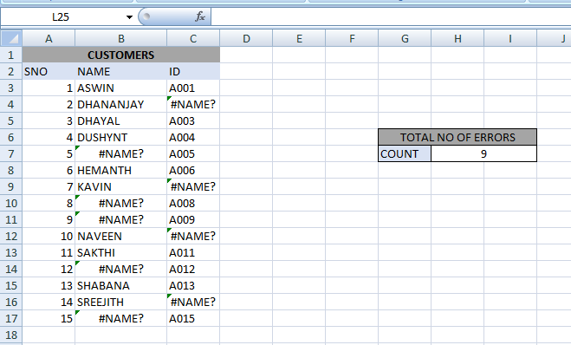

**FORMULAS:**

1.Open a New Worksheet

2.Count of errors = Sum of Total no. of errors {=sum (IF (ISERROR (D4:D12)1))}

**RESULT;**

Hence we have created an error checking array formula in excel.

**DATE: 19.11.2021**

***8.For a car sales company, create a combination chart that combines the yearly sales comprised of two or more charts in a single chart.***

**AIM:**

To develop a combination chart that combines the yearly sales comprised of two or more charts in a single chart.

**TABLE:**

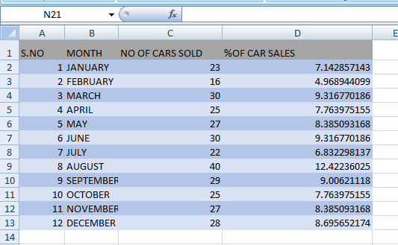

**GRAPH:**

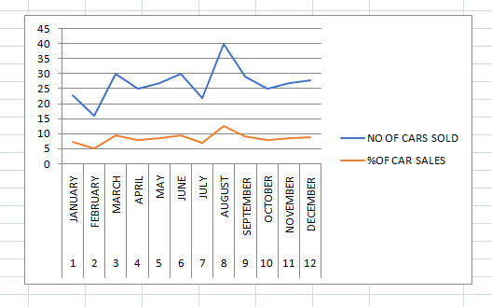

**RESULT:**

Hence we have created a combination chart using excel.

**DATE: 19.11.2021**

***9.Generate random numbers using different functions of Excel.***

**AIM:**

To Generate random numbers using different functions of Excel

**TABLE:**

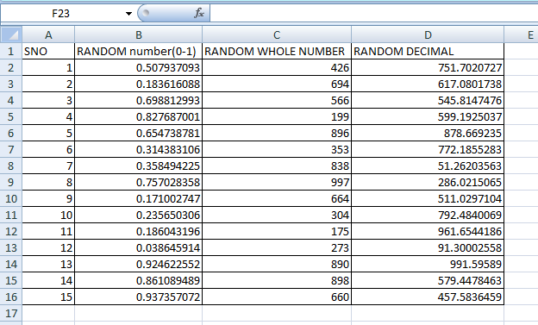

**FORMULAS:**

1.Rand (): This function returns a random number greater than or equal to 0 and lesser than 1 = RAND ()

2.Rand between (): This Function returns a random number between the range you specify = RANDBETWEEN (10, 100)

3.To Generate random number decimal number greater than 1

WE USE = Lower limit + (upper limit – lower limit) rand () = 10+ 90 rand ()

**RESULT:**

Hence we have generated random numbers using various functions of excel.

**DATE: 20.11.21**

***10.To develop product quality checker in departmental stores using column headings: PRODUCT ID, PRODUCT NAME, EXPIRED DATE, STATUS, DAYS LEFT, PRICE, NO OF QUANTITY, and AMOUNT. You need to display the word “expired” or “usable” in status column and no of days that one product is already expired in days left column Amount should be calculated as (price * no of quantity).***

**AIM:**

To develop product quality checker in departmental stores using column headings

**TABLE:**

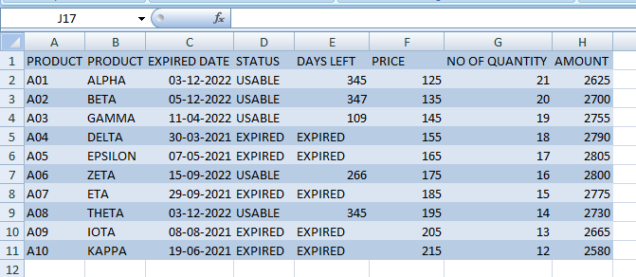

**FORMULAS:**

1.Calculate the days left using the formula = NETWORKDAYS (TODAYS (), D3)

2.Calculate the status using the formula =IF (E3<=0, “EXPIRED “,” USABLE”)

3.Calculate the amount using the formula = Price * No. of Quantity

**RESULT:**

Hence we have created a product quality checker using excel.

**DATE: 22.11.2021**

***11.To develop a frequency distribution table of 50 students and marks scored by them .The table should consist of the following details. I. Max II. Min III. No of classes IV. Range V. Class interval VI. Upper limit VII. Frequency VIII. Sum of freq IX. Frequency Range. Create a bar chart for the above created table.***

**AIM:**

To create a frequency distribution table.

**TABLE:**

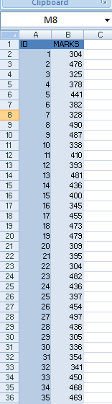  
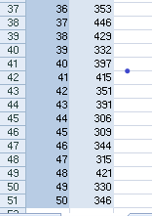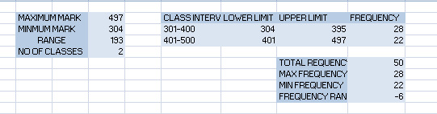

**GRAPH:**

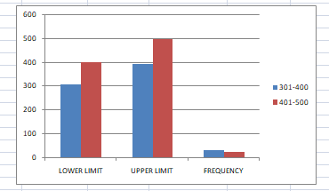

**FORMULAS:**

1.MAX =It return the high value in the set of given data

{=MAX (C3:C51)

2.MIN = It return the lowest value in the set of given data

3.Range = Max value – Min value = 1

4.Frequency = Its return how often values occur within the range of values and then return the vertical array.

{=FREQUENCY (C3:C52, F8:G8)

5.Total Frequency = Sum of all frequencies

= SUM (H8:H13)

Using conditional formatting I highlighted the marks that are greater than 550 and less than 350 with green and red boxes.

**RESULT:**

Hence we created frequency distribution table.

**DATE: 20.11.21**

***12. To create a salary sheet of 25 employees and perform simple mathematical functions such as SUM, MAX,MIN, AVERAGE, MEDIAN, MEAN, SD.***

**AIM:**

To create a salary sheet of 25 employees and perform simple mathematical functions

**TABLE:**

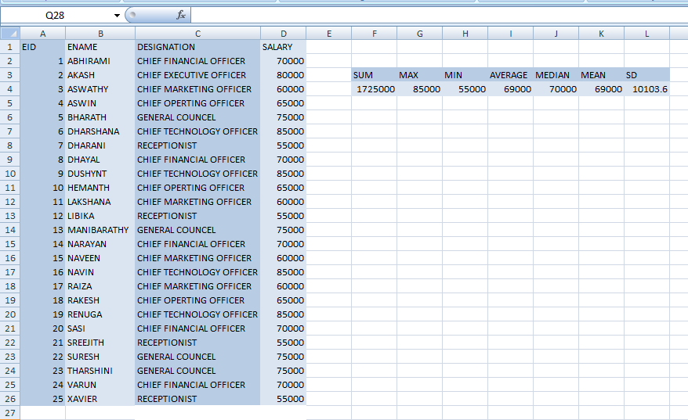

**FORMULAS:**

1.Calculate sum using the formula = SUM (D2:D22)

2.Calculate max using the formula = MAX (D2:D22)

3.Calculate min using the formula = MIN (D2:D22)

4.Calculate Average using the formula = AVERAGE (D2:D22)

5.Calculate Median using the formula = MEDIAN (D2:D22)

6.Calculate Mean using the formula = AVERAGE (D2:D22)

7.Calculate standard deviation using the formula = STDEV (D2:D22)

**RESULT:**Hence we have created salary sheet using various mathematical functions in excel.

**DATE: 20.11.2021**

***13.Create a component, percentage bar chart.***

**AIM:**

To develop Create a component, percentage bar chart.

**TABLE:**

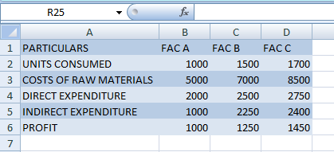

**GRAPH:**

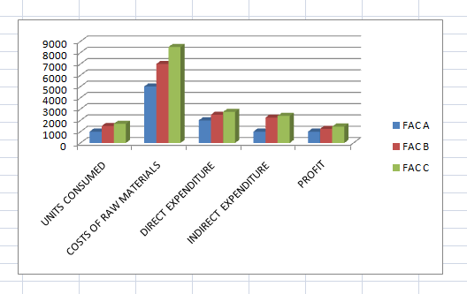

**FORMULAS:**

1.Total = Sum of entries→ = sum (B2:B6)

2.Percentage = particular data/ Total → B2/B$7

Here we use dollar symbol it is used to lock a specific cell or rows or columns in the sheet.

We use this symbol while working in formulas when we do not want the reference to be changed when we copy or drag down the formula to other cell reference

**RESULT:**Hence we have created a percentage composition chart using excel.

**DATE: 20.11.2021**

***14.Create a Pie chart for the following table***

**AIM:**

To develop a Pie chart for the following table

**TABLE:**

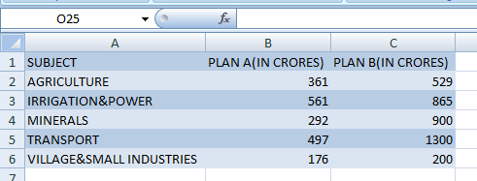

**GRAPH:**

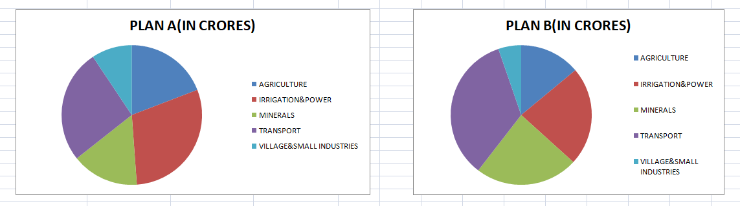

**FORMULAS:**

Select the table and create a pie chart buy following step, First click Insert pie chart and choose the required layout for both PLAN A and B

**RESULT:**Hence we have created pie charts for both plans A and B using excel.

**DATE: 26.11.2021**

***15. Matrix operation try these operations:   
1. Organization of data in matrices 2.add matrices3.subtract matrices4.transpose of a matrix5.multiply a matrix by a scalar6.inverse of a square matrix7.determinant of a square matrix.***

**AIM:**

To develop a spreadsheet to try these matrix operations

**TABLE:**

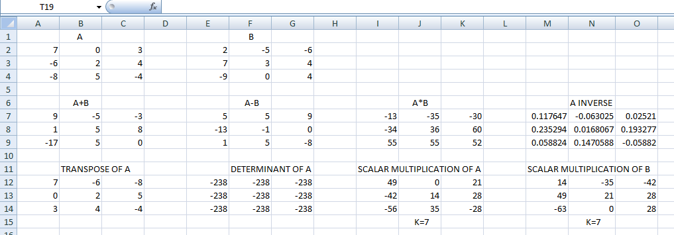

**FORMULAS:**

1.Add those two-matrix using the formula {= C3:E5+H3:J5}

2.Subtract the two-matrix using the formula {=C3:E5-H3:J5}

3.Multiply the two-matrix using the formula {=MMULT (C3:E5,H3:J5)}

4.Transpose the two-matrix using the formula {=Transpose (C3:E5)}

5.Inverse of A using formula {=MINVERSE (C3:E5)}

7.Determinant of square matrix using the formula {=MDETERM (C3:E5)}

8.Multiply a matrix by scalar (k=6) {=C3:E5*6}

**RESULT:**

Hence we have performed various matrix operations using excel.

**DATE: 03.12.2021**

***16.*** ***Prove the following properties of addition for 3X3 Matrix:  
1. Commutative Law , 2. Associative Law , 3. Identity of the Matrix ,4. Additive Inverse***

**AIM:**

To create a spreadsheet to prove the following properties of the matrices.

**TABLE:**

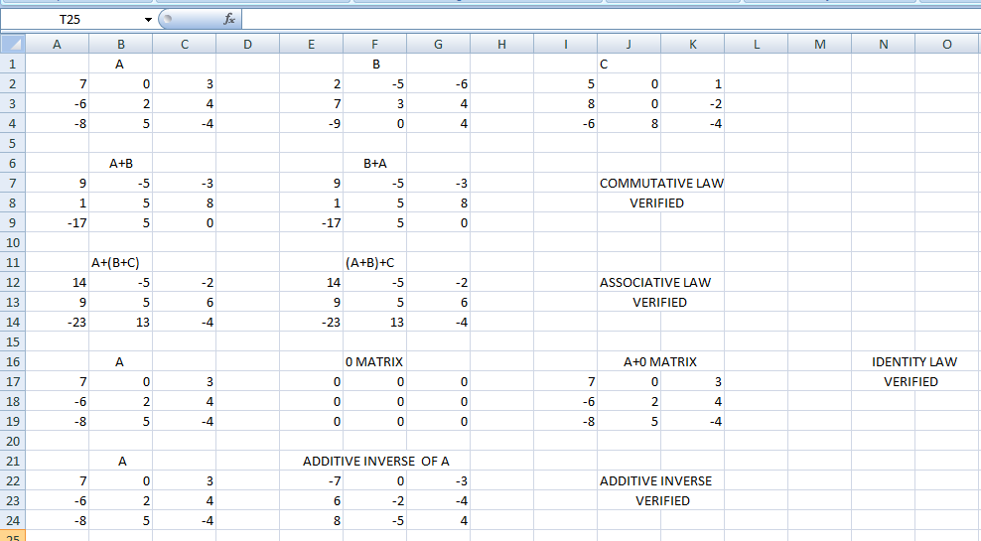

**FORMULAS:**

1.Add matrix A to B using the formula {=A2:C4+E2:G4}.

2.Add matrix B to A using the formula {=E2:G4+A2:C4}.

3.Verify Commutative property by using the formula {=IF (D=E,"TRUE","FALSE")}.

4.Add matrices A,B and C[A+(B+C)] using the formula {=A2:C4+Q2:S4}.

5.Add matrices A,B and C[(A+B)+C] using the formula {=M2:O4+I2:K4}.

6.Verify Associative property by using the formula {=IF (A12:C14=E12:G14,"TRUE","FALSE")}.

7.Add matrix A to 0 matrix using the formula {=A17:C19+E17:G19}.

8.To find the Additive inverse of matrix A using the formula {=A22:C24*-1}.

**RESULT:**

Hence we have proved all the properties of the 3x3 matrices.

**DATE: 10/12/2021**

***17) Arrange the following data in ascending order, descending order and construct frequency table for each of the data.***

**AIM:**

To create a spreadsheet to arrange the given datThe marks obtained out of 25 by 30 students of a class in the examination are given below.

20, 6, 23, 19, 9, 14, 15, 3, 1, 12, 10, 20, 13, 3, 17, 10, 11, 6, 21, 9, 6, 10, 9, 4, 5, 1, 5, 11, 7, 24

Represent the above data as a grouped data taking the class interval 0 – 5a in ascending order.

**TABLE:**

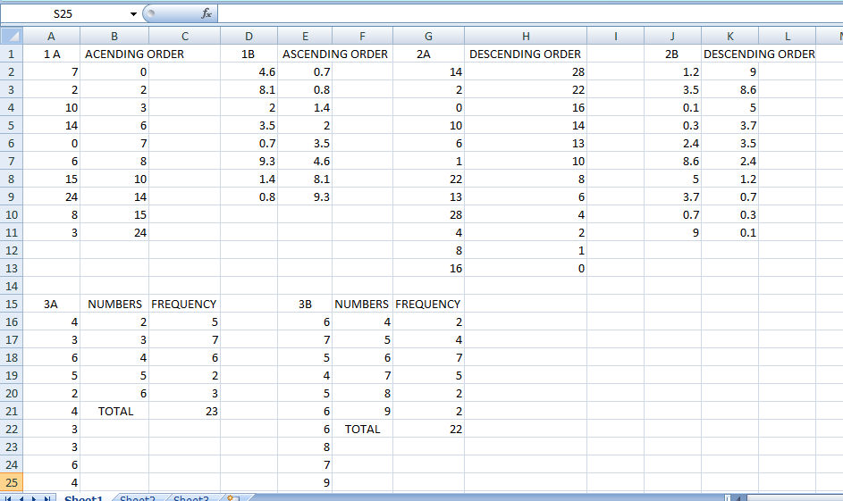

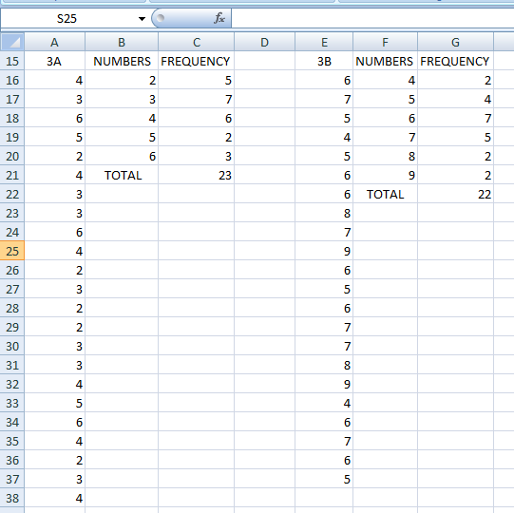

**FORMULAS:**

1.For finding the frequency in 1st frequency table : =COUNT(A22:A44)

2.For finding the total in 1st frequency table : =SUM(C22:C26)

3.For finding the frequency in the 2nd frequency table : =COUNT(D22:D43)

4.For finding the total in the 2nd frequency table : =SUM(F22:F27)

**RESULT:**

Hence we have arranged the following data in ascending order, descending order and constructed a frequency table for the following table.

**DATE: 10/12/2021**

***18) The marks obtained out of 25 by 30 students of a class in the examination are given below. 20, 6, 23, 19, 9, 14, 15, 3, 1, 12, 10, 20, 13, 3, 17, 10, 11, 6, 21, 9, 6, 10, 9, 4, 5, 1, 5, 11, 7, 24***

***Represent the above data as a grouped data taking the class interval 0 – 5***

**AIM:**

To create a spreadsheet to represent the given data.

**TABLE:**

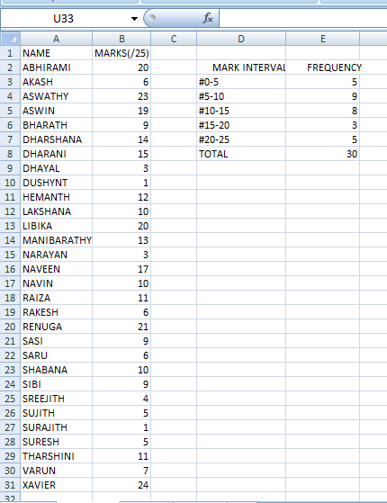

**FORMULAS:**

1.To calculate the marks out of 25 column we use: =COUNT(Bn:Bn)

2.To calculate the frequency column we use: =COUNTIF($B$4:$B$31,"<=5")

3.To calculate the total column we use: =SUM(En:En)

**NOTE:** Here n= the specific column number used according to the formula.

**RESULT:**

Hence we created a spreadsheet to represent the given data.

**DATE: 10/12/2021**

**19) *Complete the table.***

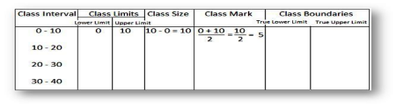

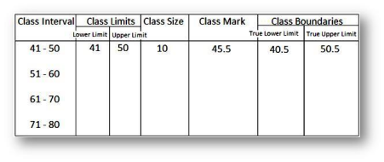

**AIM:**

To complete the given tables.

**TABLES:**

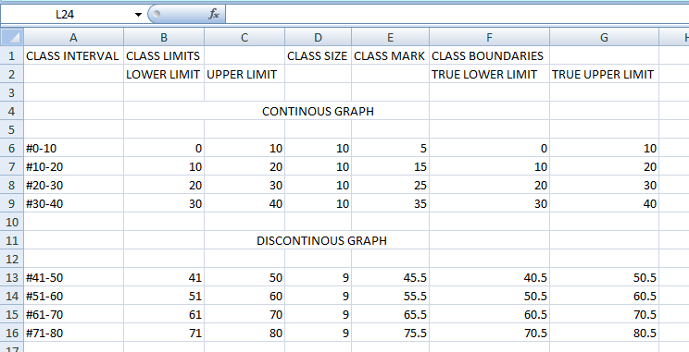

**FORMULAS:**

**Table: 1**

1.To make a discontinuous interval we use: = (ROWS(A$4:A8)-1)*$K$6+1&"-"&ROWS(A$4:A8)*$K$6.

2.To make the class marks we use: = (Fn+Gn)/2

3.To make true lower limits we use: = Bn-0.5

4.To make true upper limits we use: = Cn+0.5

**Table: 2**

1.To make lower limits we use: =Bn+K$6

2.To make upper limits we use: =Cn+K$6

3.To make class size we use: =Cn-Bn

4.To make class marks we use: =(Bn+Cn)/2

5.To make true lower limit we use: =Bn

6.To make true upper limits we use: =Cn

**NOTE:** Here n=specific column number required to the field.

**RESULT:**

Hence we have completed the given table.

**DATE: 13/12/2021**

***20) Create a spreadsheet to construct the grouped frequency table with the class interval of equal width such as 30 - 35. Also, find the range of the weekly pocket expenses of the given values.***

***Weekly pocket expenses (in $) of 30 students of class VIII are 37, 41, 39, 34, 71, 26,  56, 61, 58, 79, 83, 72, 64, 39, 75, 39, 37, 59, 57, 37, 53, 38, 49, 45, 70, 82, 44, 37, 79,  76.***

**AIM:**

To create a spreadsheet to create a Frequency Table.

**TABLE:**

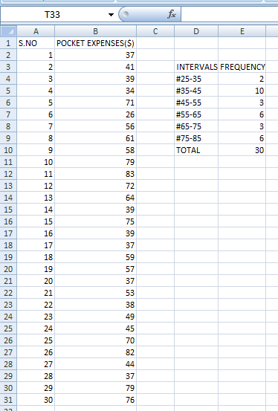

**FORMULAS:**

1.To find the frequency of the intervals we use: =COUNTIFS (B2:B31,">lower limit", B2:B31,"<=upper limit").

2.To find the total frequency we use: =SUM (E6:E11) [columns containing frequencies].

3.To find the maximum in the pocket expenses we use: =MAX (B2:B31) [columns containing pocket expenses].

4.To find the minimum in the pocket expenses we use: =MIN (B2:B31) [columns containing pocket expenses].

5.To find the range we use: E18-E17(columns containing maximum and minimum).

**RESULT:**

Hence we created a spreadsheet to construct a frequency distribution table for the pocket expenses.

**DATE: 13/12/2021**

***21) Pulse rate (per minute) of 25 persons were recorded as 61, 75, 71, 72, 70, 65, 77, 72, 67, 80, 77, 62, 71, 74, 79, 67, 80, 77, 62, 71, 74, 61, 70, 80, 72,  59, 78, 71, 72.***

***Construct a frequency table expressing the data in the inclusive form taking the class interval 61-65 of equal width. Now, convert this data again into the exclusive form in the separate table.***

**AIM:**

To create a spreadsheet to construct a frequency table of inclusive and exclusive form in two separate tables.

**TABLE:**

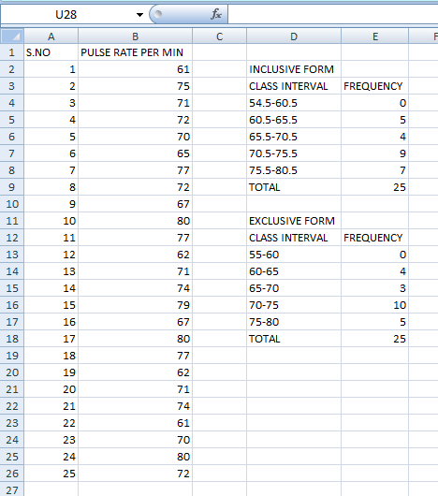

**FORMULAS:**

**TABLE1 (Inclusive):**

1.To find the frequency of class interval: =COUNTIFS(B2:B30,">lower limit",B2:B30,"<=upper limit").

2.To find the sum of the frequencies: { =SUM(E6:E10)}[columns containing the frequencies].

**TABLE2 (Exclusive):**

1.To find the frequency of class interval: =COUNTIFS(B2:B30,">lower limit",B2:B30,"<=upper limit").

2.To find the sum of the frequencies: { =SUM(E20:E24)}[columns containing the frequencies].

**RESULT:**

Hence we created a spreadsheet to construct a frequency table of inclusive and exclusive form separately.

**DATE: 13/12/2021**

***22) The frequency distribution of weights (in kg) of 40 persons is given below.***

|  |  |  |  |  |  |
| --- | --- | --- | --- | --- | --- |
| **Weights (in kg)** | 30 - 35 | 35 - 40 | 40 - 45 | 45 - 50 | 50 - 55 |
| **Frequency** | 6 | 13 | 14 | 4 | 3 |

***(a) What is the lower limit of fourth class interval?***

***(b) What is the class size of each class interval?***

***(c) Which class interval has the highest frequency?***

***(d) Find the class marks of all the class intervals?***

**AIM:**

To create a spreadsheet to answer the following questions in Microsoft Excel.

**TABLE:**

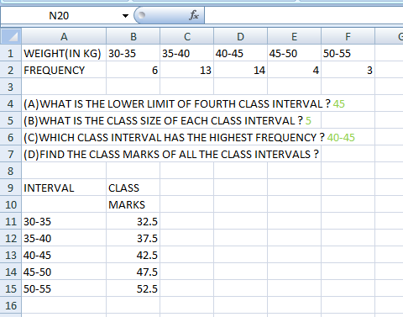

**FORMULAS:**

1.To find the class interval having highest frequency we assign a max variable using: =MAX (C3:G3)[column containing frequencies].

2.Now we use the formula: =_xlfn.IFS (C3=I9,"30-35", D3=I9,"35-40", E3=I9,"40-45", F3=I9,"45-50", G3=I9,"50-55").

3.To find class marks we use: = (upper limit + lower limit)/2.

**RESULT:**

Hence we created a spreadsheet to answer the following questions in Microsoft Excel.

**DATE: 13/12/2021**

***23.Construct the frequency distribution table for the data on heights (cm) of 20 boys using the class intervals 130 - 135, 135 - 140 and so on. The heights of the boys in cm are: 140, 138, 133, 148, 160, 153, 131, 146, 134, 136, 149, 141, 155, 149, 165, 142, 144, 147, 138, and 139. Also, find the range of heights of the boys.***

**AIM:**

To create a spreadsheet to construct a frequency table for the distribution of heights if 20 students.

**TABLE:**

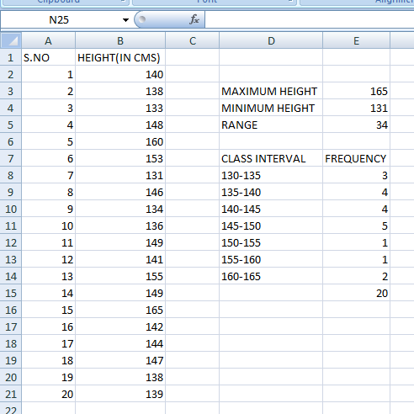

**FORMULAS:**

1.To find the maximum height we use: =MAX (B2:B21) [columns containing all the heights].

2.To find the minimum height we use: =MIN (B2:B21) [columns containing all the heights].

3.To find the frequency of each class intervals we use: =COUNTIFS ($B$2:$B$21,">lower limit", $B$2:$B$21,"<=upper limit").

4.To find the sum of the frequencies we use: =SUM (E9:E15)[columns containing the frequencies].

**RESULT:**

Hence we created a spreadsheet to construct a frequency table for the distribution of heights if 20 students.

**DATE: 13/12/2021**

***24.Construct a frequency distribution table for the following weights (in gm) of 30 oranges using the equal class intervals, one of them is 40-45 (45 not included). The weights are: 31, 41, 46, 33, 44, 51, 56, 63, 71, 71, 62, 63, 54, 53, 51, 43, 36, 38, 54, 56, 66, 71, 74, 75, 46, and 47.***

**AIM:**

To create a spreadsheet to construct a frequency table of the weight of the oranges.

**TABLE:**

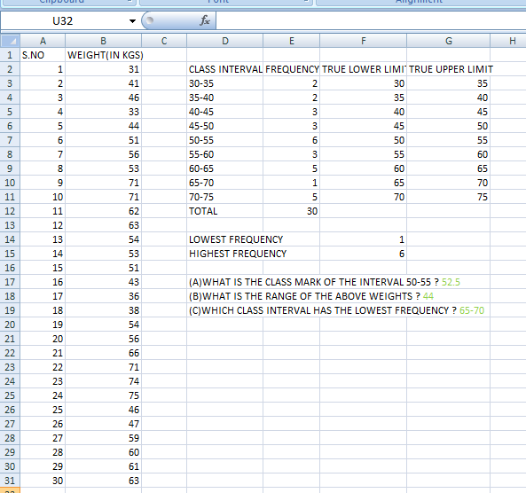

**FORMULAS:**

1.To find the minimum weight of the oranges we use: =MIN (B2:B31) [columns containing weights].

2.To find the maximum weight of the oranges we use: =MAX (B2:B31) [columns containing weights].

3.To find the frequency of each class interval we use: =COUNTIFS (B2:B31,">=lower limit", B2:B31,"<upper limit").

4.To find the sum of the frequencies we use: =SUM (E11:E19) [columns containing frequencies].

5.To find the lowest frequency we use: =MIN (E11:E19) [columns containing frequencies].

6.To find the highest frequency we use: = MAX (E11:E19)[columns containing frequencies].

For Q) A we use: = (F15+G15)/2.

For Q) B we use: = B33-B32.

For Q) C we use: = COUNT (E11:E19).

For Q) D we use: {=_xlfn.IFS(I15=E11,"30-35",I15=E12,"35-40",I15=E13,"40-45",I15=E14,"45-50",I15=E15,"50-55",I15=E16,"55-60",I15=E17,"60-65",I15=E18,"65-70",I15=E19,"70-75")}.

**RESULT:**

Hence we created a spreadsheet to construct a frequency table of the weight of the oranges.

**DATE: 17/12/2021**

***25. Prepare the frequency distribution table for the given set of scores:***

***39, 16, 30, 37, 53, 15, 16, 60, 58, 26, 28, 19, 20, 12, 14, 24, 59, 21, 57, 38, 25, 36, 24,15, 25, 41, 52, 45, 60, 63, 18, 26, 43, 36, 18, 27, 59, 63, 46, 42, 48, 35, 64, 24.***

***Take class interval as (10-20), (20-30) . . . . . . and answer the following:***

***I. What does the frequency corresponding to the third class interval mean?***

***II. What is the size of each class interval? Find the midpoint of the class interval 30-40***

***III. What is the range of the given set of scores?***

**AIM:**

To create a spreadsheet to construct a frequency table of the given set of scores,

**TABLE:**

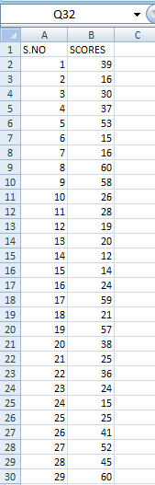 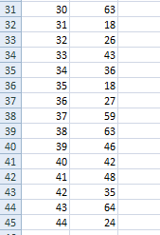

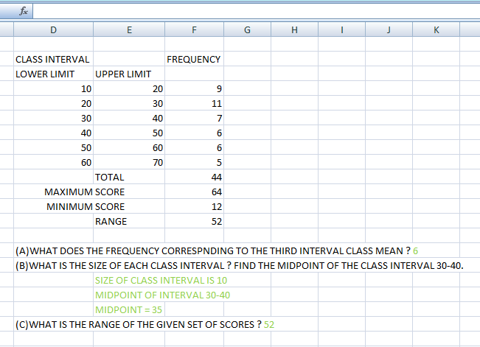

**FORMULAS:**

1.Open new worksheet.

2.Maximum weight using the formula =MAX (B3:B46).

3.Minimum weight using the formula =MIN (B3:B46).

4.Range using the formula =F13-F14

5.Frequency of each class intervals using the formula =COUNTIFS ($B$2:

$B$46,">lower limit", $B$2: $B$46,"<=upper limit").

6.Sum of the frequencies using the formula =SUM (E9:E15).

7.To find the mid-point using formula =(D8+E8)/2

**RESULT:**

Hence we created a spreadsheet to construct a frequency table for given set of scores.

**DATE: 17/12/2021**

***26.Data: Student’s body weight (kg):***

***41 60 72 72 65 64 48 90 60 75 53 48 63 49 58 39 39 75 55 62 53 59 58 38 72 62 60 59 68 60 70 60 56 80 65 85 71 45 70 55***

***Make the frequency distribution table of the above data. Calculate range and***

***frequency for the same.***

**AIM:**

To create a spreadsheet to construct a frequency table of students body weight.

**TABLE:**

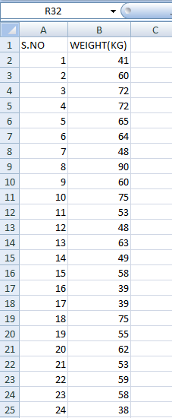  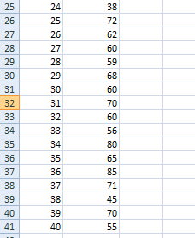

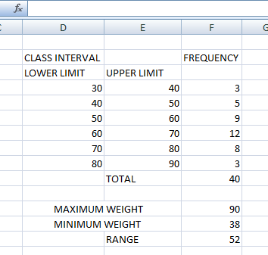

**FORMULAS:**

1.Open new worksheet.

2.Maximum weight using the formula =MAX (B3:B42).

3.Minimum weight using the formula =MIN (B3:B42).

4.Range using the formula =F13-F14

5.Frequency of each class intervals using the formula =COUNTIFS ($B$2:

$B$42,">lower limit", $B$2: $B$42,"<=upper limit").

6.Sum of the frequencies using the formula =SUM (E9:E15).

**RESULT:**

Hence we created a spreadsheet to construct a frequency table for students body weight.

**DATE: 17/12/2021**

***27. EPAGAS - The Environmental Protection Agency (EPA) perform extensive tests on all new car models to determine their mileage ratings. The 25 measurements given below represent the results of the test on a sample of size 25 of a new car model. EPA mileage ratings on 25 cars are 36.3 41.0 36.9 37.1 44.9 40.5 36.5 37.6 33.9 40.2 38.5 39.0 35.5 34.8 38.6 41.0 31.8 37.3 33.1 37.0 37.1 40.3 36.7 37.0 33.9. Construct Frequency Distribution table for the same by using 5 intervals of equal length.Include the left end point and omit the right end point.***

**AIM:**

To create a spreadsheet to construct a frequency table of car models based on their mileage ratings.

**TABLE:**

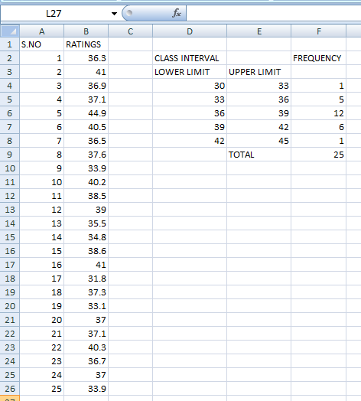

**FORMULAS:**

1.Open new worksheet.

2.Frequency of each class intervals using the formula =COUNTIFS ($C$2:

$C$27,">lower limit", $C$2: $C$27,"<=upper limit").

3Su.m of the frequencies using the formula =SUM (G4:G8).

**RESULT:**

Hence we created a spreadsheet to construct a frequency table for car models based on their mileage ratings.

**DATE: 27/12/2021**

***28. From the following data find***

***a) Range and coefficient of range.***

***b) Quartile deviation and coefficient of quartile deviation.***

https://lh6.googleusercontent.com/5v_8CXKD5nDbco6TT9Tm2vxX3o90Ty0l0D1l-iOWPo0tljlFCoLLjBeFP8Kiuflz3vOsIPh-ffEs077MIIobiUXfpcqnWVB_-eN2sLt1MmEwFRfeiVPgnq1CjapiEzK7dDv0Gdc1

**AIM:**

To create a spreadsheet to find the answers for the following questions.

**TABLE:**

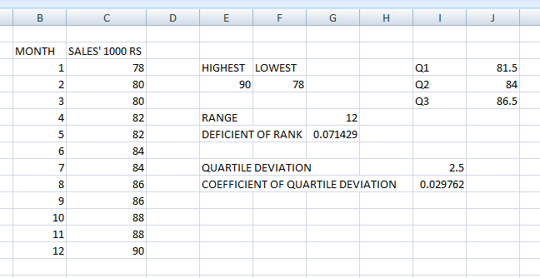

**FORMULAS:**

1. To find the highest salary we use: =max (salary column rows).
2. To find the lowest salary we use: =min (salary column rows).
3. To find range we use: = highest salary – lowest salary.
4. To find coefficient of range we use: = range/(highest salary + lowest salary).
5. To find Q 1 we use: =quartile (salary column, 1).
6. To find Q 2 we use: =quartile (salary column, 2).
7. To find Q 3 we use: =quartile (salary column, 3).
8. To find quartile deviation we use: = (Q3-Q1)/2.
9. To find coefficient of quartile deviation we use: = (Q3-Q1)/(Q3+Q1).

**RESULT:**

Hence the given questions were answered by creating a spreadsheet.

**DATE: 27/12/2021**

***29) Find the mean of the following data.***

***(a) 9, 7, 11, 13, 2, 4, 5, 5***

***(b) 16, 18, 19, 21, 23, 23, 27, 29, 29, 35***

***(c) 2.2, 10.2, 14.7, 5.9, 4.9, 11.1, 10.5***

***(d) 11/4, 21/2, 51/2, 31/4, 21/2***

**AIM:**

To create a spreadsheet to find the answers for the following questions.

**TABLE:**

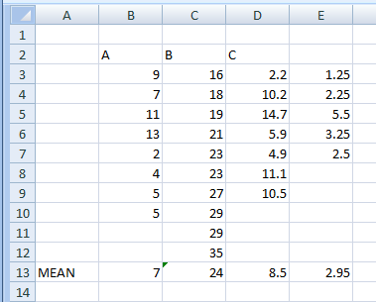

**FORMULAS:**

1. To find the mean for the following questions we use: =average(column containing values).

**RESULT:**

Hence we have answered the following questions using the spreadsheet.

**DATE: 27/12/2021**

***30) The mean of 8, 11, 6, 14, x and 13 is 66. Find the value of the observation x.***

**AIM:**

To create a spreadsheet to find the unknown value of ‘x’.

**TABLE:**

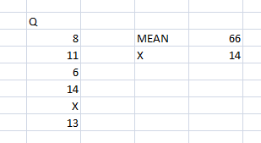

**FORMULAS:**

1. To find the mean we use: = {mean-SUM (column containing values)}.

**RESULT:**

Hence we have answered the following question using the spreadsheet.

**DATE: 27/12/2021**

***31)*** ***Find the mean of the following distribution.***

***(a) The age of 20 boys in a locality is given below.***

|  |  |  |  |  |  |
| --- | --- | --- | --- | --- | --- |
| **Age in Years** | 12 | 10 | 15 | 14 | 8 |
| **Number of Boys** | 5 | 3 | 2 | 6 | 4 |

***(b) Marks obtained by 40 students in an exam are given below.***

|  |  |  |  |  |  |
| --- | --- | --- | --- | --- | --- |
| **Marks** | 25 | 30 | 15 | 20 | 24 |
| **Number of Students** | 8 | 12 | 10 | 6 | 4 |

***(c)***

|  |  |  |  |  |  |
| --- | --- | --- | --- | --- | --- |
| **xi** | 1 | 2 | 3 | 4 | 5 |
| **fi** | 4 | 5 | 8 | 10 | 3 |

***(d) The daily wages of 50 employees in an organization are given below:***

|  |  |  |  |  |
| --- | --- | --- | --- | --- |
| **Daily wages (in $)** | 100 - 150 | 150 - 200 | 200 - 250 | 250 - 300 |
| **Number of Workers** | 12 | 13 | 17 | 8 |

***Find the mean daily wages.***

**AIM:**

To create a spreadsheet to find mean of the daily wages of the above question.

**TABLE:**

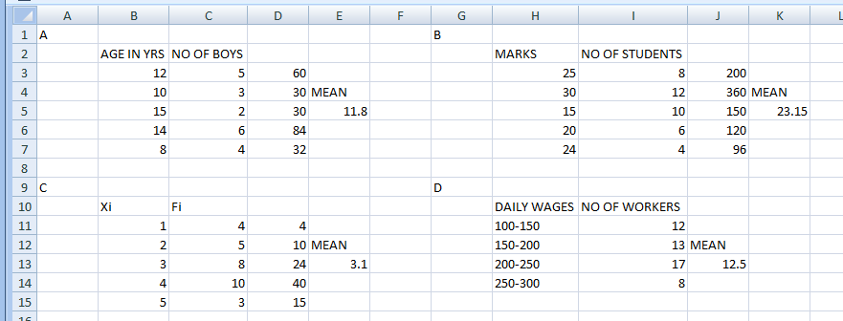

**FORMULAS:**

1. To find the mean we use: = average (column containing values).

**RESULT:**

Hence we have found the mean of the daily wages in the above questions using a spreadsheet.

**DATE: 27/12/2021**

***32)*** ***The runs scored in a cricket match by 11 players is as follows:***

***7, 16, 121, 51, 101, 81, 1, 16, 9, 11, 16***

***Find the mean, mode, median of this data.***

**AIM:**

To create a spreadsheet to find the mean, median, mode of the following data.

**TABLE:**

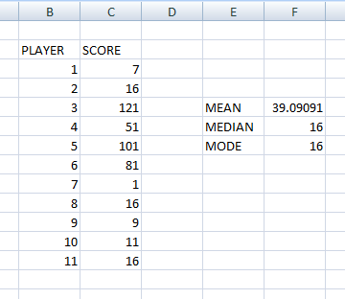

**FORMULAS:**

1. To find the mean we use: = average (range of column containing values).
2. To find the median we use: = median (range of column containing values).
3. To find the mode we use: = mode (range of column containing values).

**RESULT:**

Hence we have found the mean, median, mode of the following data using the spreadsheet.

**DATE: 07/01/2022**

***33)*** ***Create a file name “STUDENT SURVEY DATA FILE”. Create (age) a random sample of 20 students using the random number generator.***

1. ***Find the 5 measure of central tendency for the given values. Calculate co-efficient of variation and interpret your result.***
2. ***Construct the frequency distribution summarizing the ages of students selected in your sample.***
3. ***For this FDT construct the histogram, frequency curve/polygon, ogives and interpret your results.***
4. ***Construct the bar chart for the input data.***

**AIM:**

To create a spreadsheet to answer the following questions.

**TABLE:**

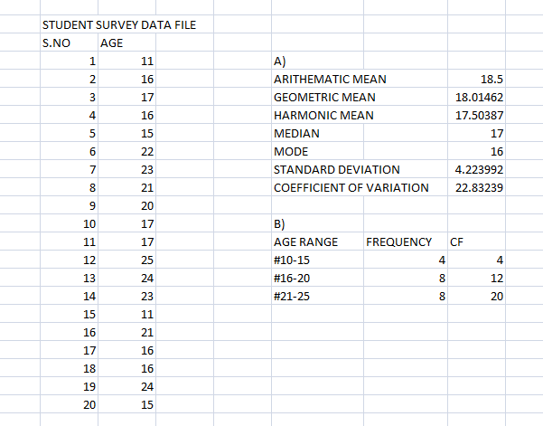

**GRAPH:**

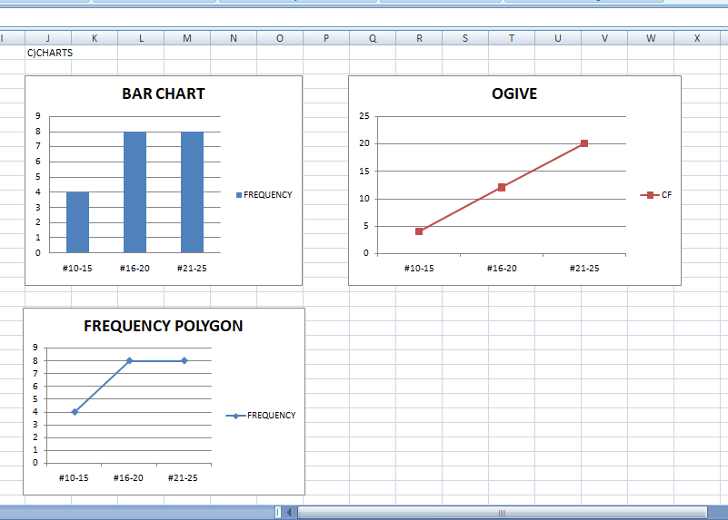

**FORMULAS:**

1.To find the random age we use: =Randbetween(xx:yy).

2.To find the arithmetic mean we use: =Average (xx:yy).

3.To find the geometric mean we use: =Geomean (xx:yy).

4.To find the harmonic mean we use: =Harmean (xx:yy).

5.To find the median we use: =Median (xx:yy).

6.To find the mode we use: =Mode (xx:yy).

7.To find the standard deviation we use: =Stdev (xx:yy).

8.To find coefficient of variation we use: = (arithmetic mean/standard deviation)*100.

9.To find frequency we use: =countifs (xx:yy,”>=10”,xx:yy,”<=20”),same way for each range we check using this function.

10.To find CF, the first number is the frequency itself and the next numbers are: =above CF+ next frequency

**RESULT:**

Hence we successfully solved all the given questions using the spreadsheet.

**DATE: 07/01/2022**

***34) The following data gives the distribution of total monthly household expenditure of families in a village.***

***Expenditure (in Rs.) Number of families***

***2000 - 2500 11***

***2500 - 3000 27***

***3000 - 3500 43***

***3500 - 4000 55***

***4000 - 4500 31***

***4500 - 5000 23***

***5000 – 5500 14***

***5500 – 6000 7***

***Construct the following: Harmonic mean, standard deviation, variance, Histogram, frequency curve / polygon, ogives and interpret your result chart appropriately.***

**AIM:**

To create a spreadsheet to construct the following using spreadsheet.

**TABLE:**

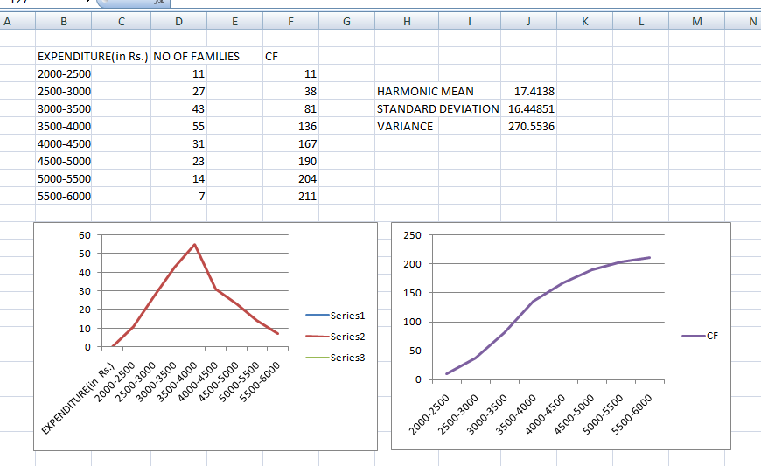

**GRAPH:**



**FORMULAS:**

1.To find CF, the first number is the frequency itself and the next numbers are: =above CF+ next frequency.

2.To find harmonic mean we use: =Harmean(xx:yy).

3.To find standard deviation we use: =Stdev(xx:yy).

4.To find variance we use: =var(xx:yy).

**RESULT:**

Hence we have constructed the following using the spreadsheet.

**DATE: 07/01/2022**

***35) Following are the values of contestants for the competitive exam.***

1. ***Find the 5 measures of central tendency for the given values. Calculate co-efficient of variation and interpret your result.***
2. ***21, -6,17,18,13,12,1.5,14,6,15,1.7,20,12,15, -7,14,1.3,15,14,13,14,20,20,3.1,35,9,-18,2.8,24,2.5.***
3. ***Construct the frequency distribution table for 30 observation and its continuous variables.***
4. ***For this FDT construct the histogram, frequency curve/polygon, ogives and interpret your results.***
5. ***Construct the pie chart for the input data.***

**AIM:**

To create a spreadsheet to answer the following questions.

**TABLE:**

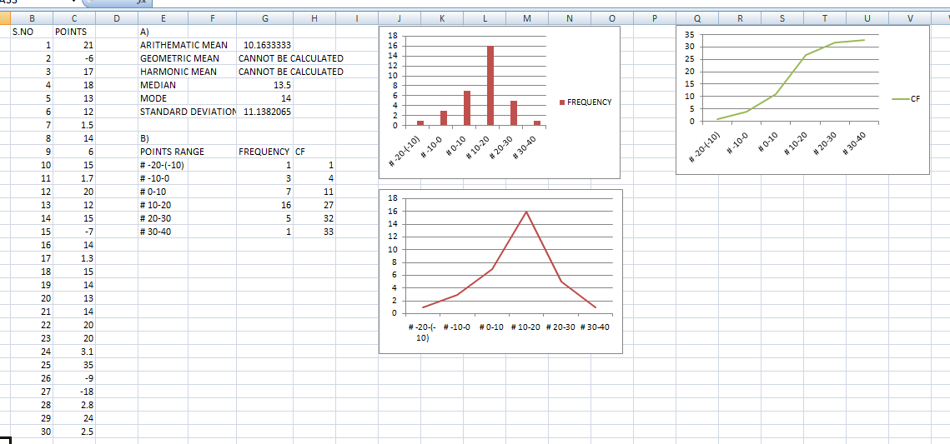

**GRAPH:**



**FORMULAS:**

1.To find arithmetic mean we use: =average(xx:yy).

2.To find harmonic mean and geometric mean we must have all the frequencies with positive values, but here there are negative values, hence they can’t be calculated.

3.To find median we use: =median(xx:yy).

4.To find the mode we use: =mode(xx:yy).

5.To find standard deviation we use: =Stdev(xx:yy).

6.To find frequency we use: =countifs(xx:yy,”>=-20”,xx:yy,”<=-10”), the same way we use different ranges to find all the frequencies.

7.To find CF, the first number is the frequency itself and the next numbers are: =above CF+ next frequency.

8.To find the coefficient of variation we use: =(arithmetic mean/standard deviation)*100.

**RESULT:**

Hence we have answered all the questions using the spreadsheet.

**DATE: 07/01/2022**

***36)  For the monthly income data presented below, calculate Skewness and kurtosis.***

|  |  |  |  |  |  |  |  |  |  |
| --- | --- | --- | --- | --- | --- | --- | --- | --- | --- |
| Monthly income | Upto100 | 100-200 | 200-300 | 300-400 | 400-500 | 500-600 | 600-700 | 700-1000 | Above 1000 |
| Freq | 9 | 51 | 120 | 240 | 136 | 33 | 12 | 9 | 2 |

**AIM:**

To create a spreadsheet to calculate the skewness and kurtosis of monthly income table.

**TABLE:**

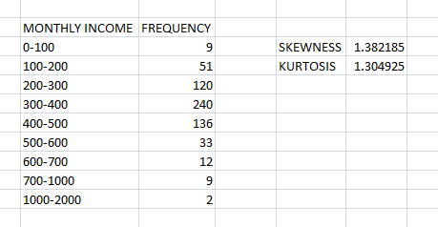

**FORMULAS:**

1.To find skewness we use: =skew(xx:yy).

2.To find the kurtosis we use: =Kurt(xx:yy).

**RESULT:**

Hence we have found the skewness and kurtosis from the monthly income table.

**DATE: 07/01/2022**

***37) For the following data given below, calculate the value of kurtosis and find out the nature of distribution***:

|  |  |  |  |  |  |
| --- | --- | --- | --- | --- | --- |
| X: | 0-10 | 10-20 | 20-30 | 30-40 | 40-50 |
| F: | 5 | 10 | 15 | 10 | 5 |

**AIM:**

To create a spreadsheet to calculate skewness and kurtosis and find the nature of distribution.

**TABLE:**

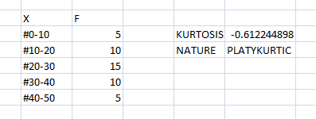

**FORMULAS:**

1.To find kurtosis we use: =Kurt(xx:yy).

2.To find nature of distribution we use: =IF(kurtosis<=3,"Platokurtic",IF(kurtosis=3,"Mesokurtic","Leptokurtic")).

**RESULT:**

Hence we have created the spreadsheet for finding the kurtosis and nature of distribution.

**DATE: 07/01/2022**

***38) Suppose we have the following observations :{ 12, 12, 54, 56, 25}.Determine the skewness and kurtosis of the data and interpret it.***

**AIM:**

To create a spreadsheet to find skewness, kurtosis and interpret the data.

**TABLE:**

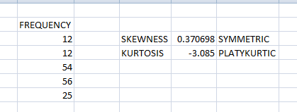

**FORMULAS:**

1.To find skewness we use: =skew(xx:yy).

2.To find kurtosis we use: =Kurt(xx:yy).

3.To find nature of skewness we use: =IF(D2<=-1,"High negative”, IF(AND(D2>-1, D2<0.5),"Moderatenegative",IF(AND(D2>=0.5,D2<=0.5),"Symmetric",IF(AND(D2>0.5,D2<=1),"Moderate positive”, “High positive")))).

4.To find nature of kurtosis we use: =IF(D3<=3,"Platokurtic",IF(E3=3,"Mesokurtic","Leptokurtic")).

**RESULT:**

Hence we have created a spreadsheet to find the skewness, kurtosis and interpret the data.

**DATE: 07/01/2022**

***39) Find the skewness and kurtosis.***

|  |  |  |  |  |  |
| --- | --- | --- | --- | --- | --- |
| Class int | 0-10 | 10-20 | 20-30 | 30-40 | 40-50 |
| F | 10 | 20 | 40 | 20 | 10 |

**AIM:**

To create a spreadsheet to find the skewness and kurtosis of the data.

**TABLE:**

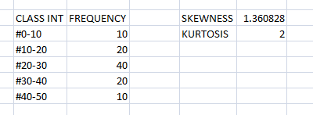

**FORMULAS:**

1.To find skewness we use: =skew(xx:yy).

2.To find kurtosis we use: =Kurt(xx:yy).

**RESULT:**

Hence we have created a spreadsheet to find the skewness and kurtosis of the given data.

**SCILAB DOCUMENTATION**

**Matrix Operations 1**

***1. Create a 5x5 matrix.***

**AIM:** To create a 5x5 matrix in scilab.

**FORMULA**: disp- to display the which is mentioned inside disp()

**CODE:**

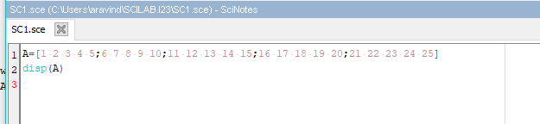

**OUTPUT:**

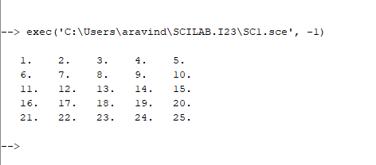

***2. Create a 5x8 matrix with all elements zero.***

**AIM:** To create a 5x5 matrix in with all elements zero.

**FORMULA**: disp- to display the which is mentioned inside disp()

**CODE:**

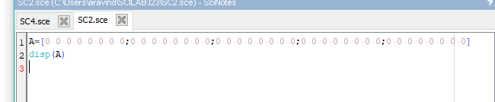

**OUTPUT:**

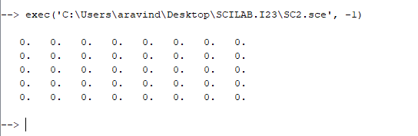

***3. Create a 3x3 identity matrix.***

**AIM:** To create a 3x3 identity matrix in scilab.

**FORMULA**: disp- to display the which is mentioned inside disp()

**CODE:**

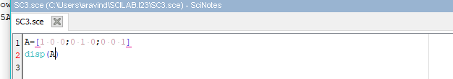

**OUTPUT:**

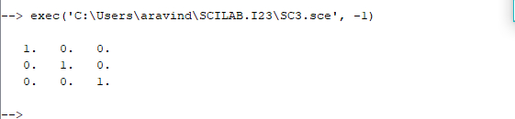

***4. Create a 4x6 matrix with all elements 1.***

**AIM:** To create a 4x6 matrix with all elements 1 in scilab.

**FORMULA**: disp- to display the which is mentioned inside disp()

**CODE:**

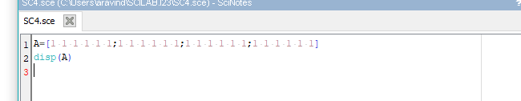

**OUTPUT:**

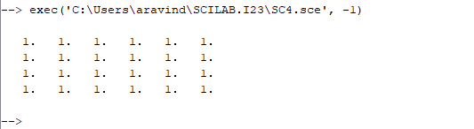

***5. Create a 3x3 diagonal matrix with diagonal elements equal to 10.***

**AIM:** To create a 3x3 diagonal matrix with diagonal elements equal to 10.

**FORMULA**: disp- to display the which is mentioned inside disp()

Eye- is used to return the identity matrix.

**CODE:**

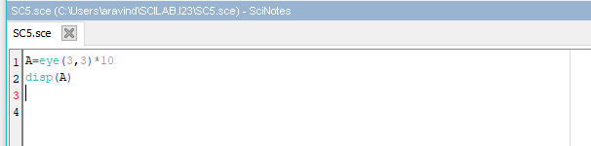

**OUTPUT:**

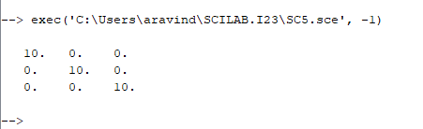

***6. Create a vector with 5 elements as follows [1, 2, 3, 4, 5]***

**AIM:** To create a vector with 5 elements as follows [1, 2, 3, 4, 5]

**FORMULA**: disp- to display the which is mentioned inside disp()

**CODE:**

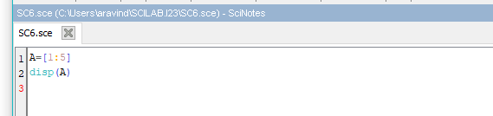

**OUTPUT:**

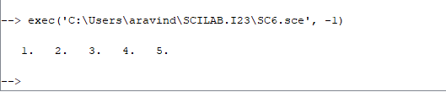

***7. Create a vector with 11 elements as follows [0, 0.5, 1.0, ….4.5, 5.0]***

**AIM:** To create a vector with 11 elements as follows [0, 0.5, 1.0, ….4.5, 5.0]

**FORMULA**: disp- to display the which is mentioned inside disp()

**CODE:**

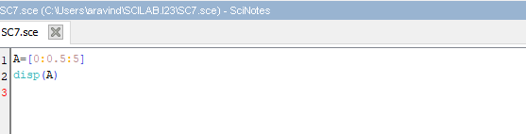

**OUTPUT:**

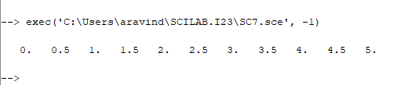

***8. Extract the off-diagonal terms (at an offset of 1) of a square matrix into a vector.***

**AIM:** To create a vector by extracting the off-diagonal terms (at an offset of 1) of a square matrix.

**FORMULA**: disp- to display the which is mentioned inside disp()

Diag**-** is used to return the diagonal elements of the matrix

**CODE:**

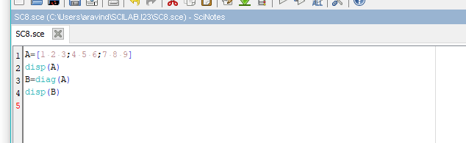

**OUTPUT:**

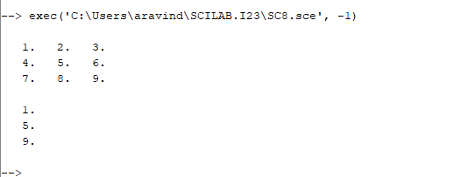

***9. Create a matrix of size 5x5 having the required elements on the diagonal and below the diagonal.***

**AIM:** To create a matrix of size 5x5 having the required elements on the diagonal and below the diagonal.

**FORMULA**: disp- to display the which is mentioned inside disp()

**CODE:**

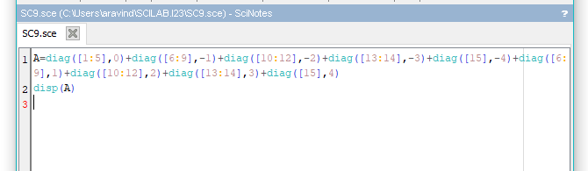

**OUTPUT:**

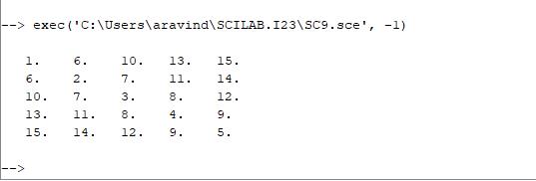

***10. Create a matrix of size 5x5 having the required elements on the diagonal above the main diagonal.***

**AIM:** To create a matrix of size 5x5 having the required elements on the diagonal above the main diagonal.

**FORMULA**: disp- to display the which is mentioned inside disp()

**CODE:**

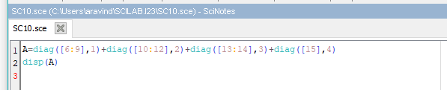

**OUTPUT:**

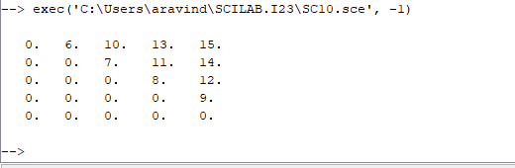

***11. Create a tri-diagonal matrix of size 5x5 with the specified elements on the main diagonal, above and below the main diagonal.***

**AIM:** To create a matrix of size 5x5 with the specified elements on the main diagonal, above and below the main diagonal

**FORMULA**: disp- to display the which is mentioned inside disp()

**CODE:**

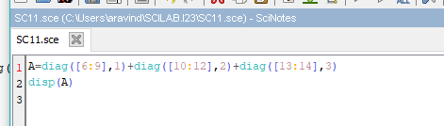

**OUTPUT:**

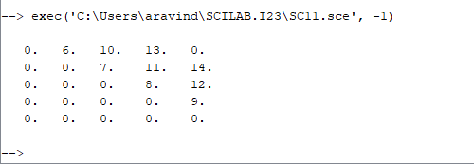

***12. Extract the last column of a matrix a and store it in matrix b.***

**AIM:** To create a matrix b by extractingthe last column of a matrix a.

**FORMULA**: disp- to display the which is mentioned inside disp()

**CODE:**

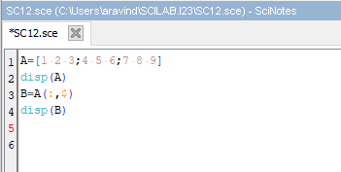

**OUTPUT:**

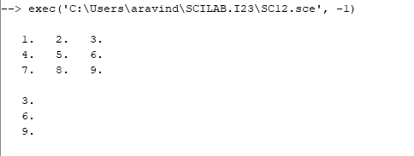

***13. Extract the last but one column of a matrix a and store it in matrix b.***

**AIM:** To create a matrix b by extractingthe last one column of a matrix a.

**FORMULA**: disp- to display the which is mentioned inside disp()

**CODE:**

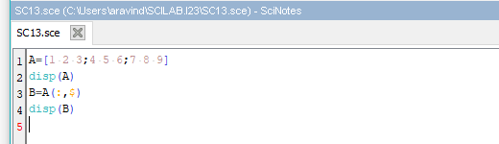

**OUTPUT:**

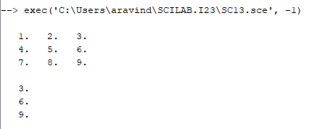

***14. Replace the sub-matrix between rows 3 to 5 and columns 2 to the last but one column, in matrix a of size 5x5 with zeros.***

**AIM:** To create a matrix b by extractingthe last one column of a matrix a.

**FORMULA**: disp- to display the which is mentioned inside disp()

Zeros- is used to display zeros.

**CODE:**

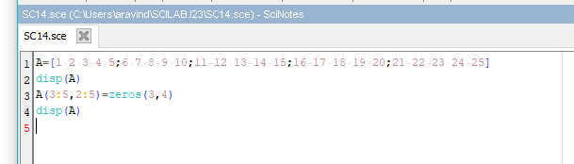

**OUTPUT:**

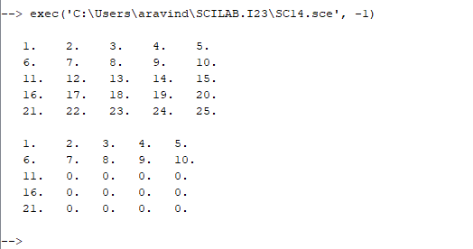

***15. Replace the even numbered columns of matrix a having size 3x5 with ones.***

**AIM:** To create a matrix by replacing the even numbered columns of matrix a having size 3x5 with ones.

**FORMULA**: disp- to display the which is mentioned inside disp()

Ones- it is used to display ones.

**CODE:**

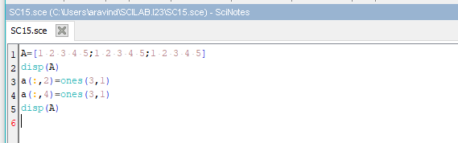

**OUTPUT:**

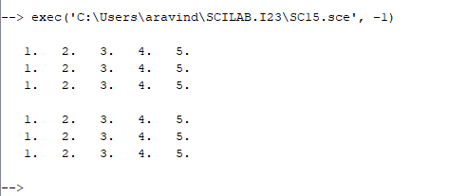

**Matrix Operations 2**

***16. Create a 4x4 matrix with random numbers (use random number generating function)***

**AIM:** To create a 4x4 matrix with random numbers in scilab.

**FORMULA**: disp- to display the which is mentioned inside disp()

**CODE:**

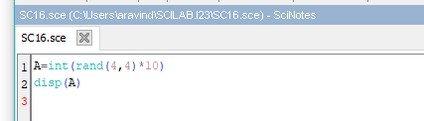

**OUTPUT:**

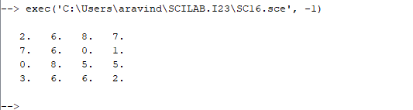

***17. Display the largest element in a vector.***

**AIM:** To display the largest element in a vector.

**FORMULA**: disp- to display the which is mentioned inside disp()

Max- it is used to print the maximum value.

**CODE:**

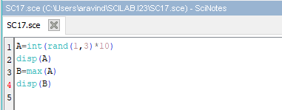

**OUTPUT:**

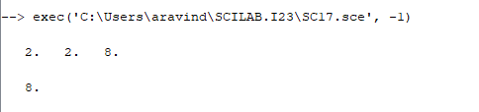

***18. Display the smallest element in a vector.***

**AIM:** To display the smallest element in a vector.

**FORMULA**: disp- to display the which is mentioned inside disp()

Min- it is used to return the minimum value.

**CODE:**

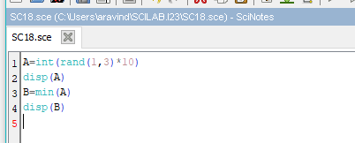

**OUTPUT:**

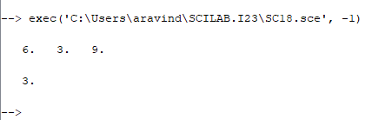

***19. Display the sum of elements in a vector.***

**AIM:** To display the sum element in a vector.

**FORMULA**: disp- to display the which is mentioned inside disp()

Sum- it is used to print the sum of values.

**CODE:**

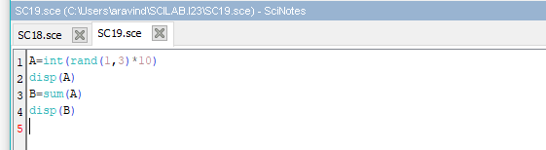

**OUTPUT:**

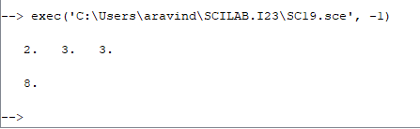

***20. Display the product of all elements in a vector.***

**AIM:** To display the product of all elements in a vector.

**FORMULA**: disp- to display the which is mentioned inside disp()

Prod- it is used to return the product of values.

**CODE:**

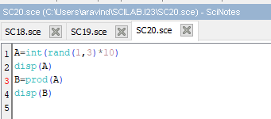

**OUTPUT:**

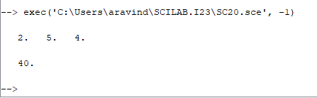

***21. Display the eigen values of a matrix.***

**AIM:** To display the eigen values of a matrix.

**FORMULA**: disp- to display the which is mentioned inside disp()

Spec- it is used to return the eigen values.

**CODE:**

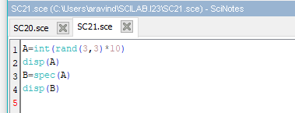

**OUTPUT:**

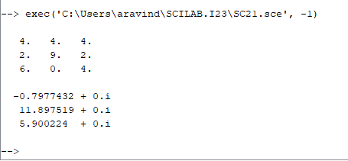

***22. Extract the last column of a matrix A and store it in matrix B.***

**AIM:** To create a matrix B by extractingthe last column of a matrix A.

**FORMULA**: disp- to display the which is mentioned inside disp()

**CODE:**

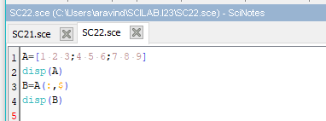

**OUTPUT:**

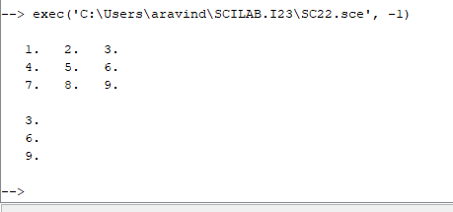

***23. Replace the sub-matrix between rows 3 to 5 and columns 2 to the last but one column in a matrix A of size 5x5 with zeros.***

**AIM:** To create a matrix by extractingthe last one column of a matrix B.

**FORMULA**: disp- to display the which is mentioned inside disp()

Zeros- it is used to display zeros.

**CODE:**

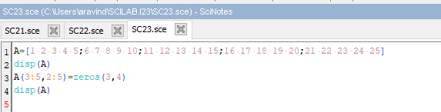

**OUTPUT:**

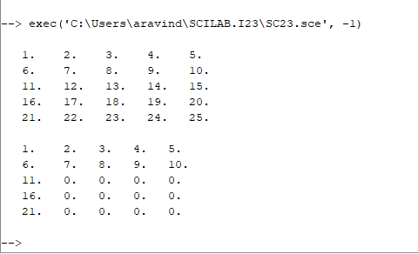

***24. Replace the even-numbered columns of matrix A having size 3x5 with ones.***

**AIM:** To create a matrix by replacing the even numbered columns of matrix A having size 3x5 with ones.

**FORMULA**: disp- to display the which is mentioned inside disp()

Ones- it is used to display ones.

**CODE:**

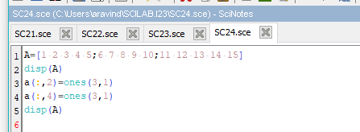

**OUTPUT:**

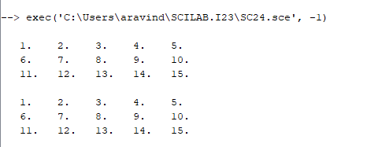

***25. Compute power for each of the elements of a 2x2 matrix.***

**AIM:** To calculate the square of each element of a 2x2 matrix.

**FORMULA**: disp- to display the which is mentioned inside disp()

Sqrt- it is used to take the square root of the values.

**CODE:**

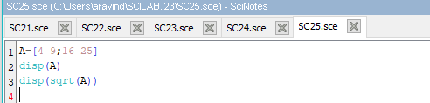

**OUTPUT:**

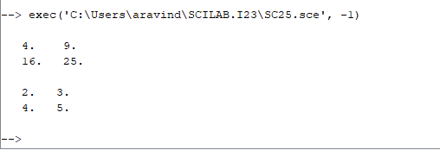

***26. Create a Scilab program to compute addition of two matrices. (Get values dynamically and compute addition)***

**AIM:** To create a Scilab program to compute addition of two matrices.

**FORMULA**: disp- to display the which is mentioned inside disp()

**CODE:**

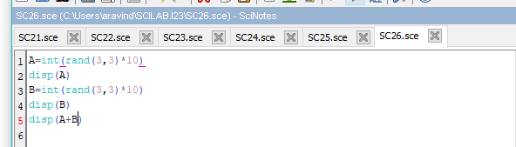

**OUTPUT:**

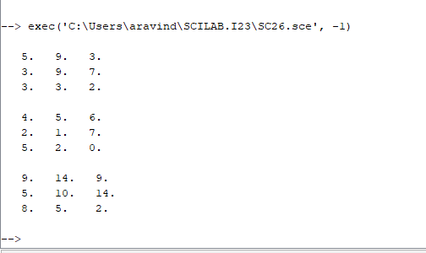

***27. Create a Scilab program to compute multiplication of two matrices.***

**AIM:** To create a Scilab program to compute multiplication of two matrices.

**FORMULA**: disp- to display the which is mentioned inside disp()

**CODE:**

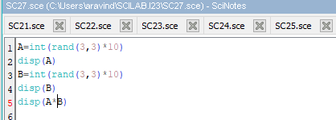

**OUTPUT:**

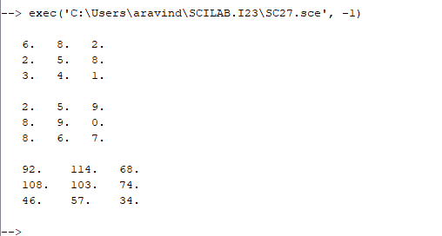

***28. Create a Scilab program to get a matrix from the user and display its transpose.***

**AIM:** To create a Scilab program to get a matrix from the user and display its transpose.

**FORMULA**: disp- to display the which is mentioned inside disp()

a’- is used to display the transpose of the matrix.

**CODE:**

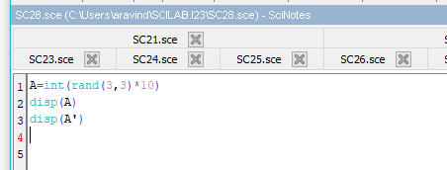

**OUTPUT:**

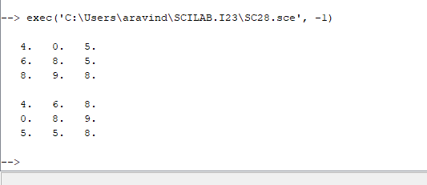

***29. Create a Scilab program to get a matrix from the user and find its determinant.***

**AIM:** To create a Scilab program to get a matrix from the user and display its determinant.

**FORMULA**: disp- to display the which is mentioned inside disp()

Det- is used to display the determinant of the matrix.

**CODE:**

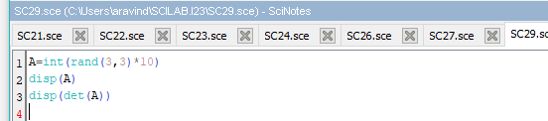

**OUTPUT:**

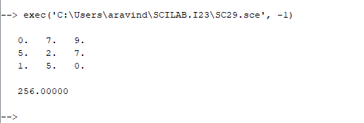

***30. Create a Scilab program to get 2 matrices from the user and perform the following operations to the matrices. a. Relational operations b. Logical operations c. Bitwise operations by applying the required operators.***

**AIM:** To create a Scilab program to get 2 matrix from the user and perform the following operations.

a. Relational operations

b. Logical operations

c. Bitwise operations by applying the required operators

**FORMULA**: disp- to display the which is mentioned inside disp()

Bitand- it is used to perform bitwise and operation.

Bitor- it is used to perform bitwise or operation.

**CODE:**

a**.**

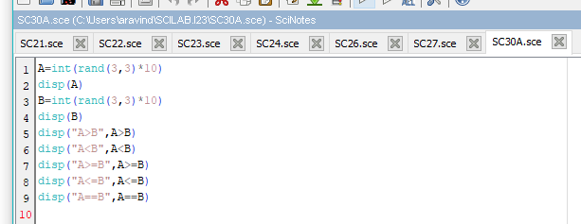

.

b.

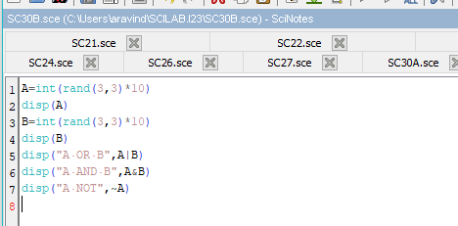

c.

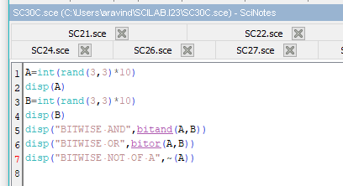

**OUTPUT:**

a.

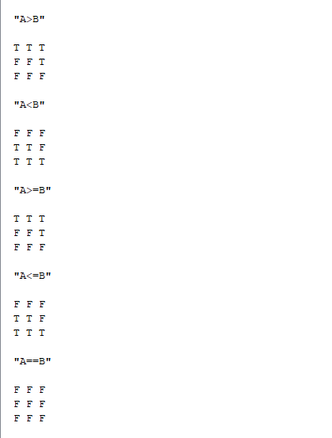

b.

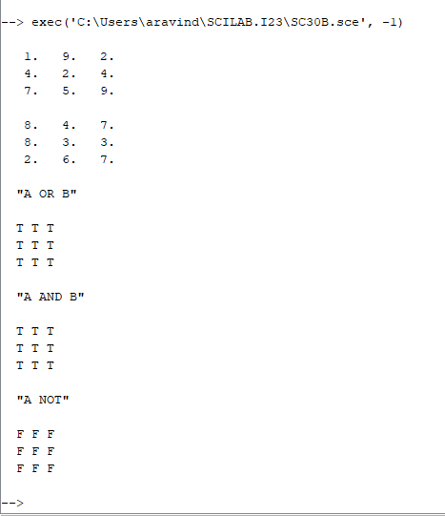

c.

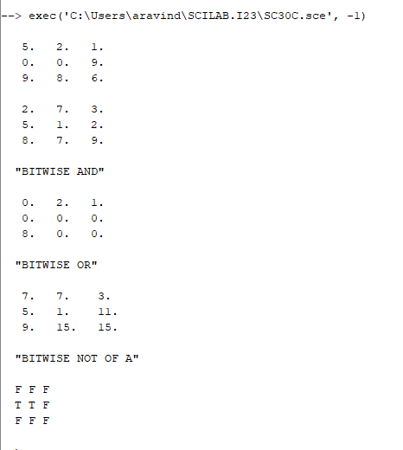

**Matrix Operations 3**

***31. Write a scilab code to predict nature of equation using rank of matrix.***

**AIM:** To create a Scilab code to predict nature of equation using rank of matrix.

**FORMULA**: disp- to display the which is mentioned inside disp()

Rank- it is used to display the rank of the matrix

**CODE:**

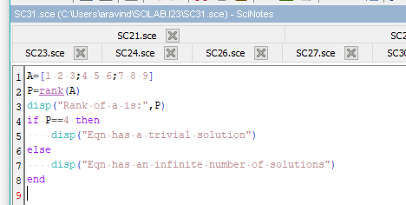

**OUTPUT:**

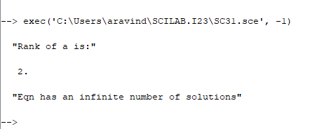

***32. Write a scilab code to transpose the given 2 matrices and find the product of the transpose.***

**AIM:** To create a Scilab code to transpose the given 2 matrices and find the product of the transpose.

**FORMULA**: disp- to display the which is mentioned inside disp()

A’, b’- is used to return the transpose of the matrix

**CODE:**

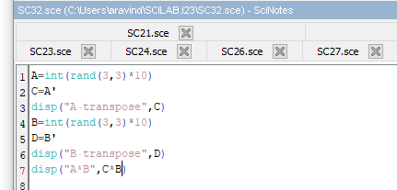

**OUTPUT:**

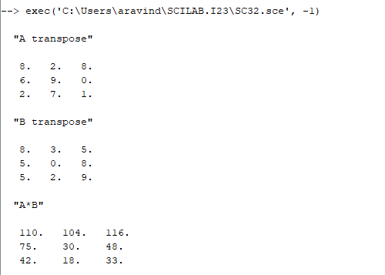

***33. Write a scilab code to find the eigen values and find its vectors.***

**AIM:** To create a Scilab code to find the eigen values and find its vectors.

**FORMULA**: disp- to display the which is mentioned inside disp()

Spec- it is used to return the eigen values of the matrix.

**CODE:**

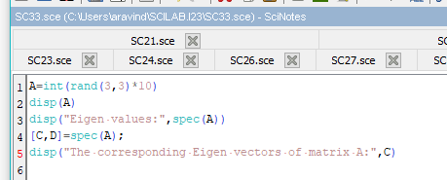

**OUTPUT:**

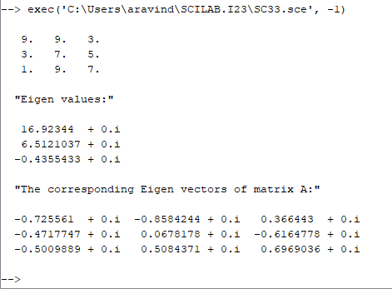

***34. Write a scilab code to compute the row reduced echelon form of a matrix.***

**AIM:** To create a Scilab code to compute the row reduced echelon form of a matrix.

**FORMULA**: disp- to display the which is mentioned inside disp()

Rref- is used to return the row reduced echelon form of a matrix

**CODE:**

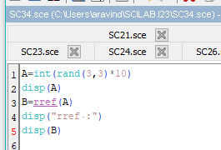

**OUTPUT:**

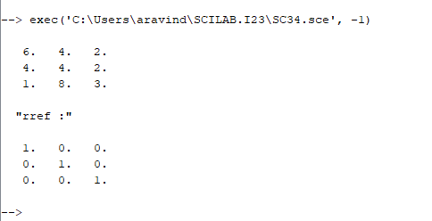

**STATISTICS 1**

***35. The following data depicts the starting salary of employees and their frequencies. Write a Scilab code to compute the relative frequency of the data.***

***Starting salary (in rupees) 47 48 49 50 51 52 53 54 56 57 60***

***Frequency 4 1 3 5 8 10 0 5 2 3 1***

**AIM:** To create a Scilab code to compute the relative frequency of the data which depicts the starting salary of employees.

**FORMULA:**

disp- to display which is mention inside disp().

sum- it returns the sum.

**CODE:**

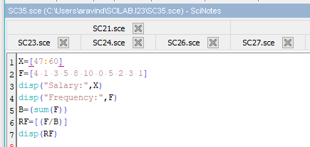

**OUTPUT:**

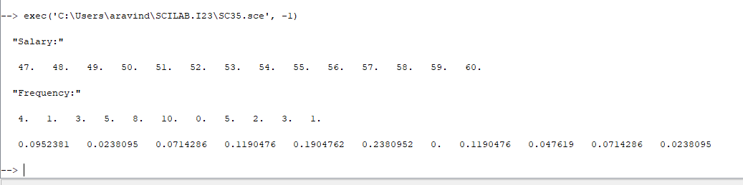

***36. The cancer data consisting of type of cancer and number of patients suffering from the disease is given in the below table***

***Disease Lung Breast Colon Prostate Melanoma Bladder***

***No. of patients 42 50 32 55 9 12***

***Construct a pie chart in scilab to find the percentage of patients suffering from a particular type of cancer.***

**AIM:** To construct a pie chart in scilab to find the percentage of patients suffering from a particular type of cancer.

**FORMULA:**

Pie- to print the pie chart.

**CODE:**

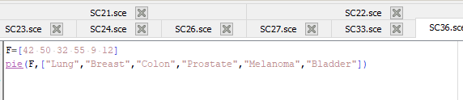

**OUTPUT:**

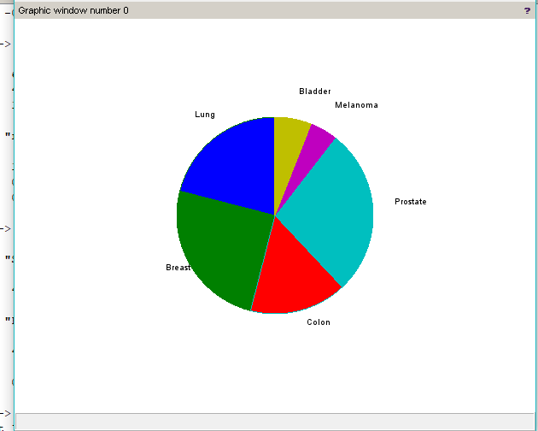

***37. The data consists of the students belonging to various ages and number of students lying in particular age. Find the mean, median and mode for the data***

***Age 15 16 17 18 19 20***

***Frequencies 2 5 11 9 14 13***

**AIM:** To find the mean, median and mode for the data consists of the students belonging to various ages and number of students lying in particular age.

**FORMULA:**

Disp - to display which is mention inside disp().

Meanf- to return the mean for x and frequency.

Median- to return the median.

Mode- to return the maximum frequency.

**CODE:**

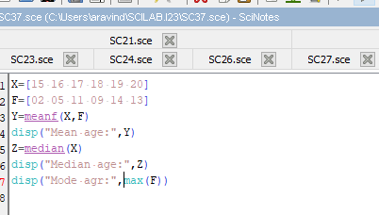

**OUTPUT:**

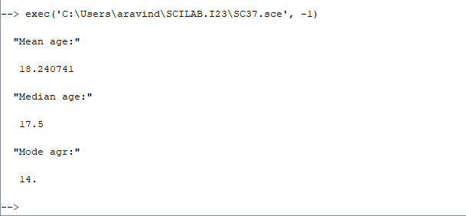

***38. Find the variance of following data:***

***i. 3, 4, 6,7,10***

***ii. -20, 5, 15, 24***

**AIM:** To find the variance for the following data. i. 3, 4, 6,7,10

ii. -20, 5, 15, 24.

**FORMULA:**

Disp - to display which is mention inside disp().

Variance- it returns the variance of x and y.

**CODE:**

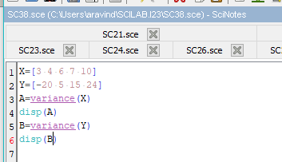

**OUTPUT:**

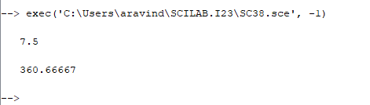

***39. Find the quartiles of the following data:***

***82, 89, 94, 110, 74, 122, 112, 95, 100, 78, 65, 60, 90, 83, 87, 75, 114, 85, 69, 94,***

***124, 115, 107, 88, 97, 74, 72, 82, 68, 83, 91, 90, 102, 77, 125, 108, 65***

**AIM:** To find the quartiles of the following data.

**FORMULA:**

Disp - to display which is mention inside disp().

Quart- to return the quartiles.

**CODE:**

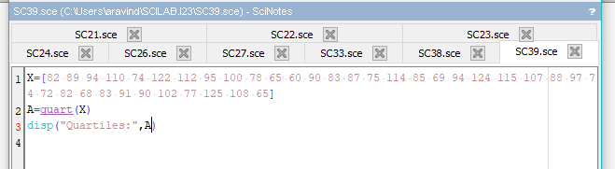

**OUTPUT**

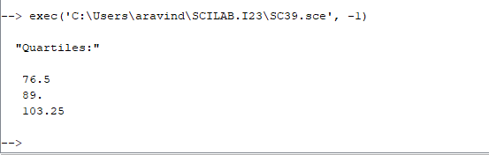

***40. The following are the data for the variable: Number of movies watched in the past months:***

***1, 5, 5, 4, 5, 4, 0, 15, 1, 0, 0, 1. Calculate mean, median, mode, variance , standard deviation and range.***

**AIM:** To find mean, median, mode, variance, standard deviation and range.

**FORMULA:**

Disp - to display which is mention inside disp().

Mean- to return the mean.

Median- to return the median.

Tabul- to return the mode of each value of x.

Variance- it returns the variance.

Stdev- it return the standard deviation.

**CODE:**

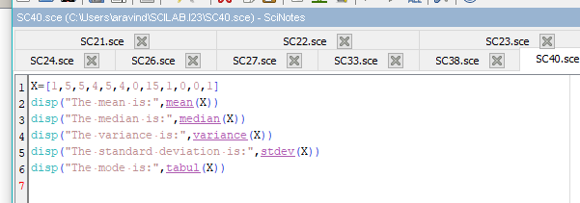

**OUTPUT:**

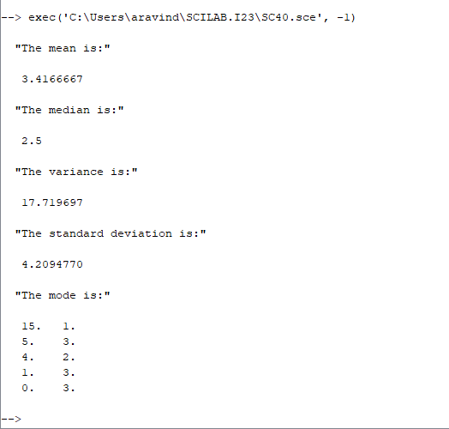

***41. Find the mean, median and mode of the following data representing test scores: 90, 76, 53, 78, 88, 80, 81, 91, 99, 68, 62, 78, 67, 82, 88, 89, 78, 72, 77, 96, 93, 88, 88.***

**AIM:** To find mean, median, mode of the following data representing test scores.

**FORMULA:**

Disp - to display which is mention inside disp().

Mean- to return the mean.

Median- to return the median.

Tabul- to return the mode of each value of x.

**CODE:**

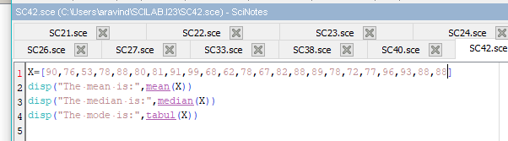

**OUTPUT:**

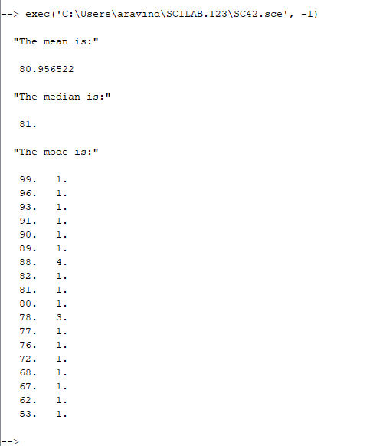

***42. Calculate the harmonic mean for the following: The marks obtained by 9 students are given below: 45, 32, 37, 46, 39, 36, 41, 48, 36***

**AIM:** To find harmonic mean for the following data.

**FORMULA:**

Disp - to display which is mention inside disp().

harmean- to return the harmonic mean.

**CODE:**

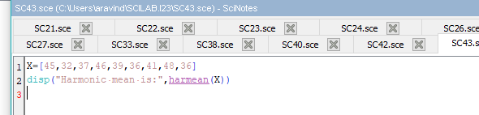

**OUTPUT:**

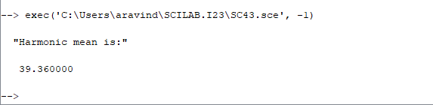

***43. Compute the mean of the following frequency distribution:***

***Class 0-11 11-22 22-33 33-44 44-55 55-66***

***Frequency 9 17 28 26 15 8***

**AIM:** To find mean for the following frequency distribution

**FORMULA:**

Disp - to display which is mention inside disp().

meanf- to return the mean for x and frequency.

**CODE:**

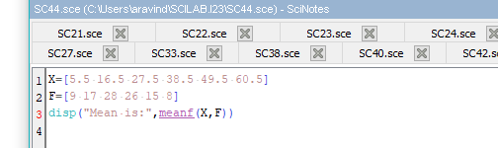

**OUTPUT:**

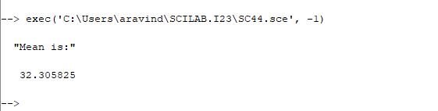

***44. Find the mean and standard deviation of the following distribution:***

***Wages in rs 0-10 10-20 20-30 30-40 40-50***

***No. of workers 22 38 46 35 20***

**AIM:** To find mean and standard deviation for the following frequency distribution

**FORMULA:**

Disp - to display which is mention inside disp().

meanf- to return the mean for x and frequency.

Stdevf- it returns the standard deviation.

**CODE:**

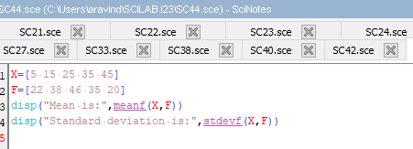

**OUTPUT:**

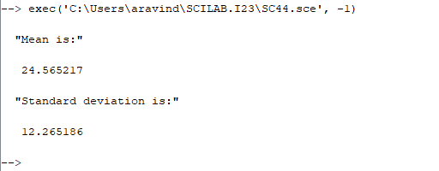

***45. The lengths of power failures, in minutes, are recorded in the following table. 22 18 135 15 90 78 69 98 102 83 55 28 121 120 13 22 124 112 70 66 74 89 103 24 21 112 21 40 98 87 132 115 21 28 43 37 50 96 118 158 74 78 83 93 95.***

***(a) Find the sample mean and sample median of the power-failure times.***

***(b) Find the sample standard deviation of the power-failure times.***

**AIM:** To find mean, median and standard deviation for the lengths of power failure, in minutes for the collected data.

**FORMULA:**

Disp - to display which is mention inside disp().

Mean- it return the mean.

Median- it return the median.

Stdev- it returns the standard deviation.

**CODE:**

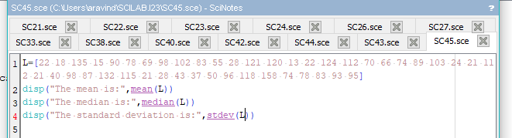

**OUTPUT:**

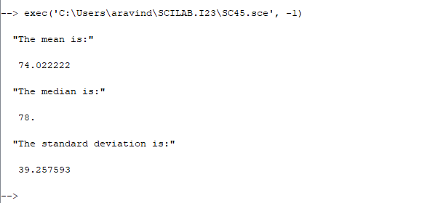

***46. The following scores represent the final examination grades for an elementary statistics course: 23 60 79 32 57 74 52 70 82 36 80 77 81 95 41 65 92 85 55 76 52 10 64 75 78 25 80 98 81 67 41 71 83 54 64 72 88 62 74 43 60 78 89 76 84 48 84 90 15 79 34 67 17 82 69 4 63 80 85 61 (a) Construct a relative frequency histogram, and calculate skewness of the distribution. (b) Compute the sample mean, sample median, and sample standard deviation.***

**AIM:** To construct a relative frequency histogram, to calculate skewness and to find mean, median and standard deviation for the scores representing the final examination grades for an elementary statistics course.

**FORMULA:**

Disp - to display which is mention inside disp().

(a) histplot- plots the histogram diagram

(b) Mean- it return the mean.

Median- it return the median.

Stdev- it returns the standard deviation.

**CODE:**

**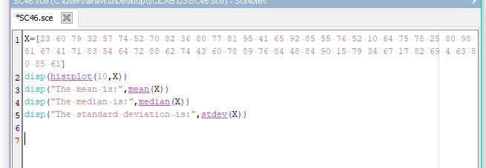  
OUTPUT:**

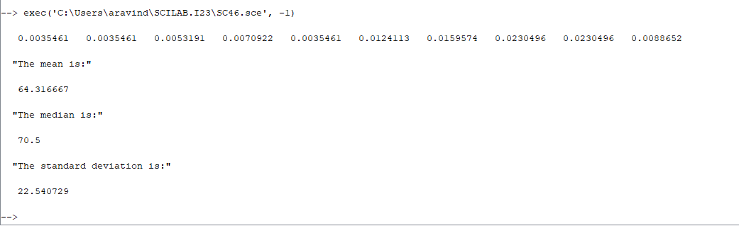

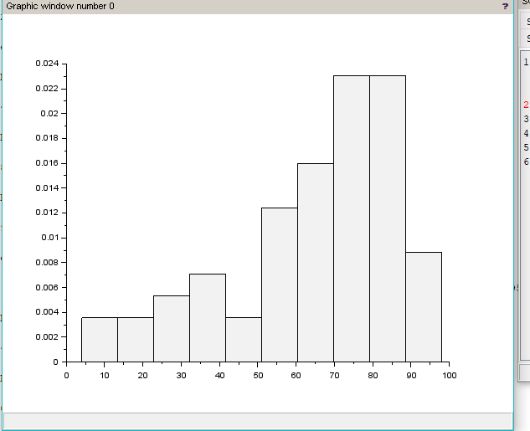

***47. The following data gives the percentages of the families that are in the upper income level. 72.2 31.9 26.5 29.1 27.3 8.6 22.3 26.5 20.4 12.8 25.1 19.2 24.1 58.2 68.1 89.2 55.1 9.4 14.5 13.9 20.7 17.9 8.5 55.4 38.1 54.2 21.5 26.2 59.1 43.3 (a) Calculate the sample mean. (b) Calculate the sample median.***

**AIM:** To find mean and median for the percentages of the families that are in the upper income level.

**FORMULA:**

Disp - to display which is mention inside disp().

Mean- it return the mean.

Median- it return the median.

**CODE:**

**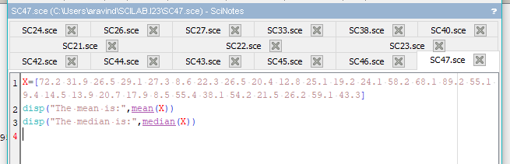  
OUTPUT:**

