DATASTRUCTURE LAB EXAM

ARUN V DAS
TKMMCA-2012
SEM-2

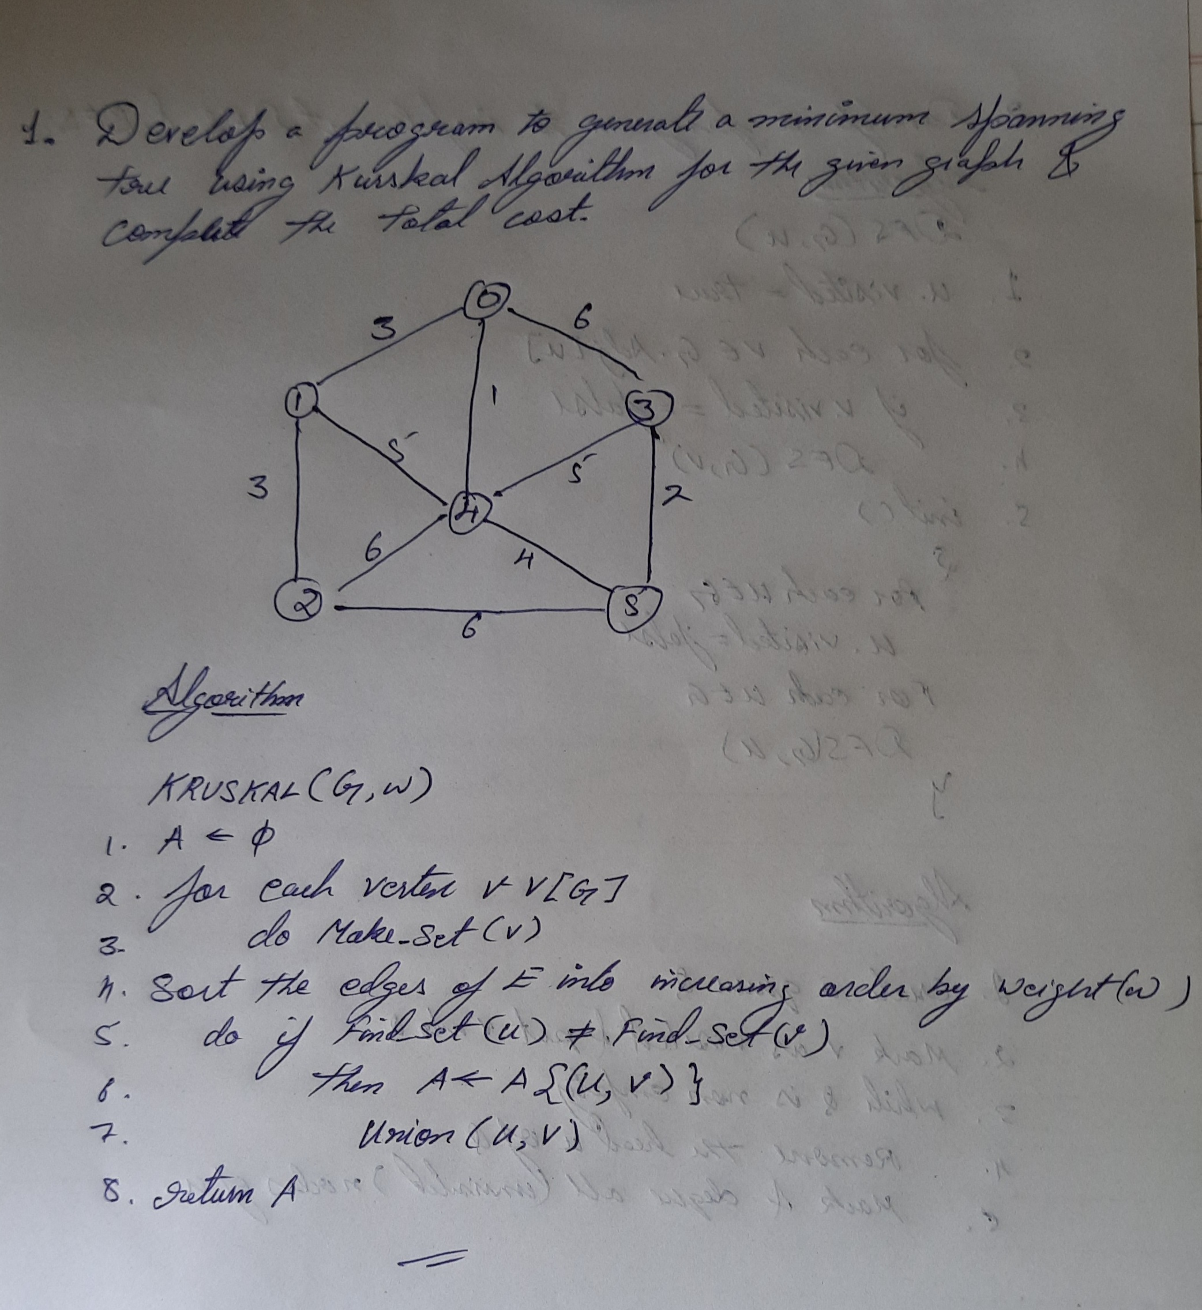

SOURCE CODE

#include<stdio.h>
#include<stdlib.h>
int i,j,k,a,b;
int u,v,n,ne=1;
int min,mincost=0,cost[10][10],p[10];
int find(int);
int uni(int,int);
void main()
{
printf("\nEnter the no. of vertices:");
scanf("%d",&n);
printf("\nEnter the cost adjacency matrix:\n");
for(i=1;i<=n;i++)
{
for(j=1;j<=n;j++)
{
scanf("%d",&cost[i][j]);
if(cost[i][j]==0)
cost[i][j]=999;
}
}
printf("\nThe edges of Minimum Cost Tree are\n");
while(ne < n)
{
for(i=1,min=999;i<=n;i++)
{
for(j=1;j <= n;j++)
{
if(cost[i][j] < min)
{
min=cost[i][j];
a=u=i;
b=v=j;
}
}
}
u=find(u);
v=find(v);
if(uni(u,v))
{
printf("Edge %d (%d,%d) = %d\n",ne++,a,b,min);
mincost +=min;
}
cost[a][b]=cost[b][a]=999;
}
printf("\nMinimum cost = %d\n",mincost);

}
int find(int i)
{
while(p[i])
i=p[i];
return i;
}
int uni(int i,int j)
{
if(i!=j)
{
p[j]=i;
return 1;
}
return 0;
}

OUTPUT:

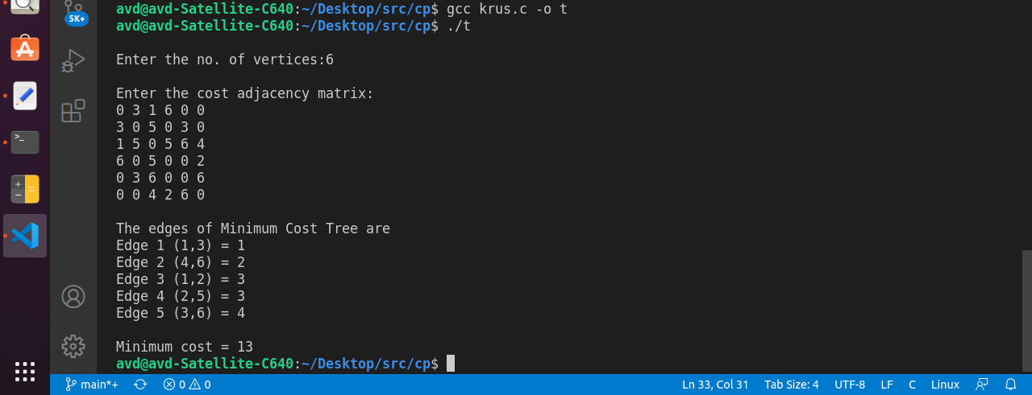

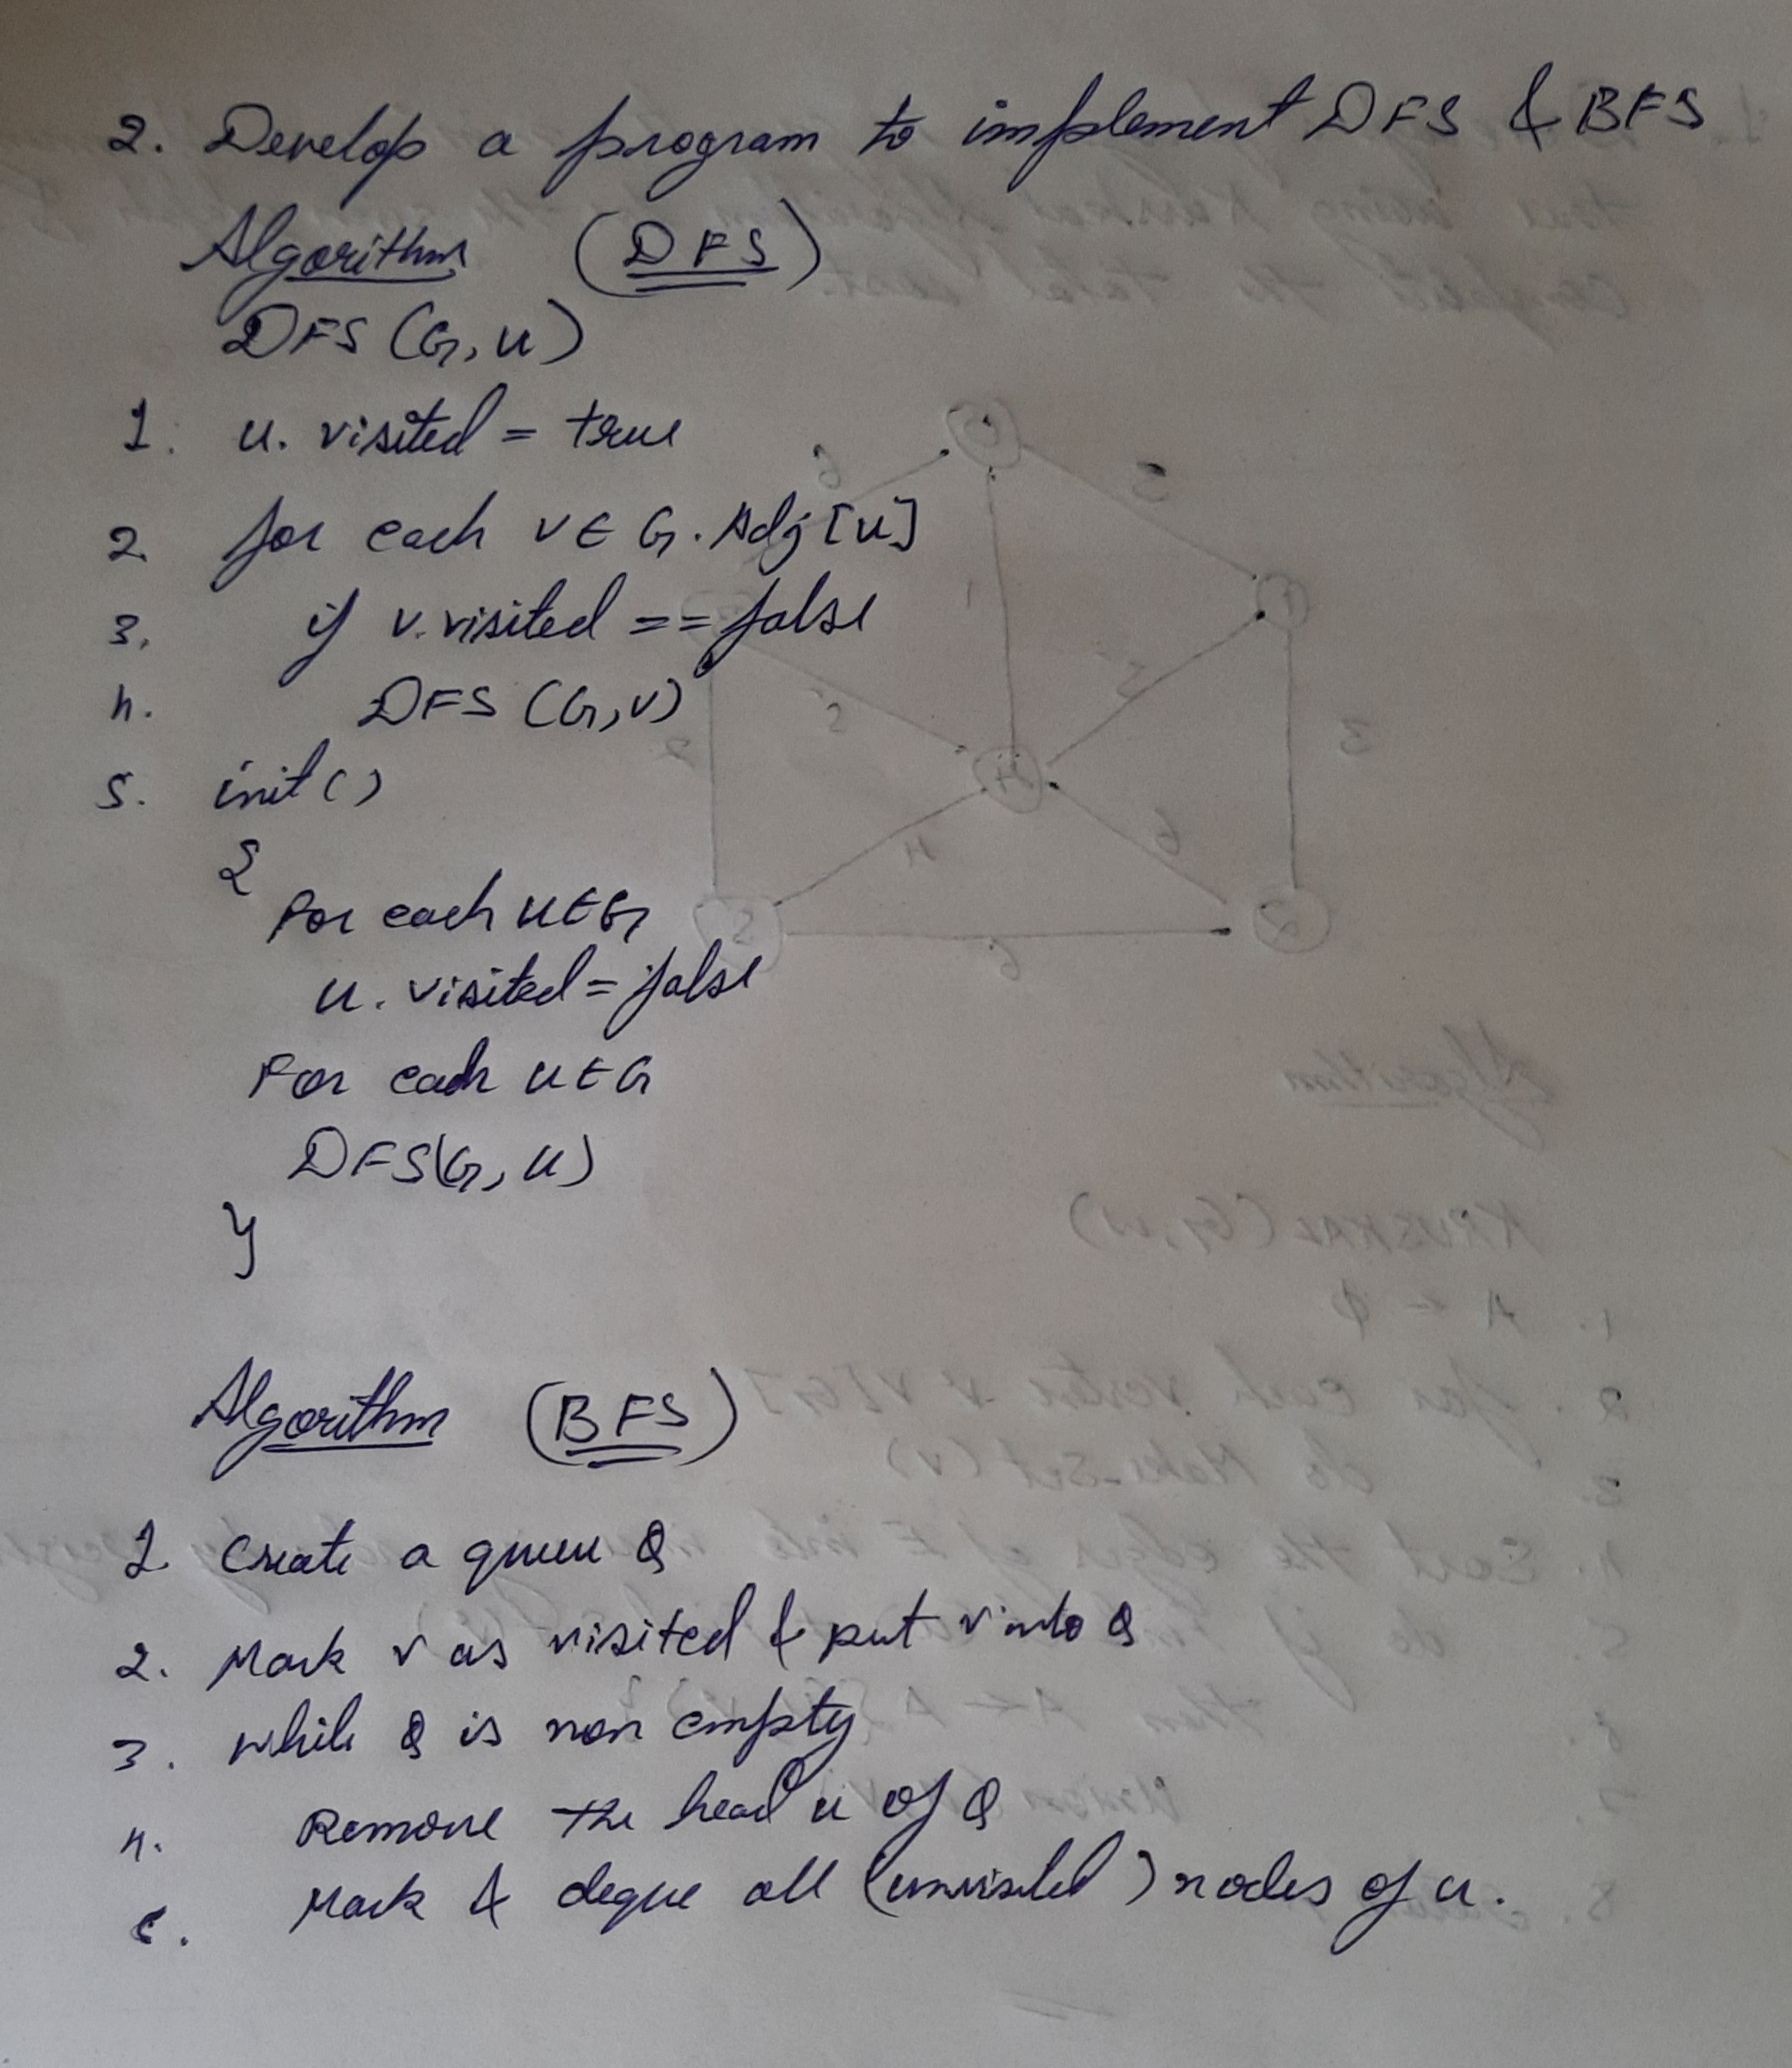

SOURCE CODE

BFS

#include<stdio.h>

int a[20][20],q[20],visited[20],n,i,j,f=0,r=-1;
void bfs(int v) {
for (i=1;i<=n;i++)
if(a[v][i] && !visited[i])
q[++r]=i;
if(f<=r) {
visited[q[f]]=1;
bfs(q[f++]);
}
}
void main() {
int v;

printf("\n Enter the number of vertices:");
scanf("%d",&n);
for (i=1;i<=n;i++) {
q[i]=0;
visited[i]=0;
}
printf("\n Enter graph data in matrix form:\n");
for (i=1;i<=n;i++)
for (j=1;j<=n;j++)
scanf("%d",&a[i][j]);
printf("\n Enter the starting vertex:");
scanf("%d",&v);
bfs(v);
printf("\n The node which are reachable are:\n");
for (i=1;i<=n;i++)
if(visited[i])
printf("%d\t",i);
else
printf("\n Bfs is not possible");

}

OUTPUT:

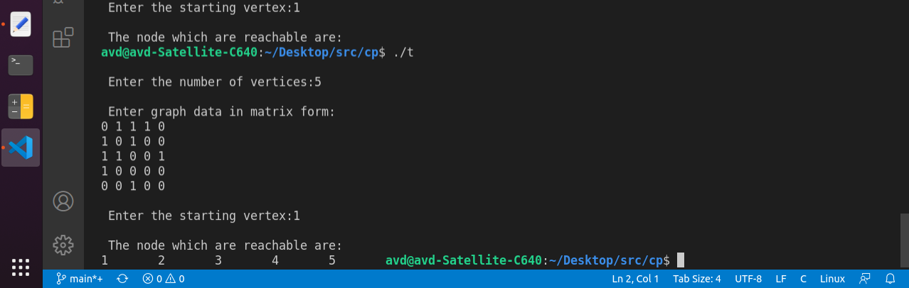

SOURCE CODE

DFS

#include<stdio.h>
int a[20][20],reach[20],n;
void dfs(int v)
{
int i;
reach[v]=1;
for(i=1;i<=n;i++)
if(a[v][i] && !reach[i])
{
printf("\n %d->%d",v,i);
dfs(i);
}
}
void main()
{
int i,j,count=0;

printf("\n Enter number of vertices:");
scanf("%d",&n);
for(i=1;i<=n;i++)
{
reach[i]=0;
for(j=1;j<=n;j++)
a[i][j]=0;
}
printf("\n Enter the adjacency matrix:\n");
for(i=1;i<=n;i++)
for(j=1;j<=n;j++)
scanf("%d",&a[i][j]);
dfs(1);
printf("\n");
for(i=1;i<=n;i++)
{
if(reach[i])
count++;
}
}

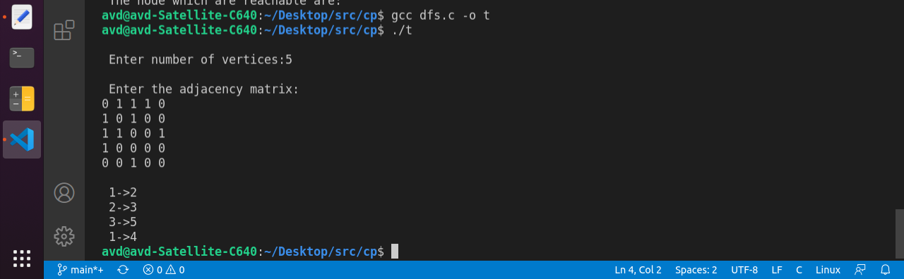
OUTPUT:

