AVDAN
System Architecture Document
Logistics + Commerce Platform

Version | v3.0
Status | Draft — Confidential
Classification | Internal Use Only
Supersedes | v2.0
Key Changes v3.0 | Correct Contabo plans, network diagrams, CI/CD flow, type-sharing diagram

1. Executive Summary
AVDAN is a multi-role logistics and commerce platform connecting Customers, Vendors, Riders, Agent Hubs, and Administrators within a single tightly coordinated system. The platform manages the full order lifecycle — from customer purchase through vendor preparation, rider dispatch, agent hub quality assurance, last-mile delivery, and automated escrow payment release.
Core Design Principle: Every actor on the platform operates within clearly defined state transitions. No money moves, no status changes, and no notifications fire outside of the defined lifecycle engine.

Platform Roles
Role | Primary Responsibility | Interface
Customer | Place orders, track delivery, receive goods | Web App (Next.js 16)
Vendor | Accept orders, prepare goods for pickup | Vendor Dashboard (Next.js 16)
Rider | Collect from vendor, deliver to customer | Rider App (React Native + Expo)
Agent Hub | QA verification + dispatch coordination | Hub Portal (Next.js 16)
Admin | Platform oversight, analytics, operations | Admin Panel (Next.js 16)
Support | Dispute resolution, user assistance | Support Dashboard (Next.js 16)

2. Key Architectural Decisions
This section documents every decision made during architecture review. Any future change must be recorded here with justification before implementation begins.

2.1 Repository Structure — Monorepo
Decision: A single Git repository using Turborepo and pnpm workspaces, hosted on GitHub.
Why not multiple repos? AVDAN has five frontends sharing the same backend, types, API contracts, and deployment pipeline. Separate repos create type drift, duplicated CI config, and coordination overhead a small team cannot afford.
Why Turborepo? Turborepo understands the dependency graph between apps and packages. When an API endpoint changes, Turborepo rebuilds only the API and the frontend apps that depend on changed types — not the entire monorepo. CI stays fast as the codebase grows.

Monorepo Directory Layout
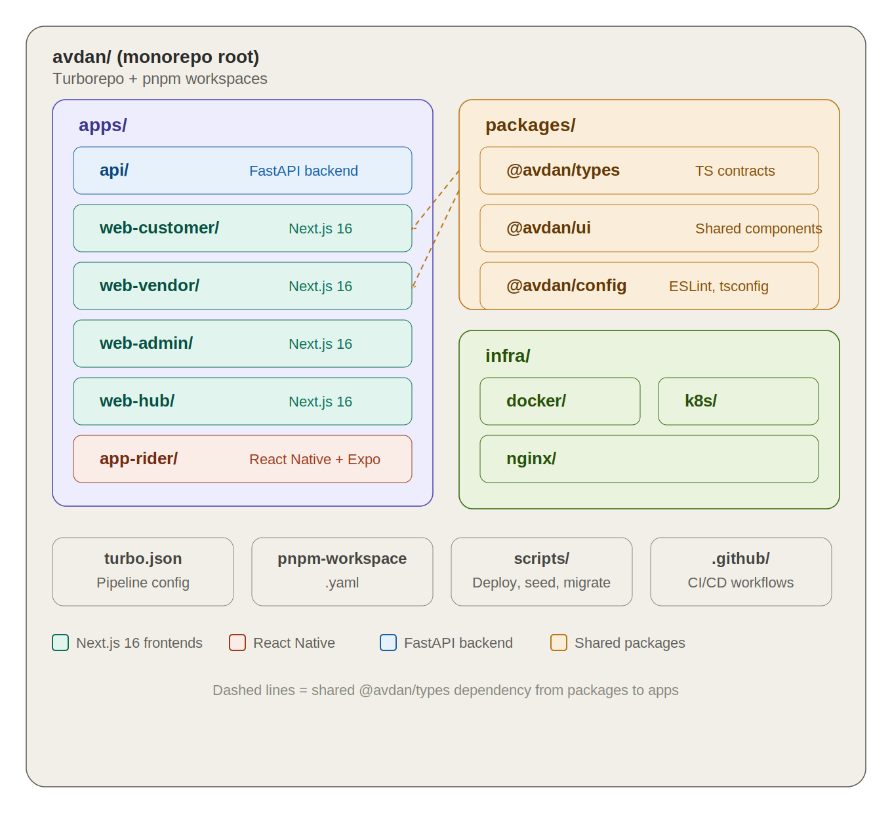
Figure 1 — Monorepo structure: apps/, packages/, infra/, and root config files

avdan/
apps/
api/ # FastAPI backend (Python 3.12)
web-customer/ # Next.js 16 — customer-facing app
web-vendor/ # Next.js 16 — vendor dashboard
web-admin/ # Next.js 16 — admin panel
web-hub/ # Next.js 16 — agent hub portal
app-rider/ # React Native + Expo — rider mobile app
packages/
@avdan/types/ # Generated TypeScript types from FastAPI
@avdan/ui/ # Shared component library
@avdan/config/ # ESLint, Prettier, tsconfig base
infra/
docker/ # Dockerfiles per service
k8s/ # Kubernetes manifests (K3s compatible)
nginx/ # Nginx config files
scripts/ # generate-types.sh, deploy.sh, seed.py
docker-compose.dev.yml # Local dev environment
turbo.json / pnpm-workspace.yaml / .github/workflows/

2.2 How TypeScript and FastAPI Share Types
Next.js is TypeScript. FastAPI is Python. They do not share types natively. The solution is automatic type generation from FastAPI's built-in OpenAPI specification.
FastAPI automatically generates a JSON-format OpenAPI spec at /openapi.json — this requires zero extra work. A CLI tool (openapi-typescript) reads that spec and writes a TypeScript types file into the shared @avdan/types package. All Next.js apps import from this package. Frontend developers never write API types manually.

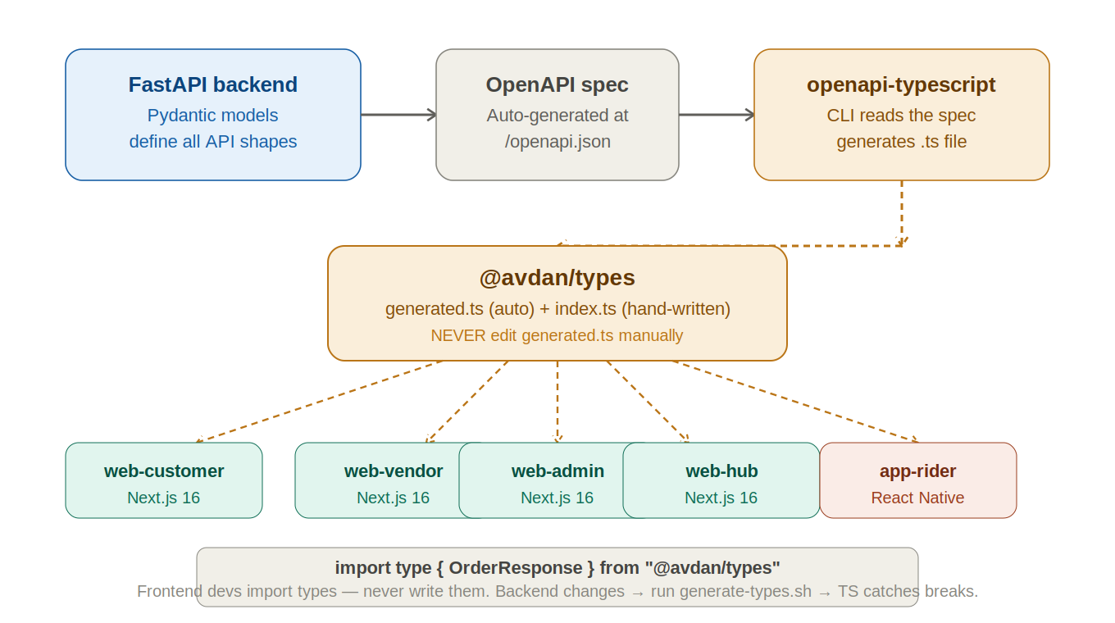
Figure 2 — Type sharing pipeline: Pydantic models → OpenAPI spec → generated.ts → all Next.js apps

The frontend developer NEVER writes API types manually. If the backend changes an endpoint, running generate-types.sh takes 2 seconds and regenerates the file. TypeScript immediately flags every broken usage across all five frontend apps. The compiler does the communication between teams.

Generation Script
# scripts/generate-types.sh
#!/bin/bash
# Run while FastAPI dev server is running on :8000
npx openapi-typescript http://localhost:8000/openapi.json \
--output packages/types/src/generated.ts

# Frontend usage (in any Next.js app)
import type { OrderResponse, VendorProfile } from "@avdan/types";

generated.ts is never edited by hand. It is regenerated by CI on every backend change and committed to git so frontend developers always have current types without running the backend locally.

2.3 Architecture Pattern — Modular Monolith
The backend starts as a modular monolith: all service modules run inside a single FastAPI process. Service boundaries are enforced by code structure and import rules, not by network boundaries. Each module owns its domain and communicates only through defined service interfaces.
Why not microservices at MVP? A two-person team building microservices from day one spends more time on inter-service networking, distributed tracing, and deployment coordination than on the actual product.
How do we decompose later? Because each module communicates only through defined interfaces, extracting a module means: copy it, add HTTP or message-queue transport, update the caller. No business logic is rewritten.
First services to extract at growth phase: Tracking Service (WebSocket-heavy) and Notification Service (I/O-bound). Both are identified in the scaling roadmap in Section 14.

2.4 Frontend Stack — Next.js 16 + React Native
App | Technology | Rationale
Customer App | Next.js 16 (App Router) | SSR for SEO + initial load; shared types with API
Vendor Dashboard | Next.js 16 (App Router) | Auth-gated; complex real-time order management
Admin Panel | Next.js 16 (App Router) | Data-heavy; server components for performance
Agent Hub Portal | Next.js 16 (App Router) | Real-time updates via WebSocket + RSC
Rider App | React Native + Expo | GPS, camera, push notifications, offline support

Next.js 16 is the target. Scaffold with: npx create-next-app@16 --typescript --app --tailwind

2.5 Payment Architecture — Provider Abstraction
AVDAN supports multiple payment providers over time. Paystack launches first. Flutterwave, Stripe, and Interswitch are planned. The Payment Service uses a provider abstraction layer so escrow business logic never changes when a new provider is added.

Abstract Payment Provider Interface
# services/payment/provider_base.py
from abc import ABC, abstractmethod

class PaymentProvider(ABC):
@abstractmethod
async def initiate_charge(self, order_id, amount, customer) -> ChargeResult: ...
@abstractmethod
async def verify_payment(self, reference: str) -> PaymentStatus: ...
@abstractmethod
async def transfer_to_vendor(self, vendor_id, amount, ref) -> TransferResult: ...
@abstractmethod
async def refund(self, payment_ref, amount) -> RefundResult: ...
@abstractmethod
async def verify_webhook(self, payload, signature, headers) -> WebhookEvent: ...

Provider Registry
# services/payment/registry.py
PROVIDERS: dict[str, PaymentProvider] = {
"paystack": PaystackProvider(),
"flutterwave": FlutterwaveProvider(), # add when ready
"stripe": StripeProvider(), # add when ready
}

def get_provider(name: str) -> PaymentProvider:
return PROVIDERS[name]

Provider-Agnostic Database Columns
-- escrow_transactions
provider VARCHAR(30) -- "paystack", "flutterwave", "stripe"
provider_ref VARCHAR(100) -- provider transaction ID
provider_metadata JSONB -- provider-specific fields (no schema changes needed)

CRITICAL: Verify the Paystack x-paystack-signature header on every incoming webhook. An unverified endpoint allows an attacker to fake payment confirmations and trigger escrow releases.

3. Infrastructure Architecture

3.1 Hosting — Contabo VPS + K3s
AVDAN is self-hosted on Contabo VPS servers running Ubuntu 22.04 LTS. Container orchestration uses K3s — a fully certified, lightweight Kubernetes distribution that uses ~512 MB RAM (vs ~2 GB for full Kubernetes), installs in one command, and uses the identical kubectl API and manifest format. All K3s manifests deploy unchanged to AWS EKS or Google GKE if you ever migrate.

3.2 Three-Node Cluster — Actual Contabo Plans
Server specs updated to reflect actual Contabo Cloud VPS plans available at time of writing. The previously specified "6 vCPU / 16 GB" plan does not exist on Contabo.

Node | Role | Contabo Plan | Spec | Price
Node 1 | K3s master + Nginx + API pods | Cloud VPS 30 | 8 vCPU / 24 GB RAM / 200 GB NVMe | $13.44/mo
Node 2 | K3s worker + API pods + Celery | Cloud VPS 20 | 6 vCPU / 12 GB RAM / 100 GB NVMe | $6.72/mo
Node 3 | PostgreSQL + Redis + backups | Cloud VPS 20 | 6 vCPU / 12 GB RAM / 100 GB NVMe | $6.72/mo

Total: $13.44 + $6.72 + $6.72 = $26.88/month servers + ~$3/month Contabo Object Storage = ~$30/month. Node 1 uses the larger VPS 30 because it runs the K3s control plane (etcd, scheduler, API server) in addition to app pods — the control plane alone uses 300–500 MB RAM. Node 2 is a pure worker and does not need that headroom.

3.3 Why Node 1 Is the Only Public Server
Only Node 1 has ports 80 and 443 open to the internet. Nodes 2 and 3 operate entirely on Contabo's internal private LAN — they are unreachable from the internet. All five subdomains resolve to Node 1's single public IP via Cloudflare DNS. Nginx on Node 1 reads the Host: header on every incoming request and routes to the correct K8s Service. K3s then delivers the response from whichever node the pod runs on — the caller never knows or cares.

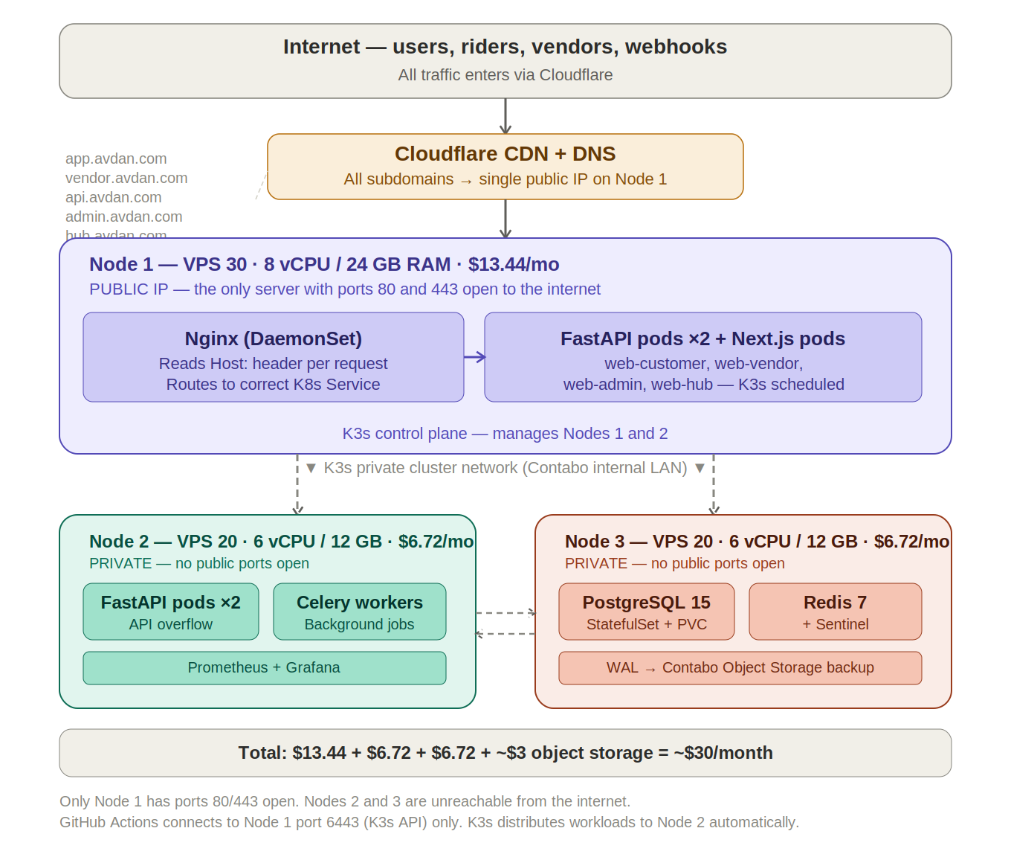
Figure 3 — Network topology: one public IP on Node 1, Nodes 2 and 3 on private LAN only

Subdomain Routing
Subdomain | Nginx Routes To | Pod Location
api.avdan.com | FastAPI Service (ClusterIP) | Nodes 1 and 2 (K3s schedules)
app.avdan.com | web-customer Service | Node 1 or 2 (K3s schedules)
vendor.avdan.com | web-vendor Service | Node 1 or 2 (K3s schedules)
admin.avdan.com | web-admin Service | Node 1 or 2 (K3s schedules)
hub.avdan.com | web-hub Service | Node 1 or 2 (K3s schedules)

3.4 RAM Budget (Node 1 — 24 GB)
Component | RAM Allocation
K3s control plane (etcd, scheduler, API server) | ~500 MB
Nginx DaemonSet pod | ~50 MB
FastAPI pod × 2 (2 Gunicorn workers each) | ~600 MB total
Next.js pods (customer, vendor, admin, hub) | ~800 MB total
OS + kernel + page cache | ~1 GB
Available headroom for spikes and growth | ~21 GB remaining

3.5 Traffic Capacity vs Orders
At 10,000 orders/month, peak load is approximately 1.2 HTTP requests/second during a 6-hour rush window. A single FastAPI worker handles 50–200 req/sec. With 8 workers across both app nodes, capacity is 400–1,600 req/sec. At 10K orders/month the platform runs at under 1% of capacity.

Orders/month | Peak req/sec | % of capacity | Action
10,000 | ~1.2 | < 1% | None — monitor
50,000 | ~6 | ~3% | Monitor, no action needed
100,000 | ~12 | ~6% | Add Node 4, enable HPA
500,000 | ~60 | ~30% | Extract Tracking + Notification
1,000,000+ | ~120+ | 60%+ | Full microservices + Kafka

3.6 K3s vs Full Kubernetes
Dimension | K3s | Full Kubernetes (kubeadm)
RAM to run control plane | ~512 MB | ~2 GB
Install time | 1 command, under 1 minute | Hours of config and troubleshooting
kubectl API identical? | Yes — certified Kubernetes | Yes
Same manifests? | Yes — zero changes needed | Yes
Scale to multi-node? | Yes — just join more nodes | Yes — built for large clusters
Best for | VPS, edge, prod clusters under ~20 nodes | Large org clusters, managed cloud K8s

K3s is not a "lite" or "fake" Kubernetes. It passes the same CNCF conformance tests. Every manifest you write for K3s deploys unchanged to AWS EKS or Google GKE. You are not locked in.

3.7 No Single Point of Failure — Mitigations
Component | Risk | Mitigation
FastAPI | Pod crash | 4 replicas + K8s liveness probes — traffic rerouted instantly
Nginx | Node failure | DaemonSet (1 per node) + Cloudflare failover to healthy node
Redis | Pod crash | Redis Sentinel sidecar — automatic failover in < 30 seconds
PostgreSQL | Pod crash | StatefulSet restarts pod; data on PVC persists; WAL to Object Storage
Celery | Worker crash | Stateless workers; K8s restarts dead pods; tasks persist in Redis
Payment webhook | Double delivery | Idempotency key checked before processing; duplicates rejected
Celery beat | Multiple instances | Single-replica Deployment; PodDisruptionBudget enforces exactly one

4. CI/CD Pipeline — Deployment Flow
GitHub Actions is the bridge between the monorepo and the cluster. It is the only thing that ever connects to the servers. Developers never SSH into production servers for routine deployments.

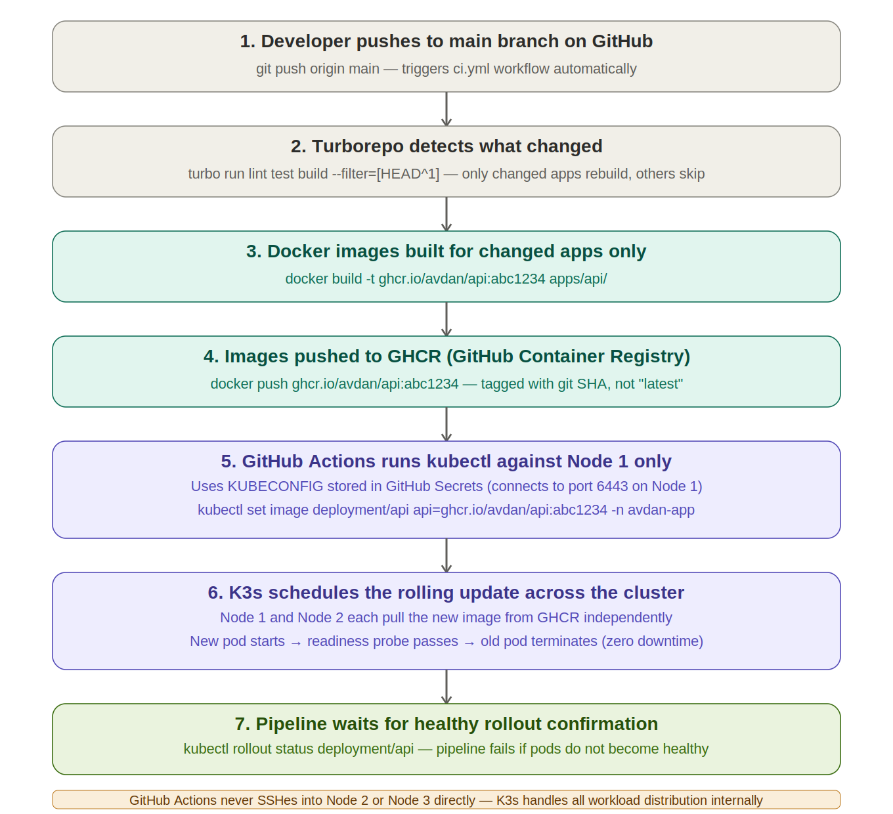
Figure 4 — GitHub Actions deployment pipeline: push to cluster in 7 steps

4.1 Pipeline Steps Explained
- Developer pushes to main branch. GitHub Actions triggers automatically via ci.yml.
- Turborepo runs: turbo run lint test build --filter=[HEAD^1]. Only apps that changed since the last commit are rebuilt. A pure CSS change in web-customer does not trigger an API rebuild.
- Docker images are built for changed apps only. Each image is tagged with the git commit SHA — never "latest".
- Images are pushed to GHCR (GitHub Container Registry). Free, no storage limits, integrated with GitHub auth.
- GitHub Actions runs kubectl using the KUBECONFIG stored as a GitHub Secret. This connects to Node 1 on port 6443 (the K3s API server port — separate from ports 80/443). Nodes 2 and 3 are never contacted directly.
- K3s schedules the rolling update. Node 1 and Node 2 each pull the new image from GHCR independently. Rolling update: new pod starts, readiness probe passes, old pod terminates. Zero requests dropped.
- kubectl rollout status waits for the deployment to complete. If any pod fails to become healthy, the pipeline fails and the team is notified.

4.2 Rollback
Rollback is a single kubectl command using the previous git SHA as the image tag:
kubectl set image deployment/api api=ghcr.io/avdan/api:<previous-sha> -n avdan-app
kubectl rollout status deployment/api -n avdan-app

This is why images are tagged with git SHAs, not "latest". Every deployment is traceable and reversible in under 30 seconds.

4.3 Branch Strategy
Branch | Purpose | Who pushes
main | Production. Protected — only via PR. Auto-deploys to production. | GitHub Actions only
develop | Integration. Auto-deploys to staging environment. | Both developers via PR
feature/* | Feature work. Backend and frontend devs work independently. | Individual developers

5. Secrets Management

5.1 Why Not Plain GitHub Secrets for K8s?
GitHub Secrets are fine for CI pipeline credentials (KUBECONFIG, GHCR_TOKEN). The problem is the last mile: getting secrets into running pods. The naive approach is to put them in K8s Secret manifests — but Kubernetes Secrets are base64-encoded, not encrypted. Anyone with kubectl read access can decode all secrets instantly. Committing raw K8s Secret manifests to git (even private) is a security anti-pattern.

5.2 Strategy — GitHub Secrets + Sealed Secrets
Secret type | Where stored | Purpose
KUBECONFIG | GitHub Secrets | Allows Actions to run kubectl against the cluster
GHCR_TOKEN | GitHub Secrets | Allows Actions to push Docker images to GHCR
DB credentials, JWT secret, payment API keys | Sealed Secrets (in-cluster) | Encrypted in git; decrypted only inside the cluster

Sealed Secrets (Bitnami/CNCF, fully free) works as follows: a controller runs inside the cluster and holds a private key. You encrypt secrets on your local machine with the matching public key. The encrypted SealedSecret manifest is safe to commit to git. Only the in-cluster controller can decrypt it.

# Install Sealed Secrets controller (once, on cluster setup)
kubectl apply -f https://github.com/bitnami-labs/sealed-secrets/releases/latest/download/controller.yaml

# Seal a secret locally
kubectl create secret generic avdan-api-secrets \
--from-literal=DATABASE_URL="postgresql+asyncpg://..." \
--from-literal=PAYSTACK_SECRET_KEY="sk_live_..." \
--dry-run=client -o yaml | kubeseal -o yaml > infra/k8s/sealed-secret-api.yaml

# Commit the sealed file to git — it is safe, encrypted with cluster public key
git add infra/k8s/sealed-secret-api.yaml && git commit -m "add sealed API secrets"

6. Backend Service Architecture
The backend is organised into distinct service modules within a single FastAPI application. Each module owns a specific domain. This structure enables future microservice extraction without rewriting business logic.

6.1 Service Modules
Module | Responsibility | Key Operations
Auth | Identity, sessions, JWT lifecycle | Register, login, refresh, revoke, RBAC enforcement
Order | Order lifecycle state machine | Create, transition states, validate actors, emit events
Payment | Provider-agnostic escrow engine | Initiate, hold, transfer to vendor, refund, reconcile
Dispatch | Rider assignment engine | Match rider to order, zone logic, timeout + reassign
Tracking | Real-time location and ETA | Receive GPS, broadcast via WebSocket, ETA calculation
Notification | Multi-channel dispatch | Push, SMS, in-app — triggered by order state events
QA | Agent hub inspection workflow | Log inspection, pass/fail, exception routing
Vendor | Vendor management and catalog | Onboarding, product management, availability
Analytics | Platform metrics and reporting | Aggregate events, compute KPIs, serve dashboards
Dispute | Dispute intake and resolution | Create dispute, evidence, admin decision
Admin | Platform config and oversight | User actions, config changes, escrow interventions

6.2 Order State Machine (17 States)
The Order Service is the most critical service. Every major system interaction — payment, dispatch, QA, notifications — is triggered by a state transition. No service modifies order state directly; all transitions flow through the Order Service.

State | Trigger | Next States | Side Effects
PENDING | Customer submits order | PAID, CANCELLED | Inventory reserve check
PAID | Payment confirmed | VENDOR_NOTIFIED, REFUND_INITIATED | Escrow funded, vendor notified
VENDOR_ACCEPTED | Vendor accepts | PREPARING | Dispatch engine activated
VENDOR_REJECTED | Vendor rejects | REFUND_INITIATED | Escrow released to customer
PREPARING | Vendor starts prep | READY_FOR_PICKUP | Rider assignment begins
READY_FOR_PICKUP | Vendor marks ready | PICKED_UP | Rider navigates to vendor
PICKED_UP | Rider confirms | IN_TRANSIT_TO_HUB | ETA to hub calculated
IN_TRANSIT_TO_HUB | Rider departs vendor | AT_HUB | Real-time tracking active
AT_HUB | Rider arrives at hub | QA_IN_PROGRESS | Agent hub notified
QA_IN_PROGRESS | Agent begins inspection | QA_PASSED, QA_FAILED | Timer started
QA_PASSED | Agent approves | OUT_FOR_DELIVERY | Rider dispatched to customer
QA_FAILED | Agent rejects | VENDOR_REMEDIATION | Vendor + admin notified
OUT_FOR_DELIVERY | Rider departs hub | DELIVERED, FAILED_DELIVERY | Customer notified
DELIVERED | OTP/customer confirms | PAYMENT_RELEASE_PENDING | 48h release timer starts
PAYMENT_RELEASED | Auto or manual release | COMPLETED | Vendor paid, order closed
DISPUTED | Customer raises dispute | DISPUTE_RESOLVED | Escrow frozen, admin alerted
CANCELLED | Pre-pickup cancellation | REFUND_INITIATED | Escrow released

7. Database Architecture

7.1 Core Entities
Entity | Purpose | Key Fields
users | All platform actors | id, role, email, phone, status, created_at
vendors | Vendor business profiles | id, user_id, name, zone_id, rating, status
products | Vendor product catalog | id, vendor_id, name, price, available
riders | Rider profiles + live status | id, user_id, zone_id, online, lat, lng
agent_hubs | Physical hub locations | id, name, zone_id, lat, lng, capacity
orders | Order records + state | id, customer_id, vendor_id, rider_id, hub_id, status, total
order_items | Line items per order | id, order_id, product_id, quantity, unit_price
order_events | Immutable state log (append-only) | id, order_id, from_state, to_state, actor_id, timestamp
escrow_transactions | Payment records (provider-agnostic) | id, order_id, provider, provider_ref, provider_metadata JSONB, amount
delivery_zones | Geographic service zones | id, name, polygon_coordinates, active
qa_inspections | Hub QA records | id, order_id, agent_id, result, evidence_urls
disputes | Customer/vendor disputes | id, order_id, raised_by, reason, status, resolution
notifications | Notification log | id, user_id, type, channel, content, sent_at
rider_locations | Time-series GPS (partitioned by day) | id, rider_id, lat, lng, recorded_at
audit_log | Admin action log | id, actor_id, action, target_type, target_id, timestamp

7.2 Critical Design Rules
- order_events is append-only. States are never updated — each transition creates a new event row.
- escrow_transactions is provider-agnostic. The provider_metadata JSONB column holds any provider-specific fields without schema changes.
- rider_locations uses time-series partitioning. Partitioned by day, auto-purged after 90 days.
- All monetary values stored as integers in kobo. No floating point in financial data.

7.3 Connection Pooling
PostgreSQL default max_connections = 100. With 4 API pods × 2 Gunicorn workers × up to 10 async connections = up to 80 connections. This is within limits at MVP but must be monitored. Formula: pool_size = floor(max_connections / (pods × workers)) − 5. At growth phase, deploy PgBouncer as a connection pooler.

8. Authentication & Security

8.1 RBAC Matrix
Role | Access Scope
Customer | Own orders, own profile, vendor catalog, dispute submission
Vendor | Own orders (inbound), own catalog, own earnings, own analytics
Rider | Assigned orders only, own location updates, own earnings
Agent | Hub orders only, QA operations, dispatch within zone
Support | Read-only order access, dispute management, user communication
Admin | Full platform access, config changes, financial operations

8.2 Key Security Controls
- Nginx terminates SSL/TLS. All traffic is HTTPS. HTTP redirects to HTTPS.
- Rate limiting at Nginx: per IP globally and per authenticated user per role
- Role-specific rate limits: riders broadcasting GPS get higher limits on /tracking/location
- Paystack x-paystack-signature verified on every incoming webhook — mandatory
- Input validation on all endpoints using Pydantic v2 models
- Database queries use parameterised statements — no raw SQL string concatenation
- Rider location data accessible only to the assigned order's customer and admin
- Sensitive fields (passwords, payment tokens) are never logged

9. Payment & Escrow

9.1 Escrow Flow
Stage | Action | Escrow State
Customer pays | Provider Charge API captures payment | HELD
Vendor rejects | Refund API releases to customer | REFUNDED
QA fails | Escrow held pending remediation decision | HELD (dispute)
Delivery confirmed | 48-hour release window begins (Celery beat) | PENDING_RELEASE
No dispute within 48h | Automatic Transfer API to vendor | RELEASED
Dispute raised | Escrow frozen pending admin decision | FROZEN
Admin resolves | Escrow split or released per decision | RESOLVED

The 48-hour Celery beat scheduler MUST run as exactly one replica. Multiple instances double-process escrow releases. Use a PodDisruptionBudget in K8s to enforce this.

10. Scaling Roadmap

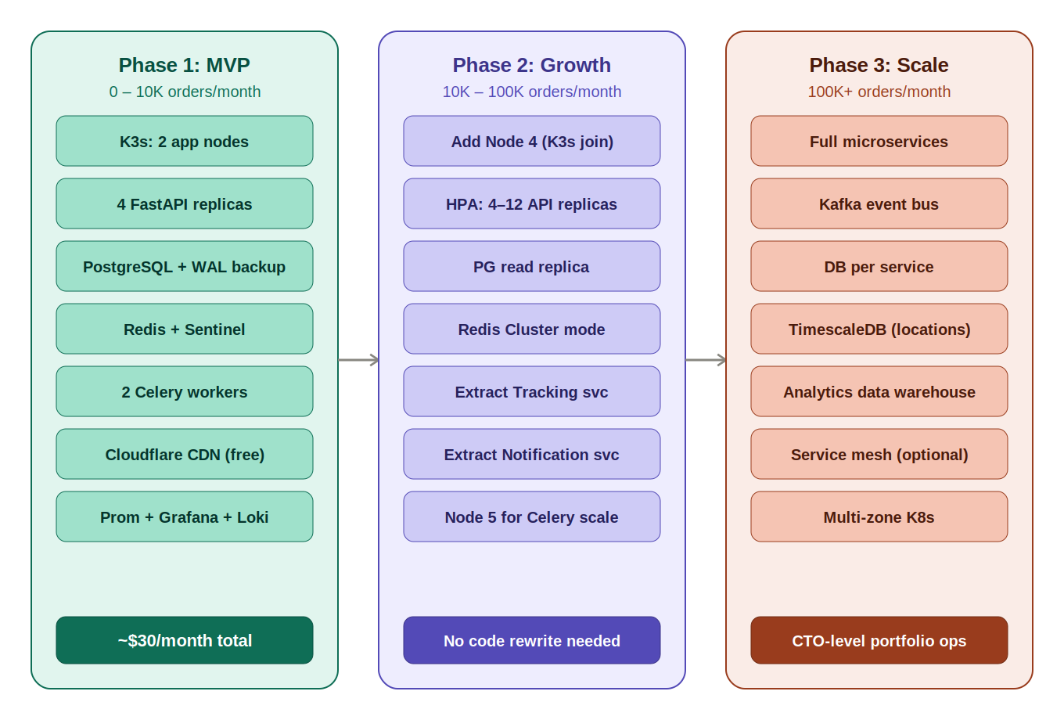
Figure 5 — Three-phase scaling roadmap: MVP → Growth → Scale

Phase 1 — MVP (0–10K orders/month) · ~$30/month
- K3s 2-node cluster (Node 1 master, Node 2 worker)
- 4 FastAPI replicas (2 per node, 2 Gunicorn workers each)
- PostgreSQL single instance with WAL + pg_dump to Object Storage
- Redis with Sentinel sidecar (automatic failover, no SPOF)
- Cloudflare CDN for static assets (free tier)

Phase 2 — Growth (10K–100K orders/month)
- Add Node 4 (K3s join) — WebSocket pods isolated here
- HPA on API pods: auto-scale 4–12 replicas based on CPU utilisation
- Add PostgreSQL read replica (Node 5) — analytics queries isolated
- Redis Cluster mode — cache and pub/sub separated
- Extract Tracking Service and Notification Service as independent K8s Deployments
No code rewrite is required. All changes are infrastructure and K8s manifest changes.

Phase 3 — Scale (100K+ orders/month)
- Full microservice extraction guided by service boundary map in Section 6
- Kafka replaces Redis Pub/Sub for inter-service event streaming
- TimescaleDB for rider_locations time-series data
- Dedicated analytics data warehouse decoupled from operational DB
- Multi-zone Kubernetes for active-active across data centres

11. Monitoring & Observability
Tool | Purpose | Deployment
Prometheus | Metrics — scrapes all K8s pods | K8s Deployment in avdan-obs namespace
Grafana | Dashboards + alerting rules | K8s Deployment in avdan-obs namespace
Loki | Log aggregation from all pods | K8s Deployment in avdan-obs namespace
Promtail | Log shipping from all pods to Loki | K8s DaemonSet in avdan-obs namespace

Key Alerts
Metric | Threshold | Action
API error rate | > 1% over 5 minutes | Page on-call engineer
Order state transition failures | Any failure | Immediate alert + auto-retry
Payment webhook errors | Any error | Immediate alert; escrow protection holds
Rider location gap (active order) | > 60 seconds | Alert dispatch + customer
DB connection pool utilisation | > 80% | Scale warning; review pool sizing
Redis memory | > 70% used | Review TTLs; plan Cluster migration

12. Team Workflow

12.1 Local Development Setup
One command starts the full backend stack — regardless of your specialism:
# From monorepo root — backend dev and frontend dev run the same command
docker compose -f docker-compose.dev.yml up

# Starts: api (FastAPI on :8000), postgres (:5432), redis (:6379), celery worker

# Frontend dev then runs the specific Next.js app separately
cd apps/web-customer && pnpm dev # localhost:3000
cd apps/web-vendor && pnpm dev # localhost:3001

12.2 Type Generation Workflow
- Backend dev changes a FastAPI Pydantic model or adds an endpoint
- Run: bash scripts/generate-types.sh (2 seconds)
- Regenerated packages/types/src/generated.ts is committed alongside backend change
- TypeScript in all Next.js apps immediately flags any broken usages

12.3 Team Ownership Map
Area | Owner | Notes
apps/api/ | Backend dev | FastAPI, Pydantic models, Alembic migrations
apps/web-customer/ | Frontend dev | Customer-facing Next.js app
apps/web-vendor/ | Frontend dev | Vendor dashboard
apps/web-admin/ | Frontend dev | Admin panel
apps/web-hub/ | Frontend dev | Agent hub portal
apps/app-rider/ | Frontend dev | React Native (may need backend GPS API support)
packages/@avdan/types/ | Backend dev (generates) + Frontend dev (consumes) | Generated from FastAPI; re-exported in index.ts
packages/@avdan/ui/ | Frontend dev | Shared component library
infra/ | Both (backend dev leads DevOps) | Docker, K8s manifests, Nginx config

13. Technology Stack Reference
Category | Technology | Purpose
Backend Framework | FastAPI (Python 3.12) | API server, business logic, WebSocket
Database | PostgreSQL 15 (K8s StatefulSet) | Primary data store
Cache / Queue Broker | Redis 7 + Sentinel | Session cache, pub/sub, Celery broker
Task Queue | Celery | Background jobs, escrow release, cleanup
Escrow Timer | Celery Beat (single-replica pod) | 48-hour release scheduler
Web Frontends | Next.js 16 (App Router) | All five web-facing apps
Mobile App | React Native + Expo | Rider app with GPS, camera, offline
Shared Types | openapi-typescript + @avdan/types | Generated from FastAPI; used by Next.js
Reverse Proxy | Nginx (K8s DaemonSet) | SSL, routing by Host header
Authentication | JWT (PyJWT) + Redis blacklist | Stateless auth, RBAC, token refresh
ORM | SQLAlchemy 2.0 async + Alembic | DB access layer, schema migrations
Validation | Pydantic v2 | Request/response shapes, type safety
Real-Time | WebSockets (FastAPI) + Redis Pub/Sub | Live tracking, order updates
Payment (launch) | Paystack | Charge, Transfer, Refund APIs
Payment (future) | Flutterwave, Stripe, Interswitch | Via PaymentProvider abstraction
Orchestration | K3s (certified Kubernetes) | Container scheduling, rolling deploys
Servers | Contabo VPS 30 + VPS 20 + VPS 20 | $26.88/month — Ubuntu 22.04 LTS
Container Registry | GHCR (GitHub Container Registry) | Free, no limits, GitHub-native
Backup Storage | Contabo Object Storage (S3-compatible) | ~$3/month; WAL archives, dumps, media
Secrets | GitHub Secrets (CI) + Sealed Secrets | Encrypted in git; decrypted in cluster only
Monorepo | Turborepo + pnpm workspaces | Build only what changed; shared packages
CI/CD | GitHub Actions | Test, build, push GHCR, kubectl rollout
Monitoring | Prometheus + Grafana + Loki | Metrics, dashboards, log aggregation
CDN | Cloudflare (free tier) | DNS, DDoS, static asset caching

Appendix: Document Control

Document Title | AVDAN System Architecture Document
Version | v3.0
Supersedes | v2.0
Status | Draft — pending team review
Classification | Confidential — Internal Use Only
Next Action | Team review → scaffolding session

Changes from v2.0 to v3.0
- Server plans corrected to actual Contabo Cloud VPS offerings (VPS 30 + VPS 20 + VPS 20)
- Node 1 upgraded to VPS 30 (8 vCPU / 24 GB) — K3s control plane requires the extra RAM
- Total cost revised to ~$30/month (was ~€36/month estimated)
- Figure 3 added: network topology showing one public IP, private LAN for Nodes 2 and 3
- Figure 4 added: CI/CD pipeline 7-step deployment flow with kubectl mechanics
- Figure 2 added: TypeScript/FastAPI type sharing pipeline diagram
- Figure 5 added: 3-phase scaling roadmap diagram
- Figure 1 added: monorepo directory structure diagram
- Subdomain routing table added (how all five subdomains map to one IP via Nginx)
- Rollback procedure documented (kubectl set image with git SHA)
- K3s vs full Kubernetes comparison table added to infrastructure section
This document is the single source of truth for AVDAN architecture. Any engineering decision not recorded here should be considered unofficial until documented.

