Apoorv Verma | Reporter + Sever Docs | January 11, 2016

iCims-Reporter & Server

by: Apoorv Verma [AP]



# About iCims-Reporter

This tool overcomes all the data presentation and storage shortcomings of JMeter by creating a real-time architecture around it while structurally persisting all results to a DB.

This tool, spearheaded by Mahadevan Subramani [Project Manager], and Apoorv Verma [Developer and Architect], consists of two parts: the reporting plugin, and a complementary server that persists the results, while generating a real-time dashboard.

# Technology Stack – The good stuff

This Suite uses: [MEAN](http://mean.io), [Java](https://www.java.com/en/download/), [JMeter](http://jmeter.apache.org/), and [AWS](https://aws.amazon.com/).

## Plugin:

The plugin uses Java, and Spring to create a virtual listener that snoops sampler results every second, and delivers them to a declaratively defined server [usually: [qa1.dev.icims.net](http://qa1.dev.icims.net)] every 5 seconds. It has a co-dependency with the [Standard JMeter Plugin](http://jmeter-plugins.org/wiki/StandardSet/) Set.

## Server:

This server is written with [Node.js](https://nodejs.org/en/), where results are persisted with [MongoDB](https://www.mongodb.org/) [using the [mongoose](http://mongoosejs.com/) adapter]. The middleware is provided by [Express](http://expressjs.com/), and the front-end is written with [Polymer 1.0](https://www.polymer-project.org/1.0/). The real-time functionality is provided by [Socket.io](http://Socket.io) which leverages [web sockets](http://www.html5rocks.com/en/tutorials/websockets/basics/). This server exposes a public API for any JMeter Instance using the Reporter plugin, and a real-time dashboard viewable via the browser. This dashboard also features a completely responsive, and modern material design based UI. The metrics/charts are also calculated real-time using asynchronously map🡪reduce on the browser. The server is now hosted on AWS under: [qa1.dev.icims.net](http://qa1.dev.icims.net).

# Getting Started!

For most cases, all you need is to install the plugin and point it to: [qa1.dev.icims.net](http://qa1.dev.icims.net).

## Installing the Plugin

Download and install the [Standard Plugin Set](http://jmeter-plugins.org/wiki/StandardSet/).  
Download and install the [Reporter Plugin](http://qa1.dev.icims.net/Download-Plugin).  
Run JMeter!

## Using The Plugin

In JMeter right click your thread group and go to Add 🡪 Listener 🡪 iCims Reporter.

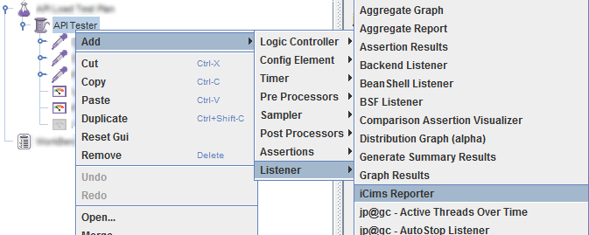

Fill in the Name. And the rest is handled by the Plugin!  
*Note: Host and Port should only be changed if you’re hosting a personal version of the server*

# See the Results

Assuming all the stuff ↑ worked. You can now head to <http://qa1.dev.icims.net> [The portal that shows all the Load-Tests real-time] Your test will be visible with the name you set in JMeter. In case you’re having a hard time finding it, you can either type in the name/regex for your test, or click the active tests tab above. This will add a filter to your search query only matching *active tests*.

Click open to see a realtime dashboard, with three tabs:

1. Real-time: Shows time window based charts [ex: *last 9 of requests per second*]
2. Aggregate: Total Behavior during the test
3. Statistics: Metrics that get calculated as the test progresses. And has an Apdex Calculator.

The dashboard will be aware as soon as the test is completed, and will hide your real-time tab, since it becomes obsolete. The Quantiles Chart will now reflect the distribution across every result received, instead of the last 5 seconds. And the Apdex Calculator becomes real-time, so it will calculate the score for you as you adjust the T [*Acceptable Time*].

For an architecture diagram: [Get-Diagram](http://qa1.dev.icims.net/Get-Arch-Diagram).

# FIN

For more questions: [Email Me](mailto:avdaredevil@gmail.com)