Hospital-Wastewater Pathogen Detections: BLAST False-Positive Validation
Methods & approach summary for review. Pipeline: ww-blast-validation (github.com/avdarlingphd/ww-blast-validation).

1. Purpose
Kraken2 assigns each wastewater metagenomic read to a taxon by k-mer content. It is fast but can misassign reads, producing false-positive pathogen “detections.” This pipeline independently BLAST-validates each candidate (sample × taxon) detection against NCBI nt and labels it TRUE_POSITIVE, FALSE_POSITIVE, UNCERTAIN, UNCULTURED_DOMINANT, or NO_DATA — so classifier false positives can be removed from the wastewater pathogen tables before downstream analysis.

2. What the pipeline does (per sample)
For each wastewater sample (250 total) and each candidate taxon on the pathogen panel (141 species):
- EXTRACT — pull the FULL reads Kraken2 assigned to that taxon (the species node and anything below it, via --include-children). Reads Kraken parked at a higher clade are not pulled into a species target (0 reads → NO_DATA).
- SUBSAMPLE + TAG — if a taxon has >500 reads, randomly keep 500 (seeded); otherwise keep all (~86% of targets use all reads). Each read’s header is tagged with its taxon, and all of the sample’s tagged reads are concatenated into one query.
- ONE BLAST per sample — each read is aligned independently against NCBI nt (megablast, max_target_seqs 100). Batching loads the ~1 TB nt database once per sample instead of once per taxon; the taxon tags let results be split back apart. Reads never interact, so the batched result is identical to BLASTing each taxon separately.
- CLASSIFY — split the results by taxon tag and decide each call (next section).
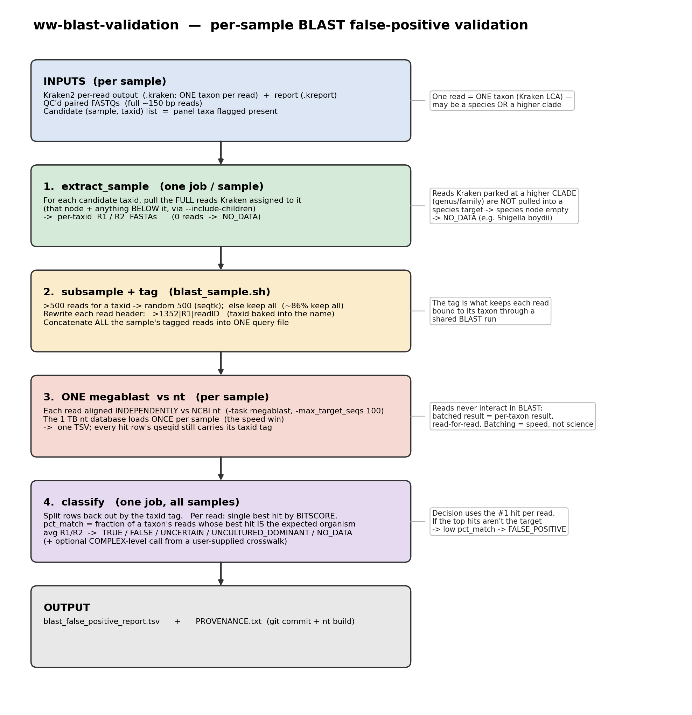
Figure 1. Pipeline flow.

3. How a call is made
For each read we take its single best BLAST hit by bitscore (bitscore rewards both alignment identity and length, and is database-size-independent; it orders the same as E-value). pct_match = the fraction of a taxon’s reads whose best hit is the expected organism, averaged over R1/R2. Then:
- TRUE_POSITIVE: pct_match ≥ 80%, the expected organism is among the top-2 best-hit organisms, >2 matching reads per read set, ≥ 2 reads total.
- FALSE_POSITIVE: pct_match < 10% (reads overwhelmingly hit something else).
- UNCULTURED_DOMINANT: >50% of best hits are uncultured/environmental sequences (unresolved).
- UNCERTAIN: anything in between. NO_DATA: no reads to validate.
Tie-aware matching (recommended refinement). Closely related species (e.g. Klebsiella variicola vs K. pneumoniae) often tie at the same best score because the read region is identical in both. The default rule keeps one arbitrary top hit, so the database over-representing a sibling (K. pneumoniae has far more deposited sequences) can win the tie and the true call is lost. Tie-aware counts a read for the target if the target is among its tied-best hits — removing the database-bias artifact. Reads that match a different organism strictly better are still excluded.
Species vs complex. Tie-aware answers “is this a real detection?” robustly. Residual species ambiguity among siblings (which exact species) is reported separately by an optional complex-level score driven by a user-supplied crosswalk (to be set to the RPIP-panel / YNHH clinical complex scheme).

4. Key design decisions and rationale
Choice | Decision | Rationale
Subsample to ≤500 reads/target | Keep | pct_match is a proportion; 500 reads estimate it to ±~2%, tighter than the 10/80% thresholds. 86% of targets use all reads; the capped 14% are abundant organisms already called TRUE. Removing it = full re-BLAST, timeout risk, ~0 changed calls.
max_target_seqs = 100 | Keep | Per read; up to 100 database hits. It is a collection heuristic (Shah 2019) that can drop the true best hit if set low; 100 ensures the real best hit and the tied-best cluster are captured.
Rank hits by bitscore | Keep | Combines identity + alignment length (and is DB-size-independent); better than raw % identity.
Tie-aware matching | Recommended | Removes database over-representation bias on sibling ties. Rescues 1,170 detections concentrated in sibling-rich taxa (Enterococcus, Klebsiella, Acinetobacter/ACB, Citrobacter, Salmonella, E. coli).
>2 matching reads (min_match_reads=3) | Keep | Independent evidence-depth guard; a single read is trivially 100%. Rescued TRUEs already satisfy it.
Uncultured = uninformative (optional) | Available | Option to drop uncultured-best non-match reads from the denominator (many ‘uncultured clone’ entries are the organism); UNCULTURED_DOMINANT kept as a separate flag.

5. Results (8,623 candidate detections)
Classification | Default | Tie-aware
TRUE_POSITIVE | 4,980 | 6,146
UNCERTAIN | 2,168 | 1,219
UNCULTURED_DOMINANT | 920 | 920
FALSE_POSITIVE | 529 | 312
NO_DATA | 26 | 26
Under the recommended tie-aware rule: +1,166 TRUE_POSITIVE and −217 FALSE_POSITIVE vs default. The changes are 1,163 UNCERTAIN→TRUE and 7 FALSE→TRUE (rescues), plus 210 FALSE→UNCERTAIN (more cautious), and only 4 TRUE→UNCERTAIN. The rescued detections concentrate in exactly the sibling-rich, heavily-deposited taxa, which is the signature of correcting database-bias tie-breaking rather than loosening thresholds. NO_DATA is unchanged (26) — all benign zero-read cases (mostly Shigella boydii, which Kraken cannot resolve from E. coli, plus Candida and a few rare host-associated pathogens).

6. Reproducibility
Every run records a PROVENANCE file (git commit of the code + the exact nt database build from blastdbcmd), a snapshot of the configuration, and the matching modes used. The nt database is pinned to a dated snapshot (2026_09), the software environment is pinned (conda), and the code is a single versioned repository. Any result traces to an exact code + reference-database version.

7. Open items for sign-off
- Adopt tie-aware matching as the primary rule (recommended), keeping >2 reads.
- Replace the provisional complex crosswalk with the RPIP panel v1 and/or YNHH clinical complex scheme to finalize species-vs-complex reporting.
- Optional: clade-level capture (add genus/complex targets, re-extract + re-BLAST) to recover the NO_DATA/ambiguous species (e.g. Shigella).
- Optional: threshold sensitivity (80% vs 75%) — regenerated for free from saved BLAST output.

