Implement a Planning Search.
Project results
Alexey Denisov
01/13/2018

Part 1. Planning problems
The following tables show the results obtained from seven non-heuristic search types (see the tables) applied to air cargo problems for this project. The goal of this analysis is to compare the outcomes of different search types and to find an optimal solution for each of the problems.
The optimal solution is the lowest path among all possible paths from start to goal.
For each problem the optimal solution is highlighted.
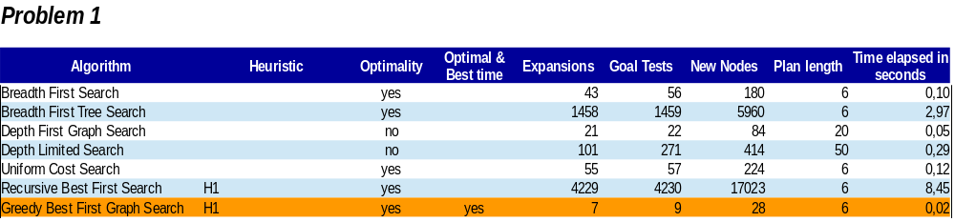
The outcome of the GBFS is following:(aind) a_denisov@denisov-HP-ProBook-4310s:~/PycharmProjects/AI Udacity/AIND-Planning$ python run_search.py -p 1 -s 7

Solving Air Cargo Problem 1 using greedy_best_first_graph_search with h_1…

Expansions Goal Tests New Nodes
7 9 28

Plan length: 6 Time elapsed in seconds: 0.020334993999313156

Load(C1, P1, SFO)
Load(C2, P2, JFK)
Fly(P1, SFO, JFK)
Fly(P2, JFK, SFO)
Unload(C1, P1, JFK)
Unload(C2, P2, SFO)

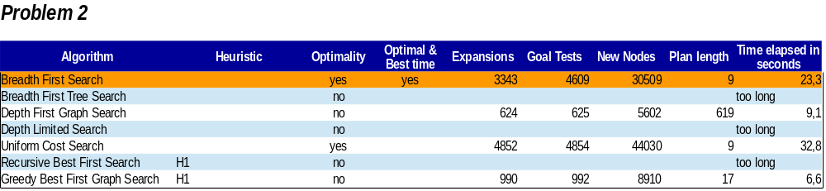
The outcome of BFS is following:(aind) a_denisov@denisov-HP-ProBook-4310s:~/PycharmProjects/AI Udacity/AIND-Planning$ python run_search.py -p 2 -s 1

Solving Air Cargo Problem 2 using breadth_first_search...

Expansions Goal Tests New Nodes
3343 4609 30509

Plan length: 9 Time elapsed in seconds: 23.327612735000002
Load(C1, P1, SFO)
Load(C2, P2, JFK)
Load(C3, P3, ATL)
Fly(P2, JFK, SFO)
Unload(C2, P2, SFO)
Fly(P1, SFO, JFK)
Unload(C1, P1, JFK)
Fly(P3, ATL, SFO)
Unload(C3, P3, SFO)

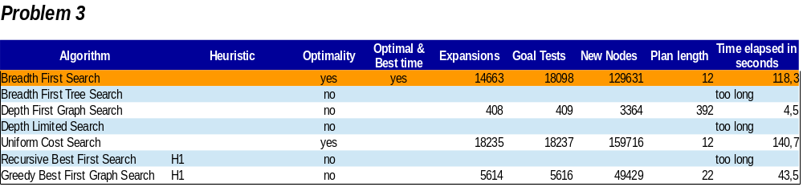
The outcome of BFS is following:
(aind) a_denisov@denisov-HP-ProBook-4310s:~/PycharmProjects/AI Udacity/AIND-Planning$ python run_search.py -p 3 -s 1

Solving Air Cargo Problem 3 using breadth_first_search...

Expansions Goal Tests New Nodes
14663 18098 129631

Plan length: 12 Time elapsed in seconds: 118.2852048220002
Load(C1, P1, SFO)
Load(C2, P2, JFK)
Fly(P2, JFK, ORD)
Load(C4, P2, ORD)
Fly(P1, SFO, ATL)
Load(C3, P1, ATL)
Fly(P1, ATL, JFK)
Unload(C1, P1, JFK)
Unload(C3, P1, JFK)
Fly(P2, ORD, SFO)
Unload(C2, P2, SFO)
Unload(C4, P2, SFO)

Part 2. Domain-independent heuristics
The following tables show the results obtained from three A* search types with different heuristics (see the tables) applied to air cargo problems for this project. The goal of this analysis is to compare the outcomes and to find an optimal solution for each of the problems.
The optimal solution is the lowest path among all possible paths from start to goal.
For each problem the optimal solution is highlighted.
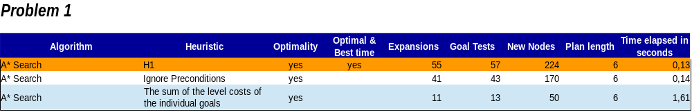
The outcome of the A*Search with H1 heuristic is following:
(aind) a_denisov@denisov-HP-ProBook-4310s:~/PycharmProjects/AI Udacity/AIND-Planning$ python run_search.py -p 1 -s 8

Solving Air Cargo Problem 1 using astar_search with h_1...

Expansions Goal Tests New Nodes
55 57 224

Plan length: 6 Time elapsed in seconds: 0.13157273299293593
Load(C1, P1, SFO)
Load(C2, P2, JFK)
Fly(P1, SFO, JFK)
Fly(P2, JFK, SFO)
Unload(C1, P1, JFK)
Unload(C2, P2, SFO)

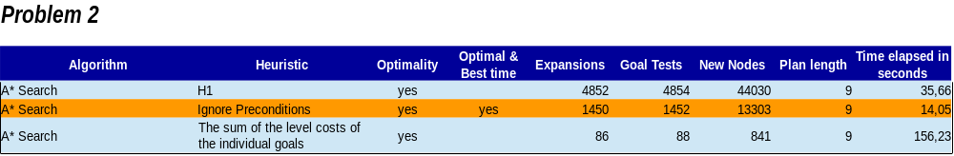The outcome of the A*Search with the Ignore Preconditions heuristic is following:
(aind) a_denisov@denisov-HP-ProBook-4310s:~/PycharmProjects/AI Udacity/AIND-Planning$ python run_search.py -p 2 -s 9

Solving Air Cargo Problem 2 using astar_search with h_ignore_preconditions...

Expansions Goal Tests New Nodes
1450 1452 13303

Plan length: 9 Time elapsed in seconds: 14.049305744003505
Load(C3, P3, ATL)
Fly(P3, ATL, SFO)
Unload(C3, P3, SFO)
Load(C1, P1, SFO)
Fly(P1, SFO, JFK)
Unload(C1, P1, JFK)
Load(C2, P2, JFK)
Fly(P2, JFK, SFO)
Unload(C2, P2, SFO)

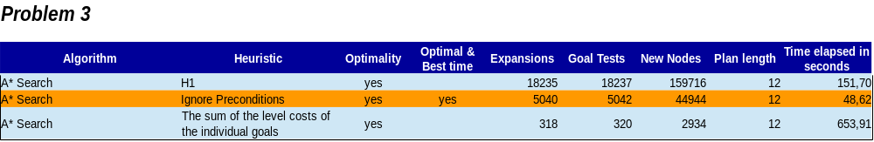The outcome of the A*Search with the Ignore Preconditions heuristic is following:
(aind) a_denisov@denisov-HP-ProBook-4310s:~/PycharmProjects/AI Udacity/AIND-Planning$ python run_search.py -p 3 -s 9

Solving Air Cargo Problem 3 using astar_search with h_ignore_preconditions...

Expansions Goal Tests New Nodes
5040 5042 44944

Plan length: 12 Time elapsed in seconds: 48.623760232003406
Load(C2, P2, JFK)
Fly(P2, JFK, ORD)
Load(C4, P2, ORD)
Fly(P2, ORD, SFO)
Unload(C4, P2, SFO)
Load(C1, P1, SFO)
Fly(P1, SFO, ATL)
Load(C3, P1, ATL)
Fly(P1, ATL, JFK)
Unload(C3, P1, JFK)
Unload(C1, P1, JFK)
Unload(C2, P2, SFO)

Part 3. Written Analysis
The optimal plans for each of the problems are following:
Problem 1 (BFS)
Load(C1, P1, SFO)
Load(C2, P2, JFK)
Fly(P2, JFK, SFO)
Unload(C2, P2, SFO)
Fly(P1, SFO, JFK)
Unload(C1, P1, JFK)
Problem 2 (BFS)
Load(C1, P1, SFO)
Load(C2, P2, JFK)
Load(C3, P3, ATL)
Fly(P2, JFK, SFO)
Unload(C2, P2, SFO)
Fly(P1, SFO, JFK)
Unload(C1, P1, JFK)
Fly(P3, ATL, SFO)
Unload(C3, P3, SFO))

Problem 3 (BFS)
Load(C1, P1, SFO)
Load(C2, P2, JFK)
Fly(P2, JFK, ORD)
Load(C4, P2, ORD)
Fly(P1, SFO, ATL)
Load(C3, P1, ATL)
Fly(P1, ATL, JFK)
Unload(C1, P1, JFK)
Unload(C3, P1, JFK)
Fly(P2, ORD, SFO)
Unload(C2, P2, SFO)
Unload(C4, P2, SFO)

Non-heuristic test results (see Part 1)
Five out of seven non-heuristic searches resulted in optimal solutions for Problem 1: BFS, BFTS, UCS, RBFS and GBFGS. Two searches – DFGS and DLS – resulted in much longer plans, 20 and 50 instead of 6, respectively. GBFGS became the fastest out of all searches.
Only two out of seven non-heuristic searches resulted in optimal solutions for Problem 2: BFS and UCS. Two searches – GBFGS and DFGS – resulted in much longer plans, 17 and 619 instead of 9, respectively. Three searches – BFTS, DLS and RBFS – did not finish in a reasonable amount of time (took longer than 10 minutes). BFS became the fastest out of all searches that gave an optimal solution.
The same two non-heuristic searches - BFS and UCS - out of seven resulted in optimal solutions for Problem 3. Two searches – GBFGS and DFGS – resulted in much longer plans, 22 and 392 instead of 12, respectively. Three searches – BFTS, DLS and RBFS – did not finish in a reasonable amount of time (took longer than 10 minutes). BFS became the fastest out of all searches hat gave an optimal solution.
Based on these experiments, we may conclude that only BFS consistently gives an optimal and speedy solution among non-heuristic searches.
According to Artificial Intelligence. A Modern Approach by Russel and Norvig, the memory requirements are a bigger problem for BFS than is the execution time. We can see this in the Expansions and New Nodes columns. Moreover, exponential-complexity search problems cannot be solved by uniformed methods for any but the smallest instances.

Heuristics test results (see Part 2)
All three heuristic searches resulted in optimal solutions for Problem 1: H1, Ignore_Preconditions and LevelSum. H1 became the fastest out of all searches and gave slightly better result than Ignore_Preconditions.
All three heuristic searches resulted in optimal solutions for Problem 2: H1, Ignore_Preconditions and LevelSum. Ignore_Preconditions became the fastest out of all searches.
All three heuristic searches resulted in optimal solutions for Problem 3: H1, Ignore_Preconditions and LevelSum. Ignore_Preconditions became the fastest out of all searches.
Based on these experiments, we may conclude that A* Search with Ignore Preconditions heuristic consistently gives an optimal and speedy solution. The more complex heuristic – LevelSum - does not give solutions that are better than Ignore_Preconditions when applied to Problems 1,2 and 3 despite it is more accurate. It may be related to the size of the problems – they are small enough to use the better accuracy.

Overall, heuristic based search performs better as the complexity of the problem increased. This is more evident in the Problems 2 and 3, where A* search with Ignore_Preconditions heuristics outperformed all the other types of searches, non-heuristic and heuristic.

