EEPROM Editor User Manual

1. Overview
The EEPROM Editor is the kiosk’s maintenance interface for configuring non-volatile settings and service data.
Primary use cases:
- Commissioning and HWID setup.
- Hydraulic and kiosk parameter tuning.
- NFC token table management.
- RTC date/time setting.
- Service counters inspection/reset.
The editor is a boot-time service mode and is non-returning. Exit is by reset.

2. Entry And Exit

2.1 How To Enter
You can enter EEPROM Editor in either way:
- Automatic maintenance entry:
  - On boot, if EEPROM magic is invalid or HWID is 0.
- Manual boot chord:
  - Hold Sensor Bypass + Backwash during boot.
  - Release when prompted.

2.2 How To Exit
- Long BACK (~4s) triggers watchdog reset.
- Re-init EEPROM flow ends with reset.
- Editor does not return directly to runtime flow.

3. High-Level Navigation Diagram
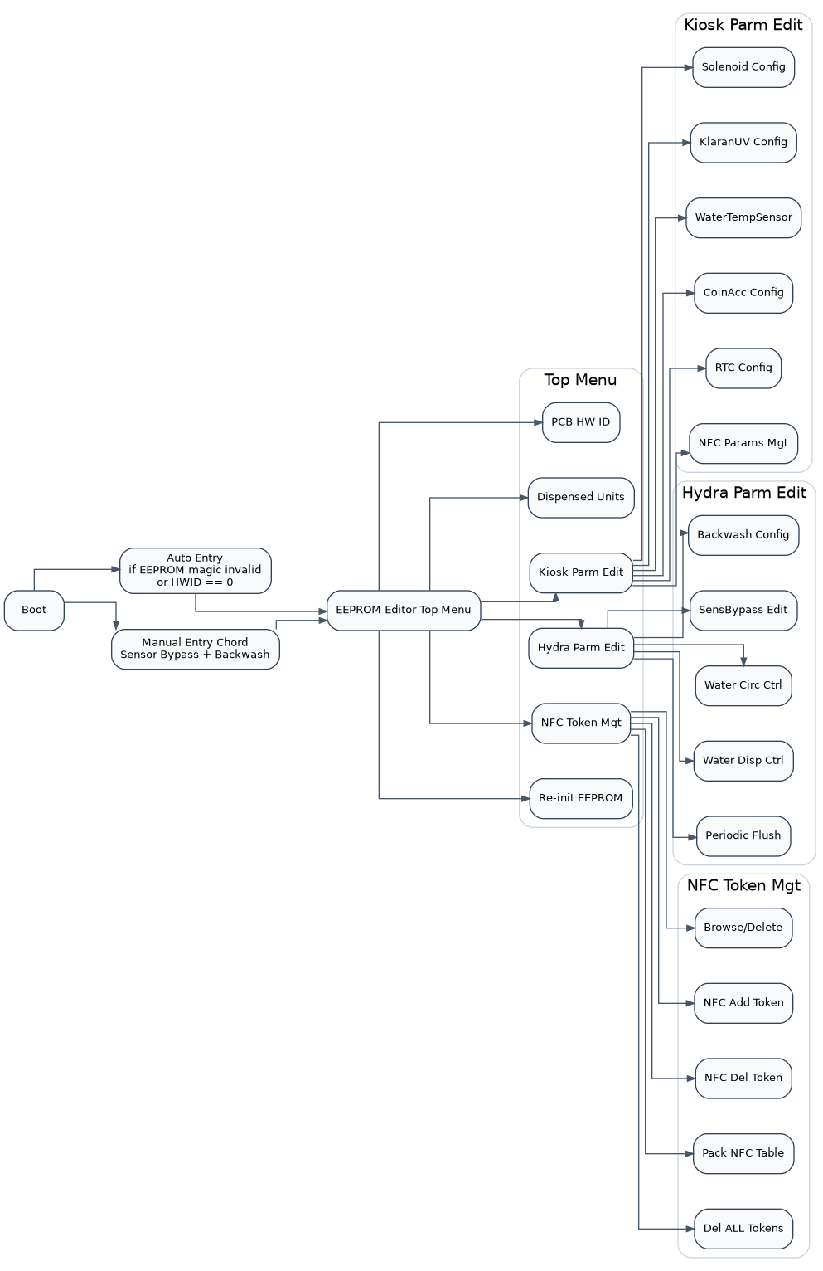
EEPROM Editor Navigation

4. Buttons In EEPROM Editor Mode
During editor mode, panel buttons are remapped:
Editor Action | Physical Button Constant | Typical Panel Label
UP | BTN_CONT_CIRC | Continuous Circulation
DOWN | BTN_WATER_INLET | Water Inlet
SELECT | BTN_SENSOR_BYPASS | Sensor Bypass
BACK | BTN_BACKWASH_CTL | Backwash
Press semantics:
- Short UP/DOWN: move cursor or change value.
- Hold UP/DOWN: auto-repeat starts after ~2s, then accelerates.
- Short SELECT: enter submenu, advance field, or toggle prompt.
- Long SELECT (~3s): save/confirm for current context.
- Short BACK: go to previous menu layer.
- Long BACK (~4s): reset and exit editor.
Special BACK behavior:
- In RTC Config, short BACK moves to previous RTC field first.
- In NFC Add/Del scan screens, short BACK exits immediately.

5. Save/Write Behavior Diagram
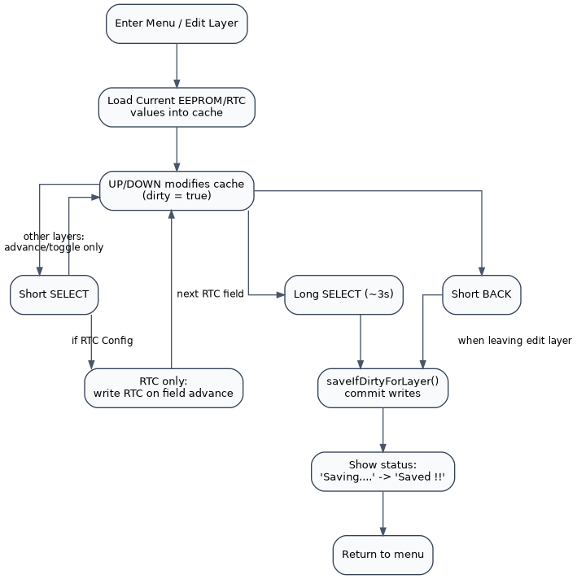
EEPROM Editor Save Model

6. Display Layout (OLED)
General layout:
- Row 0: EEPROM Edit Mode
- Row 1: separator
Top-level menu only:
- Row 2: HWID:...
- Row 3: SWID:...
Lower-level menus:
- Row 2: current menu title
- Row 3: blank
- Menu list starts at row 4
Value presentation:
- For value-heavy layers (e.g. Backwash, Water Disp, NFC Params),
  - row 12 is cleared,
  - current value is centered on row 13.
- Row 14 is normally blank for editor layers.
Status line:
- Row 15 shows one of:
  - Saving....
  - Saved !!
  - navigation hint
RTC screen is a special layout:
- Date/time display lines are shown with a caret row indicating active editable cluster.

7. Top-Level Menu Structure
Top-level entries:
- PCB HW ID
- Dispensed Units
- Kiosk Parm Edit
- Hydra Parm Edit
- NFC Token Mgt
- Re-init EEPROM

7.1 Kiosk Parm Edit
- Solenoid Config
- KlaranUV Config
- WaterTempSensor
- CoinAcc Config
- RTC Config
- NFC Params Mgt

7.2 Hydra Parm Edit
- Backwash Config
- SensBypass Edit
- Water Circ Ctrl
- Water Disp Ctrl
- Periodic Flush

7.3 NFC Token Mgt
- Browse/Delete
- NFC Add Token
- NFC Del Token
- Pack NFC Table
- Del ALL Tokens

8. Menu Details

8.1 PCB HW ID
Purpose:
- Set stored HWID used by firmware/profile branching.
Operation:
- UP/DOWN change HWID.
- Long SELECT saves.

8.2 Dispensed Units
Menu entries:
- App Disp
- Coin Disp
- NFC Token Disp
- Bypassed Disp
- TOTAL Dispensed (read-only aggregate)
Operation:
- First four counters are editable.
- Long SELECT saves edited counter.

8.3 Kiosk Parm Edit

8.3.1 Solenoid Config
For each solenoid profile:
- StartPWM
- HoldPWM
- SwOnDelay (seconds)

8.3.2 KlaranUV Config
- UV OK Delay (ms)
- UV MAX ON time (mins)

8.3.3 WaterTempSensor
- Toggle T1/T2.

8.3.4 CoinAcc Config
- Toggle fitted state YES/NO.

8.3.5 RTC Config
Editable clusters in sequence:
- YYYY, MM, DD, HH, MM, SS
Controls:
- UP/DOWN: adjust active cluster (wrap behavior applied).
- Short SELECT: write current RTC value and move to next cluster.
- Short BACK: move to previous cluster; from first cluster, exit RTC screen.
- Long SELECT: explicit save still available.
Important behavior:
- On entry, fields are pre-populated from DS3231.
- Date/time is clamped to valid ranges before write.

8.3.6 NFC Params Mgt
- NFC Init Delay (ms)
- NFC Scan Duratn (ms)
- Inter NFC Delay (ms)

8.4 Hydra Parm Edit

8.4.1 Backwash Config
Parameters:
- Auto duration (s)
- Auto after N (pulse)
- Backwash dispense counter (pulse)
- Daily duration (s/mins)
- Daily time (HH:MM)
- Manual short (s)
- Manual long (mins)

8.4.2 SensBypass Edit
Parameters:
- Duration (s)
- Period (mins)
- Manual short (s)
- Manual long (s)

8.4.3 Water Circ Ctrl
Parameters:
- Auto duration (mins)
- Auto period (mins)
- Manual short (mins)
- Manual long (mins)

8.4.4 Water Disp Ctrl
Parameters:
- Dispense mode (TIMED / PULSE)
- Timed duration (s)
- Pulse count (pulse)
- Pre-dispense circulation/purge time and pulse values

8.4.5 Periodic Flush
Parameters:
- DNF repeat period (mins)
- DNF duration (s)
- Pre-flush beep delay (s)
- Beep period (ms)
- Beep on-time (ms)
- Beep count

8.5 NFC Token Mgt

8.5.1 Browse/Delete
Display format:
- I ### <HASH>
- I indicates table index.
Navigation:
- UP: decrement index
- DOWN: increment index
- Wrap at first/last slot.
Delete flow:
- Short SELECT: enter delete prompt (YES/NO).
- Long SELECT on YES: delete selected token.

8.5.2 NFC Add Token
Flow:
- Screen waits for tag.
- Two consecutive matching scans are required.
- On success, token hash is added.

8.5.3 NFC Del Token
Flow:
- Same two-scan validation.
- On success, matching token hash is removed.

8.5.4 Pack NFC Table
- Compacts and de-duplicates token table.

8.5.5 Del ALL Tokens
- Opens confirmation modal.
- Toggle YES/NO.
- Long SELECT executes delete-all when confirmed.

8.6 Re-init EEPROM
Safety flow:
- Enter prompt.
- Set confirmation to YES.
- Hold SELECT for hold-time countdown.
Result:
- EEPROM reset to defaults.
- Resetting/completed messages shown.
- Device restarts.

9. Typical Service Workflows

9.1 Set RTC Quickly
- Kiosk Parm Edit -> RTC Config.
- Edit field with UP/DOWN.
- Short SELECT to write and advance.
- Repeat for all fields.
- BACK out when done.

9.2 Add NFC Token
- NFC Token Mgt -> NFC Add Token.
- Present tag until success message.
- BACK to return to token menu.

9.3 Tune Backwash Auto Trigger
- Hydra Parm Edit -> Backwash Config.
- Edit BW AutoAfter N.
- Long SELECT to save.
- Confirm status line shows save message.

10. Troubleshooting
- No DS3231 RTC !
  - RTC not detected. Check DS3231 wiring, power, and I2C lines.
- NFC add/delete not changing table
  - Verify tag is scanned twice consistently.
  - Verify token writes are permitted in the editor configuration.
- Edited values revert
  - Ensure long SELECT save was executed (except RTC next-field writes).
- Cannot leave editor
  - Use long BACK to force reset.

11. Safety And Change Control
- Re-init EEPROM is destructive. Use only with planned recovery.
- Record critical values (RTC, backwash, dispense, NFC timing) before major changes.
- Perform configuration updates in controlled maintenance windows.

