Kiosk Software Operating Manual

1. Scope
This manual describes the runtime software behavior of the kiosk firmware in Kiosk.ino and its primary modules:
- KioskBehavior.*
- KioskHydraulics.*
- KioskIO.*
- KioskEeprom.* (runtime parameter reads/writes)
Explicitly excluded from this manual:
- EEPROM Editor mode (KioskEepromEditor.*)
- Sequential I/O Test mode (KioskSeqTest.*)
Those have separate dedicated manuals.

2. Runtime Architecture
The runtime loop is split into three control layers:
- UI layer (KioskBehavior::Ui)
- Runs the LCD-facing customer state machine.
- Emits requestDispensePulse and LED/backlight intents.
- Policy/orchestration layer (KioskBehavior::updateHydraulics)
- Resolves mode-specific rules and button choreography.
- Arbitrates SensorBypass, Backwash, WaterInlet, Tank circulation, DayEnd, and Periodic Nozzle Flush.
- Actuator layer (KioskHydraulics + KioskIO)
- Executes dispense/UV/backwash low-level state machines.
- Drives physical outputs and inlet PWM kick/hold behavior.

3. Operating Modes

3.1 Normal Mode
- Payment is required before dispense.
- Front button drives payment and dispense flow via UI states.
- Rear hydraulic control buttons are still read by hydraulics policy.

3.2 Override Mode
- Front button bypasses payment path (goes directly to UI_DISP_RDY).
- Hydraulic control buttons can override/terminate conflicting functions (as defined below).

3.3 Dark Mode
- Enter from UI_WELCOME using the front-button gesture: press in Override, then release after the mode switch is moved to Normal.
- Entry phase (UI_DARK_MODE_IN) shows a 60s countdown; pressing front can truncate to immediate dark transition.
- In dark phase, LCD backlight and front LED are off; OLED row 14 shows IN DARK MODE.
- Exit phase (UI_DARK_MODE_OUT) requires holding front button for 15s.
- Releasing early during exit returns to dark-in state.
- Completing exit hold requests a reset.

4. Boot-Time Entry Points
At startup the firmware checks button chords:
- Dispense calibration mode: BTN_SINGLE_DISP held at boot.
- EEPROM editor chord (excluded from this manual).
- Sequential test chord (excluded from this manual).

5. UI State Machine
The runtime UI state machine is shown below.
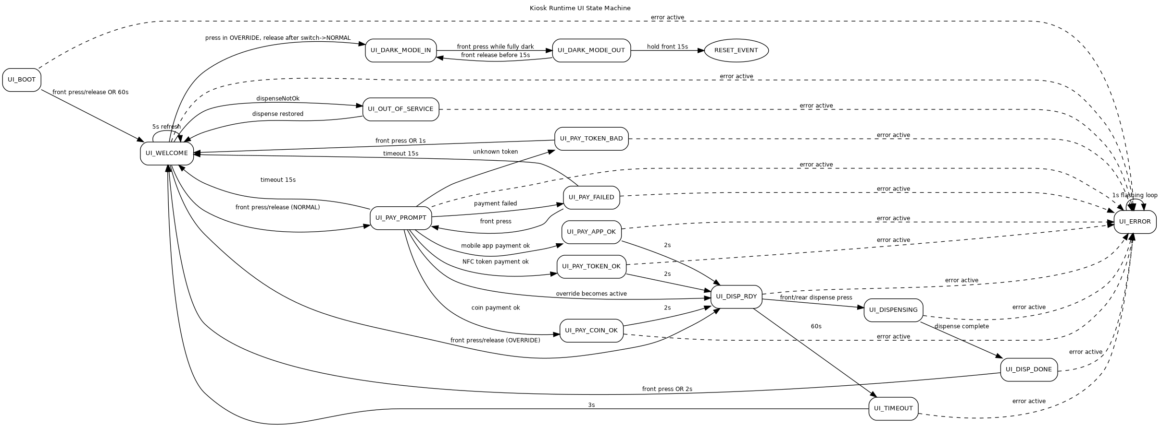
UI Runtime State Machine

5.1 UI State Summary
State | Purpose | Main exit conditions
UI_BOOT | Show counters on LCD | Front press/release or 60s timeout
UI_WELCOME | Idle welcome screen | Normal: to payment; Override: to dispense ready; dark gesture; out-of-service
UI_PAY_PROMPT | Payment collection | Payment OK/failed/bad token, or 15s timeout
UI_PAY_*_OK | Payment success acknowledgements | 2s to UI_DISP_RDY
UI_PAY_FAILED | Payment failed notice | Front press retry or 15s timeout
UI_PAY_TOKEN_BAD | Unknown token notice | Front press or 1s timeout
UI_DISP_RDY | Waiting for dispense trigger | Front/rear dispense press, or 60s timeout
UI_DISPENSING | Active dispense progress | Dispense complete
UI_DISP_DONE | Dispense complete message | Front press or 2s timeout
UI_TIMEOUT | Transaction timeout message | 3s timeout
UI_OUT_OF_SERVICE | Not currently dispensable | Auto-return when dispensable again
UI_DARK_MODE_IN | Dark-mode entry and dark hold state | Front press in dark -> UI_DARK_MODE_OUT
UI_DARK_MODE_OUT | Dark-mode exit hold | 15s hold -> reset, or release -> UI_DARK_MODE_IN
UI_ERROR | Error state | Self-refresh loop until reset/recovery path

6. Hydraulics Core State Machine
Low-level dispense, UV gating, and backwash execution are implemented in KioskHydraulics.
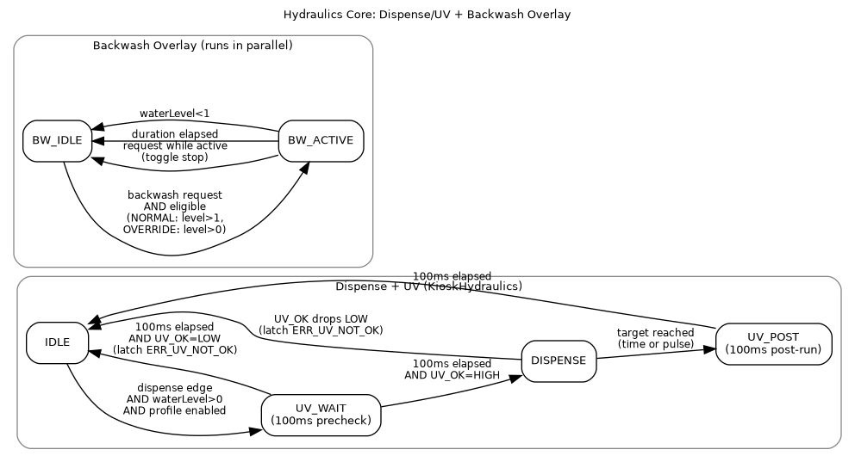
Hydraulics Core State Machine

6.1 Dispense and UV Interlock
Dispense state flow:
- IDLE -> UV_WAIT on dispense edge if:
- water level > 0
- selected dispense profile is enabled
- UV_WAIT (100ms):
- If UV_OK is HIGH, transition to DISPENSE.
- If UV_OK is LOW, abort and latch ERR_UV_NOT_OK.
- DISPENSE:
- UV remains enabled.
- If UV_OK goes LOW at any time, dispense aborts and ERR_UV_NOT_OK is latched.
- Completion is by selected mode: time target or pulse target.
- UV_POST (100ms) after dispense completion:
- UV remains on for post-run delay.
- Then returns to IDLE.

6.2 Backwash Overlay
Backwash runs in parallel with dispense state:
- Start request while idle:
  - Normal: requires water level > 1
  - Override: requires water level > 0
- Request while active: toggles backwash OFF.
- Auto-stop on duration expiry or tank level < 1.

7. Hydraulics Orchestration Rules
KioskBehavior::updateHydraulics() handles policy and conflict resolution.

7.1 Water Level Semantics
- 0: empty
- 1: low
- 2: mid
- 3: full (FULL sensor active-low asserted)

7.2 Water Inlet Strategy
Inlet demand combines an auto latch and a manual latch:
- Startup prime:
- On first update after boot, if level < 3, manual inlet demand is set ON.
- Hysteresis latch:
- If level < 2 -> auto latch ON.
- If level > 2 -> auto latch OFF.
- At level == 2 -> hold previous auto latch state.
- Hard safety:
- If level > 2, manual inlet demand is cleared.
- Physical inlet output is forced OFF.
- Manual hold-off (BTN_WATER_INLET):
- If inlet demand is currently ON, press enters hold-off for up to 1 hour.
- If OFF/HOLD and level < 3, press sets manual inlet demand ON and clears hold.
- Hold auto-expires after 1 hour.
- Override suppression cancel:
- In Override, inlet button press can terminate active SensorBypass and/or Backwash first.
- If that suppression was blocking inlet and level < 3, inlet demand is re-enabled immediately.
- Final inlet ON condition:
- (autoLatch OR manualLatch) AND !hold AND level < 3 AND !backwashActive AND !sensorBypass.

7.3 SensorBypass
- Manual toggle source: BTN_SENSOR_BYPASS release.
- Duration chosen by press length:
  - <= 2s -> MAN Bypass Short (100ms LSB)
  - > 2s -> MAN Bypass Long (10s LSB)
- Auto expiry by timer.
- If periodic bypass is enabled, schedule is maintained and restartable from button interaction.
Interaction with Backwash:
- Normal mode:
  - If backwash active/starting, SensorBypass request is queued.
- Override mode:
  - If backwash active, button first stops backwash then applies bypass toggle.

7.4 Backwash
- Manual source: BTN_BACKWASH_CTL release.
- Manual duration chosen by press length:
  - <= 2s -> BW MAN Short (1s LSB)
  - > 2s -> BW MAN Long (2min LSB)
- Second manual press while active stops backwash.
- Auto sources:
  - Daily RTC schedule (BW Daily Time, BW Daily Duratn)
  - Dispense-count trigger (BW AutoAfter N)
Daily trigger rules:
- RTC must be present.
- Only in the first 60 minutes after configured daily time.
- Daily duration must be non-zero.
- Not already run for the same calendar date.
- Requires normal backwash eligibility by mode and level.
Dispense-count trigger rules:
- On each completed dispense: increment BW DispCount.
- If BW AutoAfter N == 0: auto trigger disabled.
- If count reaches threshold:
  - reset count to 0
  - queue auto backwash request
Backwash completion also resets BW DispCount to 0.

7.5 Tank Circulation
Manual circulation is controlled by BTN_CONT_CIRC:
- Press while inactive and level > 0:
- Start circulation immediately.
- Final timeout is resolved on button release.
- Release:
- <= 2s press -> short duration profile (ManCircDur Shrt, minutes LSB).
- > 2s press -> long duration profile (ManCircDur Long, 10-minute LSB).
- Effective timeout subtracts already-held press time.
- Press while active:
- Immediately terminates circulation and resets active tracking.
Auto circulation:
- Enabled only when both AutoCirc Duratn > 0 and AutoCirc Period > 0.
- Runs periodically at configured period for configured duration (only if level > 0).
Dispense interaction:
- Active dispense pauses circulation output and timer.
- Remaining circulation time is extended by paused duration.

7.6 DayEnd Circ+BW
DayEnd sequence is queueable only in Override mode using chord:
- Hold BTN_BACKWASH_CTL
- Hold BTN_CONT_CIRC
- Release BTN_BACKWASH_CTL
- Release BTN_CONT_CIRC
On queue/init:
- Existing circulation/backwash activity is terminated.
- Auto-backwash and pending backwash are cleared.
- Active dispense is aborted.
- Inlet demand is restored if level < 3.
Sequence:
- Run EoD circulation (EoD Circ Durat, 15s LSB), start only when level > 1.
- Then run EoD backwash (EoD BW Durat, 1s LSB), start only when level > 1.
- On completion, DayEnd state clears and inlet demand is restored if level < 3.
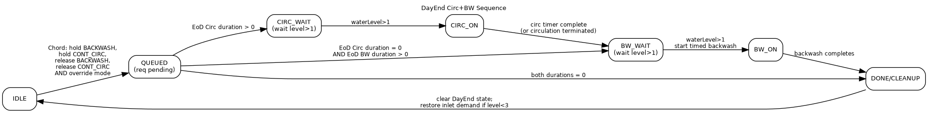
DayEnd Circ+BW State Machine

7.7 Periodic Nozzle Flush (DNF)
DNF is a timed automatic dispense in UI_WELCOME context.
Enable conditions:
- DNF Rept Period > 0
- DNF DispDurat > 0
- Beep ON Time > 0
- Beep Period > 0
- Beep Count > 0
- Not in dark mode
- Not in DayEnd
- UI currently in UI_WELCOME
Behavior:
- On entering UI_WELCOME, DNF timer and phase are reset/armed.
- After repeat period elapses:
- Acoustic alert pulses run (setAcousticAlert on Ozone output).
- Optional pre-flush delay is applied.
- DNF timed dispense starts when dispense path is free.
- DNF dispense uses DNF-specific timed duration (not normal dispense profile).
- On completion, DNF returns to idle and waits for next repeat period.
Cancellation:
- Leaving UI_WELCOME, entering dark mode/dayEnd, invalid config, or non-periodic dispense activity can cancel pending DNF phases.
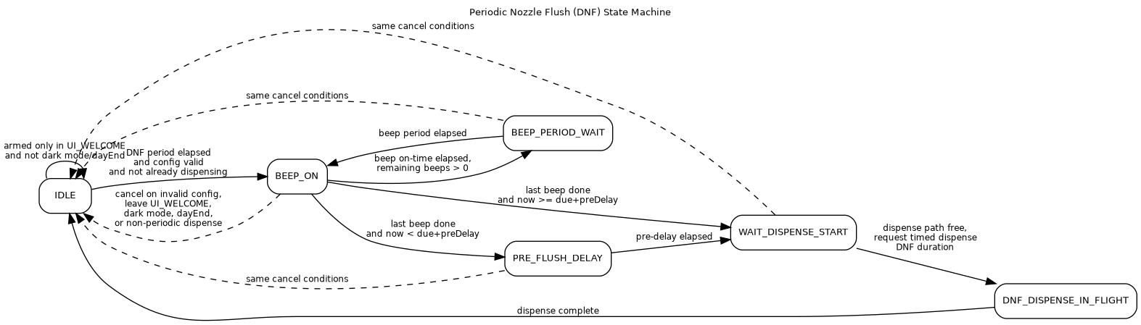
Periodic Nozzle Flush State Machine

8. Control Buttons
Button | Normal mode | Override mode
Front Dispense | UI navigation + payment flow + dispense start in UI_DISP_RDY | UI navigation + direct dispense path (no payment)
BTN_SINGLE_DISP (rear single) | Acts as rear dispense trigger in UI_DISP_RDY | Same
BTN_BACKWASH_CTL | Request/stop backwash; respects level and SensorBypass hold-off | Can terminate SensorBypass and start backwash if eligible
BTN_SENSOR_BYPASS | Toggle bypass; held if backwash active | Can stop backwash first, then toggle bypass
BTN_WATER_INLET | Toggle inlet demand/1h hold-off | Same plus suppression-cancel override behavior
BTN_CONT_CIRC | Start/stop manual circulation with short/long durations | Same
BTN_CONT_DISP | Runtime hydraulics: not used as main control | Used in DispenseCAL mode workflow

9. Displays

9.1 Customer LCD (16x4)
Primary content is driven by UI state machine:
- Welcome/payment/dispense progress/timeout/error messages.
- In UI_DISPENSING, row 3 updates at controlled rate (not full-screen redraw every loop).

9.2 Rear OLED (16 rows)
Key runtime rows:
- Row 0: mode/state header (Kiosk Operations or dark-state id text).
- Row 2-4: water level, backwash eligibility, dispense eligibility.
- Row 5: inlet PWM phase (PH0/PH1/PH2).
- Row 7: Backwash status (OFF/AUT/ON/EoD) + right-justified counter.
- Row 8: SenseByp status (OFF/AUT/ON) + counter.
- Row 9: WaterInp status (OFF/AUT/ON) + counter.
- Row 10: TankCirc status (OFF/AUT/ON/EoD) + counter.
- Row 11: Dispense status (OFF/AUT/ON/DNF) + counter.
- Row 13/14: Dark-mode and DayEnd centered overlays.
- Row 15: NORM/OVRD + RTC datetime YYMMDDHHMM.

10. Error Handling and Fail-Safe Behavior
Error codes:
- 100 = dispense profile unavailable
- 101 = UV not OK during dispense precheck or active dispense
When an error is active:
- Software latches are cleared.
- Backwash, SensorBypass, WaterInlet, Dispense, Circulation, and acoustic alert are forced OFF.
- UI transitions to UI_ERROR (except while already in dark states).

11. Runtime EEPROM Parameters Used by Operations
This section lists runtime parameters used by kiosk operation (not editor behavior):
Feature | Parameters used at runtime
Dispense | Disp Ctrl Mode, TimedDisp Dur, PulseDisp Count
Backwash | BW AutoDuration, BW AutoAfter N, BW MAN Short, BW MAN Long, BW Daily Time, BW Daily Duratn
SensorBypass | SensByp Duratn, SensByp Period, MAN Bypass Short, MAN Bypass Long
Water inlet solenoid | Inlet solenoid StartPWM, HoldPWM, SwDelaySec
Tank circulation | AutoCirc Duratn, AutoCirc Period, ManCircDur Shrt, ManCircDur Long
DayEnd | EoD Circ Durat, EoD BW Durat
Periodic nozzle flush | DNF Rept Period, DNF DispDurat, PreFlshBeepDely, Beep ON Time, Beep Period, Beep Count

12. Dispense Calibration Mode (Boot Chord)
This mode is entered by holding BTN_SINGLE_DISP at boot.
Purpose: - Measure manual dispense samples from the front button. - Build an average sample duration. - Save average duration to EEPROM measured dispense duration field.
Workflow:
- Press and hold front dispense to start sample flow.
- Release front button to stop sample and enter review.
- In review:
- Short release on front: reject sample.
- Long release on front: accept sample into aggregate.
- Long press on BTN_CONT_DISP or BTN_SINGLE_DISP:
- Save aggregate average to EEPROM.
- Trigger watchdog reset.
UI details:
- LCD row 3 shows sample count (N=) left-aligned and average (AVG=) right-aligned.
- Long-press threshold crossing blinks LCD backlight for 50ms.

13. Software/Hardware Notes
- Target platform: Arduino Mega 2560 (arduino:avr:mega).
- Water inlet PWM is two-phase: kick then hold (PH1 -> PH2).
- Acoustic alert output is mapped to Ozone output pin.
- UV_OK runtime logic is active-high (HIGH means UV ready/healthy).

