Sequential I/O Test User Manual

1. Purpose
The Sequential I/O Test is a boot-time service mode used to verify:
- Output channels (solenoids, pumps, relays, LEDs, UV/Ozone paths).
- Key digital inputs and switch states.
- Temperature sensor readings.
- Water-level and Klaran UV-OK feedback.
This mode is intended for bench/service diagnostics, not normal kiosk operation.

2. Entry And Exit

2.1 Entering Sequential I/O Test
At power-up, hold either of these buttons:
- BTN_OZONE_CTL, or
- BTN_CONT_CIRC
When the release prompt appears, release the invocation button(s).

2.2 Exiting Sequential I/O Test
Sequential test mode is non-returning and runs continuously.
To exit:
- Reset/power-cycle the controller.

3. Mode Flow Diagram
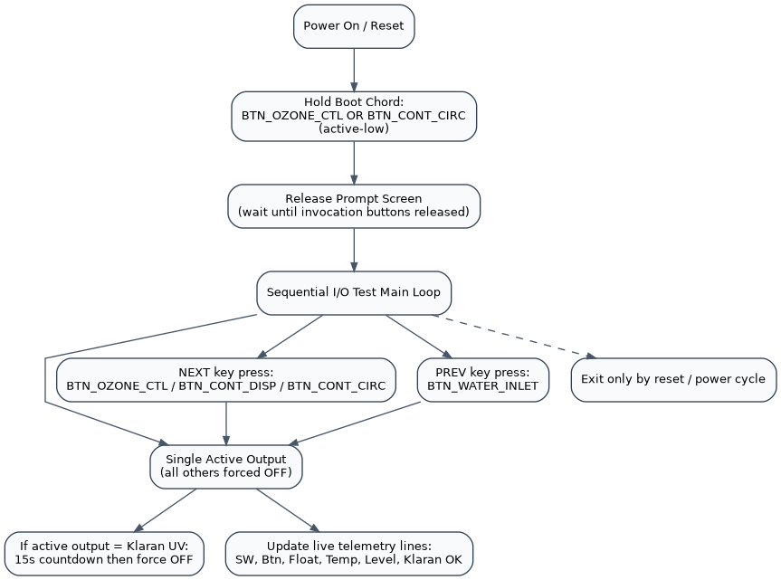
Sequential I/O Test Flow

4. Screen Behavior

3.1 OLED (primary live diagnostics)
- Row 0: I/O SeqTest Mode
- Row 1: separator
- Rows 2-4: instruction text
- Row 6: active output name (and Klaran timeout countdown when applicable)
- Rows 8-13: live input/status summary lines

3.2 LCD (operator header)
- Line 0: I/O SeqTest Mode
- Line 1: separator
- During release prompt: HWID/SWID are shown.

5. Controls During Test
The test cycles one output at a time.
- Next output: press any of
  - BTN_OZONE_CTL
  - BTN_CONT_DISP
  - BTN_CONT_CIRC
- Previous output: press
  - BTN_WATER_INLET
Navigation behavior:
- If no output is active, first “next” starts at index 0.
- If no output is active, “previous” starts at the last output.
- Exactly one output is active at a time.

6. Output Test Sequence
The sequence depends on HWID.
Shared sequence (all HWIDs):
- Dispense Button LED (PWM_DISP_BTTN_LED)
- Backwash Solenoid (PWM_BACKWASH_SOL)
- Backwash Pump (OUT_BACKWASH_PUMP)
- Water Sensor Bypass Solenoid (PWM_SENSOR_BYP_SOL)
- Inlet Boost Pump (OUT_INLET_BOOST_PUMP)
- Inlet Solenoid PWM (PWM_INLET_SOL)
- Dispense Pump (OUT_WATERDISP_PUMP)
- Dispense Solenoid (PWM_WATERDISP_SOL)
If HWID < 3:
- Klaran UV (OUT_KLARAN_UV)
- External UV (OUT_EXT_UV)
- Ozone (OUT_OZONE)
If HWID >= 3:
- Coin Acceptor (OUT_COIN_ACCEPTOR)
- External Relay 2 (OUT_EXT_RELAY_2)
- External Relay 1 (OUT_EXT_RELAY_1)
- Generic UV (OUT_EXT_UV)
- Klaran UV (OUT_KLARAN_UV)
Notes:
- PWM channels are driven at full duty while active.
- Non-PWM outputs are driven HIGH while active.
- All non-active outputs are forced OFF.

7. Output Sequence Diagram
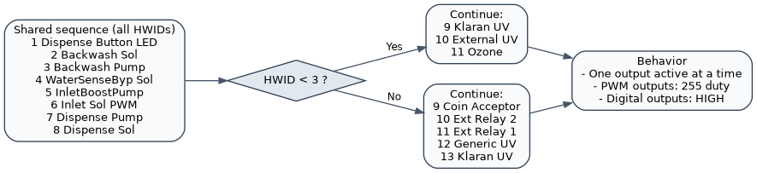
Sequential I/O Output Sequence

8. Klaran UV Special Handling
When the active output is Klaran UV:
- A 15-second safety timer starts.
- OLED row 6 shows remaining seconds.
- After timeout, Klaran UV output is forced OFF automatically.
Klaran status line (Klaran OK) behavior:
- N/A when Klaran UV is not currently under active timed check.
- OK when IN_KLARAN_UV_OK input is HIGH during active Klaran window.
- NO when the input is not asserted during active Klaran window.

9. Live Input/Status Lines (OLED Rows 8-13)
- SW: 1=... 2=...
  - SW1 uses OVERRIDE_SWITCH
  - SW2 uses IN_SW_2
- Btn: 1=... 2=...
  - Button 1 uses BTN_FRONT_DISPENSE
  - Button 2 uses BTN_SPARE_BUTTON
- FloatSW: Active/Inactive
  - Uses IN_WATER_LEVEL_FULL (active-low)
- Temp 1:xxx 2:yyy
  - From one-wire sensors on IN_TEMP_T1 and IN_TEMP_T2
  - Updates approximately once per second
  - Invalid reads shown as --
- Level: L=.. M=..
  - Raw state of IN_WATER_LEVEL_LOW and IN_WATER_LEVEL_MED
- Klaran OK: ...
  - As described in Section 6

10. Typical Test Procedure
- Enter Sequential I/O Test at boot.
- Confirm release prompt and enter main screen.
- Use “next output” buttons to step through every output.
- For each step:
  - Verify expected actuator energizes.
  - Verify all others are off.
- Observe rows 8-13 for switch/input telemetry.
- For Klaran UV step:
  - Confirm 15-second countdown appears.
  - Verify auto shutoff at timeout.
  - Verify Klaran OK response.
- Reset/power-cycle to leave test mode.

11. Troubleshooting
- No mode entry at boot:
  - Re-check button hold timing and wiring for BTN_OZONE_CTL / BTN_CONT_CIRC.
- Cannot step outputs:
  - Verify button inputs for BTN_OZONE_CTL, BTN_CONT_DISP, BTN_CONT_CIRC, BTN_WATER_INLET.
- Wrong output activates:
  - Confirm board HWID; sequence differs for <3 vs >=3.
- Temperature shows --:
  - Check one-wire sensors and bus wiring.
- Klaran never shows OK:
  - Check IN_KLARAN_UV_OK signal path and sensor logic.

12. Safety Notes
- This mode directly energizes pumps/solenoids/relays one-by-one.
- Use appropriate safe hydraulic/electrical test conditions.
- Keep downstream loads safe before activating high-power outputs.

