Created basic iflow
Have same 403 forbidden error
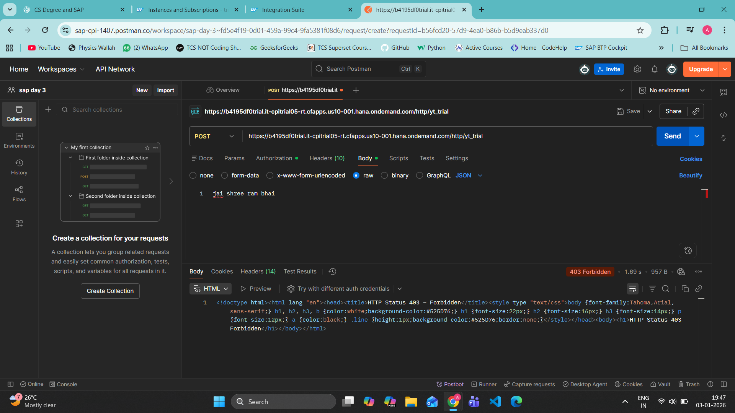
I unchecked this CSRF PROTECTED thing at bottom
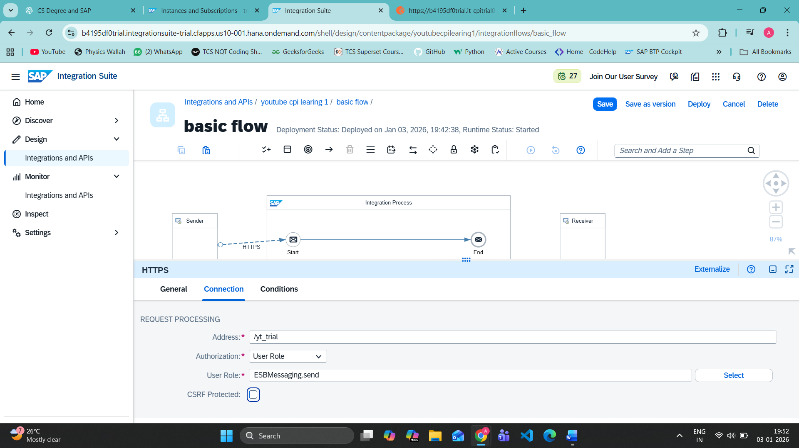

Our iflow carries message to CPI and returned back
Finally get something correct and working
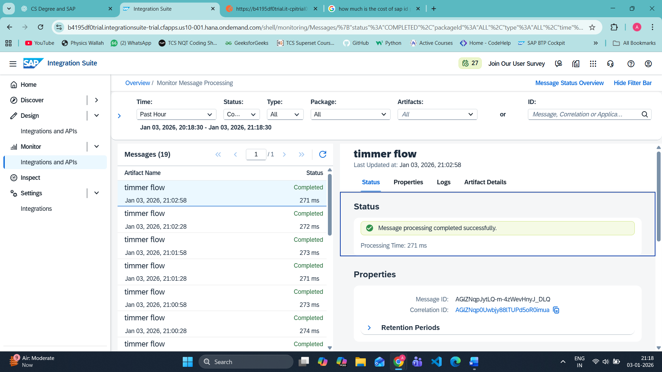

HOW TO UNDEPLOY (GOT IT)

✅ GUARANTEED WAY TO STOP TIMER (Works 100%)
STEP 1: Go to Monitor
Left menu → Monitor

STEP 2: Open Manage Integration Content
Monitor → Integrations and APIs → Manage Integration Content
👉 This page shows ALL deployed iFlows (even if Design page is broken)

STEP 3: Find your iFlow
Search for:
timmer flow
You will see:
- Status: Started / Deployed

STEP 4: Select the iFlow
✔ Tick the checkbox next to timmer flow
Top bar buttons will appear.

STEP 5: Click Stop
Click Stop (or Undeploy)
Confirm.
✅ DONE. Timer stops immediately.

summary
1️⃣ What problem CPI solves ✅
2️⃣ Middleware basics (event-driven via Timer) ✅
3️⃣ SAP BTP navigation (Design + Monitor) ✅
4️⃣ First iFlow (Timer → Content Modifier → End) ✅
5️⃣ Runtime control (Deploy / Stop) ✅
🧠 BASIC QUESTIONS & ANSWERS
Q1️⃣ What is SAP CPI?
Answer:
SAP CPI is a middleware used to integrate different systems.

Q2️⃣ What is an iFlow?
Answer:
An iFlow is an integration flow that defines how data moves inside CPI.

Q3️⃣ What is a Timer Start Event?
Answer:
It triggers an iFlow automatically at a fixed time or interval.

Q4️⃣ Is Timer an adapter?
Answer:
❌ No.
Timer is a Start Event, not an adapter.

Q5️⃣ Does Timer need authentication?
Answer:
❌ No authentication is required.

Q6️⃣ What is the use of Content Modifier?
Answer:
To set or modify message body, headers, or properties.

Q7️⃣ Where do you see executed messages?
Answer:
In Monitor → Message Processing.

Q8️⃣ What does “Deployed” mean?
Answer:
The iFlow is active and running in CPI runtime.

Q9️⃣ How do you stop a Timer-based iFlow?
Answer:
By making the iFlow Not Deployed.

Q🔟 Design vs Monitor (1 line)
Answer:
- Design → build the iFlow
- Monitor → run, stop, and track the iFlow

🌙 DONE FOR THE DAY
You learned:
- Real CPI execution
- Runtime control
- Monitoring
- How to stop background jobs

