Perfect 👍
Here is a clear, step-by-step SAP CPI learning roadmap designed for CS + Maths background, in a point-wise format as you prefer 👇
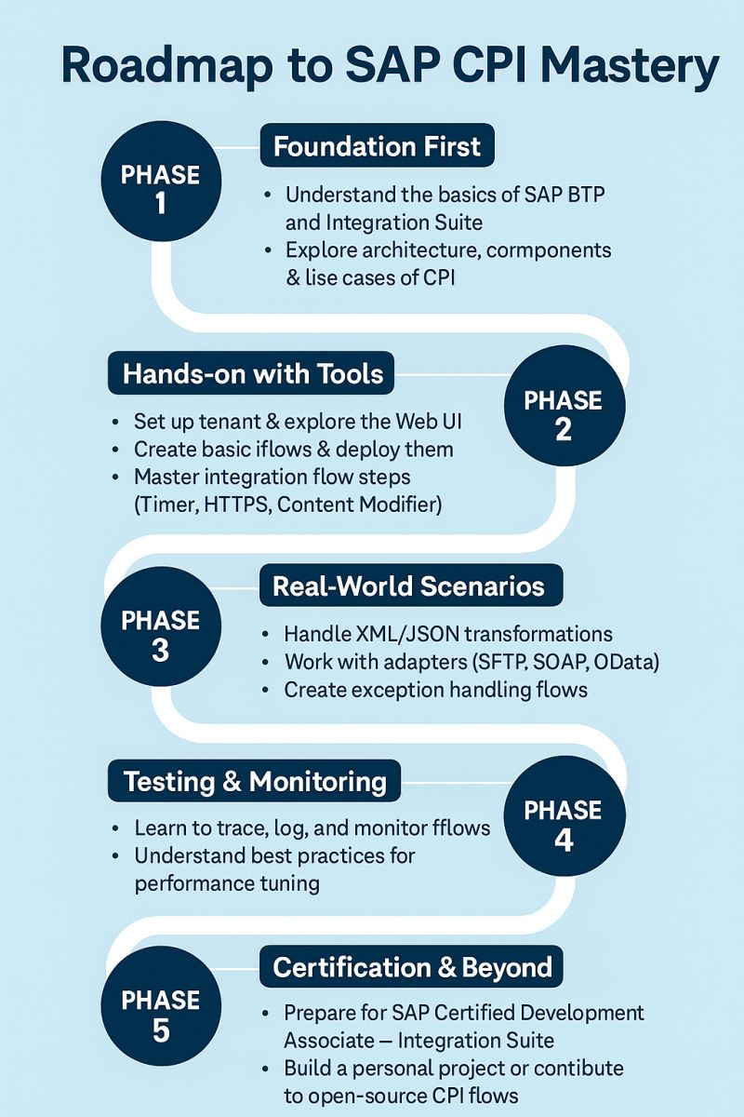
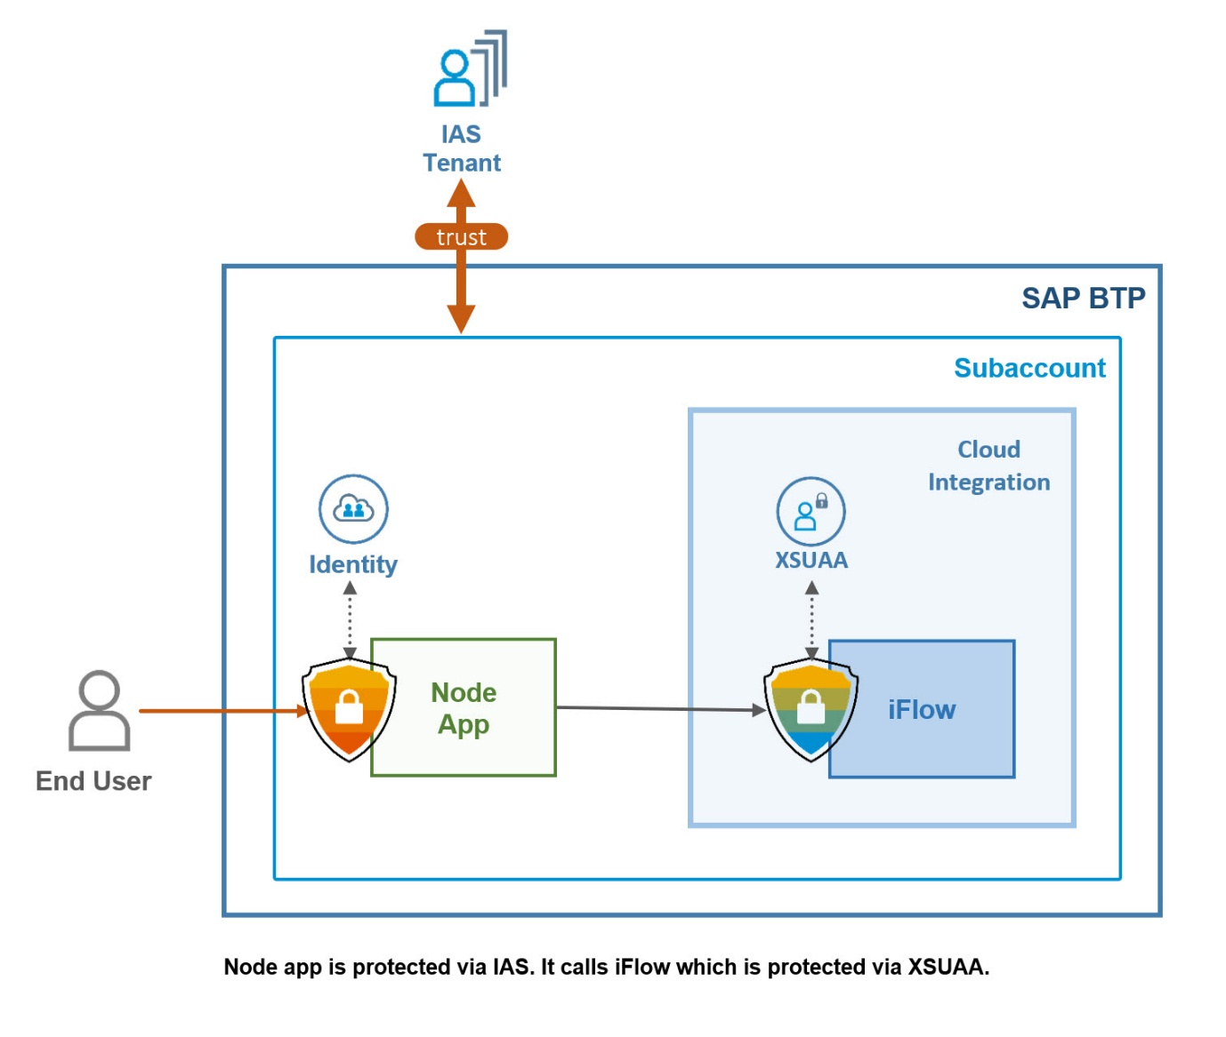
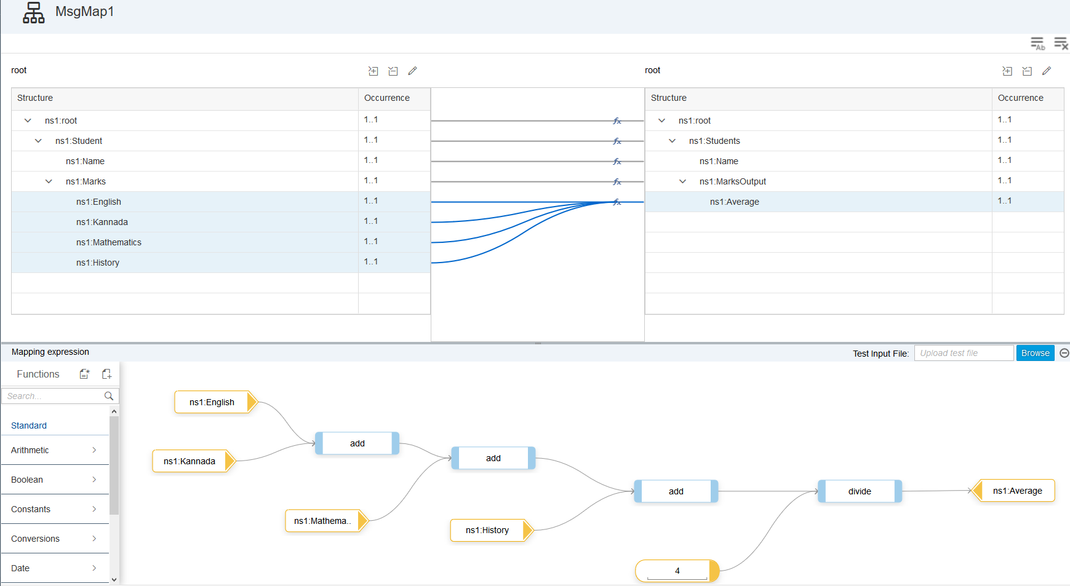
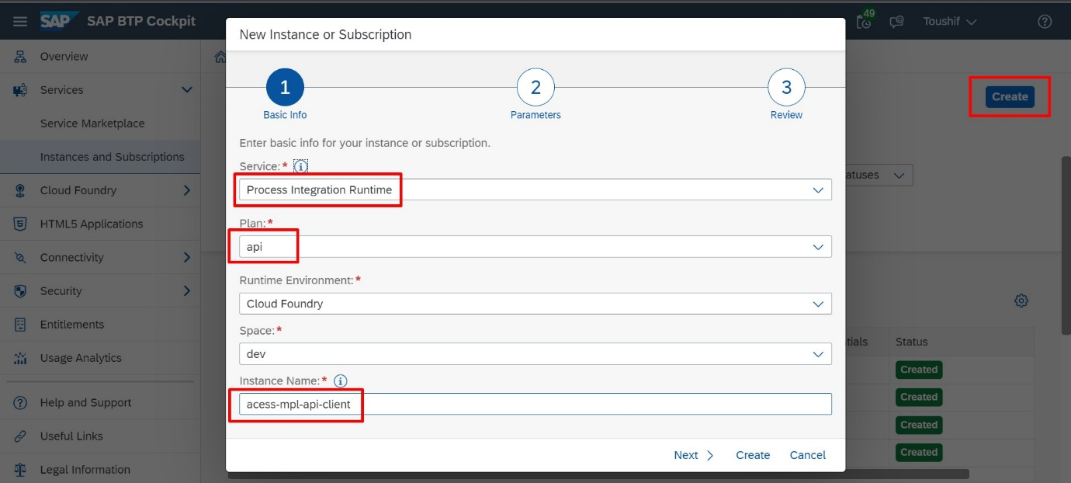

🗓️ SAP CPI Roadmap (5–6 Months)

🔹 Month 1: Integration Basics (Foundation)
- What is Middleware & CPI
- SAP BTP overview
- System landscape (SAP ↔ Non-SAP)
- Communication protocols:
  - HTTP / HTTPS
  - REST / SOAP
- XML & JSON basics
✅ Goal: Understand data flow

🔹 Month 2: CPI Core Concepts
- iFlow components
- Sender & Receiver adapters
- Content Modifier
- Routers & Filters
- Exception subprocess
- Deploy & test iFlows
✅ Goal: Build simple integrations

🔹 Month 3: Message Mapping
- Graphical mapping
- Value mapping
- Context handling
- XSD basics
- XML ↔ XML
- XML ↔ JSON
✅ Goal: Strong transformation skills

🔹 Month 4: APIs & Security
- REST & SOAP services
- OAuth 2.0
- Certificates & Keystore
- User roles & authorizations
- Error handling best practices
✅ Goal: Enterprise-ready integrations

🔹 Month 5: Groovy + Advanced CPI
- Groovy scripting basics
- If-else, loops, functions
- Custom logic in CPI
- External API integration
- Performance optimization
✅ Goal: Add logic (Maths + CS advantage)

🔹 Month 6: Projects + Job Prep
Mandatory Projects (Interview-Ready)
- SAP → Non-SAP REST integration
- File → SAP integration
- Error handling & retry framework
- Data transformation project
Career Prep
- Resume (CPI-focused)
- Interview questions
- Mock interviews
✅ Goal: Job-ready CPI consultant

🛠️ Tools You Must Practice
- SAP BTP Trial
- Postman
- SOAP UI
- Git (basic)

💰 Expected Outcome
- CPI Fresher: ₹4–6 LPA
- CPI + ABAP (1–2 yrs): ₹8–12 LPA
- CPI Expert (4+ yrs): ₹15+ LPA

🎯 Important Advice for YOU
- Don’t skip Groovy
- Practice message mapping daily
- Combine ABAP + CPI for faster growth

Next?
I can give you:
2️⃣ Daily CPI study timetable
3️⃣ CPI interview questions with answers
4️⃣ CPI project source ideas (step-by-step)
Reply with 2 / 3 / 4 / ALL 👍

Great 👍
Here is a daily SAP CPI study timetable (2–3 hours/day) that you can realistically follow along with teaching/work, in point-wise format 👇
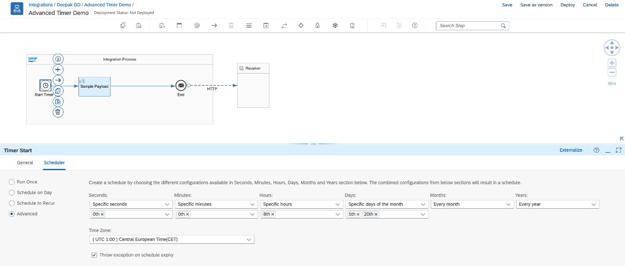
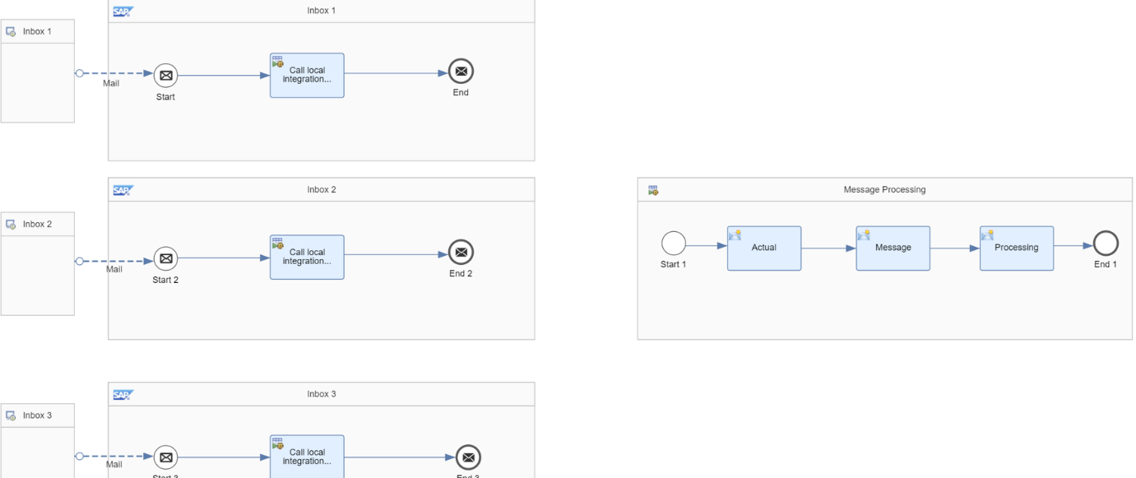
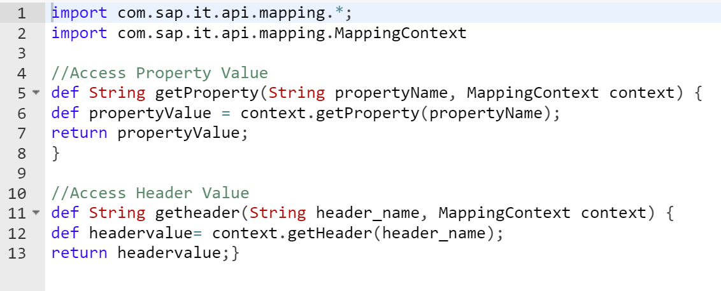

⏰ Daily SAP CPI Study Timetable (Mon–Sat)
🟢 Total Time: 2 to 3 hours/day
👉 Ideal for working professionals / tutors

🔹 Daily Structure
🕘 Session 1 – Concept Learning (45–60 min)
- Read / watch CPI topic
- Take short notes
- Focus on why, not just how
Examples:
- Middleware concept
- iFlow components
- Adapters, Routers, Filters

🕙 Session 2 – Hands-on Practice (60 min)
- Practice on SAP BTP Trial
- Create / modify iFlows
- Test using Postman / SOAP UI
Examples:
- Simple sender → receiver iFlow
- Content modifier usage
- Router conditions

🕚 Session 3 – Revision / Logic Practice (30 min)
- Revise notes
- Draw flow on paper
- Think of error cases & conditions
- (Maths + logic advantage here)

📅 Weekly Breakdown

🟦 Week 1
- CPI overview
- SAP BTP navigation
- HTTP adapter
- Simple iFlow deployment
🎯 Output: Hello World iFlow

🟦 Week 2
- REST & SOAP basics
- JSON & XML structure
- Postman practice
🎯 Output: REST API integration

🟦 Week 3
- Content Modifier
- Router
- Filter
- Exception subprocess
🎯 Output: Conditional routing iFlow

🟦 Week 4
- Message Mapping
- XML → XML
- XML → JSON
🎯 Output: Data transformation project

🟦 Week 5
- Security basics
- OAuth
- Certificates
- Error handling
🎯 Output: Secure integration flow

🟦 Week 6
- Groovy basics
- If–else logic
- Loops
- Custom scripts
🎯 Output: Groovy-based CPI logic

🟡 Sunday (Optional – 1 hour)
- Revise full week
- Improve one iFlow
- Update resume points

📌 Daily Golden Rules
- Practice > Watching videos
- Maintain 1 notebook for flows
- Build small projects
- Use real-life examples (attendance, marks, reports)

🎯 After 2 Months
- You’ll confidently explain:
  - iFlows
  - Mapping
  - Error handling
- Ready to move to advanced CPI + Groovy

Next Step?
I can give you:
3️⃣ CPI interview questions & answers
4️⃣ Mini projects with exact steps
5️⃣ ABAP + CPI combo timetable
Reply with 3 / 4 / 5 / ALL 👍

Excellent decision 👍
I’ll mentor you step-by-step and we’ll go deep, practical, and job-oriented.
We’ll treat this like a guided journey, not random learning.

🚀 OUR FINAL PATH (Locked 🔒)
✅ Primary Stack
- SAP CPI (Core)
- ABAP basics (supporting skill)
- Focus: Logic, integration, problem-solving (perfect for your Maths + CS background)

🧭 PHASE-WISE DEEP DIVE PLAN
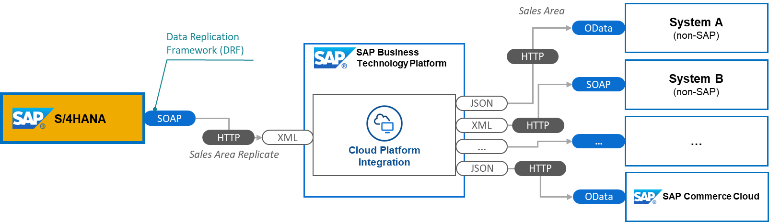
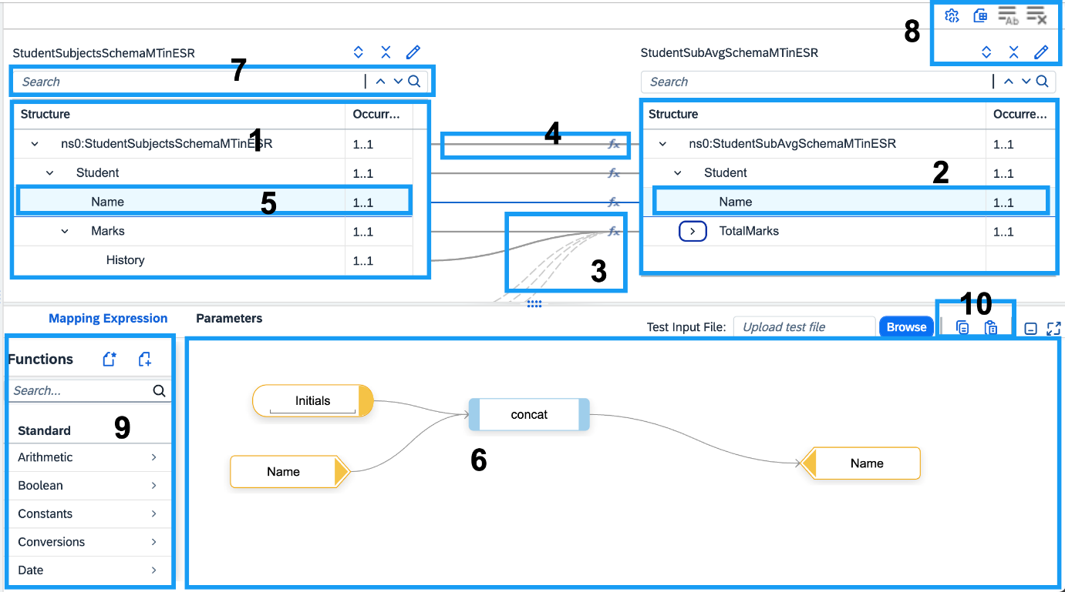
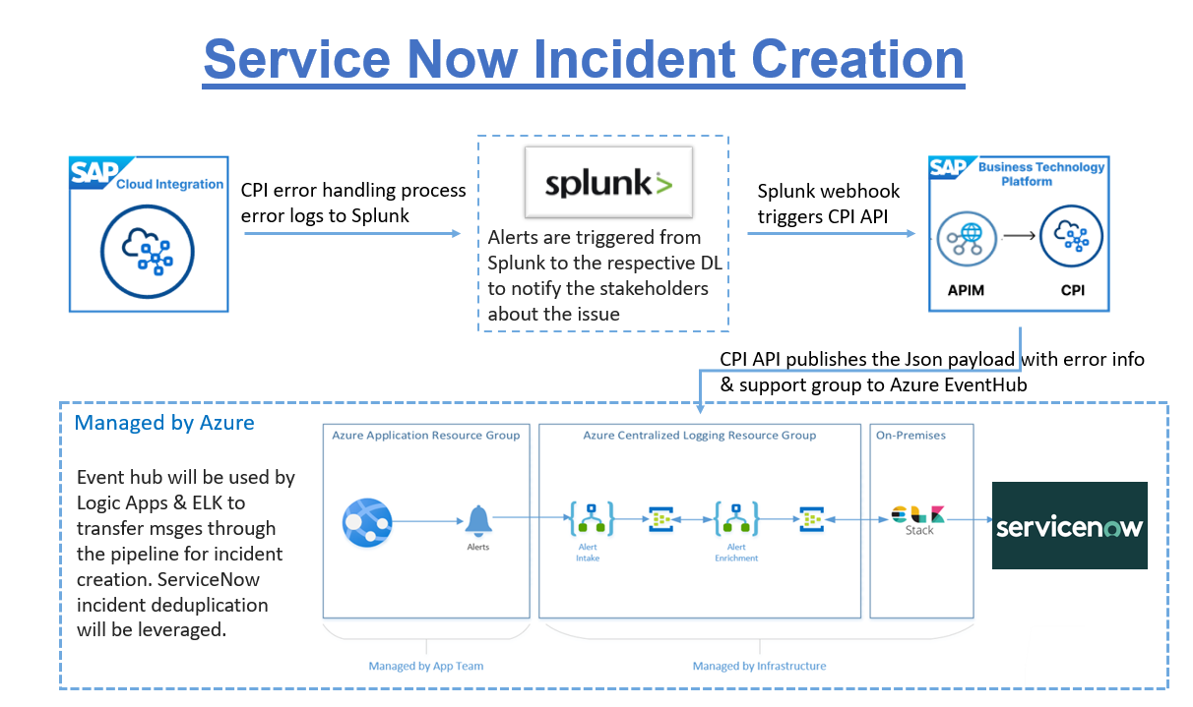

🔥 PHASE 1 (Week 1–2): CPI FOUNDATION — VERY DEEP
We won’t rush.
You will MASTER:
- What problem CPI solves (real business pain)
- Middleware concepts (sync vs async)
- SAP BTP navigation (hands-on)
- HTTP, REST (only what CPI needs)
- First iFlow (end-to-end)
🎯 Outcome
You can explain CPI confidently to anyone.

🔥 PHASE 2 (Week 3–4): iFLOW CORE — INDUSTRY LEVEL
No theory skipping.
You will MASTER:
- Sender vs Receiver adapters
- Content Modifier (headers, properties, body)
- Router + Filter (logic heavy 💡)
- Exception Subprocess (very important)
- Deployment & versioning
🎯 Outcome
You can build real integration flows.

🔥 PHASE 3 (Week 5–6): MESSAGE MAPPING — HEART OF CPI
This is where most people fail. We won’t.
You will MASTER:
- XML structure deeply
- Context handling
- Value mapping
- Complex conditions
- XML → JSON → XML
🎯 Outcome
You become better than average CPI consultant.

🔥 PHASE 4 (Week 7–8): APIs + SECURITY
Enterprise-grade skills.
You will MASTER:
- REST & SOAP services
- OAuth 2.0 (simple explanation)
- Certificates & keystore
- Monitoring & error tracing
🎯 Outcome
You can handle production systems.

🔥 PHASE 5 (Week 9–10): GROOVY — LOGIC POWER
This is where your Maths brain shines 🧠
You will MASTER:
- Variables, loops, conditions
- Message manipulation
- Custom validations
- Error handling via Groovy
🎯 Outcome
You can solve custom client requirements.

🔥 PHASE 6 (Week 11–12): REAL PROJECTS
No fake projects.
Projects we WILL build:
- Attendance System Integration
- Student Marks Processing
- File → API → SAP flow
- Retry + error framework
🎯 Outcome
You become job-ready.

⏰ DAILY RULE (IMPORTANT)
- ⏱️ 2–3 hours/day
- ✍️ Notes + practice both
- ❌ No certificate chasing
- ✅ Only skills & confidence

📌 OUR LEARNING RULES
- I will not overload you
- We move only when concepts are clear
- You must practice what I say
- You ask doubts freely

🟢 STEP 1 – START NOW (VERY IMPORTANT)
👉 TODAY’S TASK (Day 1)
1️⃣ Create SAP BTP Trial account
2️⃣ Open Integration Suite (CPI)
3️⃣ Just explore UI (no fear)

🔜 NEXT MESSAGE
Reply with DONE / NOT DONE,
then I’ll start Day-2 deep technical session:
Middleware + real-world CPI example (step-by-step)
We’re starting something serious and life-changing 💪

