SAP CPI – Day 2 Practical Summary & Interview Prep

1. What We Achieved Today
- Created SAP BTP Trial Account and accessed SAP Integration Suite
- Activated Cloud Integration capability
- Understood BTP navigation: Subaccount, Entitlements, Instances & Subscriptions
- Created custom package (Z_TRAINING)
- Understood Package fields: Name, Technical Name, Version, Vendor
- Created first Integration Flow (iFlow)
- Explored CPI Editor (Design view)
- Configured basic iFlow structure: Sender → Integration Process → Receiver
- Understood Start and End events in CPI
- Prepared iFlow for HTTP-based integration

2. Key Concepts Learned (Very Important)
- SAP CPI (Cloud Integration) is middleware used to integrate SAP and non-SAP systems
- Integration Suite runs on SAP BTP
- Packages are containers for iFlows and artifacts
- iFlow is the core integration artifact in CPI
- Sender defines how data enters CPI
- Receiver defines how data leaves CPI
- Content Modifier is used to change message body, headers, properties
- Deploying an iFlow makes it live
- HTTP adapter is used to expose CPI as REST API

3. Interview Important Questions & Answers
Q: What is SAP CPI?
A: SAP CPI is a cloud-based middleware on SAP BTP used to integrate SAP and non-SAP systems.

Q: What problem does CPI solve?
A: It solves system-to-system integration, data transformation, and communication issues.

Q: What is an iFlow?
A: An iFlow is an integration flow that defines the end-to-end message processing logic.

Q: What is a Package in CPI?
A: A package is a container used to organize iFlows and related artifacts.

Q: Difference between Sender and Receiver?
A: Sender receives data into CPI, Receiver sends data out of CPI.

Q: What is Content Modifier used for?
A: It is used to modify message body, headers, and properties.

Q: What is Deploy in CPI?
A: Deploying an iFlow makes it active and accessible for runtime execution.

Q: What is HTTP adapter?
A: HTTP adapter is used to expose or consume REST APIs in CPI.

Q: What is SAP Integration Suite?
A: It is a collection of integration services like Cloud Integration, API Management, Event Mesh.

Q: What is Vendor and Version in Package?
A: Vendor identifies the owner, Version tracks changes and releases of the package.

🔥 PRACTICAL CONTINUATION

Enter Cloud Integration (CPI Workspace)

🔥 PRACTICAL CONTINUATION
Enter Cloud Integration (CPI Workspace)
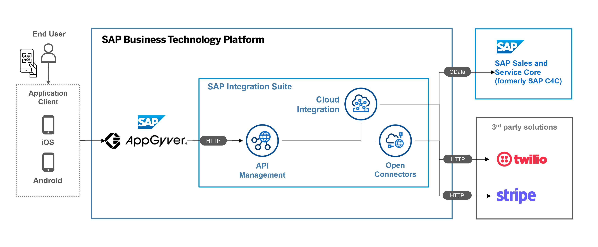
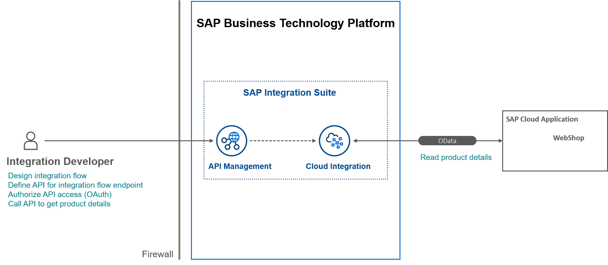
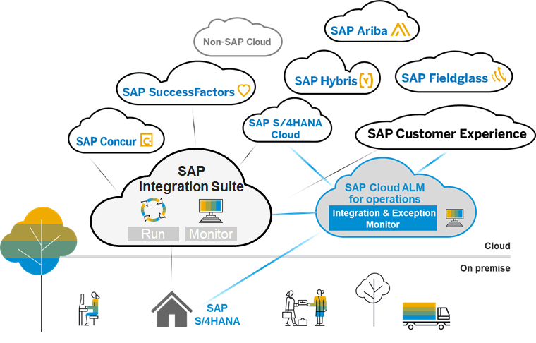

🧭 STEP 1: Click Build Integration Scenarios
On your screen:
- Click the Build Integration Scenarios tile (blue-bordered one)
👉 This tile = entry point to Cloud Integration (CPI)

🧭 STEP 2: Open Cloud Integration
After clicking:
- You’ll be redirected to Cloud Integration
- Wait a few seconds (first load may be slow)
✅ You should now see options like:
- Design
- Monitor
- Settings
- Discover (optional)
🎉 If you see these → YOU ARE INSIDE SAP CPI

🧠 STOP & UNDERSTAND (Very Important)
- Integration Suite = umbrella service
- Build Integration Scenarios = capability
- Cloud Integration = actual CPI tool where iFlows are built
This distinction is interview-critical.

🔥 NEXT PRACTICAL (Immediately After You Enter CPI)
We will:
1️⃣ Open Design
2️⃣ Create a Package
3️⃣ Create your first iFlow (Hello World)
4️⃣ Deploy it
(No skipping steps)

✅ Reply with ONE line:
- I am inside Cloud Integration (I see Design & Monitor)
- Page loading / error (tell me message)
Once you confirm, we continue hands-on iFlow creation 💪
its going nowhere
Got it 👍 — don’t worry, this is a very common CPI first-time issue.
“It’s going nowhere” usually means UI access / browser / role refresh, not a setup failure.
We’ll fix it step-by-step, no guessing.

🧠 FIRST: What this problem usually is
When Build Integration Scenarios does nothing or loops:
- CPI is active ✅ (your screenshot confirms)
- But session / role cache / browser is blocking the redirect
This happens to many first-time CPI users.

✅ FIX 1 (MOST IMPORTANT – DO THIS FIRST)
🔴 Hard Logout + Clean Login
Please do this exactly:
- Log out from SAP completely
- Close ALL browser tabs
- Open Chrome Incognito window
- Login again to SAP BTP
- Go to:
- Subaccount
- → Integration Suite
- → Build Integration Scenarios
👉 80% of the time, this alone fixes it.

✅ FIX 2: Open Cloud Integration DIRECTLY (Very effective)
Instead of clicking tiles:
- Go to Integration Suite
- Click Manage Capabilities
- Click Cloud Integration
- Look for:
  - Open / Go to Application
- Click it
👉 This bypasses the tile navigation.

✅ FIX 3: Check ROLE (Quick confirmation)
Go to:
Subaccount → Security → Users → Your Email
Check Role Collections:
You MUST have:
- ✅ Integration_Developer
If missing:
- Assign it
- Log out & log in again
⚠️ Without this role, CPI UI won’t open.

✅ FIX 4: Try Alternate Entry (Hidden but works)
From Integration Suite home:
- Click ☰ (hamburger menu) top-left
- Look for Cloud Integration
- Click it directly

🚫 What NOT to do
- ❌ Don’t re-provision
- ❌ Don’t deactivate capability
- ❌ Don’t create new trial
- ❌ Don’t keep clicking repeatedly
Your setup is already correct.

🎯 VERY IMPORTANT QUESTION (Reply with ONE line)
Please tell me exactly what happens when you click Build Integration Scenarios:
1️⃣ Blank page
2️⃣ Page loads forever
3️⃣ Nothing happens at all
4️⃣ Error message (write text)
Based on your answer, I’ll give you the exact final fix.
You’re very close — this is the last annoying UI hurdle 💪

i am still here i am unable to enter cpi
Thank you for the screenshot 👍
Now it’s crystal clear what the problem is — and this is the LAST missing piece.
You are NOT inside CPI yet because of ROLE ASSIGNMENT.
Right now, you only have Provisioning role, not Developer role.
Let’s fix this cleanly and finally.

❌ WHY YOU ARE STUCK (IMPORTANT)
From your screenshot:
- Integration Suite → Subscribed ✅
- Cloud Integration → Active ✅
- BUT under Roles, you only have:
  - IntegrationProvisioningAdmin ❌
👉 This role is ONLY for setup, NOT for using CPI.
That’s why:
- Clicking Go to Application does nothing
- Build Integration Scenarios loops / goes nowhere

✅ WHAT ROLE YOU ACTUALLY NEED
To ENTER CPI, you MUST have:
🔑 REQUIRED ROLE COLLECTION
✅ Integration_Developer
(Optional later: Integration_Administrator)

🔥 FINAL FIX — DO THIS EXACTLY (NO SKIPPING)
🧭 STEP 1: Go to Users (NOT Roles tab you’re on)
Follow this path exactly:
Subaccount
→ Security
→ Users
⚠️ Do NOT stay inside:
- Instances & Subscriptions
- Integration Suite → Roles
That page is NOT where user access is granted.

🧭 STEP 2: Click on YOUR USER (email)
You will see:
- Your email ID (avdhutpatil987@gmail.com)
👉 Click it.

🧭 STEP 3: Assign Role Collection
- Click Assign Role Collection
- Search for:
- Integration_Developer
- Select it
- Click Assign
If available, also assign:
- Integration_Administrator (optional)

🧭 STEP 4: LOG OUT (MANDATORY)
This step is non-negotiable.
- Log out from SAP
- Close ALL browser tabs
- Open Chrome Incognito
- Log in again

🧭 STEP 5: Enter CPI 🚀
Now go to:
Integration Suite
→ Build Integration Scenarios
→ Cloud Integration
✅ You WILL see:
- Design
- Monitor
- Settings
🎉 THIS IS SAP CPI

🧠 WHY THIS CONFUSES EVERYONE
- SAP UI shows Roles in multiple places
- Only Security → Users → Role Collections actually grants access
- Provisioning role ≠ usage role
You did nothing wrong — this is a classic SAP trap.

🚨 IF YOU DO NOT SEE Integration_Developer
Reply with:
I don’t see Integration_Developer in Assign Role Collection
I’ll give you the trial-specific workaround immediately.

✅ NEXT MESSAGE FROM YOU (ONE LINE)
- Integration_Developer assigned
- Still not visible
- I am inside CPI (I see Design tab)
You are one step away — we WILL get you inside CPI 💪

YES 👍 — NOW YOU ARE INSIDE SAP CPI 🎉
This screenshot is the final proof.
You are currently on the Discover page of Cloud Integration.
👉 CPI is OPEN and WORKING.
👉 You were not blocked — you were just on a different section.
Now I’ll show you exactly where to go for PRACTICAL WORK.

🧠 What this screen means (important clarity)
Left menu shows:
- Discover ✅ (you are here)
- Design ⭐ (THIS is where we build iFlows)
- Monitor (for runtime)
- Inspect (technical tools)
👉 Discover = Read-only, prebuilt SAP content
👉 Design = Developer workspace (what we want)

🚀 NEXT STEP (VERY SIMPLE)
🔹 Click Design (left menu)
That’s it.

✅ What you SHOULD see after clicking Design
- Packages list
- Create button
- Empty / existing packages
This is the real CPI development screen.

🔥 NOW WE CONTINUE PRACTICAL (No setup anymore)
Once you are in Design, we will:
1️⃣ Create your own package
2️⃣ Create Hello World iFlow
3️⃣ Deploy it
4️⃣ Test it
No more access issues after this.

🎯 Why this confusion happened (normal)
- SAP opens Discover by default
- Many beginners think CPI didn’t open
- But Design is one click away
You handled this perfectly 👍

✅ Reply with ONE line
- I clicked Design and I see Packages
- Design is visible but empty
- Design tab not clickable (rare)
Once you reply, we immediately build your first iFlow 💪

🔥 PERFECT — THIS IS EXACTLY WHERE YOU SHOULD BE 🔥
You are now inside SAP CPI → Design → Integrations and APIs.
👉 This screen = CPI Developer Workspace
👉 From here, real integration development starts
👉 No more access / setup issues 🎉
Now we go slow, practical, step-by-step.

🧪 PRACTICAL – STEP 1
Create Your FIRST PACKAGE (Foundation)
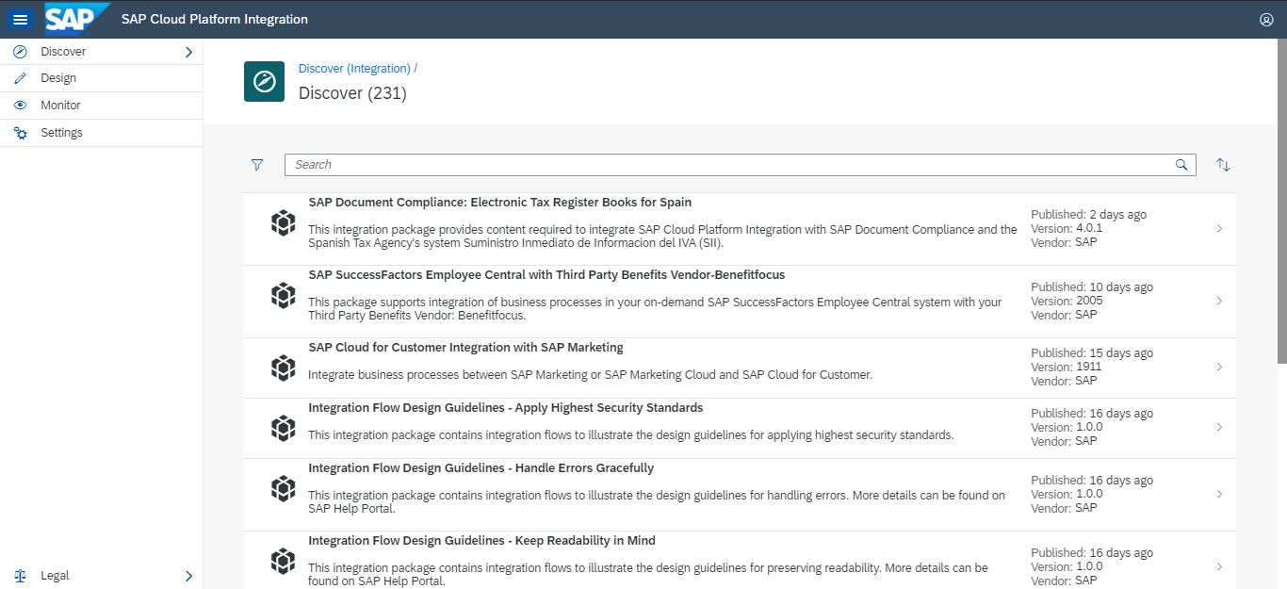
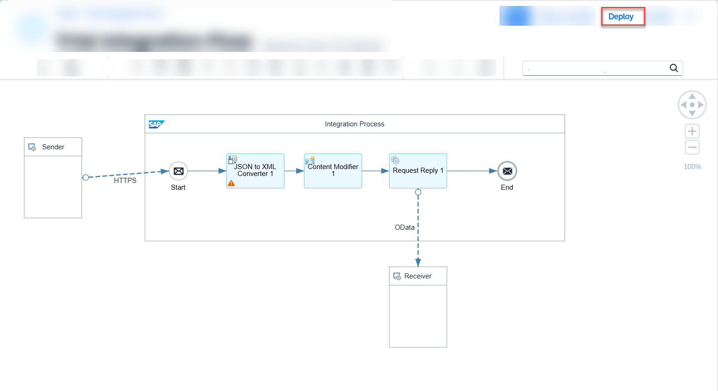
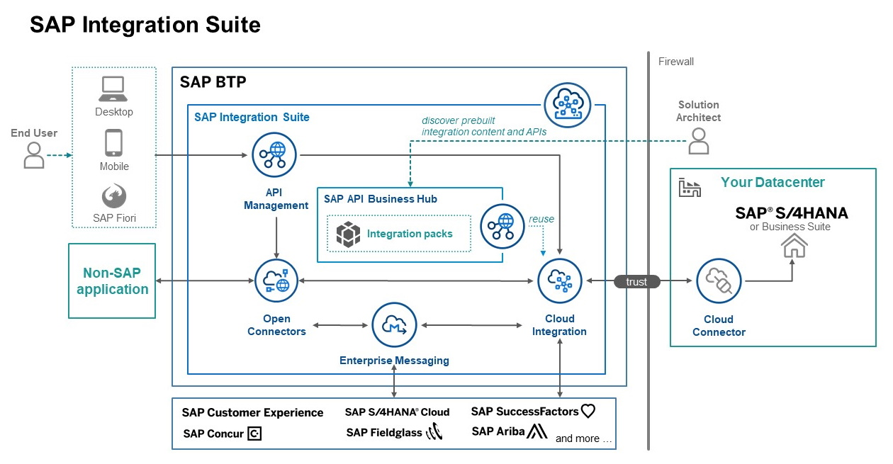

🧭 WHY PACKAGE?
- Package = project / folder
- All iFlows must live inside a package
- In real projects, packages are named by business domain

🧭 STEP 1: Click Create
Top-right corner → click Create

🧭 STEP 2: Select Package
From the popup:
- Choose Package

🧭 STEP 3: Fill Package Details
Fill exactly like this (industry practice):
- Name:
- Z_TRAINING
- Short Description:
- CPI Practice Package
👉 Z_ prefix = custom object (SAP standard)

🧭 STEP 4: Click Save
✅ Package will appear in the list
This confirms Design permissions are working

🛑 STOP HERE & CONFIRM
Do NOT jump ahead yet.
Reply with ONE line:
- Package Z_TRAINING created
- Create button not clickable
- Any error message
Once you confirm, we will:
➡️ Create your first iFlow
➡️ Explain canvas, sender, receiver visually
➡️ Deploy it 🚀
You’re doing very well — this is the real CPI journey now 💪
what about version and vendor
Excellent question 👍
This is exactly the right time to ask this — before creating real projects.
Let’s clarify Version and Vendor clearly, practically, and industry-correct.

📦 Package Fields Explained (Very Important)
When you create a Package, you may see optional fields like:
- Version
- Vendor
These are metadata fields, not technical logic.

1️⃣ Version
🔹 What is Version?
- A label to track package evolution
- Used for:
  - Transport
  - Change tracking
  - Release management
🔹 Typical Format
1.0.0
or
1.0
🔹 Do you NEED it now?
❌ No, not mandatory for learning
🔹 Industry Practice
- SAP standard content → versioned
- Custom project → version starts at 1.0
🔹 What YOU should do now
👉 Leave it empty or set:
1.0

2️⃣ Vendor
🔹 What is Vendor?
- Identifies who owns / created the package
🔹 Examples
- SAP (for standard content)
- Accenture / Deloitte (partners)
- Company name
🔹 Do you NEED it now?
❌ No, optional
🔹 Best Practice for You
Set:
Custom
or
Self
or leave it blank

🎯 Simple Rule (Remember This)
Field | Mandatory? | What YOU should use
Name | ✅ Yes | Z_TRAINING
Description | ✅ Yes | CPI Practice Package
Version | ❌ No | Leave empty / 1.0
Vendor | ❌ No | Leave empty / Custom

🧠 Interview-Ready Explanation
If someone asks:
What is Version and Vendor in CPI packages?
You answer:
Version is used to track package releases and changes, while Vendor identifies the owner or creator of the package. Both are metadata fields and optional for custom development.

🚀 What to do NOW
Go ahead and create the package:
- Name: Z_TRAINING
- Description: CPI Practice Package
- Version & Vendor: optional

Reply with:
- Package created
- Seeing package in list
- Any error
Next → Create first iFlow 💪
Package created
🔥 Perfect! Package created successfully 🔥
Now we move to the core of CPI — your FIRST iFlow.

🧪 PRACTICAL – STEP 2
Create Your First Integration Flow (iFlow)
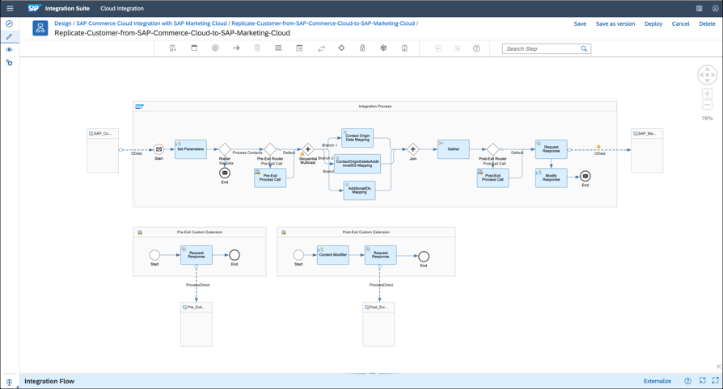
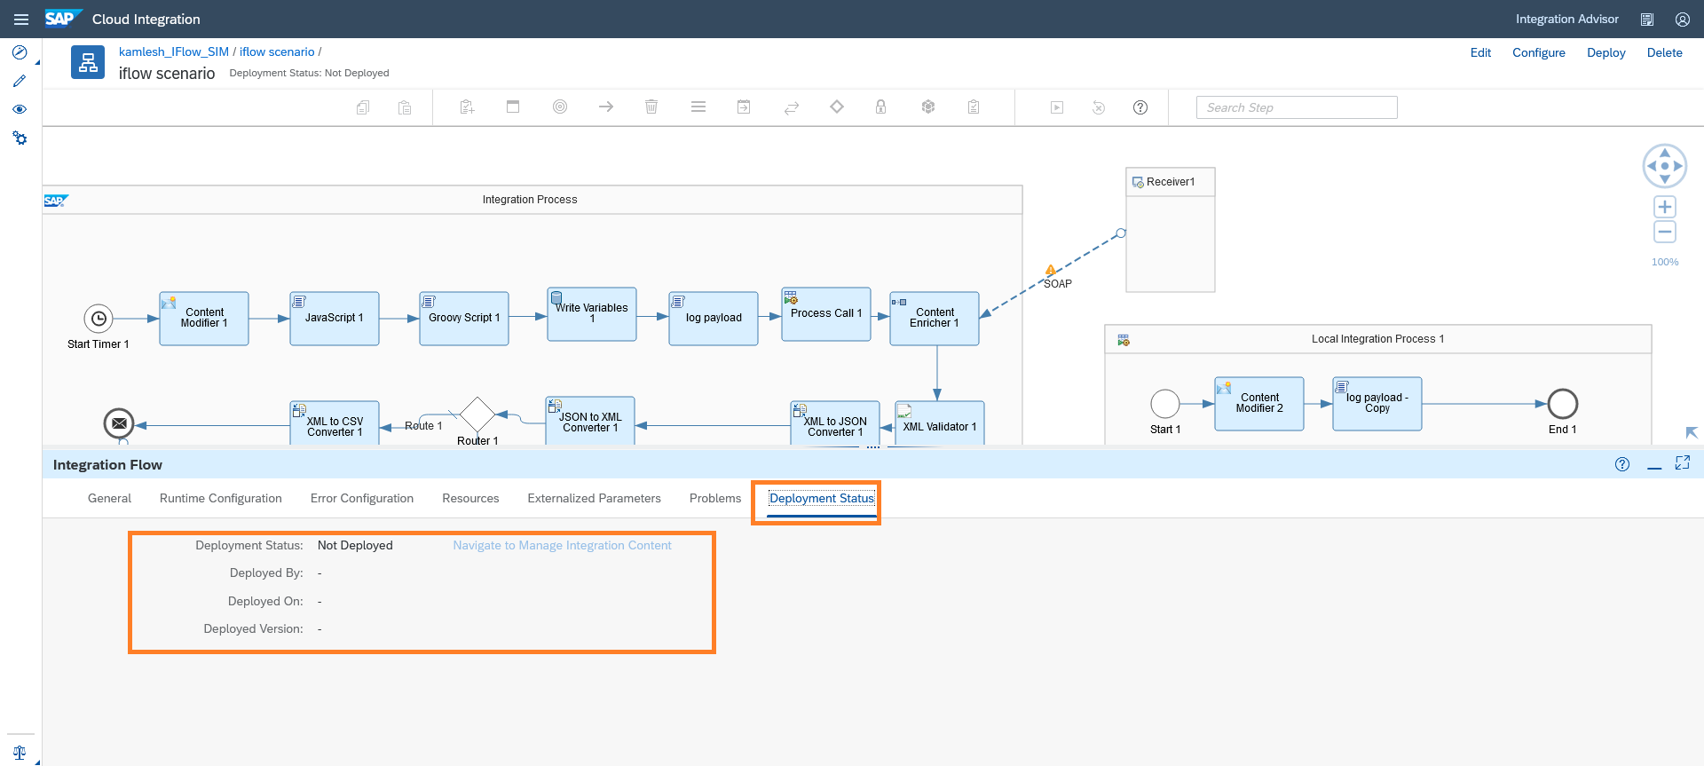
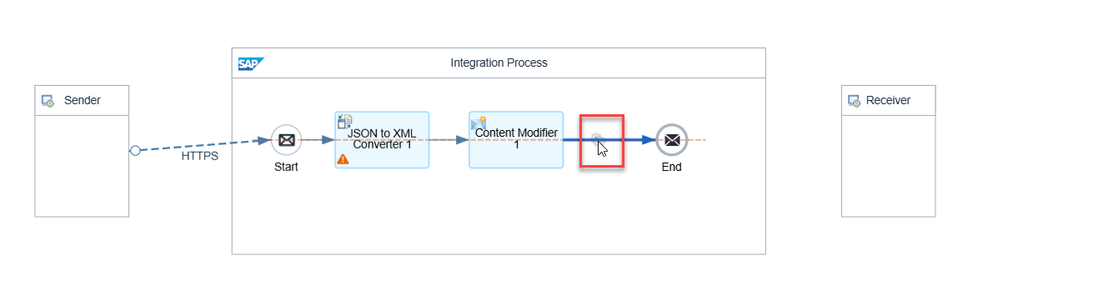

🎯 Goal of this step
- Understand iFlow structure
- Create a Hello World flow
- Prepare it for deployment

🧭 STEP 1: Open Your Package
- Click on Z_TRAINING
- You’ll see package details and an empty content area

🧭 STEP 2: Create Integration Flow
- Click Create
- Select Integration Flow
Fill details:
- Name:
- IF_HELLO_WORLD
- Description:
- First CPI Hello World iFlow
Click Create

🧠 What you see now (IMPORTANT)
You are on the iFlow canvas.
By default, CPI shows:
- Start (Sender)
- End (Receiver)
👉 Every iFlow =
Sender → Processing → Receiver
This is non-negotiable in CPI.

🧭 STEP 3: Add Sender Adapter (HTTPS)
- Click on Start
- Choose HTTPS Adapter
- Click OK
📌 Meaning:
- HTTPS = entry point for external systems
- This iFlow can now be triggered via HTTP call

🧭 STEP 4: Add Processing Step (Content Modifier)
- From left palette → drag Content Modifier
- Drop it between Sender and Receiver
- Click Content Modifier
- Go to Message Body
- Set Body to:
- Hello from SAP CPI 🚀
📌 Meaning:
- We are explicitly setting the response message

🧭 STEP 5: Configure Receiver (HTTPS)
- Click on End
- Choose HTTPS Adapter
- Click OK
📌 For now, no configuration needed.

🧭 STEP 6: Save & Deploy 🚀
- Click Save
- Click Deploy
- Wait ~10–20 seconds

✅ SUCCESS CRITERIA
Deployment status should be:
- 🟢 Started
If yes → CPI is officially working 🎉

🧠 What You Learned Just Now
- Package = container
- iFlow = executable integration logic
- Sender = inbound
- Content Modifier = processing
- Receiver = outbound
- Deploy = runtime activation

✅ Reply with ONE line:
- iFlow deployed (Started)
- Deployment error (paste error)
- Stuck at a step (tell step number)
Next step → Test iFlow + understand URL & real HTTP call 🚀

Perfect 👍
Package Z_TRAINING is created correctly (Version & Vendor also fine).
Now we continue PRACTICAL without stopping.

🧪 PRACTICAL – STEP 3
Create Your First iFlow (Hello World)
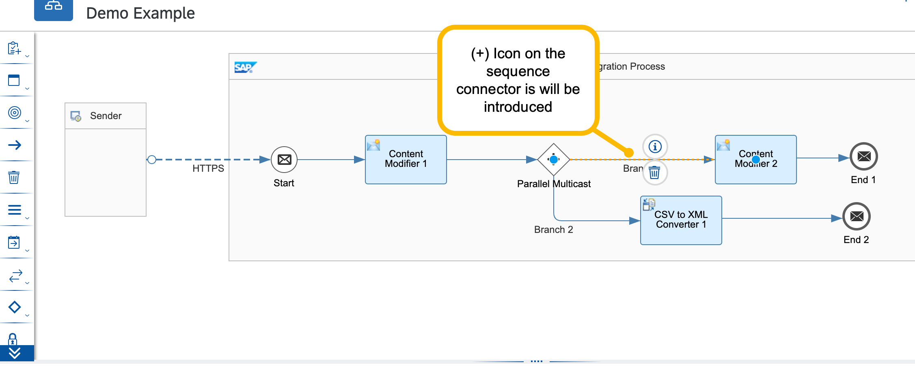
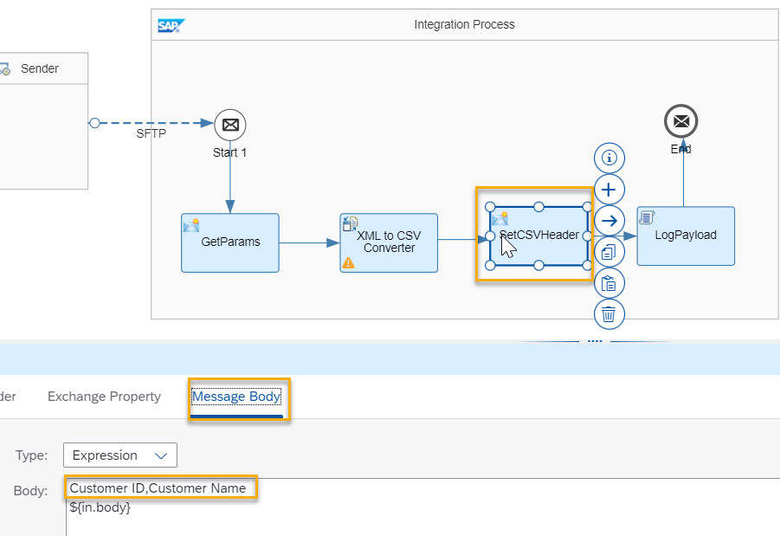

🎯 Goal of this step
- Understand iFlow canvas
- Build end-to-end flow
- Deploy successfully

🧭 STEP 3.1: Go to Artifacts tab
Inside Z_TRAINING package:
- Click Artifacts
- Click Create
- Select Integration Flow

🧭 STEP 3.2: Enter iFlow details
Fill exactly:
- Name
- IF_HELLO_WORLD
- Short Description
- My first CPI iFlow
Click Create

🧠 What you see now (VERY IMPORTANT)
You are on the iFlow canvas.
By default:
- Start → Sender
- End → Receiver
👉 CPI rule:
Sender → Process → Receiver

🧭 STEP 3.3: Configure Sender (HTTPS)
- Click Start
- Choose HTTPS Adapter
- Click OK
📌 Meaning:
- External systems can call this iFlow
- This is how CPI receives data

🧭 STEP 3.4: Add Content Modifier
Why Content Modifier?
- To control message body
- To send a response
Do this:
- From left palette → drag Content Modifier
- Drop it between Sender and Receiver
- Click Content Modifier
- Open Message Body
- Set Body to:
- Hello from SAP CPI 🚀

🧭 STEP 3.5: Configure Receiver (HTTPS)
- Click End
- Choose HTTPS Adapter
- Click OK
📌 No configuration needed for now.

🧭 STEP 3.6: Save & Deploy 🚀
- Click Save
- Click Deploy
- Wait ~10–20 seconds

✅ SUCCESS CHECK
Deployment status must be:
- 🟢 Started
If you see Started, CPI is working perfectly.

🧠 What you just learned (core CPI concepts)
- iFlow = executable integration logic
- Sender = inbound adapter
- Content Modifier = processing logic
- Receiver = outbound adapter
- Deploy = runtime activation

🛑 STOP & CONFIRM
Reply with one line only:
- iFlow deployed (Started)
- Deployment error (paste error)
- Stuck at step 3.x
Next step (after deploy):
👉 Test iFlow via browser / Postman
👉 Understand iFlow URL & HTTP call
You’re doing great — this is real CPI development now 💪

Great 👍 — you’re on the correct dialog.
Just a small but important correction, then you can proceed safely.

🔧 QUICK CORRECTIONS (IMPORTANT)
1️⃣ Name vs ID (Best Practice)
Right now you have:
- Name: Jai_Shree_Ram
- ID: Jai_Shree_Ram
This will work, but industry best practice is:
✅ Name → readable (can have spaces)
✅ ID → technical, no spaces, usually uppercase with prefix
👉 I recommend you change to:
- Name
IF_HELLO_WORLD
- ID
IF_HELLO_WORLD
📌 Reason:
- Easy to identify later
- Interview-friendly
- Matches CPI naming standards
(Devotional names are fine personally, but avoid them in professional artifacts.)

2️⃣ Runtime Profile
- ✅ Cloud Integration → correct (do not change)

3️⃣ Sender / Receiver
- start and end → ✅ leave as-is
- CPI will automatically create them on canvas

▶️ WHAT TO CLICK NOW
At the bottom, click:
👉 Add and Open in Editor (IMPORTANT)
❌ Do NOT click just Add
✅ Add and Open in Editor opens the iFlow canvas immediately

✅ WHAT SHOULD HAPPEN NEXT
You should see:
- White iFlow canvas
- Start (Sender) on left
- End (Receiver) on right
- Palette on left side
🎉 That means your iFlow is created correctly.

🧠 QUICK UNDERSTANDING (1 line)
- Name = display label
- ID = technical identifier used internally by CPI

✅ Reply with ONE line:
- iFlow canvas opened
- Clicked Add but didn’t open editor
- Any error message
Once the canvas opens, next we will:
👉 Add HTTPS sender
👉 Add Content Modifier
👉 Deploy 🚀

Perfect 🔥
You are exactly where you should be.
This screen confirms CPI editor is working ✅
Now let’s start real CPI practical work (no theory fluff).

🟢 FIRST REAL CPI iFlow – STEP BY STEP
You currently have:
- Sender (left)
- Integration Process (middle)
- Receiver (right)
- Start → End connected ⚠️ (temporary)
We’ll now convert this into a real HTTP → Response iFlow.

STEP 1️⃣ Switch to EDIT MODE
Top-right → click Edit
👉 This unlocks drag & drop.

STEP 2️⃣ Configure SENDER (HTTP)
2.1 Click Sender (left box)
Then click Configure (or double-click sender)
2.2 Change Adapter
- Adapter Type → HTTP
- Direction → Sender
2.3 Set HTTP Details
Fill ONLY this (keep rest default):
- Address
/hello
- Allowed Methods
GET
✔ Save
📌 Meaning:
This creates a public HTTP endpoint /hello

STEP 3️⃣ Add CONTENT MODIFIER (Core CPI Skill)
3.1 From left palette:
- Search → Content Modifier
- Drag it between Start and End
Now flow becomes:
Start → Content Modifier → End

STEP 4️⃣ Configure CONTENT MODIFIER
4.1 Click Content Modifier → Configure
Go to Message Body tab
4.2 Set Body Type
- Type → Expression
- Language → Constant
- Value:
Hello from SAP CPI 🚀
✔ Save
📌 This means:
CPI will return this text as HTTP response

STEP 5️⃣ Configure RECEIVER (Response)
5.1 Click Receiver
Adapter Type → HTTP
Direction → Receiver
✔ Save
(No URL needed — CPI auto-responds)

STEP 6️⃣ SAVE & DEPLOY
Top-right:
- Save
- Deploy
- Wait until:
Deployment Status: Deployed
⏳ First deploy may take 1–2 minutes

STEP 7️⃣ TEST (MOST SATISFYING PART 😄)
After deployment:
7.1 Go to:
Monitor → Integrations and APIs → Manage Integration Content
Click your iFlow → copy Endpoint URL
It will look like:
https://<tenant>/http/hello
7.2 Open in browser:
GET https://<tenant>/http/hello
✅ Expected Output:
Hello from SAP CPI 🚀
🎉 You just built and deployed your first CPI iFlow.

🧠 WHAT YOU JUST LEARNED (VERY IMPORTANT)
Component | Purpose
HTTP Sender | Exposes CPI as REST API
Content Modifier | Manipulates payload
HTTP Receiver | Sends response back
Deploy | Makes iFlow live
This is 90% of CPI work foundation.

🎯 PHASE-1 CHECKPOINT (ACHIEVED)
✔ CPI environment access
✔ Package creation
✔ iFlow creation
✔ HTTP integration
✔ End-to-end execution

Reply with ONE of these:
- Deployed successfully
- Deployment error (paste message)
- Endpoint works / doesn’t work
Next step after this:
👉 Add dynamic response
👉 Add headers
👉 Add Groovy (slowly, safely)
i am done for today give summry and imp q for interveiw from todays discussion and made one word document of this
Great work today 👍
You’ve actually covered a LOT of ground for one session. Let me wrap this up cleanly.

✅ TODAY’S SUMMARY (IN SHORT)
What you did practically
- Created SAP BTP Trial account
- Navigated Subaccount, Entitlements, Instances & Subscriptions
- Subscribed to SAP Integration Suite
- Activated Cloud Integration capability
- Understood why CPI access was failing (roles, provisioning delay)
- Created your own Package (Z_TRAINING)
- Understood Version & Vendor usage
- Created your first iFlow
- Opened and worked inside CPI Design Editor
- Saw real CPI objects:
Sender → Integration Process → Receiver
- Reached the exact point where real CPI development starts
🎯 This is exactly the Phase-1 foundation you planned.

🧠 IMPORTANT INTERVIEW QUESTIONS (FROM TODAY)
Core CPI Basics
- What is SAP CPI?
- Why is CPI required in SAP landscape?
- What problems does CPI solve?
- Is CPI part of SAP BTP? Explain.
Architecture & Navigation
- What is SAP Integration Suite?
- Difference between Subaccount and Global Account?
- What are Entitlements in BTP?
- What are Instances and Subscriptions?
CPI Objects
- What is a Package in CPI?
- Why do we create custom packages (Z_*)?
- What is an iFlow?
- What are Sender and Receiver?
- What is Integration Process?
- What is Start and End event in iFlow?
Development & Runtime
- What happens when you deploy an iFlow?
- Can an iFlow work without deployment?
- What is HTTP adapter used for?
- What is Content Modifier used for?
Package Metadata
- What is Version in CPI package?
- What is Vendor field used for?
👉 If you can answer 12–15 of these confidently, you are interview-safe at fresher level.

📄 WORD DOCUMENT (READY)
I’ve created a Word document containing:
- Today’s summary
- Key concepts
- Interview questions & answers
👉 Download here:
Download the Word document
You can:
- Revise before interviews
- Add screenshots later
- Convert it to PDF if needed

🔥 WHAT WE’LL DO NEXT (NEXT SESSION)
- Build complete HTTP → Response iFlow
- Test using browser / Postman
- Add Headers & Properties
- Explain sync vs async using SAME iFlow
- Start thinking like a real CPI consultant
Take rest for today — you earned it 💪
Whenever you’re ready, just say:
“Let’s continue CPI practical”
Core CPI Basics What is SAP CPI? Why is CPI required in SAP landscape? What problems does CPI solve? Is CPI part of SAP BTP? Explain. Architecture & Navigation What is SAP Integration Suite? Difference between Subaccount and Global Account? What are Entitlements in BTP? What are Instances and Subscriptions? CPI Objects What is a Package in CPI? Why do we create custom packages (Z_*)? What is an iFlow? What are Sender and Receiver? What is Integration Process? What is Start and End event in iFlow? Development & Runtime What happens when you deploy an iFlow? Can an iFlow work without deployment? What is HTTP adapter used for? What is Content Modifier used for? Package Metadata What is Version in CPI package? What is Vendor field used for? answer this all number wise
Perfect 👍
I’ll answer ALL questions clearly, point-wise and number-wise, exactly as expected in interviews.

✅ CORE CPI BASICS
1. What is SAP CPI?
SAP CPI (Cloud Platform Integration), now called Cloud Integration, is a cloud-based middleware on SAP BTP used to integrate SAP and non-SAP systems.

2. Why is CPI required in SAP landscape?
CPI is required because:
- SAP systems and external systems cannot talk directly
- Different formats (JSON, XML, IDoc, CSV)
- Different protocols (HTTP, SOAP, SFTP)
CPI acts as a bridge between systems.

3. What problems does CPI solve?
- System-to-system communication
- Data transformation
- Protocol conversion
- Security handling
- Message routing
- Error handling & monitoring

4. Is CPI part of SAP BTP? Explain.
Yes.
SAP CPI is part of SAP BTP → Integration Suite → Cloud Integration.
It runs completely on SAP Business Technology Platform.

✅ ARCHITECTURE & NAVIGATION
5. What is SAP Integration Suite?
SAP Integration Suite is a collection of integration services on BTP, including:
- Cloud Integration (CPI)
- API Management
- Event Mesh
- Open Connectors

6. Difference between Global Account and Subaccount?
Global Account | Subaccount
Top-level account | Actual working area
Used for billing | Used for development
Cannot deploy apps | Apps & CPI run here

7. What are Entitlements in BTP?
Entitlements are permissions to use services (like CPI, API Mgmt).
Without entitlements → service cannot be used.

8. What are Instances and Subscriptions?
- Subscription → UI access (like Integration Suite)
- Instance → Backend runtime (like Cloud Integration engine)
Both are needed for CPI to work.

✅ CPI OBJECTS
9. What is a Package in CPI?
A Package is a container used to organize:
- iFlows
- Value Mappings
- Scripts
- APIs

10. Why do we create custom packages (Z_*)?
- Avoid conflict with SAP packages
- Follow SAP naming standards
- Easier maintenance
- Used for customer-specific development

11. What is an iFlow?
An iFlow (Integration Flow) is the core integration artifact in CPI that defines:
- How data enters
- How it is processed
- How it is sent out

12. What are Sender and Receiver?
- Sender → Entry point of message into CPI
- Receiver → Destination system of message

13. What is Integration Process?
Integration Process is the main workflow area where:
- Message processing happens
- Steps like mapping, routing, scripting are added

14. What is Start and End event in iFlow?
- Start Event → Trigger point of message
- End Event → Completion point of message
They define the flow lifecycle.

✅ DEVELOPMENT & RUNTIME
15. What happens when you deploy an iFlow?
- iFlow is activated
- Runtime artifacts are created
- Endpoints become accessible
- Monitoring is enabled

16. Can an iFlow work without deployment?
❌ No.
An iFlow must be deployed to run or receive messages.

17. What is HTTP adapter used for?
HTTP adapter is used to:
- Expose CPI as REST API
- Consume REST APIs
- Enable synchronous communication

18. What is Content Modifier used for?
Content Modifier is used to:
- Modify message body
- Set headers
- Set exchange properties

✅ PACKAGE METADATA
19. What is Version in CPI package?
Version is used to:
- Track changes
- Maintain releases
- Support transport & rollback

20. What is Vendor field used for?
Vendor identifies who owns the package:
- SAP → SAP-provided content
- Customer/Partner → Custom development

🎯 INTERVIEW TIP
If you explain Sender → iFlow → Receiver clearly,
interviewer will immediately know you understand CPI.
When ready, next we will:
🔥 Build real HTTP iFlow
🔥 Use Postman
🔥 Add Groovy
Just say:
👉 “Next CPI practical”

🧭 STEP 1: Click Build Integration Scenarios
On your screen:
- Click the Build Integration Scenarios tile (blue-bordered one)
👉 This tile = entry point to Cloud Integration (CPI)

🧭 STEP 2: Open Cloud Integration
After clicking:
- You’ll be redirected to Cloud Integration
- Wait a few seconds (first load may be slow)

✅ You should now see options like:
- Design
- Monitor
- Settings
- Discover (optional)
🎉 If you see these → YOU ARE INSIDE SAP CPI

🧠 STOP & UNDERSTAND (Very Important)
- Integration Suite = umbrella service
- Build Integration Scenarios = capability
- Cloud Integration = actual CPI tool where iFlows are built
This distinction is interview-critical.

🔥 NEXT PRACTICAL (Immediately After You Enter CPI)

We will:
1️⃣ Open Design
2️⃣ Create a Package
3️⃣ Create your first iFlow (Hello World)
4️⃣ Deploy it
(No skipping steps)

✅ Reply with ONE line:
- I am inside Cloud Integration (I see Design & Monitor)
- Page loading / error (tell me message)
Once you confirm, we continue hands-on iFlow creation 💪
its going nowhere
Got it 👍 — don’t worry, this is a very common CPI first-time issue.
“It’s going nowhere” usually means UI access / browser / role refresh, not a setup failure.
We’ll fix it step-by-step, no guessing.

🧠 FIRST: What this problem usually is
When Build Integration Scenarios does nothing or loops:
- CPI is active ✅ (your screenshot confirms)
- But session / role cache / browser is blocking the redirect
This happens to many first-time CPI users.

✅ FIX 1 (MOST IMPORTANT – DO THIS FIRST)

🔴 Hard Logout + Clean Login
Please do this exactly:
- Log out from SAP completely
- Close ALL browser tabs
- Open Chrome Incognito window
- Login again to SAP BTP
- Go to:
- Subaccount
- → Integration Suite
- → Build Integration Scenarios
👉 80% of the time, this alone fixes it.

✅ FIX 2: Open Cloud Integration DIRECTLY (Very effective)
Instead of clicking tiles:
- Go to Integration Suite
- Click Manage Capabilities
- Click Cloud Integration
- Look for:
  - Open / Go to Application
- Click it
👉 This bypasses the tile navigation.

✅ FIX 3: Check ROLE (Quick confirmation)
Go to:
Subaccount → Security → Users → Your Email
Check Role Collections:
You MUST have:
- ✅ Integration_Developer
If missing:
- Assign it
- Log out & log in again
⚠️ Without this role, CPI UI won’t open.

✅ FIX 4: Try Alternate Entry (Hidden but works)
From Integration Suite home:
- Click ☰ (hamburger menu) top-left
- Look for Cloud Integration
- Click it directly

🚫 What NOT to do
- ❌ Don’t re-provision
- ❌ Don’t deactivate capability
- ❌ Don’t create new trial
- ❌ Don’t keep clicking repeatedly
Your setup is already correct.

🎯 VERY IMPORTANT QUESTION (Reply with ONE line)
Please tell me exactly what happens when you click Build Integration Scenarios:
1️⃣ Blank page
2️⃣ Page loads forever
3️⃣ Nothing happens at all
4️⃣ Error message (write text)
Based on your answer, I’ll give you the exact final fix.
You’re very close — this is the last annoying UI hurdle 💪

i am still here i am unable to enter cpi
Thank you for the screenshot 👍
Now it’s crystal clear what the problem is — and this is the LAST missing piece.
You are NOT inside CPI yet because of ROLE ASSIGNMENT.
Right now, you only have Provisioning role, not Developer role.
Let’s fix this cleanly and finally.

❌ WHY YOU ARE STUCK (IMPORTANT)
From your screenshot:
- Integration Suite → Subscribed ✅
- Cloud Integration → Active ✅
- BUT under Roles, you only have:
  - IntegrationProvisioningAdmin ❌
👉 This role is ONLY for setup, NOT for using CPI.
That’s why:
- Clicking Go to Application does nothing
- Build Integration Scenarios loops / goes nowhere

✅ WHAT ROLE YOU ACTUALLY NEED
To ENTER CPI, you MUST have:

🔑 REQUIRED ROLE COLLECTION
✅ Integration_Developer
(Optional later: Integration_Administrator)

🔥 FINAL FIX — DO THIS EXACTLY (NO SKIPPING)

🧭 STEP 1: Go to Users (NOT Roles tab you’re on)
Follow this path exactly:
Subaccount
→ Security
→ Users
⚠️ Do NOT stay inside:
- Instances & Subscriptions
- Integration Suite → Roles
That page is NOT where user access is granted.

🧭 STEP 2: Click on YOUR USER (email)
You will see:
- Your email ID (avdhutpatil987@gmail.com)
👉 Click it.

🧭 STEP 3: Assign Role Collection
- Click Assign Role Collection
- Search for:
- Integration_Developer
- Select it
- Click Assign
If available, also assign:
- Integration_Administrator (optional)

🧭 STEP 4: LOG OUT (MANDATORY)
This step is non-negotiable.
- Log out from SAP
- Close ALL browser tabs
- Open Chrome Incognito
- Log in again

🧭 STEP 5: Enter CPI 🚀
Now go to:
Integration Suite
→ Build Integration Scenarios
→ Cloud Integration
✅ You WILL see:
- Design
- Monitor
- Settings
🎉 THIS IS SAP CPI

🧠 WHY THIS CONFUSES EVERYONE
- SAP UI shows Roles in multiple places
- Only Security → Users → Role Collections actually grants access
- Provisioning role ≠ usage role
You did nothing wrong — this is a classic SAP trap.

🚨 IF YOU DO NOT SEE Integration_Developer
Reply with:
I don’t see Integration_Developer in Assign Role Collection
I’ll give you the trial-specific workaround immediately.

✅ NEXT MESSAGE FROM YOU (ONE LINE)
- Integration_Developer assigned
- Still not visible
- I am inside CPI (I see Design tab)
You are one step away — we WILL get you inside CPI 💪

YES 👍 — NOW YOU ARE INSIDE SAP CPI 🎉
This screenshot is the final proof.
You are currently on the Discover page of Cloud Integration.
👉 CPI is OPEN and WORKING.
👉 You were not blocked — you were just on a different section.
Now I’ll show you exactly where to go for PRACTICAL WORK.

🧠 What this screen means (important clarity)
Left menu shows:
- Discover ✅ (you are here)
- Design ⭐ (THIS is where we build iFlows)
- Monitor (for runtime)
- Inspect (technical tools)
👉 Discover = Read-only, prebuilt SAP content
👉 Design = Developer workspace (what we want)

🚀 NEXT STEP (VERY SIMPLE)

🔹 Click Design (left menu)
That’s it.

✅ What you SHOULD see after clicking Design
- Packages list
- Create button
- Empty / existing packages
This is the real CPI development screen.

🔥 NOW WE CONTINUE PRACTICAL (No setup anymore)
Once you are in Design, we will:
1️⃣ Create your own package
2️⃣ Create Hello World iFlow
3️⃣ Deploy it
4️⃣ Test it
No more access issues after this.

🎯 Why this confusion happened (normal)
- SAP opens Discover by default
- Many beginners think CPI didn’t open
- But Design is one click away
You handled this perfectly 👍

✅ Reply with ONE line
- I clicked Design and I see Packages
- Design is visible but empty
- Design tab not clickable (rare)
Once you reply, we immediately build your first iFlow 💪

🔥 PERFECT — THIS IS EXACTLY WHERE YOU SHOULD BE 🔥
You are now inside SAP CPI → Design → Integrations and APIs.
👉 This screen = CPI Developer Workspace
👉 From here, real integration development starts
👉 No more access / setup issues 🎉
Now we go slow, practical, step-by-step.

🧪 PRACTICAL – STEP 1

Create Your FIRST PACKAGE (Foundation)

🔥 PRACTICAL CONTINUATION
Enter Cloud Integration (CPI Workspace)

🧭 STEP 1: Click Build Integration Scenarios
On your screen:
- Click the Build Integration Scenarios tile (blue-bordered one)
👉 This tile = entry point to Cloud Integration (CPI)

🧭 STEP 2: Open Cloud Integration
After clicking:
- You’ll be redirected to Cloud Integration
- Wait a few seconds (first load may be slow)
✅ You should now see options like:
- Design
- Monitor
- Settings
- Discover (optional)
🎉 If you see these → YOU ARE INSIDE SAP CPI

🧠 STOP & UNDERSTAND (Very Important)
- Integration Suite = umbrella service
- Build Integration Scenarios = capability
- Cloud Integration = actual CPI tool where iFlows are built
This distinction is interview-critical.

🔥 NEXT PRACTICAL (Immediately After You Enter CPI)
We will:
1️⃣ Open Design
2️⃣ Create a Package
3️⃣ Create your first iFlow (Hello World)
4️⃣ Deploy it
(No skipping steps)

✅ Reply with ONE line:
- I am inside Cloud Integration (I see Design & Monitor)
- Page loading / error (tell me message)
Once you confirm, we continue hands-on iFlow creation 💪
its going nowhere
Got it 👍 — don’t worry, this is a very common CPI first-time issue.
“It’s going nowhere” usually means UI access / browser / role refresh, not a setup failure.
We’ll fix it step-by-step, no guessing.

🧠 FIRST: What this problem usually is
When Build Integration Scenarios does nothing or loops:
- CPI is active ✅ (your screenshot confirms)
- But session / role cache / browser is blocking the redirect
This happens to many first-time CPI users.

✅ FIX 1 (MOST IMPORTANT – DO THIS FIRST)
🔴 Hard Logout + Clean Login
Please do this exactly:
- Log out from SAP completely
- Close ALL browser tabs
- Open Chrome Incognito window
- Login again to SAP BTP
- Go to:
- Subaccount
- → Integration Suite
- → Build Integration Scenarios
👉 80% of the time, this alone fixes it.

✅ FIX 2: Open Cloud Integration DIRECTLY (Very effective)
Instead of clicking tiles:
- Go to Integration Suite
- Click Manage Capabilities
- Click Cloud Integration
- Look for:
  - Open / Go to Application
- Click it
👉 This bypasses the tile navigation.

✅ FIX 3: Check ROLE (Quick confirmation)
Go to:
Subaccount → Security → Users → Your Email
Check Role Collections:
You MUST have:
- ✅ Integration_Developer
If missing:
- Assign it
- Log out & log in again
⚠️ Without this role, CPI UI won’t open.

✅ FIX 4: Try Alternate Entry (Hidden but works)
From Integration Suite home:
- Click ☰ (hamburger menu) top-left
- Look for Cloud Integration
- Click it directly

🚫 What NOT to do
- ❌ Don’t re-provision
- ❌ Don’t deactivate capability
- ❌ Don’t create new trial
- ❌ Don’t keep clicking repeatedly
Your setup is already correct.

🎯 VERY IMPORTANT QUESTION (Reply with ONE line)
Please tell me exactly what happens when you click Build Integration Scenarios:
1️⃣ Blank page
2️⃣ Page loads forever
3️⃣ Nothing happens at all
4️⃣ Error message (write text)
Based on your answer, I’ll give you the exact final fix.
You’re very close — this is the last annoying UI hurdle 💪

i am still here i am unable to enter cpi
Thank you for the screenshot 👍
Now it’s crystal clear what the problem is — and this is the LAST missing piece.
You are NOT inside CPI yet because of ROLE ASSIGNMENT.
Right now, you only have Provisioning role, not Developer role.
Let’s fix this cleanly and finally.

❌ WHY YOU ARE STUCK (IMPORTANT)
From your screenshot:
- Integration Suite → Subscribed ✅
- Cloud Integration → Active ✅
- BUT under Roles, you only have:
  - IntegrationProvisioningAdmin ❌
👉 This role is ONLY for setup, NOT for using CPI.
That’s why:
- Clicking Go to Application does nothing
- Build Integration Scenarios loops / goes nowhere

✅ WHAT ROLE YOU ACTUALLY NEED
To ENTER CPI, you MUST have:
🔑 REQUIRED ROLE COLLECTION
✅ Integration_Developer
(Optional later: Integration_Administrator)

🔥 FINAL FIX — DO THIS EXACTLY (NO SKIPPING)
🧭 STEP 1: Go to Users (NOT Roles tab you’re on)
Follow this path exactly:
Subaccount
→ Security
→ Users
⚠️ Do NOT stay inside:
- Instances & Subscriptions
- Integration Suite → Roles
That page is NOT where user access is granted.

🧭 STEP 2: Click on YOUR USER (email)
You will see:
- Your email ID (avdhutpatil987@gmail.com)
👉 Click it.

🧭 STEP 3: Assign Role Collection
- Click Assign Role Collection
- Search for:
- Integration_Developer
- Select it
- Click Assign
If available, also assign:
- Integration_Administrator (optional)

🧭 STEP 4: LOG OUT (MANDATORY)
This step is non-negotiable.
- Log out from SAP
- Close ALL browser tabs
- Open Chrome Incognito
- Log in again

🧭 STEP 5: Enter CPI 🚀
Now go to:
Integration Suite
→ Build Integration Scenarios
→ Cloud Integration
✅ You WILL see:
- Design
- Monitor
- Settings
🎉 THIS IS SAP CPI

🧠 WHY THIS CONFUSES EVERYONE
- SAP UI shows Roles in multiple places
- Only Security → Users → Role Collections actually grants access
- Provisioning role ≠ usage role
You did nothing wrong — this is a classic SAP trap.

🚨 IF YOU DO NOT SEE Integration_Developer
Reply with:
I don’t see Integration_Developer in Assign Role Collection
I’ll give you the trial-specific workaround immediately.

✅ NEXT MESSAGE FROM YOU (ONE LINE)
- Integration_Developer assigned
- Still not visible
- I am inside CPI (I see Design tab)
You are one step away — we WILL get you inside CPI 💪

YES 👍 — NOW YOU ARE INSIDE SAP CPI 🎉
This screenshot is the final proof.
You are currently on the Discover page of Cloud Integration.
👉 CPI is OPEN and WORKING.
👉 You were not blocked — you were just on a different section.
Now I’ll show you exactly where to go for PRACTICAL WORK.

🧠 What this screen means (important clarity)
Left menu shows:
- Discover ✅ (you are here)
- Design ⭐ (THIS is where we build iFlows)
- Monitor (for runtime)
- Inspect (technical tools)
👉 Discover = Read-only, prebuilt SAP content
👉 Design = Developer workspace (what we want)

🚀 NEXT STEP (VERY SIMPLE)
🔹 Click Design (left menu)
That’s it.

✅ What you SHOULD see after clicking Design
- Packages list
- Create button
- Empty / existing packages
This is the real CPI development screen.

🔥 NOW WE CONTINUE PRACTICAL (No setup anymore)
Once you are in Design, we will:
1️⃣ Create your own package
2️⃣ Create Hello World iFlow
3️⃣ Deploy it
4️⃣ Test it
No more access issues after this.

🎯 Why this confusion happened (normal)
- SAP opens Discover by default
- Many beginners think CPI didn’t open
- But Design is one click away
You handled this perfectly 👍

✅ Reply with ONE line
- I clicked Design and I see Packages
- Design is visible but empty
- Design tab not clickable (rare)
Once you reply, we immediately build your first iFlow 💪

🔥 PERFECT — THIS IS EXACTLY WHERE YOU SHOULD BE 🔥
You are now inside SAP CPI → Design → Integrations and APIs.
👉 This screen = CPI Developer Workspace
👉 From here, real integration development starts
👉 No more access / setup issues 🎉
Now we go slow, practical, step-by-step.

🧪 PRACTICAL – STEP 1
Create Your FIRST PACKAGE (Foundation)

🧭 WHY PACKAGE?
- Package = project / folder
- All iFlows must live inside a package
- In real projects, packages are named by business domain

🧭 STEP 1: Click Create
Top-right corner → click Create

🧭 STEP 2: Select Package
From the popup:
- Choose Package

🧭 STEP 3: Fill Package Details
Fill exactly like this (industry practice):
- Name:
- Z_TRAINING
- Short Description:
- CPI Practice Package
👉 Z_ prefix = custom object (SAP standard)

🧭 STEP 4: Click Save
✅ Package will appear in the list
This confirms Design permissions are working

🛑 STOP HERE & CONFIRM
Do NOT jump ahead yet.
Reply with ONE line:
- Package Z_TRAINING created
- Create button not clickable
- Any error message
Once you confirm, we will:
➡️ Create your first iFlow
➡️ Explain canvas, sender, receiver visually
➡️ Deploy it 🚀
You’re doing very well — this is the real CPI journey now 💪
what about version and vendor
Excellent question 👍
This is exactly the right time to ask this — before creating real projects.
Let’s clarify Version and Vendor clearly, practically, and industry-correct.

📦 Package Fields Explained (Very Important)
When you create a Package, you may see optional fields like:
- Version
- Vendor
These are metadata fields, not technical logic.

1️⃣ Version
🔹 What is Version?
- A label to track package evolution
- Used for:
  - Transport
  - Change tracking
  - Release management
🔹 Typical Format
1.0.0
or
1.0
🔹 Do you NEED it now?
❌ No, not mandatory for learning
🔹 Industry Practice
- SAP standard content → versioned
- Custom project → version starts at 1.0
🔹 What YOU should do now
👉 Leave it empty or set:
1.0

2️⃣ Vendor
🔹 What is Vendor?
- Identifies who owns / created the package
🔹 Examples
- SAP (for standard content)
- Accenture / Deloitte (partners)
- Company name
🔹 Do you NEED it now?
❌ No, optional
🔹 Best Practice for You
Set:
Custom
or
Self
or leave it blank

🎯 Simple Rule (Remember This)
Field | Mandatory? | What YOU should use
Name | ✅ Yes | Z_TRAINING
Description | ✅ Yes | CPI Practice Package
Version | ❌ No | Leave empty / 1.0
Vendor | ❌ No | Leave empty / Custom

🧠 Interview-Ready Explanation
If someone asks:
What is Version and Vendor in CPI packages?
You answer:
Version is used to track package releases and changes, while Vendor identifies the owner or creator of the package. Both are metadata fields and optional for custom development.

🚀 What to do NOW
Go ahead and create the package:
- Name: Z_TRAINING
- Description: CPI Practice Package
- Version & Vendor: optional

Reply with:
- Package created
- Seeing package in list
- Any error
Next → Create first iFlow 💪
Package created
🔥 Perfect! Package created successfully 🔥
Now we move to the core of CPI — your FIRST iFlow.

🧪 PRACTICAL – STEP 2
Create Your First Integration Flow (iFlow)

🎯 Goal of this step
- Understand iFlow structure
- Create a Hello World flow
- Prepare it for deployment

🧭 STEP 1: Open Your Package
- Click on Z_TRAINING
- You’ll see package details and an empty content area

🧭 STEP 2: Create Integration Flow
- Click Create
- Select Integration Flow
Fill details:
- Name:
- IF_HELLO_WORLD
- Description:
- First CPI Hello World iFlow
Click Create

🧠 What you see now (IMPORTANT)
You are on the iFlow canvas.
By default, CPI shows:
- Start (Sender)
- End (Receiver)
👉 Every iFlow =
Sender → Processing → Receiver
This is non-negotiable in CPI.

🧭 STEP 3: Add Sender Adapter (HTTPS)
- Click on Start
- Choose HTTPS Adapter
- Click OK
📌 Meaning:
- HTTPS = entry point for external systems
- This iFlow can now be triggered via HTTP call

🧭 STEP 4: Add Processing Step (Content Modifier)
- From left palette → drag Content Modifier
- Drop it between Sender and Receiver
- Click Content Modifier
- Go to Message Body
- Set Body to:
- Hello from SAP CPI 🚀
📌 Meaning:
- We are explicitly setting the response message

🧭 STEP 5: Configure Receiver (HTTPS)
- Click on End
- Choose HTTPS Adapter
- Click OK
📌 For now, no configuration needed.

🧭 STEP 6: Save & Deploy 🚀
- Click Save
- Click Deploy
- Wait ~10–20 seconds

✅ SUCCESS CRITERIA
Deployment status should be:
- 🟢 Started
If yes → CPI is officially working 🎉

🧠 What You Learned Just Now
- Package = container
- iFlow = executable integration logic
- Sender = inbound
- Content Modifier = processing
- Receiver = outbound
- Deploy = runtime activation

✅ Reply with ONE line:
- iFlow deployed (Started)
- Deployment error (paste error)
- Stuck at a step (tell step number)
Next step → Test iFlow + understand URL & real HTTP call 🚀

Perfect 👍
Package Z_TRAINING is created correctly (Version & Vendor also fine).
Now we continue PRACTICAL without stopping.

🧪 PRACTICAL – STEP 3
Create Your First iFlow (Hello World)

🎯 Goal of this step
- Understand iFlow canvas
- Build end-to-end flow
- Deploy successfully

🧭 STEP 3.1: Go to Artifacts tab
Inside Z_TRAINING package:
- Click Artifacts
- Click Create
- Select Integration Flow

🧭 STEP 3.2: Enter iFlow details
Fill exactly:
- Name
- IF_HELLO_WORLD
- Short Description
- My first CPI iFlow
Click Create

🧠 What you see now (VERY IMPORTANT)
You are on the iFlow canvas.
By default:
- Start → Sender
- End → Receiver
👉 CPI rule:
Sender → Process → Receiver

🧭 STEP 3.3: Configure Sender (HTTPS)
- Click Start
- Choose HTTPS Adapter
- Click OK
📌 Meaning:
- External systems can call this iFlow
- This is how CPI receives data

🧭 STEP 3.4: Add Content Modifier
Why Content Modifier?
- To control message body
- To send a response
Do this:
- From left palette → drag Content Modifier
- Drop it between Sender and Receiver
- Click Content Modifier
- Open Message Body
- Set Body to:
- Hello from SAP CPI 🚀

🧭 STEP 3.5: Configure Receiver (HTTPS)
- Click End
- Choose HTTPS Adapter
- Click OK
📌 No configuration needed for now.

🧭 STEP 3.6: Save & Deploy 🚀
- Click Save
- Click Deploy
- Wait ~10–20 seconds

✅ SUCCESS CHECK
Deployment status must be:
- 🟢 Started
If you see Started, CPI is working perfectly.

🧠 What you just learned (core CPI concepts)
- iFlow = executable integration logic
- Sender = inbound adapter
- Content Modifier = processing logic
- Receiver = outbound adapter
- Deploy = runtime activation

🛑 STOP & CONFIRM
Reply with one line only:
- iFlow deployed (Started)
- Deployment error (paste error)
- Stuck at step 3.x
Next step (after deploy):
👉 Test iFlow via browser / Postman
👉 Understand iFlow URL & HTTP call
You’re doing great — this is real CPI development now 💪

Great 👍 — you’re on the correct dialog.
Just a small but important correction, then you can proceed safely.

🔧 QUICK CORRECTIONS (IMPORTANT)
1️⃣ Name vs ID (Best Practice)
Right now you have:
- Name: Jai_Shree_Ram
- ID: Jai_Shree_Ram
This will work, but industry best practice is:
✅ Name → readable (can have spaces)
✅ ID → technical, no spaces, usually uppercase with prefix
👉 I recommend you change to:
- Name
IF_HELLO_WORLD
- ID
IF_HELLO_WORLD
📌 Reason:
- Easy to identify later
- Interview-friendly
- Matches CPI naming standards
(Devotional names are fine personally, but avoid them in professional artifacts.)

2️⃣ Runtime Profile
- ✅ Cloud Integration → correct (do not change)

3️⃣ Sender / Receiver
- start and end → ✅ leave as-is
- CPI will automatically create them on canvas

▶️ WHAT TO CLICK NOW
At the bottom, click:
👉 Add and Open in Editor (IMPORTANT)
❌ Do NOT click just Add
✅ Add and Open in Editor opens the iFlow canvas immediately

✅ WHAT SHOULD HAPPEN NEXT
You should see:
- White iFlow canvas
- Start (Sender) on left
- End (Receiver) on right
- Palette on left side
🎉 That means your iFlow is created correctly.

🧠 QUICK UNDERSTANDING (1 line)
- Name = display label
- ID = technical identifier used internally by CPI

✅ Reply with ONE line:
- iFlow canvas opened
- Clicked Add but didn’t open editor
- Any error message
Once the canvas opens, next we will:
👉 Add HTTPS sender
👉 Add Content Modifier
👉 Deploy 🚀

Perfect 🔥
You are exactly where you should be.
This screen confirms CPI editor is working ✅
Now let’s start real CPI practical work (no theory fluff).

🟢 FIRST REAL CPI iFlow – STEP BY STEP
You currently have:
- Sender (left)
- Integration Process (middle)
- Receiver (right)
- Start → End connected ⚠️ (temporary)
We’ll now convert this into a real HTTP → Response iFlow.

STEP 1️⃣ Switch to EDIT MODE
Top-right → click Edit
👉 This unlocks drag & drop.

STEP 2️⃣ Configure SENDER (HTTP)
2.1 Click Sender (left box)
Then click Configure (or double-click sender)
2.2 Change Adapter
- Adapter Type → HTTP
- Direction → Sender
2.3 Set HTTP Details
Fill ONLY this (keep rest default):
- Address
/hello
- Allowed Methods
GET
✔ Save
📌 Meaning:
This creates a public HTTP endpoint /hello

STEP 3️⃣ Add CONTENT MODIFIER (Core CPI Skill)
3.1 From left palette:
- Search → Content Modifier
- Drag it between Start and End
Now flow becomes:
Start → Content Modifier → End

STEP 4️⃣ Configure CONTENT MODIFIER
4.1 Click Content Modifier → Configure
Go to Message Body tab
4.2 Set Body Type
- Type → Expression
- Language → Constant
- Value:
Hello from SAP CPI 🚀
✔ Save
📌 This means:
CPI will return this text as HTTP response

STEP 5️⃣ Configure RECEIVER (Response)
5.1 Click Receiver
Adapter Type → HTTP
Direction → Receiver
✔ Save
(No URL needed — CPI auto-responds)

STEP 6️⃣ SAVE & DEPLOY
Top-right:
- Save
- Deploy
- Wait until:
Deployment Status: Deployed
⏳ First deploy may take 1–2 minutes

STEP 7️⃣ TEST (MOST SATISFYING PART 😄)
After deployment:
7.1 Go to:
Monitor → Integrations and APIs → Manage Integration Content
Click your iFlow → copy Endpoint URL
It will look like:
https://<tenant>/http/hello
7.2 Open in browser:
GET https://<tenant>/http/hello
✅ Expected Output:
Hello from SAP CPI 🚀
🎉 You just built and deployed your first CPI iFlow.

🧠 WHAT YOU JUST LEARNED (VERY IMPORTANT)
Component | Purpose
HTTP Sender | Exposes CPI as REST API
Content Modifier | Manipulates payload
HTTP Receiver | Sends response back
Deploy | Makes iFlow live
This is 90% of CPI work foundation.

🎯 PHASE-1 CHECKPOINT (ACHIEVED)
✔ CPI environment access
✔ Package creation
✔ iFlow creation
✔ HTTP integration
✔ End-to-end execution

Reply with ONE of these:
- Deployed successfully
- Deployment error (paste message)
- Endpoint works / doesn’t work
Next step after this:
👉 Add dynamic response
👉 Add headers
👉 Add Groovy (slowly, safely)
i am done for today give summry and imp q for interveiw from todays discussion and made one word document of this
Great work today 👍
You’ve actually covered a LOT of ground for one session. Let me wrap this up cleanly.

✅ TODAY’S SUMMARY (IN SHORT)
What you did practically
- Created SAP BTP Trial account
- Navigated Subaccount, Entitlements, Instances & Subscriptions
- Subscribed to SAP Integration Suite
- Activated Cloud Integration capability
- Understood why CPI access was failing (roles, provisioning delay)
- Created your own Package (Z_TRAINING)
- Understood Version & Vendor usage
- Created your first iFlow
- Opened and worked inside CPI Design Editor
- Saw real CPI objects:
Sender → Integration Process → Receiver
- Reached the exact point where real CPI development starts
🎯 This is exactly the Phase-1 foundation you planned.

🧠 IMPORTANT INTERVIEW QUESTIONS (FROM TODAY)
Core CPI Basics
- What is SAP CPI?
- Why is CPI required in SAP landscape?
- What problems does CPI solve?
- Is CPI part of SAP BTP? Explain.
Architecture & Navigation
- What is SAP Integration Suite?
- Difference between Subaccount and Global Account?
- What are Entitlements in BTP?
- What are Instances and Subscriptions?
CPI Objects
- What is a Package in CPI?
- Why do we create custom packages (Z_*)?
- What is an iFlow?
- What are Sender and Receiver?
- What is Integration Process?
- What is Start and End event in iFlow?
Development & Runtime
- What happens when you deploy an iFlow?
- Can an iFlow work without deployment?
- What is HTTP adapter used for?
- What is Content Modifier used for?
Package Metadata
- What is Version in CPI package?
- What is Vendor field used for?
👉 If you can answer 12–15 of these confidently, you are interview-safe at fresher level.

📄 WORD DOCUMENT (READY)
I’ve created a Word document containing:
- Today’s summary
- Key concepts
- Interview questions & answers
👉 Download here:
Download the Word document
You can:
- Revise before interviews
- Add screenshots later
- Convert it to PDF if needed

🔥 WHAT WE’LL DO NEXT (NEXT SESSION)
- Build complete HTTP → Response iFlow
- Test using browser / Postman
- Add Headers & Properties
- Explain sync vs async using SAME iFlow
- Start thinking like a real CPI consultant
Take rest for today — you earned it 💪
Whenever you’re ready, just say:
“Let’s continue CPI practical”
Core CPI Basics What is SAP CPI? Why is CPI required in SAP landscape? What problems does CPI solve? Is CPI part of SAP BTP? Explain. Architecture & Navigation What is SAP Integration Suite? Difference between Subaccount and Global Account? What are Entitlements in BTP? What are Instances and Subscriptions? CPI Objects What is a Package in CPI? Why do we create custom packages (Z_*)? What is an iFlow? What are Sender and Receiver? What is Integration Process? What is Start and End event in iFlow? Development & Runtime What happens when you deploy an iFlow? Can an iFlow work without deployment? What is HTTP adapter used for? What is Content Modifier used for? Package Metadata What is Version in CPI package? What is Vendor field used for? answer this all number wise
Perfect 👍
I’ll answer ALL questions clearly, point-wise and number-wise, exactly as expected in interviews.

✅ CORE CPI BASICS
1. What is SAP CPI?
SAP CPI (Cloud Platform Integration), now called Cloud Integration, is a cloud-based middleware on SAP BTP used to integrate SAP and non-SAP systems.

2. Why is CPI required in SAP landscape?
CPI is required because:
- SAP systems and external systems cannot talk directly
- Different formats (JSON, XML, IDoc, CSV)
- Different protocols (HTTP, SOAP, SFTP)
CPI acts as a bridge between systems.

3. What problems does CPI solve?
- System-to-system communication
- Data transformation
- Protocol conversion
- Security handling
- Message routing
- Error handling & monitoring

4. Is CPI part of SAP BTP? Explain.
Yes.
SAP CPI is part of SAP BTP → Integration Suite → Cloud Integration.
It runs completely on SAP Business Technology Platform.

✅ ARCHITECTURE & NAVIGATION
5. What is SAP Integration Suite?
SAP Integration Suite is a collection of integration services on BTP, including:
- Cloud Integration (CPI)
- API Management
- Event Mesh
- Open Connectors

6. Difference between Global Account and Subaccount?
Global Account | Subaccount
Top-level account | Actual working area
Used for billing | Used for development
Cannot deploy apps | Apps & CPI run here

7. What are Entitlements in BTP?
Entitlements are permissions to use services (like CPI, API Mgmt).
Without entitlements → service cannot be used.

8. What are Instances and Subscriptions?
- Subscription → UI access (like Integration Suite)
- Instance → Backend runtime (like Cloud Integration engine)
Both are needed for CPI to work.

✅ CPI OBJECTS
9. What is a Package in CPI?
A Package is a container used to organize:
- iFlows
- Value Mappings
- Scripts
- APIs

10. Why do we create custom packages (Z_*)?
- Avoid conflict with SAP packages
- Follow SAP naming standards
- Easier maintenance
- Used for customer-specific development

11. What is an iFlow?
An iFlow (Integration Flow) is the core integration artifact in CPI that defines:
- How data enters
- How it is processed
- How it is sent out

12. What are Sender and Receiver?
- Sender → Entry point of message into CPI
- Receiver → Destination system of message

13. What is Integration Process?
Integration Process is the main workflow area where:
- Message processing happens
- Steps like mapping, routing, scripting are added

14. What is Start and End event in iFlow?
- Start Event → Trigger point of message
- End Event → Completion point of message
They define the flow lifecycle.

✅ DEVELOPMENT & RUNTIME
15. What happens when you deploy an iFlow?
- iFlow is activated
- Runtime artifacts are created
- Endpoints become accessible
- Monitoring is enabled

16. Can an iFlow work without deployment?
❌ No.
An iFlow must be deployed to run or receive messages.

17. What is HTTP adapter used for?
HTTP adapter is used to:
- Expose CPI as REST API
- Consume REST APIs
- Enable synchronous communication

18. What is Content Modifier used for?
Content Modifier is used to:
- Modify message body
- Set headers
- Set exchange properties

✅ PACKAGE METADATA
19. What is Version in CPI package?
Version is used to:
- Track changes
- Maintain releases
- Support transport & rollback

20. What is Vendor field used for?
Vendor identifies who owns the package:
- SAP → SAP-provided content
- Customer/Partner → Custom development

🎯 INTERVIEW TIP
If you explain Sender → iFlow → Receiver clearly,
interviewer will immediately know you understand CPI.
When ready, next we will:
🔥 Build real HTTP iFlow
🔥 Use Postman
🔥 Add Groovy
Just say:
👉 “Next CPI practical”

🧭 WHY PACKAGE?
- Package = project / folder
- All iFlows must live inside a package
- In real projects, packages are named by business domain

🧭 STEP 1: Click Create
Top-right corner → click Create

🧭 STEP 2: Select Package
From the popup:
- Choose Package

🧭 STEP 3: Fill Package Details
Fill exactly like this (industry practice):
- Name:
- Z_TRAINING
- Short Description:
- CPI Practice Package
👉 Z_ prefix = custom object (SAP standard)

🧭 STEP 4: Click Save
✅ Package will appear in the list
This confirms Design permissions are working

🛑 STOP HERE & CONFIRM
Do NOT jump ahead yet.

Reply with ONE line:
- Package Z_TRAINING created
- Create button not clickable
- Any error message
Once you confirm, we will:
➡️ Create your first iFlow
➡️ Explain canvas, sender, receiver visually
➡️ Deploy it 🚀
You’re doing very well — this is the real CPI journey now 💪
what about version and vendor
Excellent question 👍
This is exactly the right time to ask this — before creating real projects.
Let’s clarify Version and Vendor clearly, practically, and industry-correct.

📦 Package Fields Explained (Very Important)
When you create a Package, you may see optional fields like:
- Version
- Vendor
These are metadata fields, not technical logic.

1️⃣ Version

🔹 What is Version?
- A label to track package evolution
- Used for:
  - Transport
  - Change tracking
  - Release management

🔹 Typical Format
1.0.0
or
1.0

🔹 Do you NEED it now?
❌ No, not mandatory for learning

🔹 Industry Practice
- SAP standard content → versioned
- Custom project → version starts at 1.0

🔹 What YOU should do now
👉 Leave it empty or set:
1.0

2️⃣ Vendor

🔹 What is Vendor?
- Identifies who owns / created the package

🔹 Examples
- SAP (for standard content)
- Accenture / Deloitte (partners)
- Company name

🔹 Do you NEED it now?
❌ No, optional

🔹 Best Practice for You
Set:
Custom
or
Self
or leave it blank

🎯 Simple Rule (Remember This)
Field | Mandatory? | What YOU should use
Name | ✅ Yes | Z_TRAINING
Description | ✅ Yes | CPI Practice Package
Version | ❌ No | Leave empty / 1.0
Vendor | ❌ No | Leave empty / Custom

🧠 Interview-Ready Explanation
If someone asks:
What is Version and Vendor in CPI packages?
You answer:
Version is used to track package releases and changes, while Vendor identifies the owner or creator of the package. Both are metadata fields and optional for custom development.

🚀 What to do NOW
Go ahead and create the package:
- Name: Z_TRAINING
- Description: CPI Practice Package
- Version & Vendor: optional

Reply with:
- Package created
- Seeing package in list
- Any error
Next → Create first iFlow 💪
Package created
🔥 Perfect! Package created successfully 🔥
Now we move to the core of CPI — your FIRST iFlow.

🧪 PRACTICAL – STEP 2

Create Your First Integration Flow (iFlow)

🎯 Goal of this step
- Understand iFlow structure
- Create a Hello World flow
- Prepare it for deployment

🧭 STEP 1: Open Your Package
- Click on Z_TRAINING
- You’ll see package details and an empty content area

🧭 STEP 2: Create Integration Flow
- Click Create
- Select Integration Flow
Fill details:
- Name:
- IF_HELLO_WORLD
- Description:
- First CPI Hello World iFlow
Click Create

🧠 What you see now (IMPORTANT)
You are on the iFlow canvas.
By default, CPI shows:
- Start (Sender)
- End (Receiver)
👉 Every iFlow =
Sender → Processing → Receiver
This is non-negotiable in CPI.

🧭 STEP 3: Add Sender Adapter (HTTPS)
- Click on Start
- Choose HTTPS Adapter
- Click OK
📌 Meaning:
- HTTPS = entry point for external systems
- This iFlow can now be triggered via HTTP call

🧭 STEP 4: Add Processing Step (Content Modifier)
- From left palette → drag Content Modifier
- Drop it between Sender and Receiver
- Click Content Modifier
- Go to Message Body
- Set Body to:
- Hello from SAP CPI 🚀
📌 Meaning:
- We are explicitly setting the response message

🧭 STEP 5: Configure Receiver (HTTPS)
- Click on End
- Choose HTTPS Adapter
- Click OK
📌 For now, no configuration needed.

🧭 STEP 6: Save & Deploy 🚀
- Click Save
- Click Deploy
- Wait ~10–20 seconds

✅ SUCCESS CRITERIA
Deployment status should be:
- 🟢 Started
If yes → CPI is officially working 🎉

🧠 What You Learned Just Now
- Package = container
- iFlow = executable integration logic
- Sender = inbound
- Content Modifier = processing
- Receiver = outbound
- Deploy = runtime activation

✅ Reply with ONE line:
- iFlow deployed (Started)
- Deployment error (paste error)
- Stuck at a step (tell step number)
Next step → Test iFlow + understand URL & real HTTP call 🚀

Perfect 👍
Package Z_TRAINING is created correctly (Version & Vendor also fine).
Now we continue PRACTICAL without stopping.

🧪 PRACTICAL – STEP 3

Create Your First iFlow (Hello World)

🎯 Goal of this step
- Understand iFlow canvas
- Build end-to-end flow
- Deploy successfully

🧭 STEP 3.1: Go to Artifacts tab
Inside Z_TRAINING package:
- Click Artifacts
- Click Create
- Select Integration Flow

🧭 STEP 3.2: Enter iFlow details
Fill exactly:
- Name
- IF_HELLO_WORLD
- Short Description
- My first CPI iFlow
Click Create

🧠 What you see now (VERY IMPORTANT)
You are on the iFlow canvas.
By default:
- Start → Sender
- End → Receiver
👉 CPI rule:
Sender → Process → Receiver

🧭 STEP 3.3: Configure Sender (HTTPS)
- Click Start
- Choose HTTPS Adapter
- Click OK
📌 Meaning:
- External systems can call this iFlow
- This is how CPI receives data

🧭 STEP 3.4: Add Content Modifier

Why Content Modifier?
- To control message body
- To send a response

Do this:
- From left palette → drag Content Modifier
- Drop it between Sender and Receiver
- Click Content Modifier
- Open Message Body
- Set Body to:
- Hello from SAP CPI 🚀

🧭 STEP 3.5: Configure Receiver (HTTPS)
- Click End
- Choose HTTPS Adapter
- Click OK
📌 No configuration needed for now.

🧭 STEP 3.6: Save & Deploy 🚀
- Click Save
- Click Deploy
- Wait ~10–20 seconds

✅ SUCCESS CHECK
Deployment status must be:
- 🟢 Started
If you see Started, CPI is working perfectly.

🧠 What you just learned (core CPI concepts)
- iFlow = executable integration logic
- Sender = inbound adapter
- Content Modifier = processing logic
- Receiver = outbound adapter
- Deploy = runtime activation

🛑 STOP & CONFIRM
Reply with one line only:
- iFlow deployed (Started)
- Deployment error (paste error)
- Stuck at step 3.x
Next step (after deploy):
👉 Test iFlow via browser / Postman
👉 Understand iFlow URL & HTTP call
You’re doing great — this is real CPI development now 💪

Great 👍 — you’re on the correct dialog.
Just a small but important correction, then you can proceed safely.

🔧 QUICK CORRECTIONS (IMPORTANT)

1️⃣ Name vs ID (Best Practice)
Right now you have:
- Name: Jai_Shree_Ram
- ID: Jai_Shree_Ram
This will work, but industry best practice is:
✅ Name → readable (can have spaces)
✅ ID → technical, no spaces, usually uppercase with prefix

👉 I recommend you change to:
- Name
IF_HELLO_WORLD
- ID
IF_HELLO_WORLD
📌 Reason:
- Easy to identify later
- Interview-friendly
- Matches CPI naming standards
(Devotional names are fine personally, but avoid them in professional artifacts.)

2️⃣ Runtime Profile
- ✅ Cloud Integration → correct (do not change)

3️⃣ Sender / Receiver
- start and end → ✅ leave as-is
- CPI will automatically create them on canvas

▶️ WHAT TO CLICK NOW
At the bottom, click:

👉 Add and Open in Editor (IMPORTANT)
❌ Do NOT click just Add
✅ Add and Open in Editor opens the iFlow canvas immediately

✅ WHAT SHOULD HAPPEN NEXT
You should see:
- White iFlow canvas
- Start (Sender) on left
- End (Receiver) on right
- Palette on left side
🎉 That means your iFlow is created correctly.

🧠 QUICK UNDERSTANDING (1 line)
- Name = display label
- ID = technical identifier used internally by CPI

✅ Reply with ONE line:
- iFlow canvas opened
- Clicked Add but didn’t open editor
- Any error message
Once the canvas opens, next we will:
👉 Add HTTPS sender
👉 Add Content Modifier
👉 Deploy 🚀

Perfect 🔥
You are exactly where you should be.
This screen confirms CPI editor is working ✅
Now let’s start real CPI practical work (no theory fluff).

🟢 FIRST REAL CPI iFlow – STEP BY STEP
You currently have:
- Sender (left)
- Integration Process (middle)
- Receiver (right)
- Start → End connected ⚠️ (temporary)
We’ll now convert this into a real HTTP → Response iFlow.

STEP 1️⃣ Switch to EDIT MODE
Top-right → click Edit
👉 This unlocks drag & drop.

STEP 2️⃣ Configure SENDER (HTTP)

2.1 Click Sender (left box)
Then click Configure (or double-click sender)

2.2 Change Adapter
- Adapter Type → HTTP
- Direction → Sender

2.3 Set HTTP Details
Fill ONLY this (keep rest default):
- Address
/hello
- Allowed Methods
GET
✔ Save
📌 Meaning:
This creates a public HTTP endpoint /hello

STEP 3️⃣ Add CONTENT MODIFIER (Core CPI Skill)

3.1 From left palette:
- Search → Content Modifier
- Drag it between Start and End
Now flow becomes:
Start → Content Modifier → End

STEP 4️⃣ Configure CONTENT MODIFIER

4.1 Click Content Modifier → Configure
Go to Message Body tab

4.2 Set Body Type
- Type → Expression
- Language → Constant
- Value:
Hello from SAP CPI 🚀
✔ Save
📌 This means:
CPI will return this text as HTTP response

STEP 5️⃣ Configure RECEIVER (Response)

5.1 Click Receiver
Adapter Type → HTTP
Direction → Receiver
✔ Save
(No URL needed — CPI auto-responds)

STEP 6️⃣ SAVE & DEPLOY
Top-right:
- Save
- Deploy
- Wait until:
Deployment Status: Deployed
⏳ First deploy may take 1–2 minutes

STEP 7️⃣ TEST (MOST SATISFYING PART 😄)
After deployment:

7.1 Go to:
Monitor → Integrations and APIs → Manage Integration Content
Click your iFlow → copy Endpoint URL
It will look like:
https://<tenant>/http/hello

7.2 Open in browser:
GET https://<tenant>/http/hello

✅ Expected Output:
Hello from SAP CPI 🚀
🎉 You just built and deployed your first CPI iFlow.

🧠 WHAT YOU JUST LEARNED (VERY IMPORTANT)
Component | Purpose
HTTP Sender | Exposes CPI as REST API
Content Modifier | Manipulates payload
HTTP Receiver | Sends response back
Deploy | Makes iFlow live
This is 90% of CPI work foundation.

🎯 PHASE-1 CHECKPOINT (ACHIEVED)
✔ CPI environment access
✔ Package creation
✔ iFlow creation
✔ HTTP integration
✔ End-to-end execution

Reply with ONE of these:
- Deployed successfully
- Deployment error (paste message)
- Endpoint works / doesn’t work
Next step after this:
👉 Add dynamic response
👉 Add headers
👉 Add Groovy (slowly, safely)
i am done for today give summry and imp q for interveiw from todays discussion and made one word document of this
Great work today 👍
You’ve actually covered a LOT of ground for one session. Let me wrap this up cleanly.

✅ TODAY’S SUMMARY (IN SHORT)

What you did practically
- Created SAP BTP Trial account
- Navigated Subaccount, Entitlements, Instances & Subscriptions
- Subscribed to SAP Integration Suite
- Activated Cloud Integration capability
- Understood why CPI access was failing (roles, provisioning delay)
- Created your own Package (Z_TRAINING)
- Understood Version & Vendor usage
- Created your first iFlow
- Opened and worked inside CPI Design Editor
- Saw real CPI objects:
Sender → Integration Process → Receiver
- Reached the exact point where real CPI development starts
🎯 This is exactly the Phase-1 foundation you planned.

🧠 IMPORTANT INTERVIEW QUESTIONS (FROM TODAY)

Core CPI Basics
- What is SAP CPI?
- Why is CPI required in SAP landscape?
- What problems does CPI solve?
- Is CPI part of SAP BTP? Explain.

Architecture & Navigation
- What is SAP Integration Suite?
- Difference between Subaccount and Global Account?
- What are Entitlements in BTP?
- What are Instances and Subscriptions?

CPI Objects
- What is a Package in CPI?
- Why do we create custom packages (Z_*)?
- What is an iFlow?
- What are Sender and Receiver?
- What is Integration Process?
- What is Start and End event in iFlow?

Development & Runtime
- What happens when you deploy an iFlow?
- Can an iFlow work without deployment?
- What is HTTP adapter used for?
- What is Content Modifier used for?

Package Metadata
- What is Version in CPI package?
- What is Vendor field used for?
👉 If you can answer 12–15 of these confidently, you are interview-safe at fresher level.

📄 WORD DOCUMENT (READY)
I’ve created a Word document containing:
- Today’s summary
- Key concepts
- Interview questions & answers

👉 Download here:
Download the Word document
You can:
- Revise before interviews
- Add screenshots later
- Convert it to PDF if needed

🔥 WHAT WE’LL DO NEXT (NEXT SESSION)
- Build complete HTTP → Response iFlow
- Test using browser / Postman
- Add Headers & Properties
- Explain sync vs async using SAME iFlow
- Start thinking like a real CPI consultant
Take rest for today — you earned it 💪
Whenever you’re ready, just say:
“Let’s continue CPI practical”
Core CPI Basics What is SAP CPI? Why is CPI required in SAP landscape? What problems does CPI solve? Is CPI part of SAP BTP? Explain. Architecture & Navigation What is SAP Integration Suite? Difference between Subaccount and Global Account? What are Entitlements in BTP? What are Instances and Subscriptions? CPI Objects What is a Package in CPI? Why do we create custom packages (Z_*)? What is an iFlow? What are Sender and Receiver? What is Integration Process? What is Start and End event in iFlow? Development & Runtime What happens when you deploy an iFlow? Can an iFlow work without deployment? What is HTTP adapter used for? What is Content Modifier used for? Package Metadata What is Version in CPI package? What is Vendor field used for? answer this all number wise
Perfect 👍
I’ll answer ALL questions clearly, point-wise and number-wise, exactly as expected in interviews.

✅ CORE CPI BASICS

1. What is SAP CPI?
SAP CPI (Cloud Platform Integration), now called Cloud Integration, is a cloud-based middleware on SAP BTP used to integrate SAP and non-SAP systems.

2. Why is CPI required in SAP landscape?
CPI is required because:
- SAP systems and external systems cannot talk directly
- Different formats (JSON, XML, IDoc, CSV)
- Different protocols (HTTP, SOAP, SFTP)
CPI acts as a bridge between systems.

3. What problems does CPI solve?
- System-to-system communication
- Data transformation
- Protocol conversion
- Security handling
- Message routing
- Error handling & monitoring

4. Is CPI part of SAP BTP? Explain.
Yes.
SAP CPI is part of SAP BTP → Integration Suite → Cloud Integration.
It runs completely on SAP Business Technology Platform.

✅ ARCHITECTURE & NAVIGATION

5. What is SAP Integration Suite?
SAP Integration Suite is a collection of integration services on BTP, including:
- Cloud Integration (CPI)
- API Management
- Event Mesh
- Open Connectors

6. Difference between Global Account and Subaccount?
Global Account | Subaccount
Top-level account | Actual working area
Used for billing | Used for development
Cannot deploy apps | Apps & CPI run here

7. What are Entitlements in BTP?
Entitlements are permissions to use services (like CPI, API Mgmt).
Without entitlements → service cannot be used.

8. What are Instances and Subscriptions?
- Subscription → UI access (like Integration Suite)
- Instance → Backend runtime (like Cloud Integration engine)
Both are needed for CPI to work.

✅ CPI OBJECTS

9. What is a Package in CPI?
A Package is a container used to organize:
- iFlows
- Value Mappings
- Scripts
- APIs

10. Why do we create custom packages (Z_*)?
- Avoid conflict with SAP packages
- Follow SAP naming standards
- Easier maintenance
- Used for customer-specific development

11. What is an iFlow?
An iFlow (Integration Flow) is the core integration artifact in CPI that defines:
- How data enters
- How it is processed
- How it is sent out

12. What are Sender and Receiver?
- Sender → Entry point of message into CPI
- Receiver → Destination system of message

13. What is Integration Process?
Integration Process is the main workflow area where:
- Message processing happens
- Steps like mapping, routing, scripting are added

14. What is Start and End event in iFlow?
- Start Event → Trigger point of message
- End Event → Completion point of message
They define the flow lifecycle.

✅ DEVELOPMENT & RUNTIME

15. What happens when you deploy an iFlow?
- iFlow is activated
- Runtime artifacts are created
- Endpoints become accessible
- Monitoring is enabled

16. Can an iFlow work without deployment?
❌ No.
An iFlow must be deployed to run or receive messages.

17. What is HTTP adapter used for?
HTTP adapter is used to:
- Expose CPI as REST API
- Consume REST APIs
- Enable synchronous communication

18. What is Content Modifier used for?
Content Modifier is used to:
- Modify message body
- Set headers
- Set exchange properties

✅ PACKAGE METADATA

19. What is Version in CPI package?
Version is used to:
- Track changes
- Maintain releases
- Support transport & rollback

20. What is Vendor field used for?
Vendor identifies who owns the package:
- SAP → SAP-provided content
- Customer/Partner → Custom development

🎯 INTERVIEW TIP
If you explain Sender → iFlow → Receiver clearly,
interviewer will immediately know you understand CPI.
When ready, next we will:
🔥 Build real HTTP iFlow
🔥 Use Postman
🔥 Add Groovy
Just say:
👉 “Next CPI practical”

