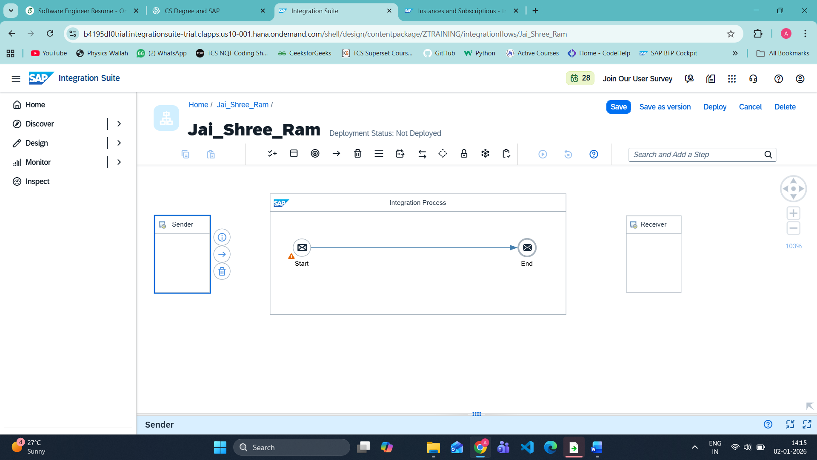

STEP YOU MUST DO NOW
👉 Click the MIDDLE ICON (→ arrow) next to Sender
📌 This arrow icon = Configure / Adapter Settings
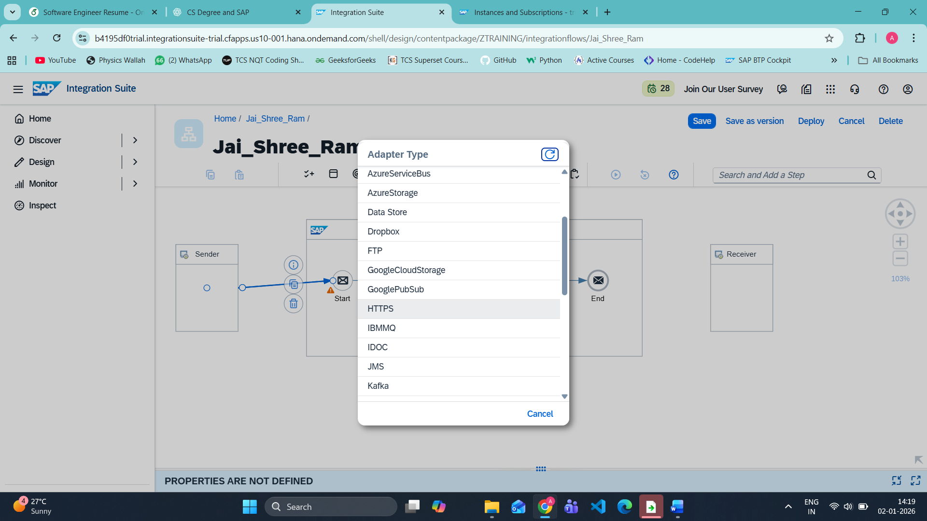

On double clicking https arrow
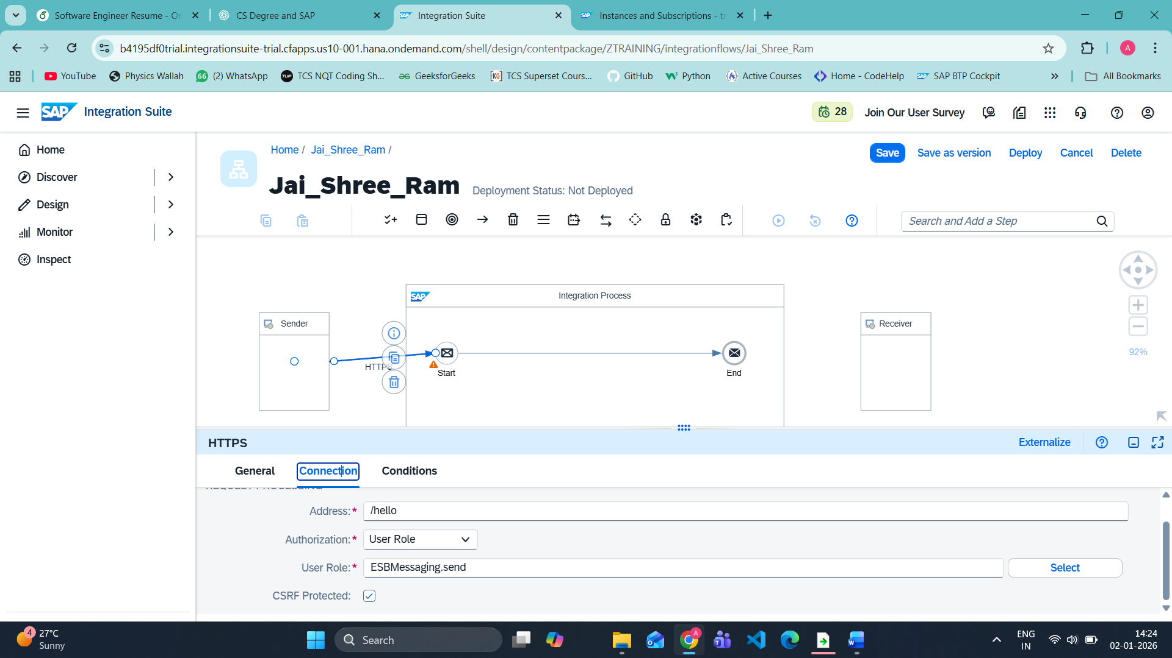

There is no need to find allowed method because it was in http but I am using https now

🧠 WHAT THIS MEANS (VERY IMPORTANT)
- HTTPS sender accepts ALL HTTP methods by default
  - GET
  - POST
  - PUT
  - DELETE
- Method filtering is now expected to be handled:
  - Inside iFlow logic
  - Or by API Management (if used)
This is a real-world CPI change, not a mistake from your side.

STEP 2️⃣ Add Content Modifier
- Click on the arrow
- Click ➕ Add Step
- Choose:
Message Transformers → Content Modifier
You should now see a rectangle block between Start and End.
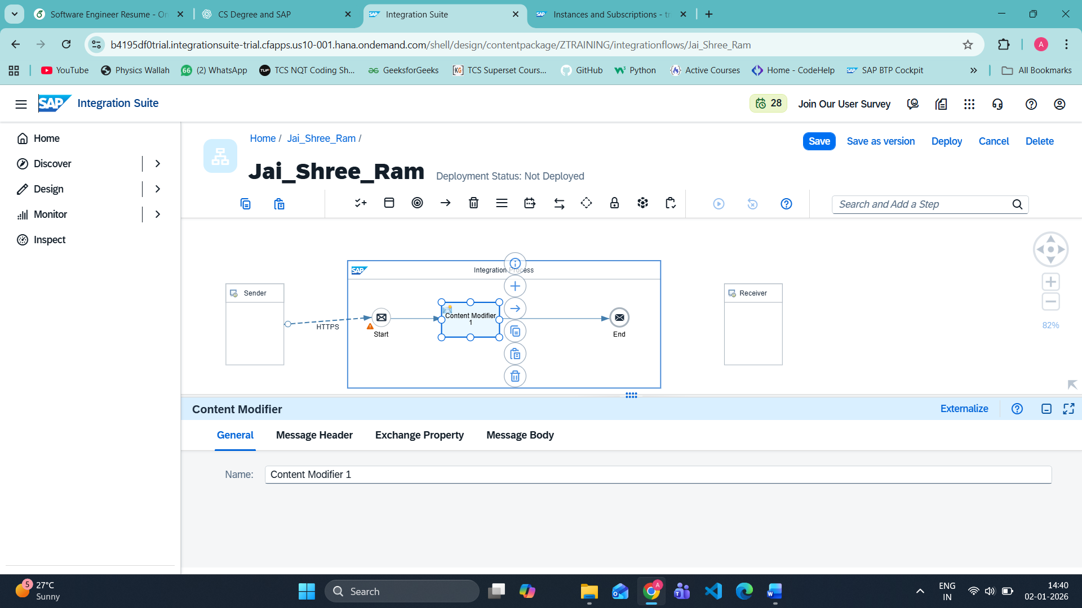

STEP 3️⃣ Configure Content Modifier (MOST IMPORTANT)
- Click Content Modifier
- In bottom pane → go to Message Body tab
- Set values:
Field | Value
Action | Create
Type | Constant
Value | Jai Shree Ram 🙏
- Click Save
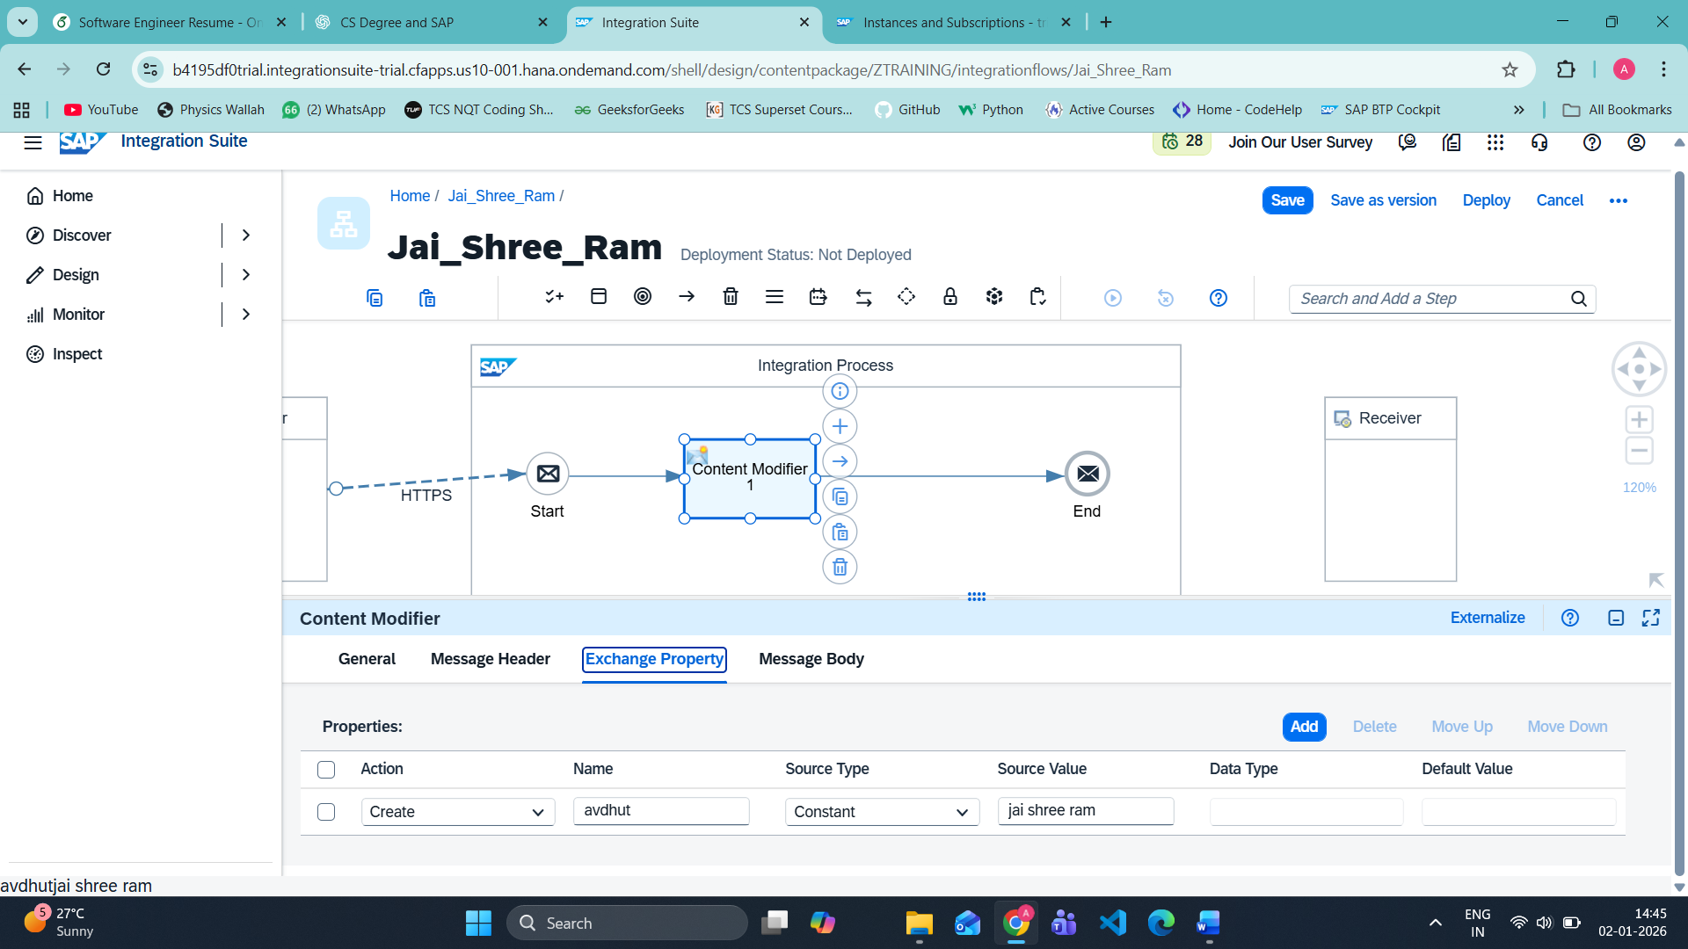

🎯 WHY THIS MATTERS (INTERVIEW GOLD)
- Exchange Property → internal variable (used for routing, conditions, mapping)
- Message Body → actual payload sent to receiver / HTTP response
Interview line:
“Content Modifier can manipulate headers, properties, and message body independently.”

don’t we need to connect end to our receiver ?
🔥 EXCELLENT QUESTION — THIS IS REAL CPI THINKING
Short answer: Not always.
Long answer (important for interviews 👇):

✅ DO WE NEED TO CONNECT End TO Receiver?
🔹 Case 1: HTTPS Sender → Response only (your current iFlow)
👉 NO receiver is required
Why?
- HTTPS Sender works in request–reply mode
- CPI returns response directly to the caller
- End itself sends the response back
✅ Your current flow is 100% correct
Client → HTTPS Sender → Start → Content Modifier → End → Client

🔹 Case 2: Sender → Target system (S/4, API, FTP, etc.)
👉 YES, receiver is mandatory
Example:
HTTPS Sender → iFlow → Receiver (S/4 via HTTP / IDoc / SOAP)
Here:
- CPI forwards data to another system
- Receiver adapter defines where data goes

🧠 RULE TO REMEMBER (INTERVIEW GOLD ⭐)
If CPI is only responding → No receiver needed
If CPI is forwarding data → Receiver is required

🎯 WHY CPI ALLOWS NO RECEIVER
Because CPI supports:
- 🔁 Request–Reply
- 📤 One-way
- 🔄 Async messaging
Your case = Request–Reply

📌 REAL-WORLD EXAMPLES
✔ Without Receiver
- Health check APIs
- Dummy test endpoints
- Token validation
- Static response APIs
✔ With Receiver
- Send Sales Order to S/4
- Push file to FTP
- Call external REST API
- Publish to Kafka / JMS

💡 WHAT YOU CAN SAY IN INTERVIEW
“In CPI, a receiver is not mandatory when using HTTPS sender in request–reply mode. The response is returned directly from the End event. A receiver is only required when CPI forwards the message to another system.”
🔥 This answer shows hands-on knowledge.

🔜 NEXT PRACTICAL STEP (WHEN YOU’RE READY)
- Add HTTPS Receiver
- Call public API
- Do end-to-end system-to-system integration
Just say: “Let’s add a receiver” 🚀

🔥 PRACTICAL 2: HTTPS → HTTPS (REAL RECEIVER)
Goal
Client → CPI → External Public API → CPI → Client
what if i use ftp or http now? To sending side
Interview line ✅
“HTTPS is always preferred in production for secure communication.”

4️⃣ Practical Comparison (VERY IMPORTANT)
Scenario | Adapter
Browser / Postman | HTTPS
Mobile App | HTTPS
SAP Fiori | HTTPS
Night file upload | SFTP
Legacy mainframe | FTP
Real-time API | HTTPS
Large CSV files | FTP/SFTP
skip this for now above

🔷 FINAL FLOW DESIGN
HTTP Sender
↓
Start Event
↓
Content Modifier
↓
End Event (Response)
👉 NO Receiver adapter needed for now
Why?
Because HTTP Sender itself returns the response.

🔴 Important Concept (VERY IMPORTANT)
In CPI, End event automatically sends response back to the HTTP caller
if no receiver is connected.
This is expected behavior, not a mistake.
🎯 Root Cause (Interview-ready line)
SAP CPI does not allow emojis or special Unicode characters in message body or properties because iFlows are compiled into XML artifacts.
🔴 What is the ACTUAL ERROR?
From your screenshot, the key error is:
Character reference "�" is an invalid XML character
✅ Meaning (simple words):
- You used an emoji 🙏 in Content Modifier → Message Body
- CPI internally converts iFlow to XML
- Emojis are NOT valid XML characters
- So build + deploy failed
- Because deploy failed → NO endpoints generated
That’s why you see:
❌ There are no endpoints configured

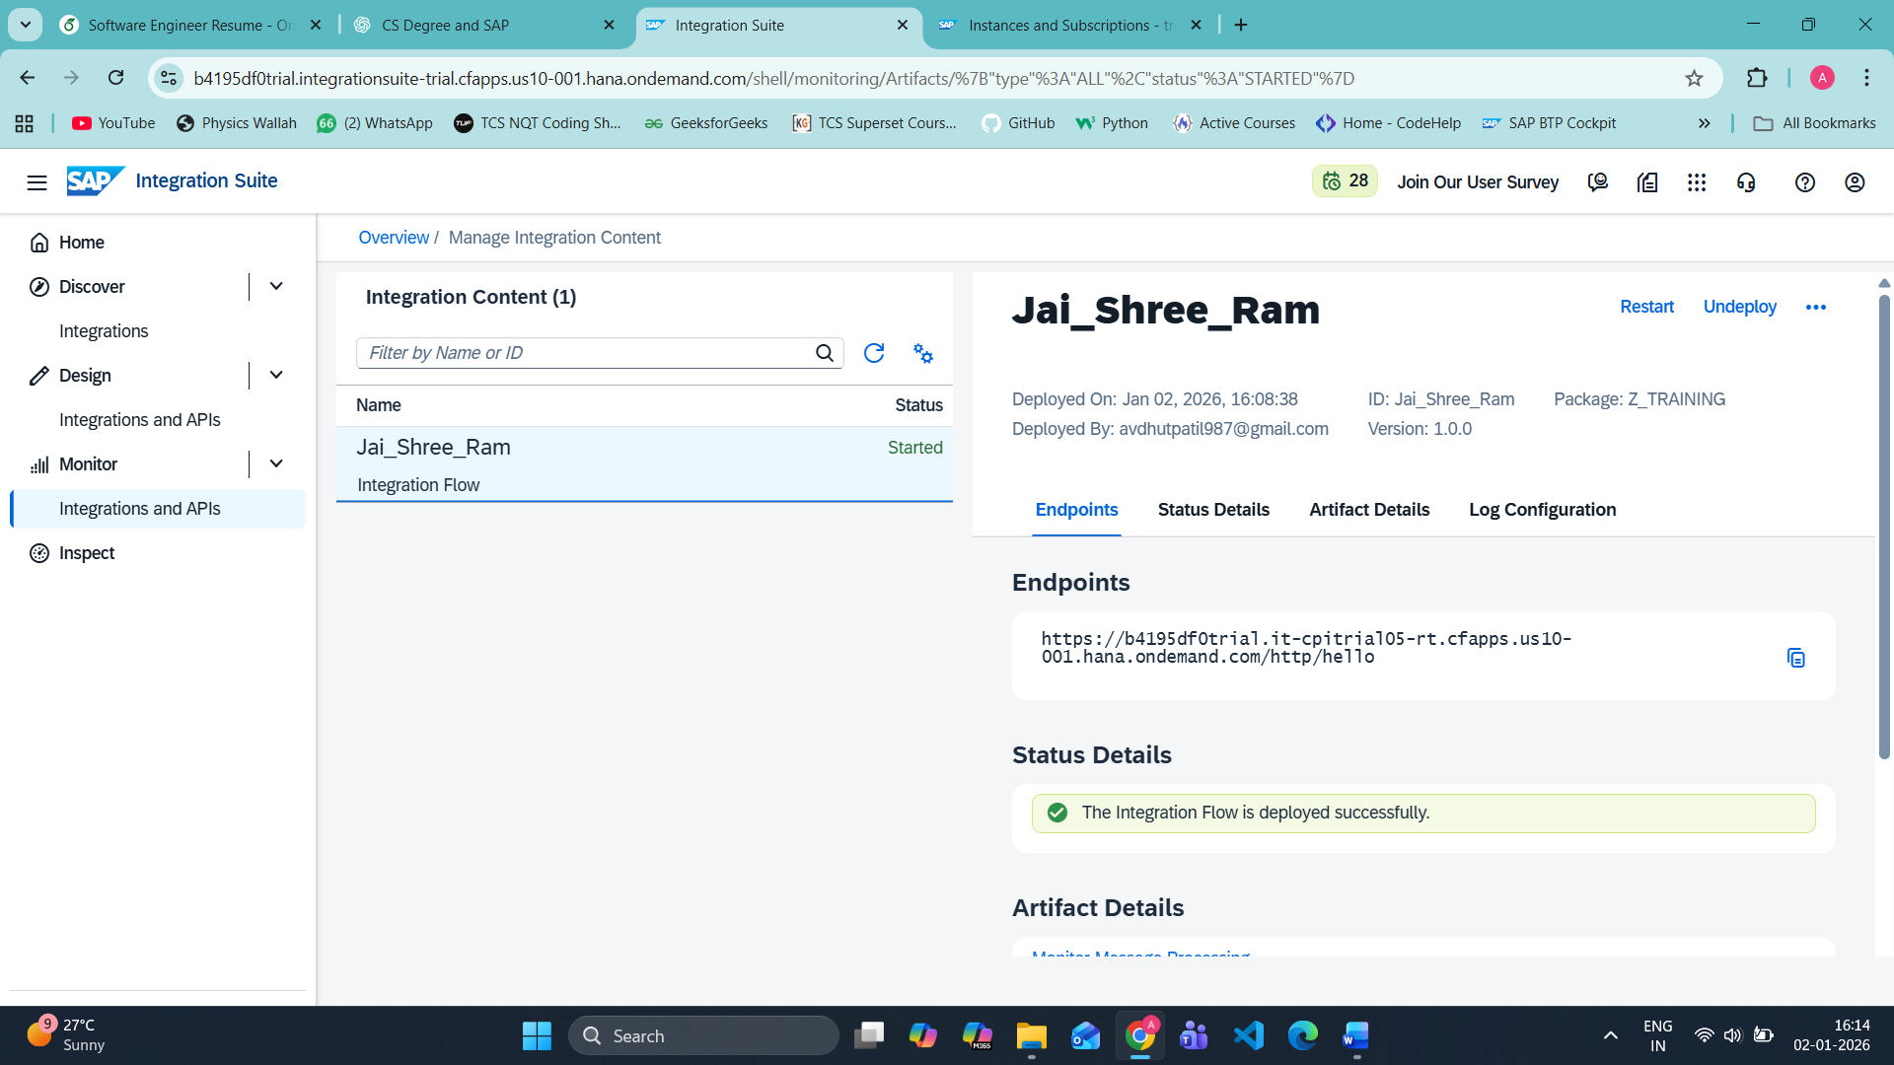

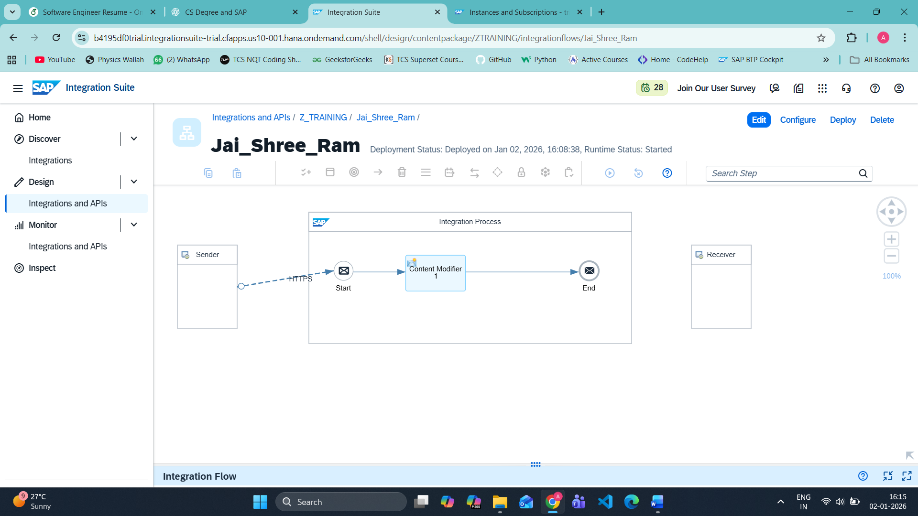

Psw av23
Usn mail
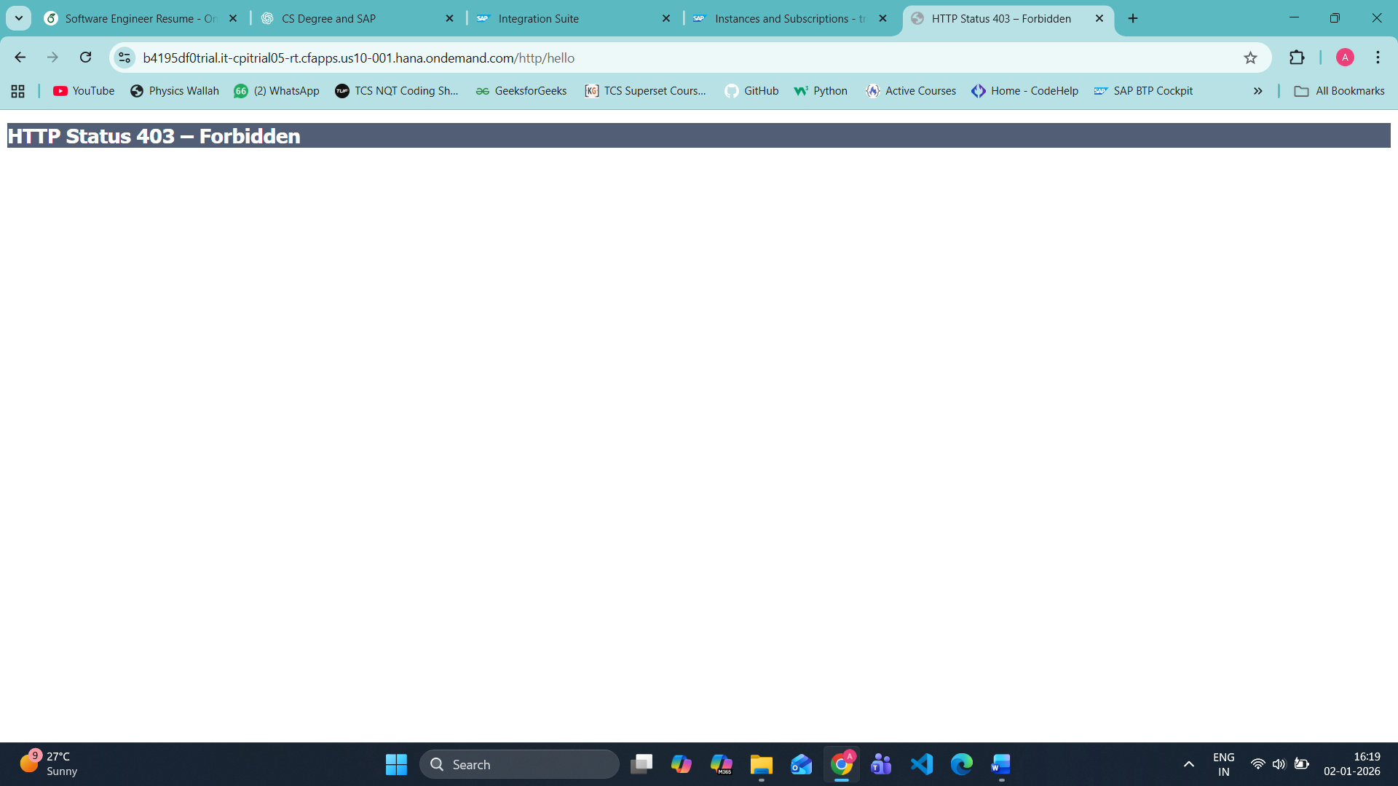

🧠 Interview-Ready Explanation (VERY IMPORTANT)
403 Forbidden in SAP CPI HTTPS adapter occurs when the user calling the endpoint does not have the required role (ESBMessaging.send) assigned in the BTP subaccount.
Say this confidently.

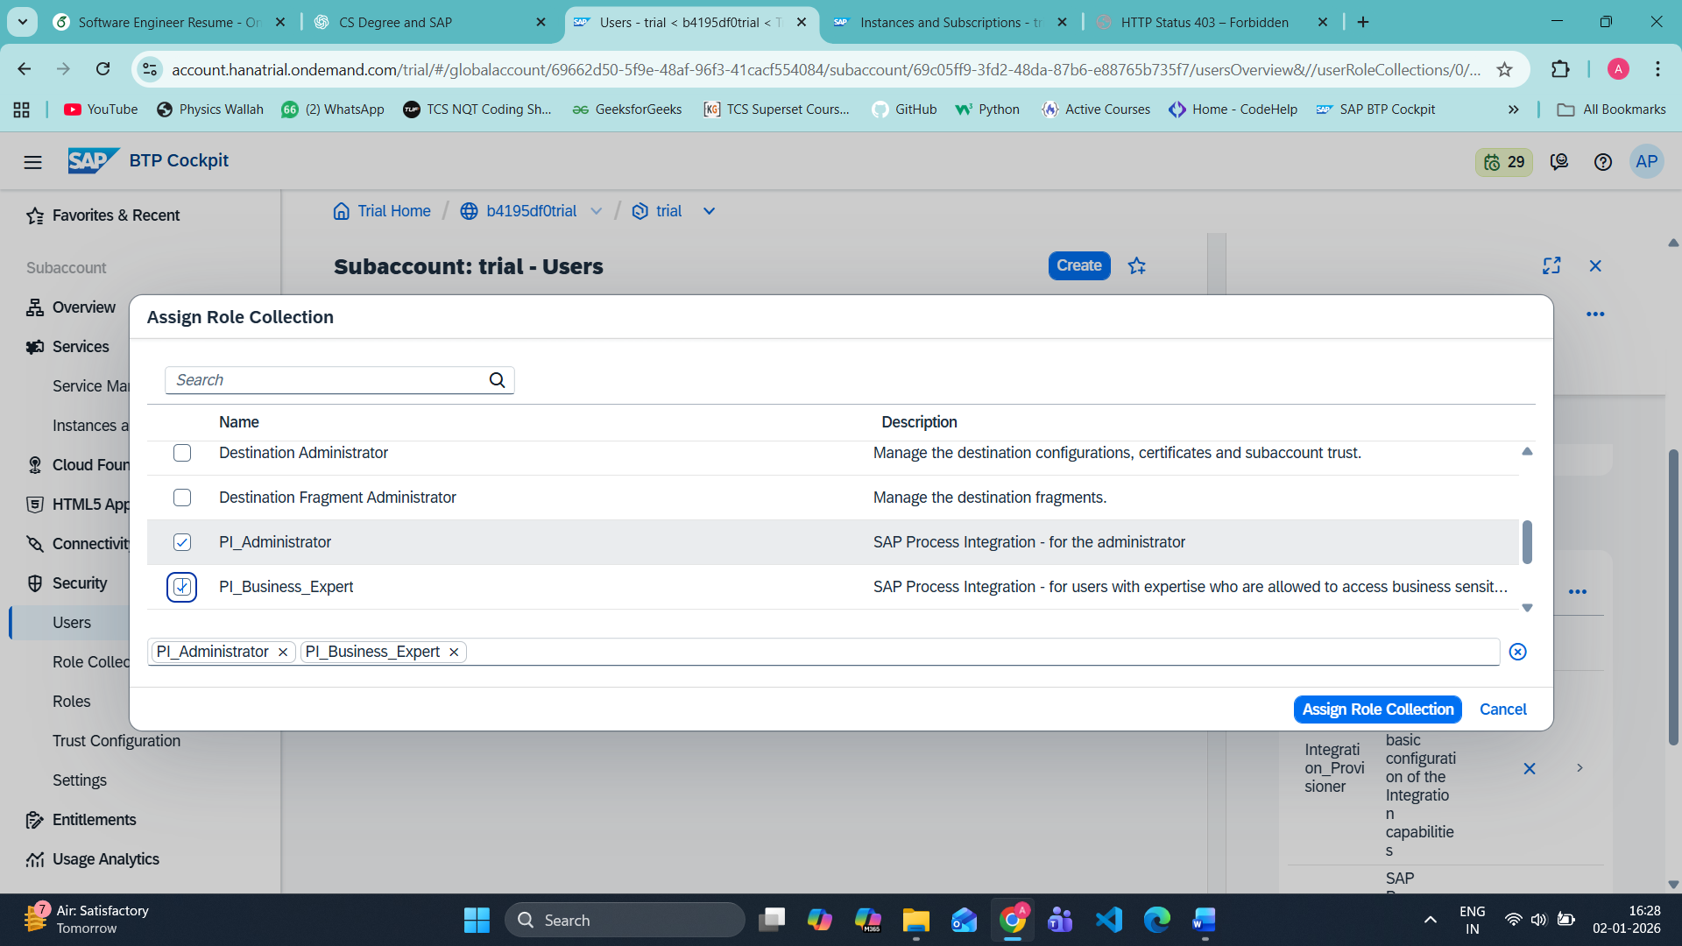

Excellent screenshot 👍
This explains everything. You are not doing anything wrong.
🔴 Why ESBMessaging.send is NOT visible (TRIAL ACCOUNT TRUTH)
In SAP BTP Trial, ESBMessaging.send is NOT exposed as a separate role collection.
👉 This role exists internally, but SAP bundles it inside CPI role collections in Trial.
So searching for ESBMessaging.send will never show it ❌
This is expected behavior in Trial.

How to TEST properly (THIS is the missing step)
❌ Wrong way (you did this)
- Browser → URL → 403 ❌
✅ Correct way (industry practice)
You MUST use Postman / REST Client
Postman settings:
- Method: GET
- URL:
https://<tenant-runtime>/http/hello
Authorization tab:
- Type: Basic Auth
- Username: Your BTP email
- Password: Your BTP password
👉 Click Send
✔ You will get response:
Jai Jai Shree Ram
Welcome to SAP CPI
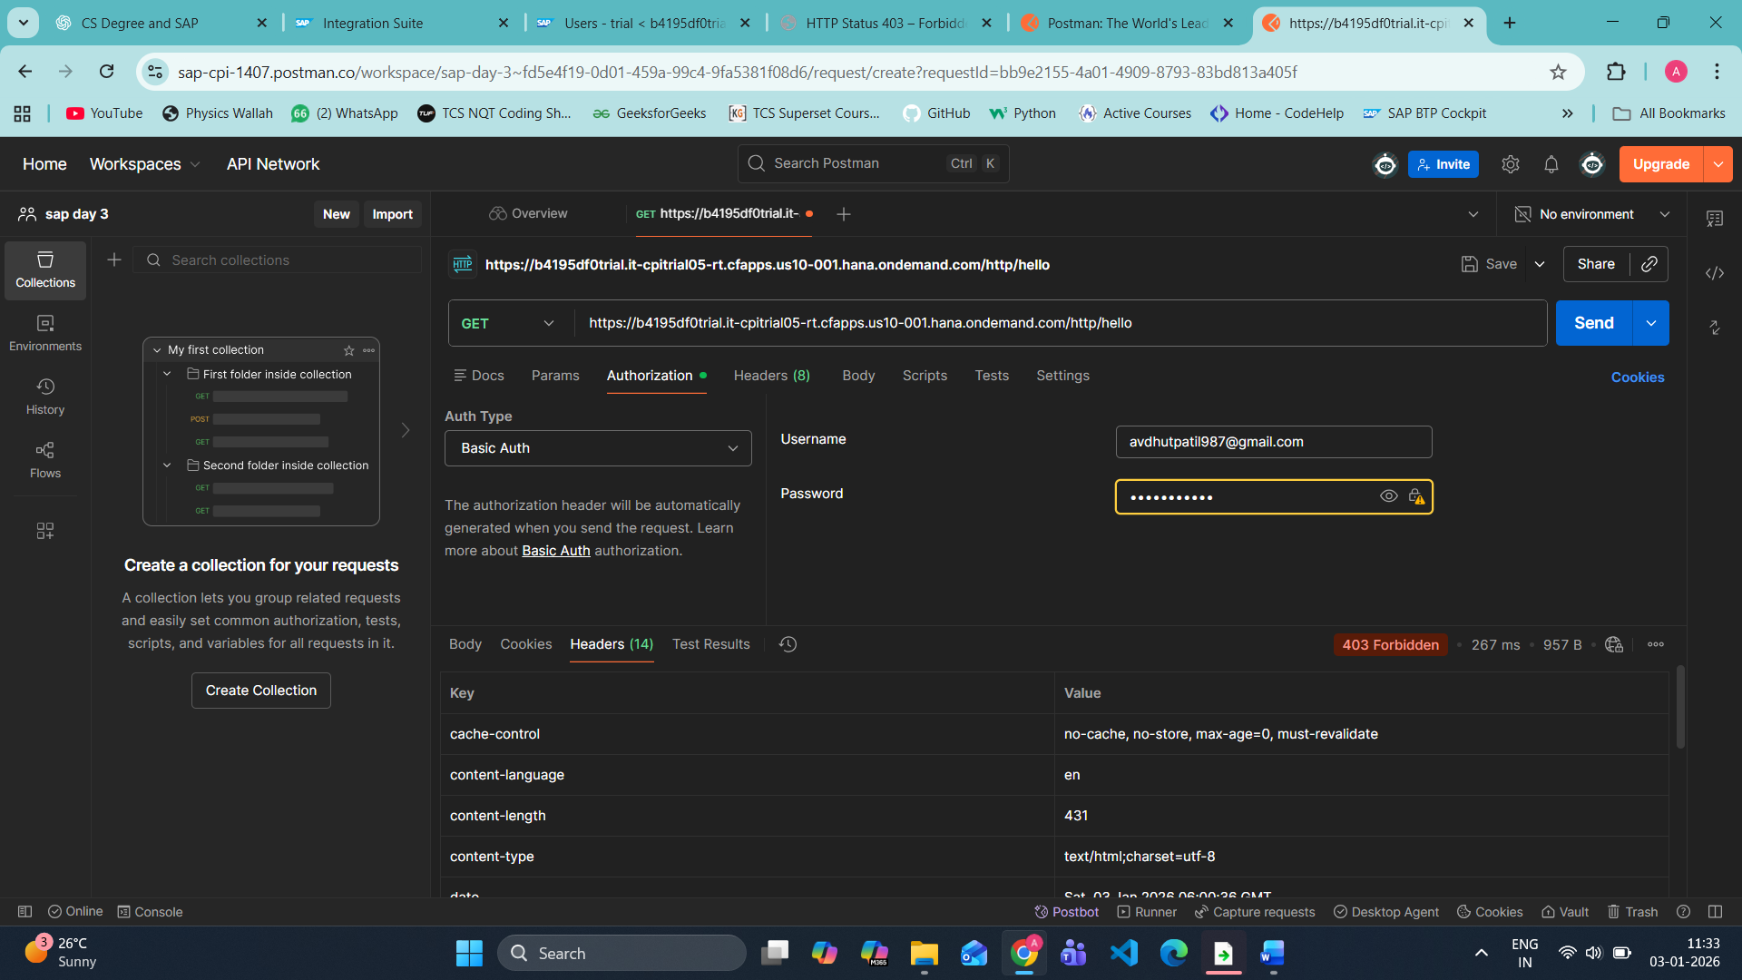
OPTION 2 (ADVANCED / REAL PROJECT WAY)
If you want User Role (what you tried):
You MUST do ALL of this:
1️⃣ Go to IAS7
BTP Cockpit → Security → Trust Configuration → IAS
2️⃣ Create / use IAS user
- Email ≠ automatically allowed
- User must exist in IAS
3️⃣ Assign runtime role
The role name is:
ESBMessaging.send
📌 Important:
- This role does NOT appear in normal BTP role collections list
- It exists in IAS Application → Role Collections

🧠 Interview-ready explanation (VERY IMPORTANT)
Even though PI roles are assigned in BTP Cockpit,
HTTPS sender authentication is enforced by IAS.
Without runtime authorization like ESBMessaging.send,
CPI returns HTTP 403.
