REPORT ON SITE VISIT
TO
SEWAGE TREATMENT PLANT,
SEAWOODS, NAVI MUMBAI
SUBMITTED IN PARTIAL FULFILLMENT OF THE REQUIREMENTS OF
DEGREE OF
BACHELOR OF ENGINEERING
IN
COMPUTER ENGINEERING

DEPARTMENT OF COMPUTER ENGINEERING
TPCT’S
TERNA ENGINEERING COLLEGE
NERUL, NAVI MUMBAI – 400706
UNIVERSITY OF MUMBAI 2025–26

SEWAGE TREATMENT PLANT
Date: 9 October 2025 (Thursday)
Time: 01:00 PM

OBJECTIVE
To study the various units of a sewage treatment plant and understand the chemical and biological processes used for the treatment of sewage wastewater.

INTRODUCTION
Sewage is waste matter such as faeces or dirty water from homes and factories that flows away through sewers. When wastewater is not treated properly, it can pollute water sources, damage natural habitats, and may cause illness. Therefore, sewage treatment is very important.

ABOUT THE SEWAGE TREATMENT PLANT
A 100 MLD Sewage Treatment Plant based on C-Tech technology was visited at Sector 50, Nerul, Navi Mumbai.

LEGENDS
- Wet well of diameter 600 mm
- Primary unit
- Blower room
- C-Tech basins
- Centrifuge
- Sludge and chlorination
- Sub-station

PROCESS OF SEWAGE TREATMENT

1. Drainage Line
Sewage is transported through drainage lines and manholes to the treatment plant.

2. Pump House
The pump house is a chamber for the storage and collection of sewage before it is distributed to other units. The report records 8 pumps, a discharge of 1,250 ml/hr, and a head of 25 m.

3. Screening
Screening is carried out mechanically using a conveyor belt attached to screens. This mechanical screening removes particles and garbage of approximately 6–20 mm present in sewage. The reported duration is 5 minutes.

4. Grit Mechanism
The report notes an aeration stage with 6 basins and a duration of 90 minutes, followed by sedimentation for 30 minutes. During decantation, clear water above the sludge surface is removed. An SBR decanter (Sequence Batch Reactor decanter) is used, operating on gravity.

5. C-Tech Basin
The C-Tech basin provides high treatment efficiency in a single-step biological process. The report mentions filamentous bacteria and notes that if bacteria are absent, the water becomes black and cannot be treated.

6. Chlorine Tank
Chlorination is performed to kill harmful bacteria present in wastewater.

7. Reuse
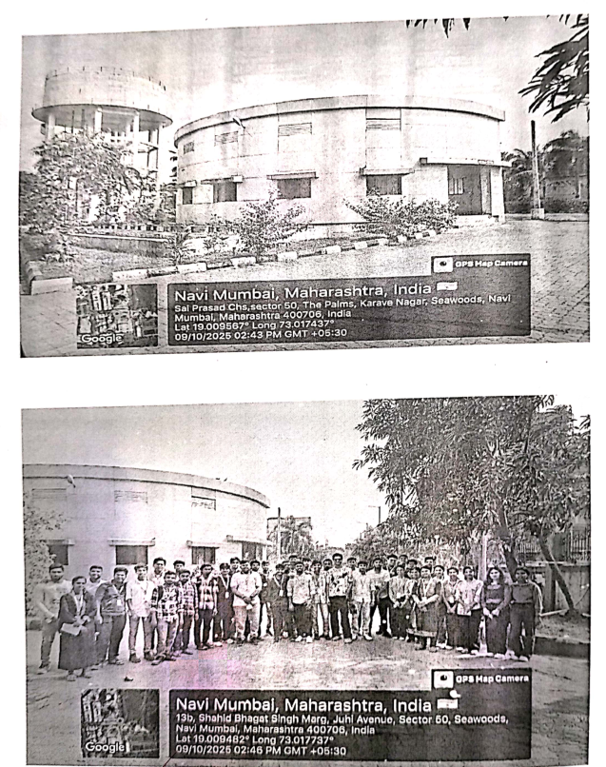
Treated sewage water is obtained as clear water and is reused for 27 gardens and for car-washing purposes.

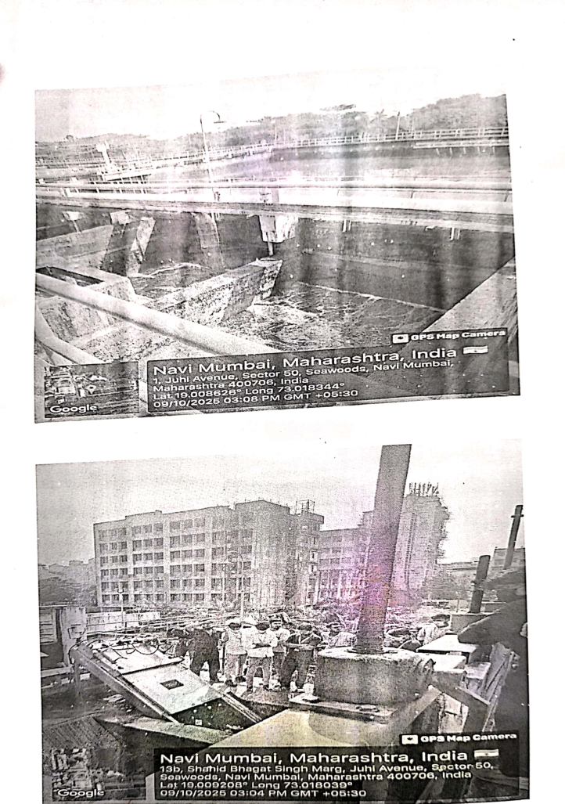

CONCLUSION
The site visit provided an opportunity to observe the major units involved in sewage treatment, including the drainage line, pump house, screening, grit and settling stages, C-Tech basin, chlorination, and reuse of treated water. The visit highlighted the importance of treating wastewater before discharge and the practical value of reusing treated water for purposes such as garden irrigation and car washing.

