Experiment 5
Compute Measures of Central Tendency and Dispersion Using the State-wise Literacy Rate Dataset in R
Aim:To compute and interpret the measures of central tendency and dispersion using the State-wise Literacy Rate in India dataset in R.

Objectives: After completing this experiment, students will be able to:

- Apply statistical techniques using R programming.
- Perform descriptive statistical analysis on real-world datasets.
- Interpret statistical measures for decision making.

Software and Hardware Requirements

  - R Programming
  - RStudio
  - Desktop/Laptop
  - 4 GB RAM

Dataset Used

State-wise Literacy Rate in India (Census 2011) Theory
What is Descriptive Statistics?

Descriptive statistics summarize and describe the characteristics of a dataset. It is mainly divided into:
- Measures of Central Tendency
- Measures of Dispersion

Measures of Central Tendency

Central tendency indicates the central or typical value of a dataset. The three major measures are:
  - Mean
  - Median
  - Mode

Mean (Arithmetic Average)

The mean is calculated by dividing the sum of all observations by the total number of observations.

Formula xˉ=n∑x where:
  - xˉ = Mean
  - ∑x = Sum of observations
  - n = Number of observations

R Function

mean()

Median

The median is the middle value when observations are arranged in ascending order.

If the number of observations is even, the median is the average of the two middle values.

R Function

median()

Mode

The mode is the value that occurs most frequently.

R does not have a built-in mode function, so a custom function is created.

Measures of Dispersion

Dispersion measures the spread or variability of data. The commonly used measures are:
  - Range

  - Variance
  - Standard Deviation
  - Interquartile Range (IQR)

Range

Difference between maximum and minimum values.

Formula Range=Maximum−Minimum R Function
range()

Variance

Measures how far observations are from the mean.

R Function

var()

Standard Deviation

Represents the average spread of observations around the mean.

Formula SD=Variance R Function sd()

Interquartile Range (IQR)

Difference between the third quartile (Q3) and first quartile (Q1).

R Function

IQR()

Applications

  - Government policy planning
  - Educational development analysis
  - Census data analysis
  - Social science research
  - Public administration
  - Comparative state-wise educational studies
  - Economic and demographic analysis

Algorithm

- Start RStudio.
- Import the cleaned literacy dataset.
- Display the dataset.
- Calculate mean.
- Calculate median.
- Calculate mode.
- Calculate minimum and maximum values.
- Calculate range.
- Calculate variance.
- Calculate standard deviation.
- Calculate quartiles and IQR.
- Display summary statistics.
- Stop.

Precautions

- Use the cleaned dataset generated in Experiment 4.
- Ensure the literacy column is numeric.
- Handle missing values before calculations.
- Verify the dataset structure using str().

Save the R script before execution

Procedure

Step 1:Import the cleaned dataset.

literacy <- read.csv("Literacy_Clean.csv")

Step 2: Display first records.

head(literacy)

Step 3:Display structure.

str(literacy)

Program 1: Calculate Mean Literacy Rate

mean(literacy$`X2011`)

Program 2: Calculate Median Literacy Rate

median(literacy$`X2011`)

Program 3: Calculate Mode

getmode <- function(v)
{
uniqv <- unique(v) uniqv[which.max(tabulate(match(v, uniqv)))]
}
getmode(literacy$`X2011`)

Program 4: Calculate Minimum Literacy

min(literacy$`X2011`)

Program 5: Calculate Maximum Literacy

max(literacy$`X2011`)

Program 6: Calculate Range range(literacy$`X2011`) Difference diff(range(literacy$`X2011`))

Program 7: Calculate Variance

var(literacy$`X2011`)

Program 8: Calculate Standard Deviation

sd(literacy$`X2011`)

Program 9: Calculate Quartiles

quantile(literacy$`X2011`)

Program 10: Calculate Interquartile Range

IQR(literacy$`X2011`)

Program 11: Calculate Summary Statistics summary(literacy$`X2011`) Output
Minimum

1st Quartile Median
Mean

3rd Quartile Maximum

Program 12: Compute All Statistics Together

cat("Mean :", mean(literacy$`X2011`), "\n") cat("Median :", median(literacy$`X2011`), "\n")

cat("Minimum :", min(literacy$`X2011`), "\n") cat("Maximum :", max(literacy$`X2011`), "\n") cat("Range :", diff(range(literacy$`X2011`)), "\n") cat("Variance :", var(literacy$`X2011`), "\n") cat("Standard Deviation :", sd(literacy$`X2011`), "\n")
cat("Interquartile Range :", IQR(literacy$`X2011`), "\n")

PART B
PART B: TO BE COMPLETED BY STUDENTS)

(Students must submit the soft copy as per following segments within two hours of the practical. The soft copy must be uploaded on the ERP or emailed to the concerned lab in charge faculties at the end of the practical in case the there is no ERP access available)

Roll No. 76 | Name: Samiksha Bharat Sawant
Class : SE-C | Batch : C2
Date of Experiment: | Date of Submission :
Grade :

Observation: (Run the programs given above in R studio and paste sceenshots of along with the output)
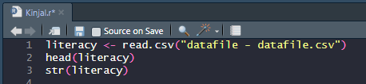

Observation Table:

Observation Table:
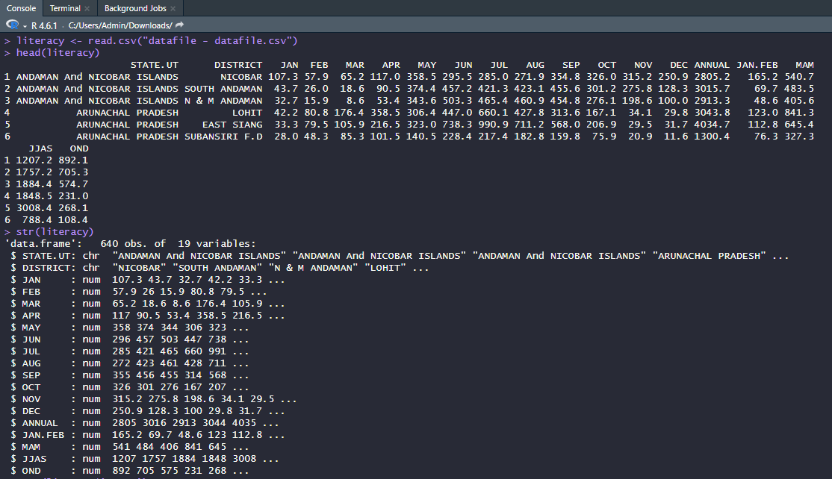

Observation : Paste screenshots of the outputs of above programs mentioned INPUT
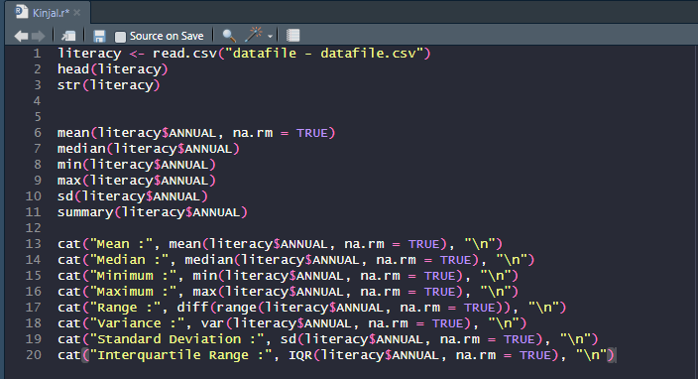

OUTPUTS:
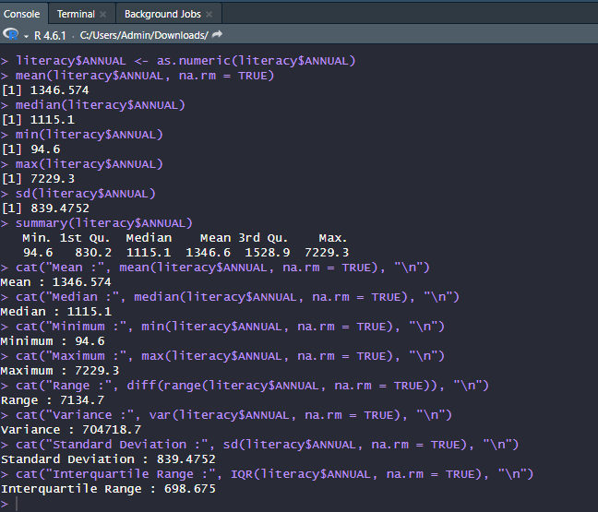

Result: The statistical measures of the ANNUAL literacy data were successfully calculated in R. The mean, median, mode, minimum, maximum, range, variance, standard deviation, quartiles, interquartile range, and summary statistics were generated.

Conclusion: The experiment was completed successfully. R was used to analyze the ANNUAL literacy dataset by calculating measures of central tendency and dispersion, providing a clear summary of the distribution and variability of the literacy values.

Curiosity Questions:

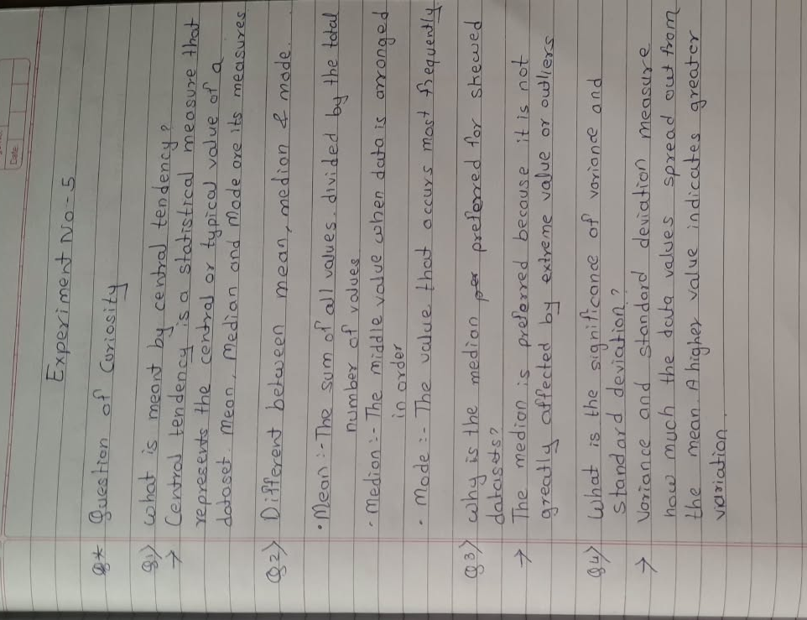



Viva voce Questions:

- What is meant by central tendency?
- Differentiate between mean, median, and mode.
- Why is the median preferred for skewed datasets?
- What is the significance of variance and standard deviation?
- What does the range indicate?
- Explain the importance of the Interquartile Range (IQR).
- Which R functions are used to calculate mean, median, and standard deviation?
- Why is preprocessing necessary before statistical analysis?
- How do outliers affect the mean and standard deviation?
- How can descriptive statistics help policymakers analyze literacy rates across states?

