EXPERIMENT NO. 06

Visualize Datasets Using Bar Chart, Histogram, Pie Chart, and Boxplot

PART A

TO BE REFERRED BY STUDENTS

A.1 Aim
To visualize datasets using bar chart, histogram, pie chart, and boxplot in R and interpret the graphical representation of data.

A.2 Objectives
After successful completion of this experiment, students will be able to:
- Understand the importance of graphical representation of data.
- Create and manipulate datasets in R.
- Create bar charts using R.
- Create histograms for numerical data.
- Create pie charts for categorical data.
- Create boxplots to study data distribution.
- Compare different graphical representations.
- Interpret trends, variations, distributions, and outliers from graphs.

A.3 Prerequisite
- Basic knowledge of R Programming.
- Basic knowledge of RStudio.
- Understanding of variables and data types.
- Basic knowledge of vectors and data frames.
- Basic knowledge of statistical data.
- Familiarity with functions in R.
- Basic understanding of charts and graphs.

A.4 Software Requirements

Hardware Requirements
- Desktop/Laptop computer
- Minimum 4 GB RAM
- Intel Core i3 processor or higher/equivalent
- Keyboard and mouse

Software Requirements
- Windows/Linux/macOS
- R Programming Language
- RStudio IDE

Required R Package
ggplot2
The Applied Statistical Lab syllabus specifies ggplot2 among the required R packages and includes graphical representation of data as part of the course content.

A.5 Theory

1. Introduction to Data Visualization
Data visualization is the process of representing data using graphical forms such as:
- Bar charts
- Histograms
- Pie charts
- Boxplots
- Line graphs
- Scatter plots
Graphical representation makes large amounts of data easier to understand.
For example, consider the following crop production data:
Crop | Production
Rice | 500
Wheat | 400
Cotton | 300
Sugarcane | 600
Maize | 350
Instead of reading the values individually, a bar chart can be used to compare crop production visually.

2. Importance of Data Visualization
Data visualization helps to:
- Identify patterns.
- Compare different categories.
- Understand data distribution.
- Identify extreme values.
- Detect possible outliers.
- Communicate statistical results.
- Support decision-making.
- Perform exploratory data analysis.
The course syllabus specifically emphasizes visualizing and interpreting real-world datasets using statistical tools.

3. ggplot2
ggplot2 is an R package used to create high-quality statistical graphs.
It is based on the Grammar of Graphics.
The general syntax is:
ggplot(data, aes(x = variable, y = value)) +
geom_function()
Example:
ggplot(data, aes(x = Crop, y = Production)) +
geom_col()
Here:
- ggplot() creates the basic plotting system.
- data specifies the dataset.
- aes() defines the variables used in the graph.
- geom_col() creates a bar chart.

4. Bar Chart
A bar chart is used to compare values among different categories.
For example, crop production can be represented using a bar chart.

Example
ggplot(data, aes(x = Crop, y = Production)) +
geom_col()

Uses
Bar charts are useful for:
- Comparing crop production.
- Comparing population among cities.
- Comparing sales among products.
- Comparing AQI among cities.
- Comparing categorical data.

5. Histogram
A histogram is used to represent the frequency distribution of numerical data.
Unlike a bar chart, a histogram groups continuous numerical values into intervals called bins.

Example
ggplot(data, aes(x = Production)) +
geom_histogram()

Uses
Histograms help to understand:
- Distribution of values.
- Frequency.
- Spread of data.
- Concentration of observations.
- Possible skewness.

6. Pie Chart
A pie chart represents data as parts of a whole.
Each category is represented by a slice.
For example, crop production percentages can be displayed using a pie chart.
In ggplot2, a pie chart can be created using a bar chart transformed into polar coordinates.

Example
ggplot(data, aes(x = "", y = Production, fill = Crop)) +
geom_col() +
coord_polar("y")

Uses
Pie charts are useful when:
- There are only a few categories.
- Categories represent parts of one total.
- Percentage/share comparison is required.

7. Boxplot
A boxplot, also known as a box-and-whisker plot, represents the distribution of numerical data.
It provides information about:
- Minimum value
- First quartile (Q1)
- Median
- Third quartile (Q3)
- Maximum value
- Possible outliers
A boxplot is especially useful for comparing distributions between different groups.

Example
ggplot(data, aes(x = Crop, y = Production)) +
geom_boxplot()

8. Components of a Boxplot
A typical boxplot contains:
Maximum
|
────┤
|
┌─────────┐
│ │
│ Median │
│ │
└─────────┘
|
────┤
|
Minimum
The box represents the interquartile range (IQR).
The median is represented by a line inside the box.
Observations lying far from the main distribution may appear as outliers.9. Difference Between Bar Chart and Histogram
Bar Chart | Histogram
Used mainly for categorical data | Used for numerical data
Bars represent categories | Bars represent numerical intervals
Bars usually have spaces | Bars generally touch each other
Used for comparison | Used to study distribution
Example: crop-wise production | Example: production frequency

10. Difference Between Pie Chart and Bar Chart
Pie Chart | Bar Chart
Shows parts of a whole | Compares categories
Uses slices | Uses rectangular bars
Best for few categories | Can handle more categories
Shows proportions | Shows magnitude
Percentages are commonly used | Actual values can be shown

11. Difference Between Histogram and Boxplot
Histogram | Boxplot
Shows frequency distribution | Shows summary of distribution
Uses bins | Uses quartiles
Shows shape of distribution | Shows median and spread
Useful for distribution shape | Useful for group comparison
Outliers may be difficult to identify | Outliers can be easily identified

A.6 Dataset Used
For this experiment, an agriculture dataset is used.
The dataset contains information about:
- Crop
- Production
- Area
- Yield

Sample Dataset
Crop | Production | Area | Yield
Rice | 500 | 100 | 5.0
Wheat | 400 | 80 | 5.0
Maize | 350 | 70 | 5.0
Cotton | 300 | 90 | 3.3
Sugarcane | 600 | 120 | 5.0
Soybean | 250 | 75 | 3.3
Groundnut | 280 | 70 | 4.0
Pulses | 220 | 60 | 3.7
Jowar | 180 | 50 | 3.6
Bajra | 160 | 45 | 3.6

A.7 Algorithm

Algorithm for Data Visualization
- Start RStudio.
- Install the ggplot2 package if required.
- Load the ggplot2 library.
- Create the agriculture dataset.
- Store the data in a data frame.
- Display the dataset.
- Create a bar chart to compare crop production.
- Create a histogram to study the distribution of production.
- Create a pie chart to show the contribution of each crop to total production.
- Create a boxplot to analyze the distribution of production.
- Add suitable titles and axis labels.
- Execute the program.
- Observe and interpret the generated graphs.
- Save screenshots of the output.
- Stop.

A.8 Important R Functions Used
Function | Purpose
ggplot() | Initializes a graph
aes() | Defines graphical mapping
geom_col() | Creates a bar chart
geom_histogram() | Creates a histogram
coord_polar() | Converts a bar chart into a pie chart
geom_boxplot() | Creates a boxplot
labs() | Adds titles and labels
theme_minimal() | Applies a simple theme
summary() | Gives statistical summary
head() | Displays first observations

PART B

TO BE COMPLETED BY STUDENTS
Roll No. 76 | Name: Samiksha Bharat Sawant
Class : S.E. - C | Batch : C2
Date of Experiment: | Date of Submission
Grade :

B.1 Program Code
#--------------------------------------------------
# EXPERIMENT NO. 06
# VISUALIZATION USING BAR CHART, HISTOGRAM,
# PIE CHART AND BOXPLOT
#--------------------------------------------------

# Install ggplot2 if required
# install.packages("ggplot2")

# Load library
library(ggplot2)

#--------------------------------------------------
# CREATE AGRICULTURE DATASET
#--------------------------------------------------

agri_data <- data.frame(
Crop = c(
"Rice",
"Wheat",
"Maize",
"Cotton",
"Sugarcane",
"Soybean",
"Groundnut",
"Pulses",
"Jowar",
"Bajra"
),

Production = c(
500,
400,
350,
300,
600,
250,
280,
220,
180,
160
),

Area = c(
100,
80,
70,
90,
120,
75,
70,
60,
50,
45
),

Yield = c(
5.0,
5.0,
5.0,
3.3,
5.0,
3.3,
4.0,
3.7,
3.6,
3.6
)
)

# Display dataset
print(agri_data)

# Display first observations
head(agri_data)

# Display summary
summary(agri_data)

#--------------------------------------------------
# 1. BAR CHART
# Crop-wise Production
#--------------------------------------------------

ggplot(
agri_data,
aes(x = Crop, y = Production)
) +
geom_col() +
labs(
title = "Crop-wise Agricultural Production",
x = "Crop",
y = "Production"
) +
theme_minimal()

#--------------------------------------------------
# 2. HISTOGRAM
# Distribution of Production
#--------------------------------------------------

ggplot(
agri_data,
aes(x = Production)
) +
geom_histogram(
bins = 5
) +
labs(
title = "Distribution of Agricultural Production",
x = "Production",
y = "Frequency"
) +
theme_minimal()

#--------------------------------------------------
# 3. PIE CHART
# Crop-wise Share of Production
#--------------------------------------------------

ggplot(
agri_data,
aes(
x = "",
y = Production,
fill = Crop
)
) +
geom_col() +
coord_polar("y") +
labs(
title = "Crop-wise Share of Total Production"
) +
theme_void()

#--------------------------------------------------
# 4. BOXPLOT
# Distribution of Production
#--------------------------------------------------

ggplot(
agri_data,
aes(
x = "Agricultural Crops",
y = Production
)
) +
geom_boxplot() +
labs(
title = "Boxplot of Agricultural Production",
x = "",
y = "Production"
) +
theme_minimal()

#--------------------------------------------------
# 5. BOXPLOT
# Yield Distribution
#--------------------------------------------------

ggplot(
agri_data,
aes(
x = "Agricultural Crops",
y = Yield
)
) +
geom_boxplot() +
labs(
title = "Boxplot of Crop Yield",
x = "",
y = "Yield"
) +
theme_minimal()

B.2 Expected Output
The program generates the following visualizations.

Output 1: Bar Chart
Title: Crop-wise Agricultural Production
The bar chart displays production values for different crops.

Interpretation
The graph makes it easy to compare production among different crops. In the given sample data, sugarcane has the highest production value, while bajra has the lowest.
Input:-
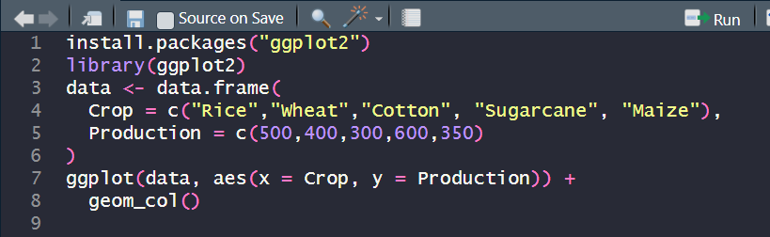

Output:-
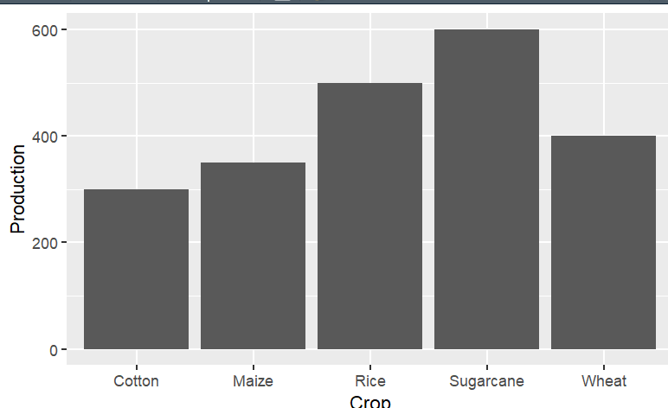

Output 2: Histogram
Title: Distribution of Agricultural Production
The histogram represents the frequency distribution of production values.

Interpretation
The histogram helps understand how the production observations are distributed across different ranges.
Input:-
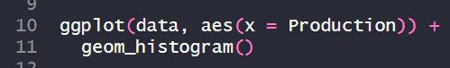
Output:-
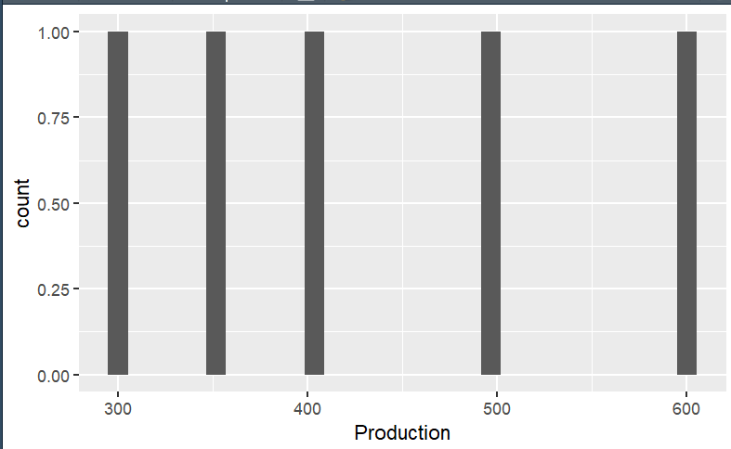

Output 3: Pie Chart
Title: Crop-wise Share of Total Production
The pie chart represents the contribution of each crop to the total production.

Interpretation
Each slice represents the proportion of total production contributed by a particular crop.

Input:-
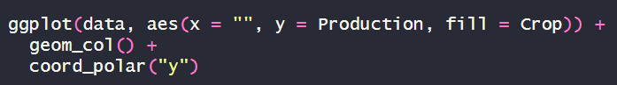
Output:-
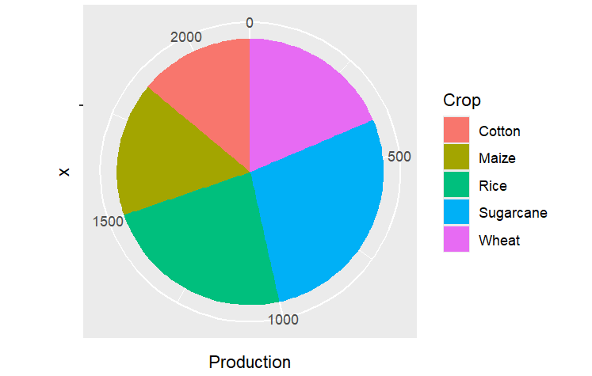

Output 4: Boxplot
Title: Boxplot of Agricultural Production
The boxplot summarizes the distribution of production values.

Interpretation
The boxplot displays the median, quartiles, spread, and possible outliers in the production data.
Input:-
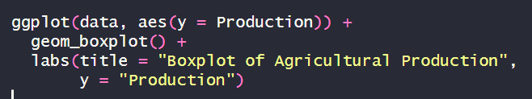
Output:-
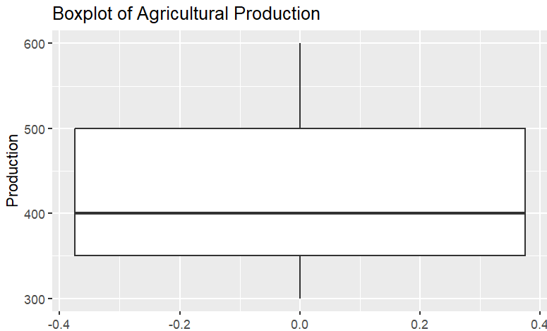

Output 5: Yield Boxplot
Title: Boxplot of Crop Yield
This graph represents the distribution of crop yield.

Interpretation
The boxplot can be used to study the spread and variation in yield values.
Input:-
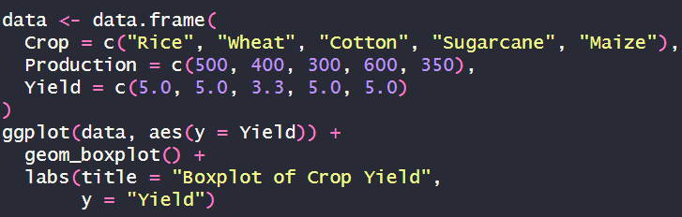
Output:-
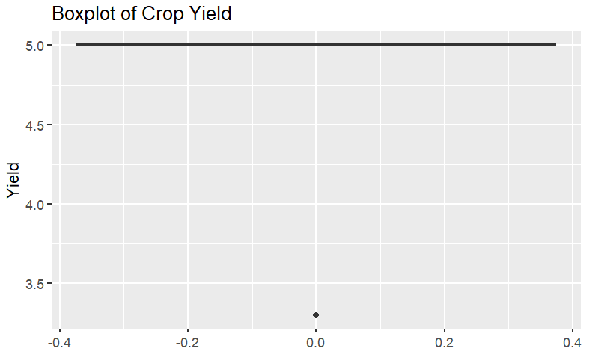

B.3 Observation
Sr. No. | Visualization | Observation
1 | Bar Chart | Crop-wise production was compared successfully.
2 | Histogram | Distribution of agricultural production was visualized.
3 | Pie Chart | Contribution of each crop to total production was represented.
4 | Boxplot | Distribution and spread of production were analyzed.
5 | Yield Boxplot | Variation in crop yield was represented.

B.4 Observation Table
Graph | Variable | Purpose | Result
Bar Chart | Crop & Production | Compare crop production | Successfully visualized
Histogram | Production | Study frequency distribution | Successfully visualized
Pie Chart | Crop & Production | Show production share | Successfully visualized
Boxplot | Production | Study spread and outliers | Successfully visualized
Boxplot | Yield | Study yield variation | Successfully visualized

B.5 Result
The agriculture dataset was successfully visualized in R using bar chart, histogram, pie chart, and boxplot.
The bar chart was used to compare crop-wise production, the histogram was used to understand the distribution of production values, the pie chart represented the contribution of each crop to total production, and the boxplot was used to study the spread and variation of the dataset.
Thus, the experiment demonstrated the practical application of graphical data visualization techniques for statistical data analysis.

B.6 Applications
The visualization techniques used in this experiment can be applied to:
- Agricultural production analysis.
- Crop yield comparison.
- Smart city data analysis.
- Air quality analysis.
- Population analysis.
- Traffic analysis.
- Healthcare data analysis.
- Business and sales analysis.
- Environmental data analysis.
- Financial data analysis.
- Exploratory data analysis.
- Statistical reporting.
- AI and machine learning data analysis.
- Decision-making and planning.
The syllabus identifies data visualization and interpretation of analytical results as an important laboratory outcome.

B.7 Precautions
- Ensure that ggplot2 is installed and loaded correctly.
- Check the dataset before visualization.
- Ensure numerical variables are stored in numeric format.
- Select an appropriate graph according to the type of data.
- Use histograms for numerical distributions.
- Use bar charts for categorical comparisons.
- Use pie charts only when categories represent meaningful parts of a whole.
- Add meaningful titles and axis labels.
- Select a suitable number of histogram bins.
- Check boxplots for possible outliers.
- Verify the generated graph before recording the result.
- Save the R program and screenshots of all outputs.

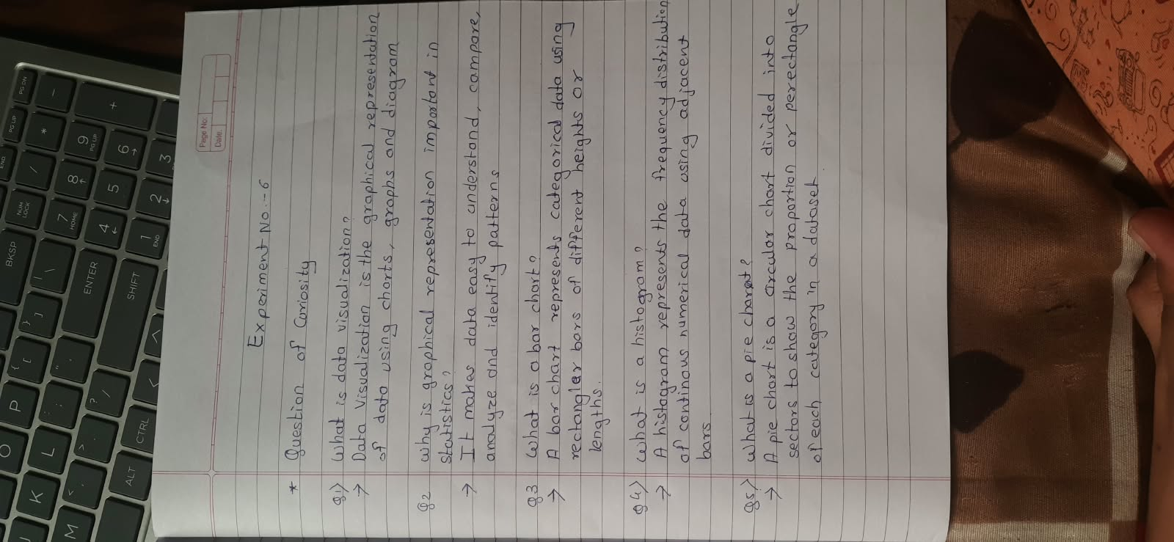
B.8 Questions of Curiosity

B.9 Viva Voce Questions
- What is R?
- What is RStudio?
- What is ggplot2?
- How do you install ggplot2?
- How do you load ggplot2?
- What is the purpose of ggplot()?
- What is aes()?
- What is a geom?
- Which function is used to create a bar chart?
- Which function is used to create a histogram?
- Which function is used to create a boxplot?
- How is a pie chart created in ggplot2?
- What is coord_polar()?
- What is the difference between geom_bar() and geom_col()?
- What does a histogram show?
- What does a boxplot show?
- What is Q1?
- What is Q3?
- What is IQR?
- What is an outlier?
- Why are graphs useful in statistical analysis?
- Which graph is suitable for comparing categories?
- Which graph is suitable for showing data distribution?
- Which graph can be used to show parts of a whole?
- Which graph is useful for identifying outliers?
- Give two applications of data visualization in agriculture.
- Give two applications of data visualization in smart cities.
- Why should graphs have proper labels?
- What is exploratory data analysis?
- How can visualization help in decision-making?

