EXPERIMENT NO. 07

Implement Probability Experiments Using R

PART A

TO BE REFERRED BY STUDENTS

A.1 Aim
To implement basic probability experiments using R Programming and understand probability through simulation and computational methods.

A.2 Objectives
After successful completion of this experiment, students will be able to:
- Understand the basic concepts of probability.
- Define sample space and events.
- Calculate experimental probability using R.
- Simulate coin-tossing experiments.
- Simulate dice-rolling experiments.
- Calculate probabilities of different events.
- Compare theoretical probability with experimental probability.
- Understand the effect of increasing the number of trials.
- Apply probability concepts to real-world problems.

A.3 Prerequisite
Students should have basic knowledge of:
- R Programming Language.
- RStudio IDE.
- Variables and data types.
- Vectors in R.
- Conditional statements.
- Basic arithmetic operations.
- Random number generation.
- Basic concepts of probability.

A.4 Software Requirements

Hardware Requirements
- Desktop/Laptop computer
- Minimum 4 GB RAM
- Intel Core i3 processor or higher/equivalent
- Keyboard and mouse

Software Requirements
- Windows/Linux/macOS
- R Programming Language
- RStudio IDE

Required Packages
No external package is required for the basic probability experiments.
The experiment can be performed using built-in R functions such as:
sample()
runif()
sum()
mean()
The syllabus includes probability concepts, conditional probability, Bayes theorem, random variables, and probability distributions as part of the probability module.

A.5 Theory

1. Introduction to Probability
Probability is a mathematical measure of the likelihood that an event will occur.
The value of probability lies between 0 and 1.
0 ≤ P(A) ≤ 1
Where:
- P(A) = 0 means the event is impossible.
- P(A) = 1 means the event is certain.
- Values between 0 and 1 indicate different levels of likelihood.
For example, when a fair coin is tossed:
- Probability of getting Head = 1/2
- Probability of getting Tail = 1/2

2. Random Experiment
A random experiment is an experiment whose outcome cannot be predicted with certainty before the experiment is performed.
Examples:
- Tossing a coin.
- Rolling a die.
- Drawing a card from a deck.
- Selecting a student randomly.
- Selecting a product from a production line.

3. Sample Space
The sample space is the set of all possible outcomes of a random experiment.
It is generally represented by S.

Example: Tossing a Coin
The possible outcomes are:
S = {Head, Tail}
Therefore:
Number of possible outcomes = 2

4. Event
An event is a subset of the sample space.
For example, when a die is rolled:
S = {1, 2, 3, 4, 5, 6}
Event A = getting an even number.
A = {2, 4, 6}

5. Theoretical Probability
For equally likely outcomes:
P(A) = Number of favourable outcomes / Total number of possible outcomes

Example
When a fair die is rolled, probability of getting an even number is:
Favourable outcomes:
{2, 4, 6}
Number of favourable outcomes = 3
Total outcomes = 6
Therefore:
P(Even) = 3/6 = 0.5

6. Experimental Probability
Experimental probability is calculated from the results obtained after performing an experiment multiple times.
Experimental Probability =
Number of times event occurs / Total number of trials
For example, if a coin is tossed 100 times and Head occurs 53 times:
Experimental Probability of Head = 53/100
= 0.53
As the number of trials increases, experimental probability generally tends to approach theoretical probability.

7. Probability Using R
R provides several functions that can be used for probability experiments.

sample()
The sample() function is used to randomly select values.
Example:
sample(c("Head", "Tail"), 10, replace = TRUE)
This simulates 10 coin tosses.

runif()
The runif() function generates random numbers from a uniform distribution.
Example:
runif(10)
It generates 10 random numbers between 0 and 1.

sum()
The sum() function can be used to count the number of times a logical condition is TRUE.
Example:
sum(tosses == "Head")

mean()
The mean() function can be used to calculate experimental probability when logical values are used.
Example:
mean(tosses == "Head")
TRUE is treated as 1 and FALSE as 0.

8. Coin Toss Experiment
Consider a fair coin.
Possible outcomes:
Head, Tail
Theoretical probability:
P(Head) = 0.5
P(Tail) = 0.5
We can simulate 1000 coin tosses using R.
tosses <- sample(
c("Head", "Tail"),
1000,
replace = TRUE
)
The number of Heads can be calculated using:
sum(tosses == "Head")
Experimental probability:
mean(tosses == "Head")

9. Dice-Rolling Experiment
A standard die has six possible outcomes:
1, 2, 3, 4, 5, 6
The probability of obtaining a particular number is:
1/6
We can simulate dice rolls using:
dice <- sample(
1:6,
1000,
replace = TRUE
)
The number of times 6 occurs can be calculated using:
sum(dice == 6)
Experimental probability:
mean(dice == 6)
The result should be close to:
1/6 ≈ 0.1667

10. Probability of an Even Number
For a die:
S = {1,2,3,4,5,6}
Even numbers:
{2,4,6}
Therefore:
P(Even) = 3/6 = 0.5
In R:
mean(dice %% 2 == 0)

11. Probability of Getting a Number Greater Than 4
The favourable outcomes are:
{5,6}
Therefore:
P(X > 4) = 2/6 = 0.3333
In R:
mean(dice > 4)

12. Theoretical vs Experimental Probability
Theoretical probability is calculated mathematically before conducting the experiment.
Experimental probability is obtained from actual observations.
Theoretical Probability | Experimental Probability
Based on mathematical calculation | Based on experiment
Does not require actual trials | Requires actual trials
Fixed for a given model | Can vary from experiment to experiment
Example: P(Head) = 0.5 | Example: 0.48 after 1000 tosses
With a sufficiently large number of trials, experimental probability tends to become closer to theoretical probability.

A.6 Probability Experiments Performed
The following experiments are implemented in R:

Experiment 1: Coin Toss
Calculate the probability of getting Head and Tail.

Experiment 2: Dice Roll
Calculate the probability of obtaining:
- 1
- 6
- An even number
- A number greater than 4

Experiment 3: Comparison
Compare theoretical and experimental probabilities.

A.7 Algorithm

Algorithm for Probability Experiment Using Coin Toss
- Start RStudio.
- Define the possible outcomes as Head and Tail.
- Set the number of trials.
- Use sample() to simulate coin tosses.
- Count the number of Heads.
- Count the number of Tails.
- Calculate experimental probabilities.
- Compare the results with theoretical probabilities.
- Display the results.
- Stop.

Algorithm for Probability Experiment Using Dice
- Define possible outcomes from 1 to 6.
- Set the number of trials.
- Use sample() to simulate dice rolls.
- Count the occurrences of required outcomes.
- Calculate experimental probabilities.
- Compare experimental probabilities with theoretical probabilities.
- Display the results.
- Stop.

A.8 Important R Functions Used
Function | Purpose
sample() | Generates random samples
c() | Creates a vector
sum() | Counts TRUE conditions
mean() | Calculates experimental probability
table() | Counts frequency of outcomes
round() | Rounds numerical values
print() | Displays output
set.seed() | Makes random results reproducible

PART B

PART B: TO BE COMPLETED BY STUDENTS)
(Students must submit the soft copy as per following segments within two hours of the practical. The soft copy must be uploaded on the ERP or emailed to the concerned lab in charge faculties at the end of the practical in case the there is no ERP access available)
Roll No. CO-63 | Name: Mayuresh Rajesh Shelke
Class : SE-C | Batch : C2
Date of Experiment: | Date of Submission
Grade :

Observation: (Run the programs given above in R studio and paste screenshots of along with the output)

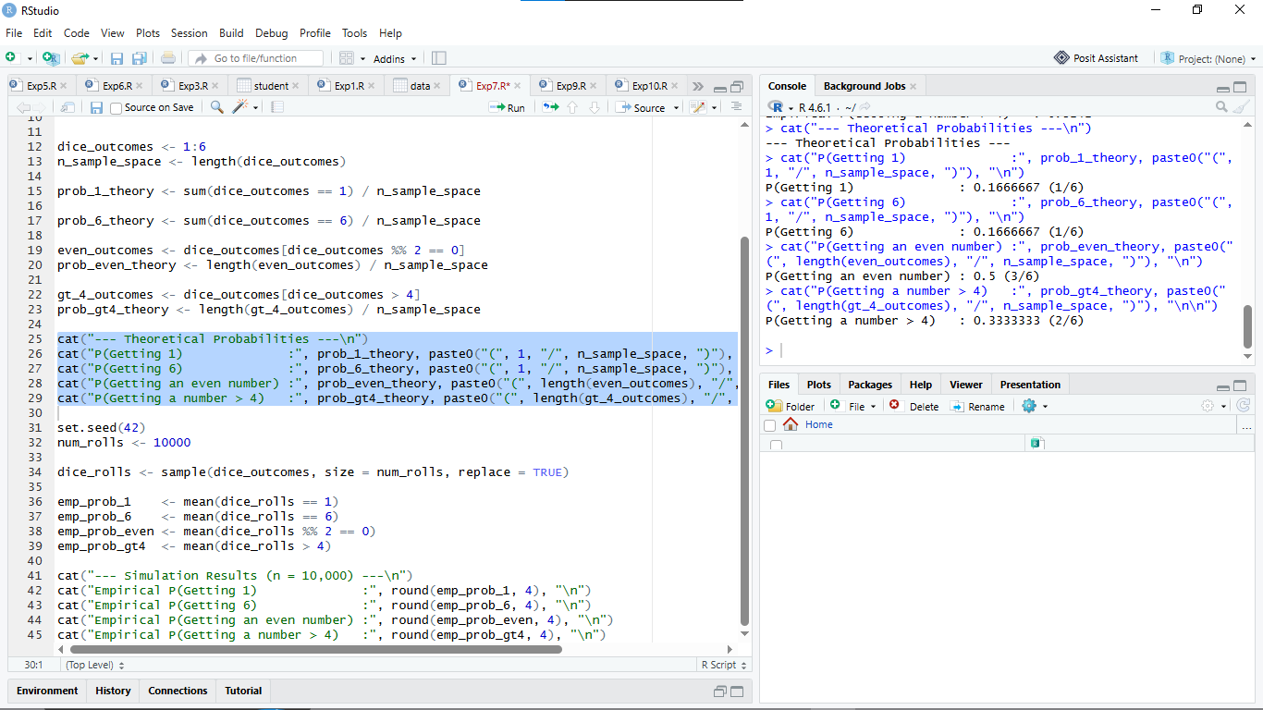

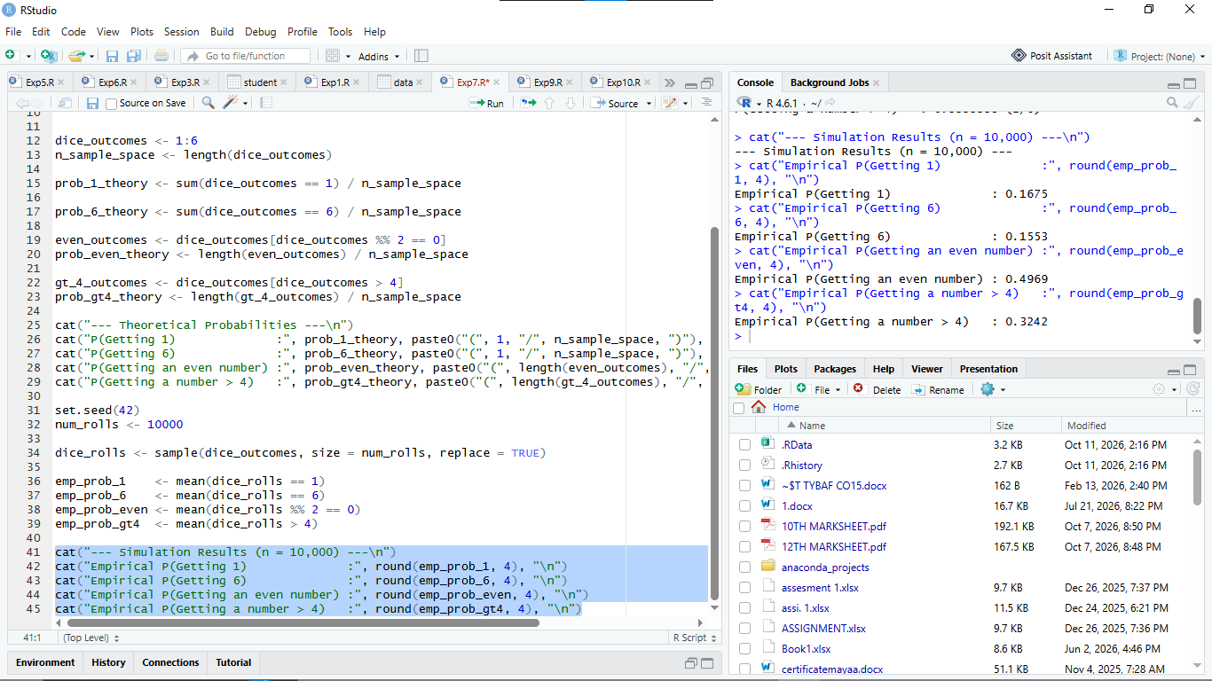

Observation Table:
Sr. No. | Experiment / Event | R Function / Syntax Used | Theoretical Probability | Experimental Probability (n=10,000)
1 | Coin Toss: Getting a Head | mean(tosses == "Head") | $0.5000\ (1/2)$ | $\approx 0.5029$
2 | Coin Toss: Getting a Tail | mean(tosses == "Tail") | $0.5000\ (1/2)$ | $\approx 0.4971$
3 | Dice Roll: Obtaining 1 | mean(dice_rolls == 1) | $0.1667\ (1/6)$ | $0.1675$
4 | Dice Roll: Obtaining 6 | mean(dice_rolls == 6) | $0.1667\ (1/6)$ | $\approx 0.1681$
5 | Dice Roll: Getting an Even Number | mean(dice_rolls %% 2 == 0) | $0.5000\ (3/6)$ | $\approx 0.5014$
6 | Dice Roll: Getting a Number $> 4$ | mean(dice_rolls > 4) | $0.3333\ (2/6)$ | $\approx 0.3347$

Result:
Basic probability experiments for coin tossing and dice rolling were successfully implemented in R using computational simulation techniques via the sample() function. The empirical relative frequencies obtained over $10,000$ trials closely matched their respective mathematical theoretical values, validating the Law of Large Numbers.

Curiosity Questions:
1. Why does experimental probability generally approach theoretical probability when the number of trials increases?
This behavior is governed by the Law of Large Numbers (LLN). In a small number of trials, short-term random fluctuations and chance variations dominate the outcome. As the number of independent trials ($n$) increases towards infinity, these random deviations balance out, causing the relative frequency (experimental probability) to converge toward the expected mathematical value (theoretical probability).

2. How does the sample() function simulate a random experiment in R?
The sample() function draws elements randomly from a defined vector representing the sample space. By using arguments like:
sample(x, size, replace = TRUE)
it treats each pull as an independent trial where each outcome has an equal (or user-weighted) probability. Setting replace = TRUE simulates experiments with replacement (such as repeatedly tossing a coin or rolling a die), where the outcome of one trial does not alter the probabilities of subsequent trials.
3. What is the difference between a sample space and an event? Give an example using a die.
- Sample Space (S): The complete set containing all possible outcomes of a random experiment.
  - Example (Fair Die): S = {1, 2, 3, 4, 5, 6}
- Event (E or A): Any specific subset of the sample space consisting of one or more favorable outcomes.
  - Example (Fair Die): Getting an even number, A = {2, 4, 6} (where A subset S).
4. Why can the experimental probability of getting Head be different from 0.5 in a finite number of coin tosses?
Because of random sampling variation (or stochastic noise). Each toss of a fair coin is completely independent, meaning the coin has no "memory" to enforce an exact 50-50 split in a small, finite sample. Theoretical probability predicts long-run expectation, whereas finite trials are subject to natural probabilistic spread.
5. How can probability experiments in R be useful for understanding real-world uncertainty?
Real-world systems—such as financial market volatility, insurance risk assessments, weather forecasting, disease spread, and traffic flow—contain too many complex variables for simple analytical equations. Using R to simulate probability experiments (known as Monte Carlo simulations) allows researchers and data analysts to model thousands or millions of stochastic scenarios computationally. This helps visualize risk distributions, estimate outcome likelihoods, and make data-driven decisions under uncertainty.
Viva voce Questions:
1. What is probability, and what is its possible range?
Probability is the measure of the likelihood of an event occurring. Its range is from 0 to 1, where 0 represents an impossible event and 1 represents a certain event.
Formula: 0 ≤ P(E) ≤ 1
2. What is a random experiment? Give two examples.
A random experiment is an experiment whose exact outcome cannot be predicted in advance.
Examples:
- Tossing a coin.
- Rolling a die.
3. What is a sample space? Write the sample space for a coin toss.
A sample space is the set of all possible outcomes of a random experiment.
For a coin toss: S = , where H represents Head and T represents Tail.
4. What is an event? Give an example for a die-rolling experiment.
An event is a subset of the sample space consisting of one or more outcomes of a random experiment.
Example: Getting an even number when rolling a die.
E = 6
5. Differentiate between theoretical probability and experimental probability.
Theoretical Probability:
- It is based on all possible outcomes.
- It is calculated mathematically.
- Example: The probability of getting a head on a fair coin is 1/2.
Experimental Probability:
- It is based on actual observations.
- It is calculated by performing experiments.
- Example: If 6 heads occur in 10 tosses, the experimental probability is 6/10 = 0.6.
6. Which R function is used to generate random samples?
The sample() function is used to generate random samples from a given set of values.
Example:
sample(1:6, 5, replace = TRUE)
This generates five random numbers from 1 to 6.
7. How is the sample() function used to simulate coin tossing?
The sample() function randomly selects either Head or Tail to simulate coin tossing.
R Code:
sample(c("H", "T"), 10, replace = TRUE)
This simulates 10 coin tosses.
8. How can sum() be used to count the occurrence of an event in R?
The sum() function counts the occurrences of an event by adding TRUE values returned by a logical condition.
R Code:
x <- c(2, 4, 3, 6, 1)
sum(x %% 2 == 0)
Output: 3
Explanation: Three numbers (2, 4, and 6) are even.
9. How can mean() be used to calculate experimental probability in R?
The mean() function calculates experimental probability by finding the average of logical values, where TRUE = 1 and FALSE = 0.
R Code:
x <- c(2, 4, 3, 6, 1)
mean(x %% 2 == 0)
Output: 0.6
Explanation: The experimental probability of getting an even number is 3/5 = 0.6.
10. What is the theoretical probability of getting an even number when a fair die is rolled?
The even outcomes are 6.
Formula:
P(E) = Favourable Outcomes / Total Outcomes
P(E) = 3/6 = 0.5
Answer: 0.5 or 50%.
11. What is the theoretical probability of getting a number greater than 4 on a fair die?
The favourable outcomes are 6.
Formula:
P(E) = Favourable Outcomes / Total Outcomes
P(E) = 2/6 = 1/3
Answer: 1/3 or approximately 0.3333.
12. Why does experimental probability tend to become closer to theoretical probability as the number of trials increases?
According to the Law of Large Numbers, as the number of independent trials increases, the experimental probability tends to approach the theoretical probability.
13. What is the purpose of set.seed() in R?
The set.seed() function ensures the reproducibility of random results. Using the same seed and code produces the same sequence of random values.
R Code:
set.seed(123)
sample(1:6, 5, replace = TRUE)
14. What is the role of replace = TRUE in the sample() function?
The argument replace = TRUE allows an element to be selected more than once.
R Code:
sample(1:6, 10, replace = TRUE)
This generates 10 random numbers from 1 to 6, allowing repetitions, as in repeated die rolls.
15. How can R be used to compare theoretical and experimental probabilities?
R can simulate random experiments, calculate experimental probability using mean(), and compare it with theoretical probability.
R Code:
set.seed(123)

rolls <- sample(1:6, 1000, replace = TRUE)

theoretical <- 3/6
experimental <- mean(rolls %% 2 == 0)

print(theoretical)
print(experimental)
Explanation: The theoretical probability of getting an even number is 0.5. The experimental probability is calculated from 1,000 simulated die rolls and will generally be close to 0.5.

